- Motivate

What was a situation where someone encouraged you and helped you?
- in playing sports
- in schoolwork
- on the job, especially when new on the job and not sure
- when you were feeling really discouraged, someone

- Transition

Consider the following statement by George Barna on the state of discipleship in America.
Print this up for distribution to the class.

The chief barrier to effective discipleship is not that people do not have the ability to become spiritually mature, but they lack the passion, perspective, and perseverance to develop their spiritual lives. Most Christians know that spiritual growth is important, personally beneficial, and expected, but few attend churches that push them to grow or provide the resources necessary to facilitate that growth. Few believers have relationships that hold them accountable for spiritual development. In the end, it boils down to personal priorities. For most of us, regardless of our intellectual assent to the importance of Christian growth, our passions lie elsewhere—and our schedule and energy follow those passions.

What do most believers not lack?  the ability to become spiritually mature
 knowledge that growth is beneficial, expected

What do believers lack?? the passion, perspective, perseverance to develop spiritual lives
relationships that hold them accountable for spiritual development

Why do many believers lack these things?
- have not been challenged
- life is easier when you don’t pursue these things
- we might be lazy
- we may need prodding that accountability provides
- we are too busy with other stuff – we need to focus on God’s priorities

- Bible Study

3.1 A Personal Commitment

Consider Luke 9:23-24: listen for what Jesus says is required to be His disciple.

"If anyone would come after me, he must deny himself and take up his cross daily and follow me. For whoever wants to save his life will lose it, but whoever loses his life for me will save it”

Specifically what is required for discipleship?
- deny self
- take up cross daily
- follow Jesus

What is the result of saving/grasping one’s life?
- you lose your life

What is the result of letting go of your life and giving it over to God?
- you save your life

As you hear to Luke 14:25-33, listen for the costs of discipleship.

²⁵ Now large crowds were going along with Him; and He turned and said to them, ²⁶ " If anyone comes to Me, and does not hate his own father and mother and wife and children and brothers and sisters, yes, and even his own life, he cannot be My disciple. ²⁷ "Whoever does not carry his own cross and come after Me cannot be My disciple. ²⁸ "For which one of you, when he wants to build a tower, does not first sit down and calculate the cost to see if he has enough to complete it? ²⁹ "Otherwise, when he has laid a foundation and is not able to finish, all who observe it begin to ridicule him, ³⁰ saying, 'This man began to build and was not able to finish.' ³¹ "Or what king, when he sets out to meet another king in battle, will not first sit down and consider whether he is strong enough with ten thousand men to encounter the one coming against him with twenty thousand? ³² "Or else, while the other is still far away, he sends a delegation and asks for terms of peace. ³³ "So then, none of you can be My disciple who does not give up all his own possessions.

What are some of the costs of discipleship that Jesus states or implies?
- separation from family
- maybe even rejection by your family
- at least the possible lack of understanding by your family
- give up rights to your own life (to God)
- give up all your possessions

What would it mean to “take up your cross”?
- take upon yourself the responsibility which God has for you
- accept the task given you
- It implies that it is voluntary, you are not forced to follow Jesus\

What is the cost of discipleship in today’s world?
- may lose friends
- in some cultures you are completely cut off from your family
- can lose a job
- persecution exists in many countries today
- we are classified as fundamentalist weirdoes
- may mean giving up some kinds of economic advantages or opportunities
- can cost time

According to this passage, why is it important to carefully consider the cost of discipleship?
- not able to finish what you start
- embarrassment, ridicule by others
- end up having to quit or retreat
The Obedient Christian
Witnessing

3.2 Personal Habits for Growth
The Word
Prayer
Christ
We will use the symbol of the “Obedient Christian Wheel” and fill
in the spokes
Fellowship
Print this up for distribution to the class.
With the spokes empty, to be filled in

- Prayer is the first spoke:

We will say that a model for praying is ACTS – which stands for
Adoration, Confession, Thanksgiving, and Supplication.

Have the class look up the following verses and determine which verses apply to which elements of prayer:
Ps 100:4, 1 John 1:9, Ps 100:1, 1 Tim 1:1-3

- The second spoke is The Word

What do the following verses say why we should study God’s Word?

Josh 1:8, Do not let this Book of the Law depart from your mouth; meditate on it day and night, so that you may be careful to do everything written in it. Then you will be prosperous and successful.
Ps 119:9-11, How can a young man keep his way pure? By living according to your word. I seek you with all my heart; do not let me stray from your commands. I have hidden your word in my heart that I might not sin against you.
Ps 119:105, Your word is a lamp to my feet and a light for my path.
2 Tim 3:16-17, All Scripture is God-breathed and is useful for teaching, rebuking, correcting and training in righteousness, so that the man of God may be thoroughly equipped for every good work.
1 Pet 2:2-3, Like newborn babies, crave pure spiritual milk, so that by it you may grow up in your salvation, now that you have tasted that the Lord is good.

Why should we study God’s Word?
- prosperity, success
- so as not to stray from God’s commands
- to keep from sinning
- a lamp or light for our path … guidance
- thoroughly equipped for serving God
- grow up in our salvation
Consider the following picture which helps you remember what you are to do with God’s Word.
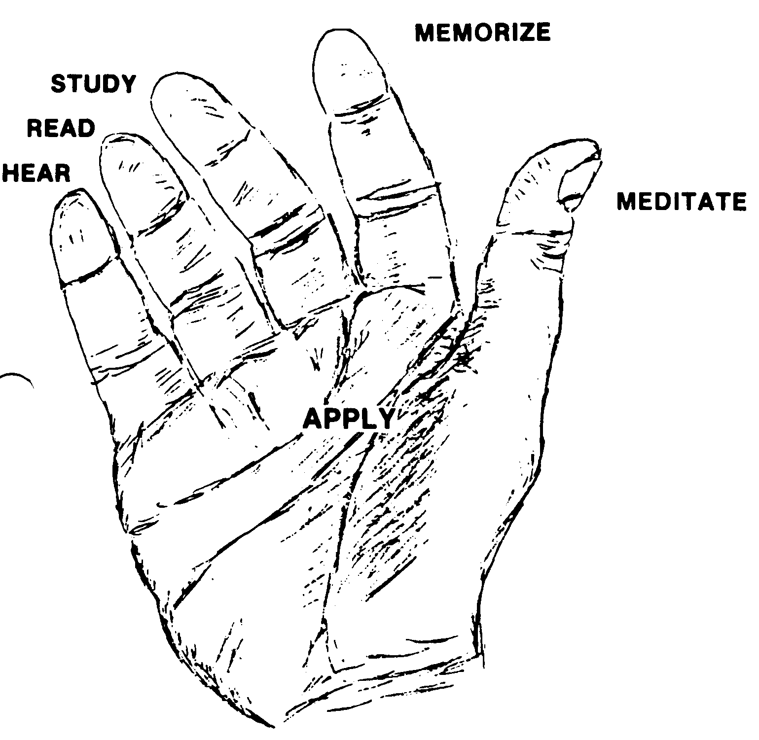
Have the class draw the outline of a hand and fill in the fingers and palm with what we should do with God’s Word

- Fellowship is the third spoke

According to the following quote, what are some reasons that Christians need to fellowship?
Jesus never intended for Christians to operate alone. You cannot be a balanced Christian if you neglect loving relationships with others. If you try to live apart from the fellowship of other believers, you will not experience the fullness of life in Christ. The Lord puts us in a body of believers because sustaining life outside the body of Christ is difficult. A lamp unplugged from its socket doesn’t shed light. As we love one another and stay connected to people in fellowship, we gain strength from one another.
–Avery Willis, in MasterLife, 1998, p. 40.

Print this up for distribution to the class.

Why should believers fellowship one with another?
- It is God’s plan
- it helps us have a balanced Christian life
- it helps you experience the fullness of life in Christ
- we help one another – where one is weak, the other is encouraging and strengthening
- we gain strength from one another

What do the following scriptures suggest as specific ways in which this happens?
Rom 12:16, Live in harmony with one another.
Gal 5:13, Serve one another in love.
Gal 6:2, Carry each other's burdens.
Eph 4:32, Be kind and compassionate to one another, forgiving each other.
1Thes 5:11, Therefore encourage one another and build each other up.
James 5:16, Confess your sins to each other and pray for each other.

- Witnessing is the last spoke.

Listen for the prophecy given in Acts 1:8

“But you will receive power when the Holy Spirit comes on you; and you will be my witnesses in Jerusalem, and in all Judea and Samaria, and to the ends of the earth"

What things did Jesus prophesy for the disciples (which ultimately includes us)?
- believers would receive power
- the Holy Spirit would come upon us (to do the empowering)
- we will be witnesses
- the witnessing would start locally, grow regionally, then globally

What fears keep us from witnessing to others?
- we will be rejected
- we might mess up and feel embarrassed
- even worse, we might actually turn them off to belief in Christ
- we are too busy
- that’s not my gift

Which of the prophesies apply to our fears?

What are some definite steps you could take to overcome whatever reservations you have about being active in witnessing?
- take FAITH training
- keep a list of people who need the Lord and pray specifically for them
- ask God to provide natural opportunities to share the gospel message
- claim the promises of the prophesies of Acts 1:8

- Conclusion – Application

4.1 Make a personal commitment to be a fully devoted follower of Jesus Christ
- As we close the class, take a moment to talk to the Lord
- Tell Him specifically of your desire to commit to His Word, Prayer, Fellowship, Witnessing

4.2 Find a daily devotional book which would help you have a daily time in God’s Word
- consider the One Year Bible
- Try using one of the day by day devotional books such as Daily Bread or a similar booklet from Lifeway (Baptist press)

4.3 Commit to sign up for the fall semester of FAITH

4.4 Ask God to help you find someone who you could invite to our next SS class fellowship who needs to know the Lord and/or needs the help that other believers can offer

Barna, 54.

