1. Motivate

Why do you think people strive after money and power when those things do not bring true happiness?
- our materialistic culture
- the constant bombardment of advertisement
- it is what we are told by parents, peers, and others
- by the examples of those around us
- we go to school so we can get good jobs and make money and advance
- we desire to keep up with folks around us
- we see other people who look like they are satisfied and living the “good life” and want the same

2. Transition

Today we contrast how two different people faced life.
- Haman pursued power and fame
- Even though she was queen, Esther acted humbly
- We will see that humility ultimately wins the day

3. Bible Study

3.1 Act With Humility

Listen for Esther’s plan to unfold.

Esther 5:1-8 (NIV) On the third day Esther put on her royal robes and stood in the inner court of the palace, in front of the king's hall. The king was sitting on his royal throne in the hall, facing the entrance. 2 When he saw Queen Esther standing in the court, he was pleased with her and held out to her the gold scepter that was in his hand. So Esther approached and touched the tip of the scepter. 3 Then the king asked, "What is it, Queen Esther? What is your request? Even up to half the kingdom, it will be given you." 4 "If it pleases the king," replied Esther, "let the king, together with Haman, come today to a banquet I have prepared for him." 5 "Bring Haman at once," the king said, "so that we may do what Esther asks." So the king and Haman went to the banquet Esther had prepared. 6 As they were drinking wine, the king again asked Esther, "Now what is your petition? It will be given you. And what is your request? Even up to half the kingdom, it will be granted." 7 Esther replied, "My petition and my request is this: 8 If the king regards me with favor and if it pleases the king to grant my petition and fulfill my request, let the king and Haman come tomorrow to the banquet I will prepare for them. Then I will answer the king's question."

In what ways did Esther demonstrate humility and show respect for the king?
- the plan Esther executed to gain the king’s attention:
- She dressed in her royal clothing.
- She positioned herself in a location where the king would see her.

How did the king respond to her unannounced appearance?
- she gained his favor
- he extended his gold scepter to her
- she came forward and touched the tip of the scepter

In what ways did Esther’s actions demonstrate both courage and humility?
Humility | Courage
- she was not too proud to take the chance for the king’s acceptance  - didn’t think her life was more important than the ongoing existence of her people  - did not show arrogance  - did not show uncontrolled anger  - showed respect for authority of the king, even though disagreeing with the new law he had agreed to | - willing to risk her life  - willing to approach the king, even though uninvited  - intentional facing the problem  - willing to confront the issue

What was her surprise proposal when the king asked her what request she had for him?
- let me sponsor a banquet for you and one of your leaders
- it will be a small affair with just you and I and your friend Haman
- let me hold off on my request until the banquet

Why do you think she invited Haman when none of the recorded conversation appears to include him?
- she knew Haman was the instigator of the anti-Jewish movement
- she also knew of his hatred for her cousin/father-figure Mordecai
- her plan to thwart his plot could have included a personal confrontation
- maybe she knew the aphorism “keep your friends close and your enemies closer”

3.2 Pride Brings No Satisfaction

Listen for mixed emotions.

Esther 5:9-14 (NIV) Haman went out that day happy and in high spirits. But when he saw Mordecai at the king's gate and observed that he neither rose nor showed fear in his presence, he was filled with rage against Mordecai. 10 Nevertheless, Haman restrained himself and went home. Calling together his friends and Zeresh, his wife, 11 Haman boasted to them about his vast wealth, his many sons, and all the ways the king had honored him and how he had elevated him above the other nobles and officials. 12 "And that's not all," Haman added. "I'm the only person Queen Esther invited to accompany the king to the banquet she gave. And she has invited me along with the king tomorrow. 13 But all this gives me no satisfaction as long as I see that Jew Mordecai sitting at the king's gate." 14 His wife Zeresh and all his friends said to him, "Have a gallows built, seventy-five feet high, and ask the king in the morning to have Mordecai hanged on it. Then go with the king to the dinner and be happy." This suggestion delighted Haman, and he had the gallows built.

Haman is happy and in high spirits after the banquet. What caused his feelings of anger and resentment to resurface?
- saw his hated acquaintance, Mordecai
- noted that he did not rise
- Mordecai did not show fear, awe at Haman’s presence
- Haman is filled with rage

What action did he take that indicates he was filled with pride?
- bragged to friends and family
- boasted about vast wealth, many sons
- boasted about how the king had honored him, elevated him above other nobles and officials
- boasted about the personal invite of Queen Esther … and again tomorrow

What makes pride so dangerous?
- comes before a fall
- blinds you to reality, you don’t realize what is really the main issue
- for believers, we end up depending on ourselves, rather than on God
- it is actually a lack of faith in God

Haman’s pride is offended by Mordecai’s continued lack of respect. What suggestion did Haman’s family offer and what did Haman think about their idea?
- go ahead and prepare for Mordecai’s execution
- build the gallows … make it 75 feet high
- then go on to the dinner and enjoy yourself

In what ways can pride be both a good and a bad attitude?
Good Pride | Bad Pride
- desire to do a good job  - want to look good, presentable  - work hard and accomplish goals  - use pride to maintain a certain standard in what you do  - aware of your own good qualities and skills, but also of your own limitations | - too proud to receive help  - using pride to put others down  - measure personal achievements against someone else’s  - can cause marital squabbles, lawsuits, church splits, etc.  - related to conceit, self-centeredness

3.3 Jesus Teaches about Humility

Listen for good advice given by Jesus

Luke 14:7-11 (NIV) When he noticed how the guests picked the places of honor at the table, he told them this parable: [8] "When someone invites you to a wedding feast, do not take the place of honor, for a person more distinguished than you may have been invited. [9] If so, the host who invited both of you will come and say to you, 'Give this man your seat.' Then, humiliated, you will have to take the least important place. [10] But when you are invited, take the lowest place, so that when your host comes, he will say to you, 'Friend, move up to a better place.' Then you will be honored in the presence of all your fellow guests. [11] For everyone who exalts himself will be humbled, and he who humbles himself will be exalted."

According to this parable, what were the typical seating arrangements at a wedding feast?
- there were places of more and lesser honor
- the host decided where people sat
- the host had the right to rearrange the seating if you happened to take a seat where he wanted a closer friend or more important person to sit

What did Jesus suggest was a way to avoid embarrassment?
- don’t assume your importance and take an honored position
- don’t think higher of yourself than you might deserve
- better to be moved up to a more honored position than to be demoted to a one of lesser importance

What was Jesus concluding remark that communicated the value of humility?
- if you exalt yourself you will likely be humbled
- if you humble yourself, you might well be promoted, exalted

What are some situations where you might be tempted to exalt yourself?
- when stopped by a policeman for a traffic violation (“I’m good friends with the chief, you know.”)
- when trying to make an impression on a new neighbor
- when trying to schmooze the boss
- when you are trying to impress a prospective client
- as a single, trying to impress a new boy/girl acquaintance

What can be the dangers of comparing yourself with others?
- you might come up looking bad
- you end up sounding like a braggart
- you don’t really get to know the person you’re talking to – you should be listening more, not talking so much
- you might talk yourself into a trap by bluffing or over selling yourself

Church Life
- let someone else take the solo in choir
- let another person take a turn at chairing the committee

At Work
- be willing to give a subordinate a break
- help the boss look good
- give credit to those who helped you succeed

Driving in Traffic
- let a car enter the lane
- don’t retaliate when you are cut off
- let the car pass, he won’t get there that much sooner

Use the last page as a handout so your learners can take home the application points of this week’s lesson.
Application
Reflect.
- Reflect on your own tendencies toward selfishness, bitterness, or the desire to seek power at others’ expense.
- Confess and give these sinful attitudes and actions to God. Trust Him and thank Him for His forgiveness.

Review.
- Create a list of your current obligations and priorities, and evaluate how any of these might feed pride or self-centeredness.
- Prayerfully consider withdrawing from or eliminating anything that nurtures pride or narcissism.

Reconcile.
- If pride in the past has caused a problem in a relationship or stirred up enmity toward another person, prayerfully consider moving toward reconciliation.
- Ask the Lord to help you forgive and/or ask for forgiveness.
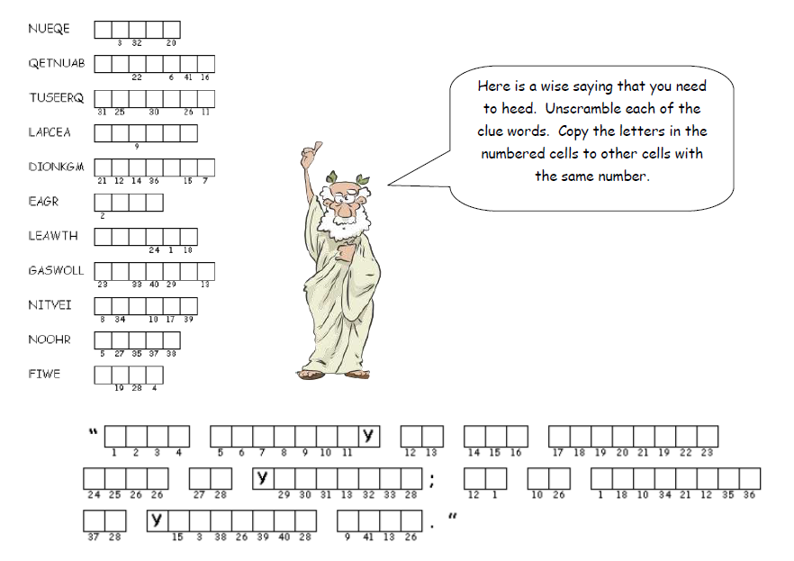
Here is a wise saying that you need to heed. Unscramble each of the clue words. Copy the letters in the numbered cells to other cells with the same number. Find the solution at https://tinyurl.com/yb8th35q along with other interesting Family Activities
Double Puzzle
Esther 5

