1. Motivate

Consider these quotes about deep conviction
- We have always held to the hope, the belief, the conviction that there is a better life, a better world, beyond the horizon. Franklin D. Roosevelt
- It's the repetition of affirmations that leads to belief. And once that belief becomes a deep conviction, things begin to happen. Muhammad Ali
- That deep emotional conviction of the presence of a superior reasoning power, which is revealed in the incomprehensible universe, forms my idea of God. Albert Einstein
- To rely upon conviction, devotion, and other excellent spiritual qualities; that is not to be taken seriously in politics. Vladimir Lenin
- When Christians say God has been talking to them about something, it simply means they have a strong inner conviction or feeling that God has made His will known to them. Billy Graham

2. Transition

Today we study someone who took action in what could have been a dangerous and difficult situation.
- He was convinced he had to do something.
- Even though it may be dangerous or controversial, it is always right to do the right thing.

3. Bible Study

3.1 Stand Against Wrong

Listen for a plot.

Esther 2:21-23 (NIV) During the time Mordecai was sitting at the king's gate, Bigthana and Teresh, two of the king's officers who guarded the doorway, became angry and conspired to assassinate King Xerxes. 22 But Mordecai found out about the plot and told Queen Esther, who in turn reported it to the king, giving credit to Mordecai. 23 And when the report was investigated and found to be true, the two officials were hanged on a gallows. All this was recorded in the book of the annals in the presence of the king.

What was the plot Mordecai discovered while he was sitting at the king’s gate?
- there were two of the kings officers there who were doorway/gate guards
- they became angry
- conspired to assassinate King Xerxes

What did he choose to do about it?
- Mordecai overheard of the plot
- he told his cousin, Queen Esther
- she reported it to the king
- the report was investigated, found to be true
- the two officials were executed

How was he rewarded for his loyalty?
- official report recorded in the king’s official records
- Mordecai given credit for the report

What risks did Mordecai and Esther take in these verses?
- the perpetrators may have found out they were going to the king
- they could have also attacked Mordecai
- they could have included Queen Esther in the assassination -- killed both king and queen when they were together

What is difficult about speaking up, about staying silent?
Difficult to speak up | Difficult to stay silent
- afraid of retaliation  - might be misunderstood  - motives misinterpreted  - not able to explain the issues sufficiently well  - you can get accused of being a squealer, fink, tattletale, whistleblower, a snitch | - the situation gets worse  - more people can become affected by the actions of those involved  - we are hurting  - you are more and more upset with the injustice

What risks do we take when we speak up against wrongdoing?
- become targets of those we speak against
- they can attack verbally
- they might work to ruin our reputation, lie about us
- could also be physical danger

Mordecai responded to vulnerability he saw with regard to the king. At the other end of the socioeconomic scale, who are the vulnerable in our culture?
- homeless
- abused children
- abused spouses
- people caught up in human trafficking
- aborted babies
- people who lose everything in natural disasters
- Christians who are persecuted for their faith

3.2 Reverence and Submit to God Only

Listen for civil disobedience.

Esther 3:1-2 (NIV) After these events, King Xerxes honored Haman son of Hammedatha, the Agagite, elevating him and giving him a seat of honor higher than that of all the other nobles. 2 All the royal officials at the king's gate knelt down and paid honor to Haman, for the king had commanded this concerning him. But Mordecai would not kneel down or pay him honor.

How did King Xerxes honor Haman?
- elevated him to higher position
- a seat of honor higher than all the other nobles
- commanded that people kneel down and pay honor to him

In what way did Mordecai disobey the king’s order?
- refused to kneel down
- would not pay him honor

Note the description of Haman’s lineage
- Descendant from the Amalekite King Agag.
- When God commanded Saul to destroy the Amalekites, King Agag was on the throne. (1 Sam. 15:7-33).
- The strife between Israel and the Amalekites started much earlier when they battled after the exodus (Ex. 17:8-15).
- Long enmity between Israelites and Amalekites

So, why do you think Mordecai refused to bow down to Haman?
- Perhaps Mordecai refused to bow because he felt he’d be violating his worship of Yahweh to bow before anyone but God.
But …
- to bow was an act of respect, not worship. And if Mordecai did serve in the king’s court, he likely had bowed previously before Ahasuerus or royal officials.
- Perhaps Mordecai refused to bow because Haman was an Agagite. … we noted above the long standing enmity

3.3 Stand for God, Even when Opposed

Listen for Haman’s reaction.

Esther 3: 3 – 6 (NIV) Day after day they spoke to him but he refused to comply. Therefore they told Haman about it to see whether Mordecai's behavior would be tolerated, for he had told them he was a Jew. 5 When Haman saw that Mordecai would not kneel down or pay him honor, he was enraged. 6 Yet having learned who Mordecai's people were, he scorned the idea of killing only Mordecai. Instead Haman looked for a way to destroy all Mordecai's people, the Jews, throughout the whole kingdom of Xerxes.

Officials questioned Mordecai about his refusal to bow. So, what did he do?
- refused to comply

When he refused, what did they do?
- They told Haman to see how he would respond.
- They revealed to Haman that Mordecai was a Jew.

When Haman saw firsthand that Mordecai refused to show him honor and learned Mordecai’s ethnicity, what did he determine to do?
- he got mad
- he was a believer of the adage “don’t get mad, get even”
- decided killing only Mordecai was not enough
- began to plan for a way to destroy all the Jews throughout the kingdom
- this may also have to do with the long standing animosity between the Jews and the Amalekites

Doing the right thing is sometimes dangerous and risky. What might be the cost of doing the right thing in these situations?

- Standing up for someone facing discrimination
  - could cost us some friendships
  - might result in demotion
  - might cause others to be angry at you
- Refusing to cheat a client or customer
  - boss gets mad
  - no promotion for you
  - lose your job
  - moved to a different position, demotion
- Letting every kid who signed up for the team—even the worst—get in the game
  - other parents mad, their kid was better
  - lose the game

Consider the ripple effect that occurs when you toss a rock into a pond or lake.
Discuss how the principle of the ripple effect plays out in life situations and the impact one small action can have.
When you do the right thing | When you fail to do the right thing
- helps the people involved  - justice is done  - can change policy for next time | - people are wronged  - injustice continues  - people continue to get away with wrong actions

Why is it important to do the right thing in private as well as in public?
- shows who you are
- need to be consistent
- cannot be “two faced”
- your family and close acquaintances would know you are fake if you don’t
- it’s a lie to act one way in public, another in private

How do we determine when to take a stand?
- must make the decision ahead of time
- good idea for teens to decide how they are going to act, even what they will say in certain situations before they ever get to that point of temptation
- we need to be thinking about situations where we might be required to take a stand and pray about how we might respond – decide now to do the right thing

What skills, gifts, talents, and resources do we have that we can use to work for justice for the vulnerable and oppressed?
- prayer support
- be an example
- involved in programs that rescue, counsel, support those coming out of abusive situations
- fight against human trafficking .
Use the last page as a handout so your learners can take home the application points of this week’s lesson.
Application
Pray for the courage to do the right thing in small ways when the opportunity is presented
- In your family,
- Your neighborhood, and
- In your church.

Think about ways you can do something meaningful to help the vulnerable around you.
- Use your gifts,
- Talents, and
- Resources

Minister to others.
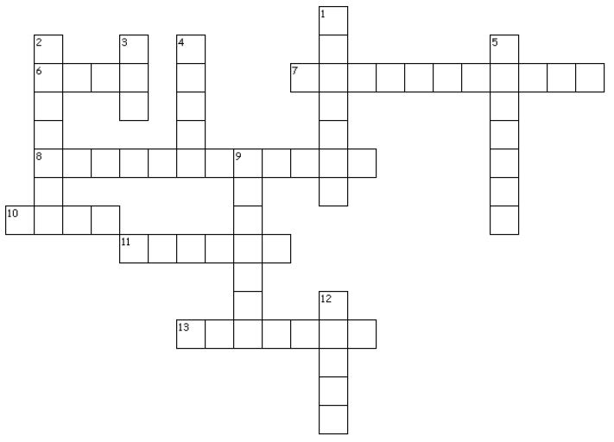

- Find ways you can help do justice and mercy on behalf of the voiceless.
Across
6. Where Mordecai sat
7. What two men wanted to do to the king
8. the report was _?_ and found to be true
10. Haman was given a _?_ of higher honor
11. Royal officials repeatedly spoke to
Mordecai, but he refused to _?_
13. Haman wanted to _?_ all Mordecai's people

Down
1. "Why do you _?_ the King's
command?"
2. Haman, son of Hammedatha, the
_?_
3. Mordecai's ethnic background
4. how people paid honor to Haman
5. Haman's response to Mordecai's
refusal
9. Where the officials were
hanged
12. Mordecai would not pay _?_ to
Haman
Crossword
Stand with Conviction
Esther 2:21 – 3:6 (NIV)

Check out some interesting discussion topics you can discuss with your kids or grandkids. There’s other family activities also at
https://tinyurl.com/y7g4mp4l

