1. Motivate

When have you regretted or been embarrassed by something you said?
- you didn’t know the person about whom you were talking (negatively) was listening
- you were talking about someone and it got back to them what you said
- you spoke angrily in the heat of the moment and it was either bad language or was hateful
- you spoke loudly right when the room quieted down and everyone heard what you said
- you were caught in a lie
- you declared something vehemently and were later proved wrong
- told a joke that was offensive to someone you didn’t know was within hearing distance

2. Transition

Today we look at two people who spoke up or spoke out.
- They had different motives
- They saw different results
- Sometimes it is important to speak up, other times it is more important to keep our mouths shut

3. Bible Study

3.1 Faithfulness Honored

Listen for self-importance.

Esther 6:3-11 (NIV) "What honor and recognition has Mordecai received for this?" the king asked. "Nothing has been done for him," his attendants answered. 4 The king said, "Who is in the court?" … 6 When Haman entered, the king asked him, "What should be done for the man the king delights to honor?" Now Haman thought to himself, "Who is there that the king would rather honor than me?" 7 So he answered the king, "For the man the king delights to honor, 8 have them bring a royal robe the king has worn and a horse the king has ridden, one with a royal crest placed on its head. … 10 "Go at once," the king commanded Haman. "Get the robe and the horse and do just as you have suggested for Mordecai the Jew, who sits at the king's gate. Do not neglect anything you have recommended." 11 So Haman got the robe and the horse. He robed Mordecai, and led him on horseback through the city streets, proclaiming before him, "This is what is done for the man the king delights to honor!"

What advice did the king request of Haman?
- we need to honor someone (but didn’t tell him who)
- what do you think would be appropriate to do to give them honor?

Assuming it was himself to be honored, what did Haman suggest should be included in the honor to be given?
- get to wear a royal robe once worn by the king (not Elvis)
- get to ride on one of the king’s horses
- have someone important parade them through town
- as they go announce loudly, “This person is being honored by the King”

What do you suppose were Haman’s thoughts and motives when he responded to the king?
- I get to declare my own reward
- I’m going to make it good
- our phrase might be “toot my own horn”
- I’ll be famous now
- it’s about time I get some recognition for being so important
- now Mordecai will see who is important

How did the king respond to Haman’s ideas?
- “great idea, Haman”
- “OK … you get the robe and the horse and take them to Mordecai”
- put the robe on him, put him on the horse
- you get to be the “noble prince” and march him through the city declaring the royal announcement of honor

What is ironic so far in the story about what happened to Haman and Mordecai?
- Haman was continuously mad at and took insult from Mordecai
- Haman was deeply involved in palace politics, climbing himself to the top
- Mordecai had quietly gone about his duties, with little recognition for busting up an assassination plot
- Mordecai had remained unimpressed with Haman and probably others who promoted themselves
- now the tables are turned, Mordecai receives honor and Haman must be the one giving and declaring that honor … loudly and prominently before the whole city

Haman’s pride is what got him into trouble (both here in the coming events). Who or what tempts you to feel proud … and could cause you trouble?
- trying to keep up with folks around us
- we look to material things to give us status – coolest vehicle, biggest house, most beautifully landscaped yard, sharpest clothes
- we try to live our lives through our children’s accomplishments – sports, academics, music, cheerleading, etc.
- climbing the corporate ladder, office politics

How can we protect ourselves against the temptation to be proud or arrogant?
- pursue an attitude of thankfulness to God
- remember that all we have, all we accomplish is due to God’s blessings
- remember

3.2 Speak Out Against Evil

Listen for evil revealed.

Esther 7:1-6 (NIV) So the king and Haman went to dine with Queen Esther, 2 and as they were drinking wine on that second day, the king again asked, "Queen Esther, what is your petition? It will be given you. What is your request? Even up to half the kingdom, it will be granted." 3 Then Queen Esther answered, "If I have found favor with you, O king, and if it pleases your majesty, grant me my life--this is my petition. And spare my people--this is my request. 4 For I and my people have been sold for destruction and slaughter and annihilation. If we had merely been sold as male and female slaves, I would have kept quiet, because no such distress would justify disturbing the king." 5 King Xerxes asked Queen Esther, "Who is he? Where is the man who has dared to do such a thing?" 6 Esther said, "The adversary and enemy is this vile Haman." Then Haman was terrified before the king and queen.

What words and phrases show how Queen Esther prefaced her request politely and tactfully?
- if I have found favor with you
- if it pleases your majesty
- I wouldn’t disturb you if it was “merely” being sold as slaves
- I didn’t want such a distress to justify disturbing the king

So, finally, what did Esther ask of the king?
- grant me my life
- spare my people
- we have been sold for destruction, slaughter and annihilation

We considered Haman’s thoughts and motives in his response to the king. Now, what do you think were Esther’s thoughts and motives? How can we tell she was not motivated by pride?
- I have to speak out, else I and the rest of the Jews will die
- motivated by impending danger
- thought of the responsibility/opportunity she had to rescue a whole group of people
- she was willing to identify her ethnicity, which she had previously not revealed
- she and those she had requested had prepared by prayer and fasting for three days
- this was a life and death task, not just an chance to look good before the king

What were the reactions of each of these three people as Esther declares her request?
King Ahasuerus | Queen Esther | Haman
- who is he  - where is the man  - who has dared to do such a thing | - this is the adversary  - this is the enemy  - it is the vile Haman | - terrified!

3.3 Leave Vengeance to God

Listen for Haman’s fate.

Esther 7:7-10 (NIV) The king got up in a rage, left his wine and went out into the palace garden. But Haman, realizing that the king had already decided his fate, stayed behind to beg Queen Esther for his life. 8 Just as the king returned from the palace garden to the banquet hall, Haman was falling on the couch where Esther was reclining. The king exclaimed, "Will he even molest the queen while she is with me in the house?" As soon as the word left the king's mouth, they covered Haman's face. 9 Then Harbona, one of the eunuchs attending the king, said, "A gallows seventy-five feet high stands by Haman's house. He had it made for Mordecai, who spoke up to help the king." The king said, "Hang him on it!" 10 So they hanged Haman on the gallows he had prepared for Mordecai. Then the king's fury subsided.

How did the king react to what he learned from Esther?
- got up in a rage
- left his wine
- stormed out into the palace garden

What did Haman attempt to do?
- realized he was “toast”, the king had probably already decided his fate
- stayed behind to beg Queen Esther for his life

What made matters worse for him?
- as the king returned, there was Haman
- he was on his knees before Esther
- it looked like he was possibly molesting the queen

What order did the king issue?
- one of his attendants noted the existence of gallows at Haman’s house
- this was what Haman had intended for Mordecai
- the King ordered Haman to be hanged on those same gallows

Let’s list all the ironic circumstances surrounding Haman’s death in chapters 6 and 7?
- by “chance” the king’s insomnia reading reveals Mordecai’s role in saving the king’s life
- by “chance” Haman is called upon to suggest ways to honor someone (thinking it would be himself)
- Haman is forced to be the one who bestows the royal honor on Mordecai, whom he hates
- the gallows he has prepared for Mordecai end up being where he was hanged instead

Esther was bold in confronting impending injustice. Where do we have opportunities to be bold about injustice in our society?
- the erosion of moral values
- the attackson religious freedoms
- Christians can and should become more involved in community leadership
- Christians can and should enter various fields of journalism, law, and entertainment to represent Christian values
- work against abortion and human trafficking
- involvement in the outreach of the gospel … when God is at work in people’s lives, many of these issues are resolved in the individuals and in families
Use the last page as a handout so your learners can take home the application points of this week’s lesson.
When we speak out, what are some things we should do first?
- pray before you speak
- consider your motives
- be careful of pride
- speak with care (Esther spoke courteously, yet formal, using court etiquette)
- give careful thought to what you say (email, post, write, publish)
- be aware of what is proper for the given situation
Application
Pray.
- Ask the Lord to reveal ways you can use what He’s given you—your time, possessions, influence, and position.
- Pray before you speak out against evil and injustice in society.

Look.
- Do some research into opportunities in your community to help fight injustice.
ADVERSARY
BANQUET
DARED
DESTRUCTION
DISTRESS
ENEMY
ESTHER
FURY
GALLOWS
GARDEN
GATE
GRIEF
HAMAN
HANGED
HONOR
HORSE
JUSTIFY
KING
KINGDOM
MORDECAI
NOBLE
PALACE
PRINCES
PROCLAIM
QUEEN
QUIET
RECLINING
REQUEST
ROBE
ROYAL
SPARE
VILE
XERXES
Act.
- As a group, prayerfully consider what you can do.
- You can act through your local church or a trusted local organization.
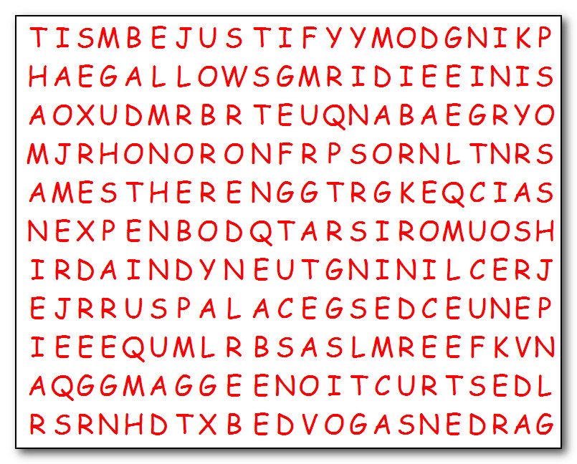

- You can help make a difference in the area God is calling you to serve.
The Royal Vocabulary List has been scrambled and hidden by the evil Haman. In the matrix above you must find the words listed on the right. Be careful, Haman has words going in all directions … up, down, backwards, and even diagonally. Find the solution and other Family Activities at https://tinyurl.com/y7wv7q4o

