1. Motivate

What are some occasions when you wish you had a guide?
- driving down town in a big city
- driving in a foreign country (on the left side of the road)
- hiking through back country
- going to one of the Disney parks for the first time
- studying for a statistics exam
- fishing in an unknown body of water
- starting a new job as a new college graduate
- playing a golf course for the first time
- filling out tax forms
- coming home with a newborn for the first time

2. Transition

Today we look at the best guide we could ever have … The Good Shepherd, Himself
- God guides us as he walks with us every day.

3. Bible Study

3.1 Guidance We Need

Listen for a shepherd’s tasks.

Psalm 23:1-3 (KJV) The LORD is my shepherd; I shall not want. 2 He maketh me to lie down in green pastures: he leadeth me beside the still waters. 3 He restoreth my soul: he leadeth me in the paths of righteousness for his name's sake.

What specific things does the Good Shepherd do for his sheep (his people)?
- keeps them from being in want
- makes them lie down in green pastures
- leads them beside the quiet waters
- restores their souls
- guides them in the right paths

Why was the metaphor of the Lord as shepherd a fitting one for David to use?
- David had been a shepherd in his youth
- he knew all the things the shepherd does for the sheep
- he saw the parallel that existed with how God cares for His people
- people who read his poetry would also see the parallel

What motivates God to guide His people?
- wants to show His faithfulness
- to prove Himself
- demonstrates that He does the right thing for His people

When have you had your soul restored? In what ways does God restore our souls?
- helped me quit worrying
- brought peaceful nights of sleep during a stressful situation
- brought someone along to give good advice
- helped me understand a difficult academic course
- gave recovery from a severe medical situation

David said that the Good Shepherd “makes me lie down.” What does “lie down,” or the idea of the reclining position suggest?
- physical rest,
- the body becoming unstressed
- spiritual rest
- peace, security, lack of anxiety

Some translations say “makes me lie down.” Why would God force us to rest?
- sometimes we need to be told or urged to do so
- a workaholic might need to be taken out of that mentality forcibly
- we can get so busy, we don’t know what we really need
- … or when we need it

Other translations say “lets me lie down.” How is this translation just as valid?
- God does not force us to receive His blessings
- we have a free will
- but when we do submit to Him, He joyfully lets us experience His provisions
- when we do know we have a need for rest and reprieve, we can depend on His divine providence

David says God restores or renews his soul. What kind of renewal or restoration did God provide for David (and for us)?
- after his sin with Bathsheeba, David’s relationship with God was restored after repentance and confession
- when we fail God and sin – if we confess our sins He is faithful to forgive and cleanse (1 John 1:9)
- renewal also is provided after particularly stressful and draining life events
- relationships with others can be renewed
- a rocky marriage can be restored
- broken relationships within families can be mended

David spoke of a shepherd and sheep—what metaphor could you use to picture your relationship with the Lord? Finish the phrase, “The Lord is my ________”
- helpful, mentoring boss
- wise teacher
- loving and encouraging grandparent
- gardener who lovingly cares for a garden
- someone who seems to have abundant common sense and shares it with you when you are confused
3.2 Walks with Us in Difficulties

Listen for difficulties faced.

Psalm 23:4-5 (KJV) Yea, though I walk through the valley of the shadow of death, I will fear no evil: for thou art with me; thy rod and thy staff they comfort me. 5 Thou preparest a table before me in the presence of mine enemies: thou anointest my head with oil; my cup runneth over.

What were some dark times David might have been alluding to in verse 4?
- pursued by Saul
- confronting wild animals
- military battles
- rebellion by his own son
- death of his sons

Why was he convinced he had no reason to fear?
- God was with him
- God comforted him
- God provided his needs

How do the images of the table, oil, and cup add to David’s description of how the Lord had cared for him?
- daily provisions
- healing
- abundant provisions

Notice the change in the pronouns from He to you or thou… David is addressing God personally. Why is intimacy, a personal relationship with God important?
- God is a personal God
- He is not a deity who views just the masses
- we know we can go to Him and He pays specific attention to us … personal attention
- a personal God knows our personal needs
- He understands our feelings, our fears, our hopes and dreams
- we don’t have to clamor for His attention

What kinds of dark valleys do we experience where David assures us that God is with us?
- health crises
- financial set backs
- loss of a loved one
- work related stress
- family relationship crises

How do we recognize God’s presence with us during those dark times of life?
- God gives a peace that goes beyond understanding
- God works out details of the problem, smooths out the rough road for us
- God provides the need
- after it is over we can see God’s specific intervention
3.3 Gives Us Security

Listen for future blessings.

Psalm 23:6 (KJV) Surely goodness and mercy shall follow me all the days of my life: and I will dwell in the house of the LORD for ever.

What present blessing does David allude to in this verse?
- goodness
- blessings he didn’t deserve
- withheld punishments he did deserve (mercy)

Why does a parent or grandparent continue to pray for even a wayward child or grandchild year after year?
- love
- faith in God’s ability
- knowledge that God can take care of them when we cannot

Note this same kind of consistent “pursuit” by God. What would be better about God pursuing us rather than us pursuing Him?
- we might give up, God does not
- God knows where to “find” us … sometimes we might be too confused or upset to discouraged to know how or where to find Him
Use the last page as a handout so your learners can take home the application points of this week’s lesson.
- God’s pursuit is consistent, ours might be intermittent
- at times we run the other way (recall Jonah), God doesn’t quit

What is his future hope?
- be with the Lord forever
- life/existence in God’s presence beyond this present life
- eternal union with God – spiritual life
- contrast to spiritual death – eternal separation from God

What can we do to show gratitude to God for His pursuing goodness, mercy, and love, the overflowing cup He provides?
- love engenders love, since God loves you, you love Him
- you respond to Him with attitudes and actions that bring positive attention to Him
- loving service
- vocal praise and worship
- communicate to others what God has done for you, what God wants to do for them

As a believer, how can confidence in your eternal security affect your approach to daily life?
- you don’t have that feeling of God poised over you ready to pounce if you mess up
- it is an encouragement to turn burdens over to Him, not to drag them around in your own strength
- not only does God forgive, He also empowers and motivates you to resist temptation the next time
Application
Rest and trust.
- Since the Good Shepherd provides everything you need, learn to differentiate between needs and wants.
- When God doesn’t provide what you think you need, trust His goodness.
- Thank Him for His protection.

Stay close.
- Sin will keep you from experiencing all the good the Shepherd desires for you.
- Acknowledge and confess any sin that keeps you separated from the One who desires to lead you to still waters.

Slow down.
- If you are rushed and harried, it may be that you aren’t taking time for the Shepherd to feed you and restore your soul.
- Slow down and spend time in His Word.

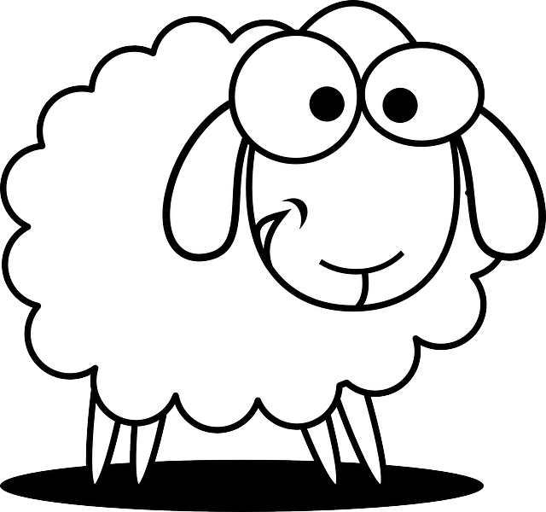
- Make changes to your schedule to ensure more quality time in God’s Word.
Find more activities you can do with your children or grandchildren at https://tinyurl.com/y9bvknxp
Good Shepherd Crossword
Psalm 23:1 – 6 (KJV)
Down
1. what to do the rod and staff do?
2. what days are we followed?
4. valley of the _?_ of death
5. color of the pastures
7. what kind of paths?
10. prepared for me
11. goes with goodness
12. for the head
14. the Lord is my _?_
16. not feared

Across
3. what does He restore?
6. where the cup runs
8. He _?_ me beside still waters
9. I shall not _?_
13. a feast in the middle of who
15. How long in God's house?

