1. Motivate

When have you admired a restoration project?
- old car
- restored house
- log cabin
- replica of the oval office
- a set of tools
- a chess board
- antique desk
- someone who got a face lift ☺

2. Transition

Today, we recognize that we are broken, we need restoration.
- Our best efforts at self-help and self-improvement tend to be vain attempts to change our appearance that are cover-ups that hide the truth.”
- God is the only one who can restore us and make us whole.

3. Bible Study

3.1 God Works Powerfully

Listen for power displayed.

Exodus 14:29-31 (NIV) But the Israelites went through the sea on dry ground, with a wall of water on their right and on their left. 30 That day the LORD saved Israel from the hands of the Egyptians, and Israel saw the Egyptians lying dead on the shore. 31 And when the Israelites saw the great power the LORD displayed against the Egyptians, the people feared the LORD and put their trust in him and in Moses his servant.

What marvelous act is summarized in verse 29?
- Israelites cross the Red Sea
- waters parted
- they walked across on dry ground
- walls of water on each side (see the fish swimming, like an aquarium?)

What two actions of God are identified in verse 30; one related to the Israelites, the other to the Egyptians?
- God saved the Israelites from the pursuing Egyptian army
- God destroyed the Egyptian army

What did Israel see literally and figuratively speaking? How did the people respond to what they saw?
- God’s power in destroying the enemy
- they feared the Lord
- They were in awe
- they put their trust in God’s power to deliver them
- they trusted God’s servant, Moses, as their leader

In what specific ways have you experienced the mighty hand of the Lord in your life?
- protection from accidents (even when I was careless)
- provision of finances
- providing a job
- guidance in decisions – house purchase, job choice, good Christian spouses for our children
- open doors of opportunity for ministry
- help in schooling

What was the response of the people once they had seen God’s power at work?
- they feared the Jehovah God
- they were in awe of Him
- they put their trust in Him
- they also began more (or again) to put their trust in Moses’ leadership

What should be our response when we see God’s power at work in our lives?
- praise Him for what He does
- worship Him for Who He is
- not forget that it is God who has provided, protected, guided
- trust Him more and more
- obey Him more faithfully

3.2 Focus on God, Not the Problem

Listen for complaining.

Exodus 15:22-24 (NIV) Then Moses led Israel from the Red Sea and they went into the Desert of Shur. For three days they traveled in the desert without finding water. 23 When they came to Marah, they could not drink its water because it was bitter. (That is why the place is called Marah.) 24 So the people grumbled against Moses, saying, “What are we to drink?”

What situation is at the center of these verses?
- traveling in the desert
- lack of water for three days
- this is with more than a million people
- resulted in grumbling

Why was Marah an appropriate name for a place and an apt description of the attitude of the people?
- the water was bitter
- so was the disposition of the people
- yes, they had escaped Egyptian slavery
- now they thought they would end up dying of thirst
- they bitterly began to think they would have been better off to remain slaves

How was their response a refutation of the claim about them found in Exodus 14:31
- they had declared their fear/awe of Jehovah and their trust in Him and in Moses
- now they are grumbling
- no mention of praying or asking God for help … just grumble and complain

Why do we complain when God doesn’t provide when we expect Him to?
- lack of faith
- ignorance
- lack of realization that God is still in control
- don’t understand that God’s plans are according to His timing and His wisdom

How is complaining and/or grumbling at God an act of disobedience?
- demonstrates a lack of faith
- they had said they would trust God, now they are complaining
- they had (and we do) go back on our promise to trust God

How is grumbling and complaining different from crying out to God in despair?
- crying out to God is more of a confession
- confession of lack of faith
- confession of personal inability to deal with the situation

How are we sometimes like the Israelites, praising God in church on Sundays and then days later grumbling or forgetting what he has done for us?
- easy to sing “How Great Thou Art” and “Praise Him, Praise Him, Jesus our blessed Redeemer”
- also too easy to complain and grumble about all the negative things that happen to us
- complain about our kids’ teachers instead of praying for them
- complain about work conditions instead of trusting God to give us strength
- complain about government instead of praying for our those who serve there
- complain about church leadership instead of praying and encouraging

How can we maintain a heart of gratitude?
- recall the gospel song, “Count Your Blessings” … do just that
- make part of your devotional time a time of praise and thanksgiving
- keep a list of prayer requests and answers to prayer … pray through the requests, praise through the answers

3.3 God Responds and Restores

Listen for God’s provision.

Exodus 15:25-27 (NIV) Then Moses cried out to the Lord, and the Lord showed him a piece of wood. He threw it into the water, and the water became fit to drink. There the Lord issued a ruling and instruction for them and put them to the test. 26 He said, “If you listen carefully to the Lord your God and do what is right in his eyes, if you pay attention to his
commands and keep all his decrees, I will not bring on you any of the diseases I brought on the Egyptians, for I am the Lord, who heals you.” 27 Then they came to Elim, where there were twelve springs and seventy palm trees, and they camped there near the water.

What happened when Moses threw the stick in the water?
- water became sweet, fit to drink
- God used this as an object lesson
- said this was a test for them, remember this

What did God say to test the Israelites?
- listen carefully to the Lord your God
- do what is right in His eyes
- pay attention to His commands
- keep His decrees
- result: you won’t get any of the diseases/plagues God brought upon the Egyptians

Why does God provide for us on His timing and not ours?
- here God says it was to get their attention and teach them a lesson
- we learn that God’s timing is never late
- God’s timing is best … He knows all the other variables in the situation
- our view is limited … we often have “tunnel vision”
- we may be wanting one thing and God wants to provide something even better

What is the significance of verse 27 to this story and what does it illustrate for us?
- God brought them to a place with plenty of water
- God provided more than they needed
- it was the same desert, but God’s provision was plentiful
- when we learn the lessons of faith God has for us, we find He is faithful and His provision is bountiful

How can our actions and attitudes demonstrate that we follow the God who heals and restores?
- lack of grumbling
Use the last page as a handout so your learners can take home the application points of this week’s lesson.
- daily communication with God
- read and think about His Truth
- apply God’s Truth (reality) to our lives, obey Him
- daily praise God for Who He is
- daily thank Him for what He has done

Application
Listen.
- Listen earnestly to the voice of God.
- What is God trying to teach you in your present circumstances?
- What can you learn about God from these events?
- Change your perspective by seeing what God is doing on your behalf.

Obey.
- When you are drinking from bitter wells, look to see if there are areas of disobedience in your life.
- Repent and turn from any disobedient actions or attitudes.
- Turn to the One who desires to heal you.
- Obedience flows from the understanding of God’s character.

Encourage.
- Encourage someone you know who is drinking from bitter waters.
- Point them to Christ who offers healing, hope, and abundance.

Yes, by grumbling he is focusing on ______________
________________________
________________________
________________________
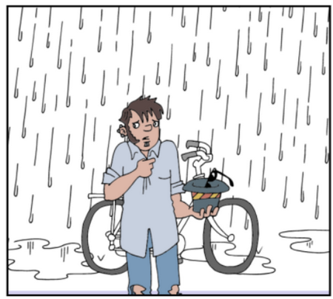

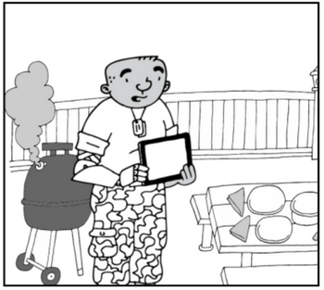

I tell ya, man … this rain is crampin’ my style. I want to go riding my bicycle … I really need the exercise. God must hate me – all this rain?
What a grumbler!
Seems to me that grumbling is an issue of the heart. Do you agree or disagree? Below, write down which way you think and why.
Instead of allowing adversity and anxiety to rule our lives, focus on God’s provision. How has God met your needs?

More family activities at https://tinyurl.com/y9trnv5r

