1. Motivate

What are some interesting ways people deal with conflict?
- yell, scream
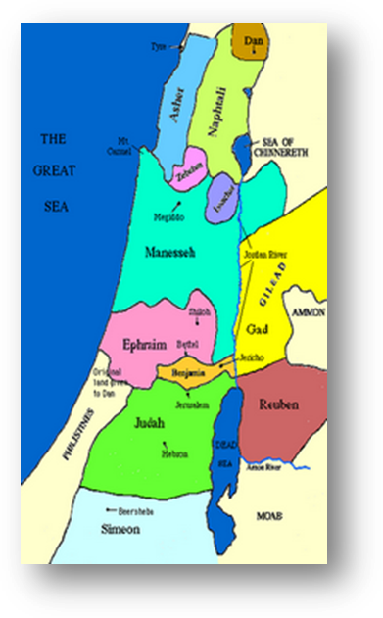
- silent treatment
- play the piano loud
- kick the dog
- cry until the other person gives in
- duke it out
- throw wet washcloths against the shower wall … hard

2. Transition

After conquering Canaan the Israelites had a serious conflict …
- They almost had civil war.
- Today we look at how they worked through that conflict and how it is a lesson for us

3. Bible Study

3.1 Confront the Issue
http://www.jewishvirtuallibrary.org/jsource/Judaism/tribes.html
Listen for escalation of conflict.

Joshua 22:11-12 (NIV) And when the Israelites heard that they had built the altar on the border of Canaan at Geliloth near the Jordan on the Israelite side, 12 the whole assembly of Israel gathered at Shiloh to go to war against them. … 22:15 When they went to Gilead--to Reuben, Gad and the half-tribe of Manasseh--they said to them: 16 "The whole assembly of the LORD says: 'How could you break faith with the God of Israel like this? How could you turn away from the LORD and build yourselves an altar in rebellion against him now? 17 Was not the sin of Peor enough for us? Up to this very day we have not cleansed ourselves from that sin, even though a plague fell on the community of the LORD! 18 And are you now turning away from the LORD? "'If you rebel against the LORD today, tomorrow he will be angry with the whole community of Israel.

What act by the Reubenites, Gadites, and half tribe of Manasseh (the eastern tribes) generated concerns among the other nine and one-half tribes (the western tribes)?
- eastern tribes had gone off track
- their altar was to a false god
- this was just like bad events in the people’s
- they needed to be attacked

What did the Israelites believe would be the consequences of the eastern tribes’ rebellion?
- God would punish them
- God would punish all the tribes, not just the eastern group
- God’s wrath would come down upon them
- the punishment might be just like happened at Peor
How do you typically respond when you think someone has wronged you?
- get mad
- get even
- feel hurt
- fire off an email
- post on Twitter or Facebook
- confront them
- go into a blue funk

What was the western tribes’ initial response to this perceived wrong? What kind of action did they initiate?
- attack
- nip it in the bud
- punish the evil doers before God punishes all of us
- go to war against them

If the western tribes were right, why would this be the proper response?
- God punishes rebellion
- we’ve seen it before, we’ve experienced it before
- God doesn’t mess around
- if any of us are disobeying God, we all will suffer
- just like happened when Achan disobeyed, we lost a battle and people lost their lives

But, the western tribes were wrong, why was this not the proper response?
- there’s no rebellion to punish
- no good reason for a civil war
- these are our relatives
- God is not mad at them, but He will be mad at us
- we should not assume their intent
- instead we should check with them, ask for an explanation

3.2 Listen to the Other Side

Listen for the explanation.

Joshua 22:26-27 (NIV) "That is why we said, 'Let us get ready and build an altar--but not for burnt offerings or sacrifices.' 27 On the contrary, it is to be a witness between us and you and the generations that follow, that we will worship the LORD at his sanctuary with our burnt offerings, sacrifices and fellowship offerings. Then in the future your descendants will not be able to say to ours, 'You have no share in the LORD.'

When have you ever been falsely accused? What happened?
- someone misheard what I really said
- boss thought I messed up on a job
- girlfriend/boyfriend thought I was flirting with someone else
- neighbor thought my kid broke his window
- parents/teacher/friend/enemy thought I had done/said something that I hadn’t
- student thought I graded the test/assignment incorrectly

The eastern tribes had been falsely accused. What was their explanation of why they built the altar on the Jordan River?
- was not for burnt offerings or sacrifices
- was to be a witness
- generations in the future would see the monument and know that the two groups belonged together
- both groups would worship Jehovah together

What fact or reality was the altar a witness to?
- both groups worshiped the same God … the LORD, Jehovah
- it’s like the monument altar had eyes and could see (witness) both groups as really one unified nation

To whom would it be a witness?
- future generations
- both eastern and western tribes would see this in years to come
- even foreigners would know

Why was this a good idea?
- geographical separation did not imply spiritual separation
- current generation knew they were united, future generations needed to grow up with that same sense of unity

What needed to happen for this explanation to be made known?
- they had to get together
- had to be willing to listen to what the eastern tribes had to say
- go in with an open mind about what is said

Why is this a hard thing for us to do?
- we’re sure we’re right and the other group has to suffer the consequences
- we might have to admit our interpretation of the facts was wrong
- the other party might take our question wrong
- they might take our question as an accusation
- it is not easy to confront someone

3.3 Embrace a God-honoring Solution

Listen for the resolution.

Joshua 22:33-34 (NIV) They were glad to hear the report and praised God. And they talked no more about going to war against them to devastate the country where the Reubenites and the Gadites lived. 34 And the Reubenites and the Gadites gave the altar this name: A Witness Between Us that the LORD is God.

How did the Israelites react to the news that the eastern tribes were not rebellious toward the Lord? (22:33)
- glad to hear the report
- praised God
- gave up plans to attack
- decided not to devastate them

In what ways was God blessed?
- people learned a lesson about how to deal with conflict
- both sides had wanted to honor God
- both sides wanted to keep worshiping God
- in the end, they still did so … together
- in the future, both groups would be united in praising God

What should our attitude be toward those who have misunderstood our actions?
- realize that not everyone will see and understand what you are doing, what you really meant by what you said
- be willing to explain
- don’t take offense at a simple misunderstanding
- maybe don’t assume everyone will understand your actions and motivations
- be proactive and explain your motivations ahead of time
- maybe the eastern tribes could have put up a sort of historical marker

What should be our attitude toward those whose actions we don’t understand?
- don’t assume they are acting in an ungodly or offensive manner
- pray God’s blessing and guidance on them
- be willing to go to them in a kindly manner and ask their motivation, their intention concerning what they have done or said
- listen to what they say
- be willing to discuss how you have interpreted or inferred their actions/comments

What lessons can this story teach us about resolving not just misunderstandings, but actual conflicts?
- pray about what they are doing
- pray about what you are doing
- ask God for guidance
- communicate before you act – with God and with the other party
- find out what the other party is thinking
- maybe allow time for both parties to think about the discussion
- seek to honor the Lord first
- pray together

4. Application

4.1 Listen
- If you are inclined to talk more than listen, break the routine this week
- Determine to listen more than speak
- Relationships are strengthened when people know they’ve been heard

4.2 Affirm
- Maybe there is someone with whom you have a conflict
- Ask God to show you something in that person you can affirm
- Send a note, a letter, an email, a phone call – acknowledge any failure on your own part which has contributed to the conflict

4.3 Mediate
- Work as a bridge to bring together two people who are in conflict
- Focus on helping them to listen to and understand each other
- Prepare for the meeting with an extended time of prayer

