1. Motivate

What are some things you can’t see but you know are there?
- electric wires behind the wall
- Wi-Fi signals, radio waves
- breaks on your car
- the medicine working in your body
- gas in your tank, water in the pipes in your house
- molecules, atoms
- bones in your body
- billions of stars in the sky

2. Transition

There are many important things we take on faith
- We trust they are there and will work as they are supposed to
- Faith in God is even more important … it makes us victorious in our Christian lives

3. Bible Study

3.1 Faith Assures

Listen for a definition of faith.

Hebrews 11:1-3 (NIV) Now faith is being sure of what we hope for and certain of what we do not see. 2 This is what the ancients were commended for. 3 By faith we understand that the universe was formed at God's command, so that what is seen was not made out of what was visible.

And a couple of other versions of verse 1:
(HCSB) 11 Now faith is the reality (assurance) of what is hoped for, the proof (conviction) of what is not seen. | (AMP) Now faith is the assurance (title deed, confirmation) of things hoped for (divinely guaranteed), and the evidence of things not seen [the conviction of their reality—faith comprehends as fact what cannot be experienced by the physical senses].

Identify the key words in the writer’s explanation of faith.

- being sure
- reality
- hope
- certain
- proof
- evidence
- conviction
- assurance
- confirmation
- guarantee

Note the two descriptive phrases from other versions.
NIV | KJV | NLT
- being sure of what we hope for  - certain of what we do not see | - substance of things hoped for  - evidence of things not seen | - confident assurance that what we hope for is going to happen  - evidence of things we cannot yet see
We see two basic elements:
- the reality required for having hope
- evidence beyond what we see and feel

What does faith help us to comprehend about the creation of the world?
- it was formed at God’s command
- God made it out of nothing
- there were no materials of which to construct all the matter that now exists

How is that different than when we call an artist “creative”?
- the artist uses a medium (paint, canvas, etc.)
- puts them together in a way that displays an image which we can view
- musical artist puts together notes to make something we listen to
- God starts with nothing, not even space, and created “stuff”
- you could say that actually we innovate or transform¸ but only God truly creates

Why does believing God is Creator require faith on our part?
- no one was there to see it happen … no first hand witnesses
- we have the Genesis account
- general opinion is that Moses actually wrote the words – but he wasn’t there to see it happen
- probably it was an orally passed down through generations
- we read it and accept it as truth

How can the creation around us fuel our faith in the unseen God?
- the beauty we see
- the marvel of the micro elements – atomic and subatomic particles
- the marvel of the macro … the immensity of the universe
- we measure gravity and have formulas to describe its effect, but don’t know why it works
- God’s power and authority and creativity are on display everywhere

What else, besides creation, compels you to have faith in God even though you’ve never seen Him?
- Scripture
- God’s Spirit speaking to our hearts, impressing on us the reality, the Truth of what God says in His Word
- changed lives
- answered prayer

3.2 Faith Expressed in Worship

Listen for who had faith.

Hebrews 11:4 (NIV) By faith Abel offered God a better sacrifice than Cain did. By faith he was commended as a righteous man, when God spoke well of his offerings. And by faith he still speaks, even though he is dead.

How did Abel demonstrate faith?
- offered a better sacrifice

Note the Genesis record:

Genesis 4:3-5a (NIV) In the course of time Cain brought some of the fruits of the soil as an offering to the LORD. 4 But Abel brought fat portions from some of the firstborn of his flock. The LORD looked with favor on Abel and his offering, 5 but on Cain and his offering he did not look with favor.

What were the differences between Cain’s and Abel’s sacrifices?
Cain | Abel
- some of first fruits of the soil  - an offering to the Lord  - God did not look favorably on it  - did not do the right thing | - fat portions from some of first born of flock  - God looked with favor on Abel and his offering  - did what was right

How/why did God commend him?
- apparently he offered the sacrifice with an attitude of faith
- God declared him righteous
- God commended him, spoke well of him

What is the relationship between faith and genuine worship?
- worship is declaring God’s worth … with music, with words, in prayer
- doing so in or with faith means we actually believe what God’s Word says as we worship
- it is more than just pretty music or impressive words
- it is singing, reading, declaring what we truly believe down deep in our heart and mind

How does Abel continue to influence us?
- we read of this even today – Abel is long gone
- by his example we gain understanding of faith and making offerings, sacrifices to God

How does our influence as people of faith live long past us and affect those who follow us?
- the life we live before family, friends, people we work with
- what we teach our children
- our participation in the Great Commission (giving, going, praying)
- things we may write that others will read
- how we model a life of faith in and obedience to God

3.3 Faith Pleases God

Listen for a unique experience.

Hebrews 11:5-6 (NIV) 5 By faith Enoch was taken from this life, so that he did not experience death; he could not be found, because God had taken him away. For before he was taken, he was commended as one who pleased God. 6 And without faith it is impossible to please God, because anyone who comes to him must believe that he exists and that he rewards those who earnestly seek him.

What was unusual about Enoch?
- did not experience death
- taken from this life
- could not be found
- God had taken him away

According to this passage, what is the only way we can please God with our lives?
- faith is the requirement for pleasing God
- must believe that God exists
- must believe that God will bless and reward a person who sincerely, seriously seeks Him

What do you think it means to earnestly seek God?
- read what God says
- apply it to your life
- talk to God … pray …
- tell God of your awe of who He is, what He is like
- confess to God, agree with Him concerning your sinful attitudes and actions
- tell Him your problems, your needs
- tell Him you are trusting Him to meet those needs, solve those problems

Why is faith necessary for pleasing God?
- God says so
- it is required if we are going to obey God (Adam and Eve did not act in faith, did not believe what God had warned them about)
- requirement of faith allows humans the ability to choose or reject God
- if we didn’t have that choice, we would be robots
- presence of faith (or disbelief) in one’s life is how God judges who is justified and righteous (or condemned)
- obedience alone is not enough … a person can obey just to look good or impress others
- faith will result in obedience, but obedience (doing good) does not guarantee one has faith

Use the last page as a handout so your learners can take home the application points of this week’s lesson.

Application
Trust.
- Trust Christ with your problems and your life.
- The One who created the entire universe can handle whatever you hand Him.

Read.
- Read the Old Testament stories of the men and women mentioned in Hebrews 11.
- Read about their lives and find out how they expressed confident trust and faith in God. With each of their lives, ask yourself what you can personally learn from them.

Encourage.
- Even as God uses the lives in Hebrews 11 to encourage us, be an encouragement to someone else.
- Encourage their faith and trust in Christ by telling them how you trusted Christ in a similar experience.
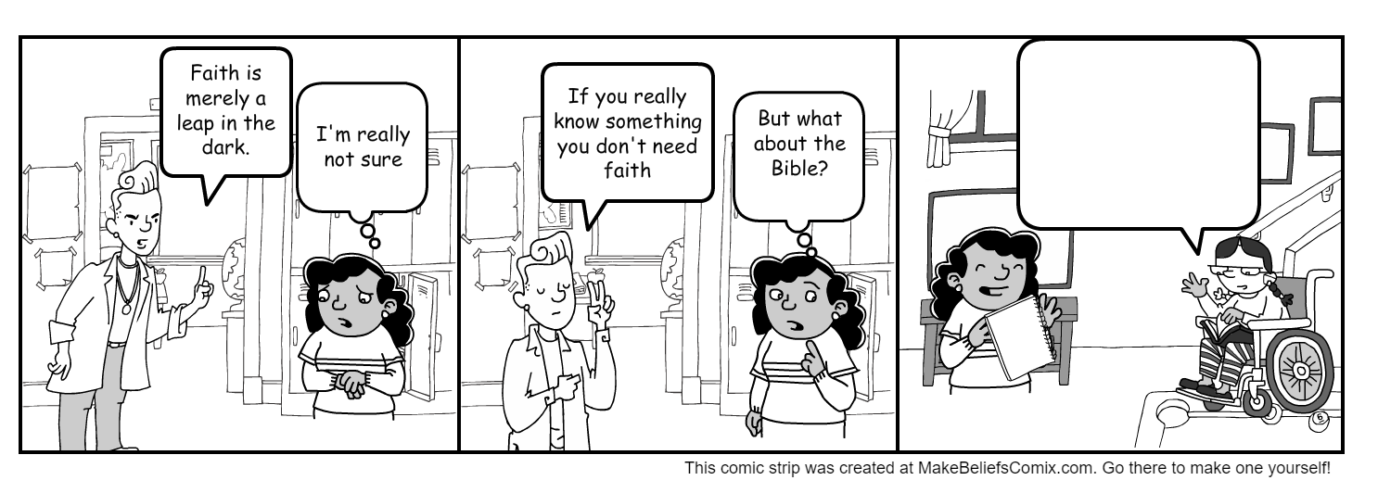
After being confused at school about faith, Maria visits her friend Susie. What would Susie have learned from our lesson today to tell Maria. Write in some encouragement and information that Susie could share. Continue on the lines below if there is not enough space in the speech bubble.
______________________________________________________
______________________________________________________
______________________________________________________
______________________________________________________

