1. Motivate

What role did prayer play in your family’s life when you were growing up?
- prayer at meals
- prayer in church
- prayer meeting on Wednesday nights
- prayer before a trip
- “Now I lay me down to sleep …”
- “God is great, God is good, now we thank Him for our food”
- prayer for the sick

2. Transition

Prayer is grounded on a desire to honor God.
- Today we look at Jesus’ teaching on how to pray.

3. Bible Study

3.1 Begin with God’s Kingdom/Rule

What do you find most difficult about the practice of prayer?
- finding time to do it
- keeping it from being a “laundry list” for God
- keeping it from being an “organ recital” … a list of physical needs
- staying awake
- mind wandering

Listen for a contrast in prayer.

Matthew 6:7-10 (HCSB) When you pray, don’t babble like the idolaters, since they imagine they’ll be heard for their many words. 8 Don’t be like them, because your Father knows the things you need before you ask Him. 9 “Therefore, you should pray like this: Our Father in heaven, Your name be honored as holy. 10 Your kingdom come Your will be done on earth as it is in heaven.

According to Jesus, how do the pagans/idolaters pray?
- babbling
  - repeating words multiple times
  - continuously in foolish, excited, incomprehensible way
- many words needed to impress or get their deity’s attention
- use of prayer wheels – every rotation of the wheel is thought to send the prayer to their deity

??!!??!!
⇨ Repetition or perseverance in prayer is not wrong … meaningless chatter is wrong.

We are looking at the end of last week’s passage along with this week’s What suggests Jesus’ prayer is a model for Jesus’ followers to use in shaping their prayers?
- “therefore” … Jesus is basing what He is about to say on previous comments
- he is contrasting the idolaters’ prayers with how Christians should pray
- you should pray like this
- note He didn’t say “pray these words”

Who taught you what you know about prayer?
- parents
- Sunday School teacher
- Bible study leader
- college professor
- self-taught from studying the Bible

What should be our attitude toward God as we begin our prayer?
- hallowed be thy name
- consecrated
- sacred
- revered
- awe
- respect
- God’s name honored as holy, separate

What are the three petitions in this section of the prayer?
- we honor your name
- your kingdom come … may your rule and authority come to happen
- may we allow you to rule in our lives here on earth just like you rule absolutely in heaven

What can help us keep a kingdom (where God rules) focus as we pray?
- telling God our spiritual needs
- holding up other people’s spiritual needs
- praying for people who need Jesus
- praying for spiritual ministries around the world
- praying for God’s guidance and protection of our pastors, our missionaries
3.2 Present Your Needs to God

Listen for more petitions.

Matthew 6:11-13 (HCSB) Give us today our daily bread. 12 And forgive us our debts, as we also have forgiven our debtors. 13 And do not bring us into temptation, but deliver us from the evil one. [For Yours is the kingdom and the power and the glory forever. Amen.]

Besides food, what do you think “daily bread” could include?
- daily patience
- wisdom
- courage
- guidance
- finances
- spiritual strength
- love for one another
- whatever we need for today

How is the petition for “daily bread” in verse 11 also an expression of trust?
- God provides our needs as they occur
- we need to trust him for each day
- we might not see God stockpile our resources, but He does supply on time
- God doesn’t need to be early
- God knows what our needs are … we need to tell Him we are trusting Him

What are some ways the word temptation can be understood? What are some synonyms for temptation?
- lure
- enticement
- attraction
- inducement
- appeal

Why would Jesus say to pray that God would not “lead us into” temptation?
- maybe it’s more to lead us out of temptation
- help us not to be lured or enticed
- help us keep focused on God’s love, God’s power and authority when we find ourselves in those situations
- remember to claim the verse which speaks of always providing an escape from temptation, the promise of not being tempted beyond what we can tolerate

Jesus said it is God’s kingdom, power, and glory … how should that affect our praying?
- God rules, He is the absolute authority in all issues of our lives
- we can trust in His power
- God works to accomplish His will for His glory
- when God answers we will glorify His name

3.3 Forgive Others

Why is it hard to forgive someone who has wronged you?
- we have been deeply hurt
- the offender shows no remorse
- the offender doesn’t even realize how insensitive they have been in hurting us
- we must swallow a lot of pride to forgive
- do you expect me to act like it never happened?

Listen for the relationship between receiving divine forgiveness and forgiving other people.

Matthew 6:14-15 (HCSB) “For if you forgive people their wrongdoing, your heavenly Father will forgive you as well. 15 But if you don’t forgive people, your Father will not forgive your wrongdoing.

What do these verses say about the relationship between God's forgiveness of us and our forgiveness of someone else?
- if we refuse to forgive someone else, God will refuse to forgive us
- we have been forgiven so much by God
- in loving response to His forgiveness, we must forgive others

By refusing to forgive someone of what they have done to you, what other sins might you be tempted to commit?
- holding a grudge
- harboring bitterness
- getting revenge
- hateful action

Remember
- our forgiveness of others must unconditional, like Christ’s forgiveness of us
- forgiveness restores fellowship with others and fellowship with God

Given Jesus warning in verse 15, how can we help each other grow in our ability to forgive?
Yes, these are funny, but so often the sentiment has an unforgiving slant to it.
- don’t gossip together about how much we’ve been wronged
- don’t take the attitude of the many country-western songs about how “he/she done me wrong”
  - How Can I Miss You If You Won't Go Away?
  - I Keep Forgettin' I Forgot About You
  - I Would Have Writ You A Letter, But I Couldn't Spell Yuck!
  - If You Don't Leave Me Alone, I'll Go And Find Someone Else Who Will
  - My Wife Ran Off With My Best Friend, And I Sure Do Miss Him
  - http://www.tonmeister.ca/personal/geoff/stuff/funny/country.html
- Support one another in prayer
- model kindness that is expressed, demonstrated despite wrongs against you

Use the last page as a handout so your learners can take home the application points of this week’s lesson.
Application
Evaluate yourself
- Compare your typical prayers and Jesus’ Model Prayer
- Consider how much you praise God versus a list of self-centered requests
- Do you need to deal with unconfessed sin or harboring unforgiveness?

Double up
- This week spend twice as much time in prayer as you usually do
- Use the Model Prayer to guide you as you pray

Seek reconciliation
- Make an effort at reconciling a damaged or broken relationship this week
- Begin by praying for the person involved
- Offer forgiveness or seek forgiveness if you were in the wrong

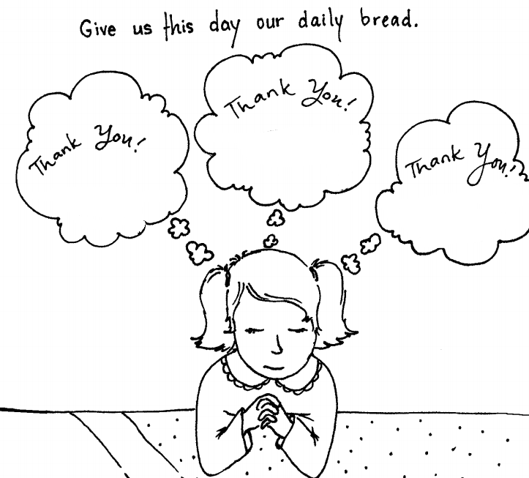
God has provided much for us today and each day. List or draw pictures of “daily bread” for which you are thankful to the Lord.
http://cdn.www.ministry-to-children.com/wp-content/uploads/2011/08/Lords-prayer-2.pdf

