1. Motivate

Read each of the following pairs of words. Your learners must choose one of the two from each pair … there are no right or wrong answers … you just must choose.

(red, blue), (tie, turtleneck), (hat, scarf), (okra, chocolate chip cookie), (talk, listen),
(coffee, tea), (work, play), (eat, sleep), (football, baseball), (needlepoint, golf),
(cold, hot), … { add your own pairs of items that fit unique interests of your class}

2. Transition

These choices were just for fun and were usually easy to make … other choices we make are more serious and can affect our lives more significantly.
- Today we look at the most important choice each person must make in their lifetime
- Choose to follow Jesus

3. Bible Study

3.1 Choose the Right Path

Listen for a contrast.

Matthew 7:13-14 (HCSB) “Enter through the narrow gate. For the gate is wide and the road is broad that leads to destruction, and there are many who go through it. 14 How narrow is the gate and difficult the road that leads to life, and few find it.

In what way did Jesus describe the gate that leads to destruction?
- wide gate
- broad road
- many people take that way

What kind of gate leads to life?
- narrow gate
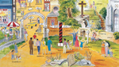
- difficult road
- fewer people find it

If possible display the picture from http://www.bclrblog.org/2012_03_01_archive.html

What broad roads did you (or people you know) travel before meeting Christ?
- pursuit of pleasure, chasing after material things
- rebellion against God, ignoring Jesus
- go along with the crowd
- no involvement in spiritual things at all
- searching for meaning and satisfaction in their jobs
- work-aholics, totally involved in their hobby (golf, sports, etc.)

What was your entry through the narrow gate like?
- heard the gospel as a child
- came to Jesus as a result of a revival service
- heard someone present the plan of salvation
- saw the Jesus film
- someone came to my door and witnessed to me, invited me to church
- life messed up and was looking for something better

What have you found difficult about the road that leads to life?
- seems like you’re going against the flow
- give up some things formerly pursued
- may face opposition of family and friends
- demands submission to God
- requires self-control (in contrast to broad way requirements)
- world makes itself attractive

In what sense is it narrow-minded to believe in Christ?
- Jesus said I am “the way” … not “a way”
- Acts 4:12 “there is salvation in no one else, for there is no other name under heaven given to people, and we must be saved by it.”
- you believe in the specifics of the Word of God
- you reject the world’s attitudes
- you are focused on living to please the Lord
- your lifestyle will reflect what God says, not what the world says

What is there about the narrow gate and the narrow road that requires a long term view or perspective of life?
- requires self-discipline now for delayed reward
- contrast to worldly wide way which offers immediate, short term gratification
- need to think with eternity’s values in mind

How do you develop that long term perspective?
- careful choice of what you fill your mind with (entertainment, news, etc.)
- fill your mind instead with Truth of God's Word
- make it a habit, a practice to invest your resources in God's Kingdom (outreach ministries, missions, spending time ministering to others)

3.2 Choose to Be Obedient

Listen for fruit inspection.

Matthew 7:15-23 (HCSB) “Beware of false prophets who come to you in sheep’s clothing but inwardly are ravaging wolves. 16 You’ll recognize them by their fruit. Are grapes gathered from thornbushes or figs from thistles? 17 In the same way, every good tree produces good fruit, but a bad tree produces bad fruit. 18 A good tree can’t produce bad fruit; neither can a bad tree produce good fruit. 19 Every tree that doesn’t produce good fruit is cut down and thrown into the fire. 20 So you’ll recognize them by their fruit. 21 “Not everyone who says to Me, ‘Lord, Lord!’ will enter the kingdom of heaven, but ⌊only⌋ the one who does the will of My Father in heaven. 22 On that day many will say to Me, ‘Lord, Lord, didn’t we prophesy in Your name, drive out demons in Your name, and do many miracles in Your name?’ 23 Then I will announce to them, ‘I never knew you! Depart from Me, you lawbreakers!’

According to this passage, what are some characteristics of false prophets?
- come in sheep’s clothing
- inwardly are like ferocious wolves
- they are disguised to look harmless or good, but are really mean and nasty
- you should be able to spot them by absence of the Fruit of the Spirit and the presence of the fruit of the flesh.

What would be some examples of false prophets in our world?
- certain media (Radio/TV) preachers
- people who are in Christian ministry for the fame and fortune
- people who advocate liberal, non-biblical theologies
- “humanists” who want to reject the influence of God on our culture (through government, media, materialism)
- entertainment (movies, music, etc.) – live for the gusto, get your jollies NOW

What kinds of things will people claim before God who want to enter heaven?
- we called you “Lord”
- we prophesied in your name
- we drove out demons in your name
- we performed miracles in your name

According to this passage, why will they be denied?
- they did not do God's will
- God never knew them
- in reality, they were evildoers

What kind of “fruit” should be being produced in our lives so we do not act as false prophets?
- Fruit of the Spirit (love, joy, peace, patience, kindness, goodness, long suffering, gentleness, faithfulness)
- pointing others to Jesus (by our lives, by verbal witness)
- by how we live our lives before others – when our actions and attitudes match our verbal claims
- by abiding in Christ – John 15:5 (NIV) I am the vine; you are the branches. If a man remains in me and I in him, he will bear much fruit; apart from me you can do nothing.

Remember that these Fruit of the Spirit are qualities that are the result of being under the Kingdom/Rule of God

⇨ When God is ruling in your life, these beautiful fruit are what will naturally be seen.

3.3 Choose the Right Foundation

Listen for zoning laws.

Matthew 7:24-27 (HCSB) “Therefore, everyone who hears these words of Mine and acts on them will be like a sensible man who built his house on the rock. 25 The rain fell, the rivers rose, and the winds blew and pounded that house. Yet it didn’t collapse, because its foundation was on the rock. 26 But everyone who hears these words of Mine and doesn’t act on them will be like a foolish man who built his house on the sand. 27 The rain fell, the rivers rose, the winds blew and pounded that house, and it collapsed. And its collapse was great!”

What does a wise man do?
Note that the words of the children’s chorus say “build your life on the Lord Jesus Christ” While this is a good admonition, it is not exactly what the verse says.
- build house on the rock
- hear God's words
- put God's words into practice

If the rock is God's Word and its application, what are the winds, rain, and floods? What kinds of storms does your foundation in Christ help you through?
- life trials
- tragedies
- job losses, financial setbacks
- health crises
- war, terrorism, persecution
- family relationship problems
- bad or unfortunate choices we make

What kinds of things are the “sand” upon which some folks build their lives?
- materialism
- fame and fortune
- gaining power
- acquiring more “toys”
- entertainment, having fun

Why don’t they stabilize our lives when we have those “storms?”
- they satisfy temporarily only
- nothing there can really help us during tough times

What is there about God's Word that provides a foundation which is unshakable?
- it is absolute Truth
- it is God's plan for our lives
- it tells of God's sufficiency, God's love, God's power, God's authority

How can we help one another continue to build on the right foundation?
- prayer support of one another
- encourage one another
Use the last page as a handout so your learners can take home the application points of this week’s lesson.
- accountability partner
- involvement in spiritual ministries, church outreach

Application
Enter the narrow gate
- If you haven’t experienced salvation offered by Jesus Christ, now is the time
- Speak with your pastor or a fellow class member about what it means to choose the “narrow path” that leads to a full and abundant life

Move toward community
- Take a step to become more involved in your church community
- Volunteer for a new ministry
- Consider taking on a leadership role

Spread the Word
- Sharing the message of the Gospel is an important part of following Jesus
- This week, make a commitment to speak with at least one person about what God has done in your life.

Choose to build your life on Truth from Jesus’ words.
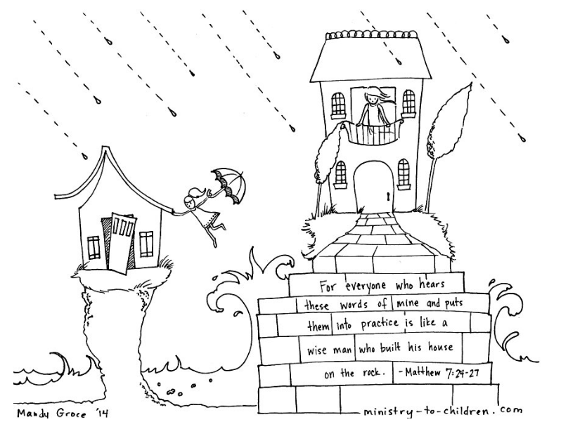
Color and/or shade the picture … on your own or with your kids or grandkids.
http://ministry-to-children.com/build-your-house-upon-the-rock-matthew-724-coloring-page/

