1. Motivate

What do you think draws people to the occult?
- it’s freaky
- they like to be scared
- they are curious, just for fun
- they want to know the future
- they want to use it to make a decision
- seems like a game
- they read Harry Potter
- they like ghost stories around a campfire
- Halloween season

2. Transition

In reality dabbling with evil is destructive
- Today we emphasize that seeking direction from God brings life.

3. Bible Study

3.1 Evil Practices

Listen for what is detestable.

Deuteronomy 18:9-11 (NIV) When you enter the land the LORD your God is giving you, do not learn to imitate the detestable ways of the nations there. 10 Let no one be found among you who sacrifices his son or daughter in the fire, who practices divination or sorcery, interprets omens, engages in witchcraft, 11 or casts spells, or who is a medium or spiritist or who consults the dead.

By what right was Israel able to enter into their new land?
- God was giving them the land
- God would help them conquer the Canaanite peoples
- this was the Promised Land

What warning did Moses give the people?
- don’t learn the ways of the nations there
- their ways are detestable

What kinds of detestable behavior were they to avoid?
- sacrificing children in fire
- divination
- sorcery
- interpreting omens
- witchcraft
- casting spells
- consulting a medium or Spiritist who consults the dead
How do people still dabble in these kinds of practices? What evidence do you see that our culture is fascinated with the paranormal and the occult?
- faithfully reading horoscope
- fascination with entertainment which include these practices
- playing with a Ouija board game
- having superstitions like a lucky piece of clothing you wear for important occasions

For what purpose do people become involved in occult, magic, or Spiritism?
- a means of learning the future
- making key life decisions
- trying to learn the unknown
- for the purpose of entertainment
- they like scary stuff

What are some reasons God has higher expectations for His people?
- God want believers to get their insight from Him
- some of these practices can be evil and involve Satanic influences
- many of these things are totally bogus and have no truth behind them
- shows a lack of faith in God and His guidance, His truth
- a person can become obsessed with something that at best is foolishness and at worst is Satanic

3.2 God’s Condemnation

Listen for God’s judgment.

Deuteronomy 18:12-14 (NIV) Anyone who does these things is detestable to the LORD, and because of these detestable practices the LORD your God will drive out those nations before you. 13 You must be blameless before the LORD your God. 14 The nations you will dispossess listen to those who practice sorcery or divination. But as for you, the LORD your God has not permitted you to do so.

How was Israel’s occupation of Canaan an act of God’s judgment
on the Canaanites?
- because of these detestable practices God would drive out those nations before them
- God would enable the Israelites to dispossess the peoples who practice sorcery, divination
- this was God’s judgment against peoples who rebel against Him and pursue evil

What statement reinforces the fact that God expected His people to live by a different standard?
- you must be blameless before the Lord
- your behavior must be in contrast to their detestable practices
- God has not permitted you to do these things

The Israelites were told to be “blameless” what are some synonyms for this word?

- innocent,
- guiltless,
- above reproach,
- exemplary,
- virtuous,
- pure
- impeccable,
- faultless;

What does this passage teach us about discerning truth from evil?
- God hates evil in any form, at any level
- God wants His people to be above reproach in all things
- it is important for us to make the right choices
- God wants us to have nothing to do with any of these practices
- Truth is to be found from God
- He is our only source of spiritual truth

How are people naive about consulting horoscopes, fortune-tellers, and other "innocent" occult practices?
- they are fakes, they are fiction
- they are waste of time, money, and effort
- some think if a horoscope is right maybe 75% of the time it is useful
- if something is of God it must be 100% correct 100% of the time
- anything less is not of God

What are some ways Christians water down or ignore the dangers of the paranormal?
- it’s just a game
- it’s only a story (Harry Potter, The Twilight Zone)
- “I just read the horoscope for fun”
- I like scary movies, it’s fun to be scared

What makes the practices in these verses so dangerous and destructive?
- treating them as fun or entertaining can increase our interest in such things
- that can lead to deeper involvement
- we can end up giving credence to activities that involve evil as their basis
- these things can distract us away from knowing and pursuing our relationship with God
- anything that becomes more important to us than God has become an idol
3.3 Direction Found in God

Listen for what God provides.

Deuteronomy 18:15-18 (NIV) The LORD your God will raise up for you a prophet like me from among your own brothers. You must listen to him. 16 For this is what you asked of the LORD your God at Horeb on the day of the assembly when you said, "Let us not hear the voice of the LORD our God nor see this great fire anymore, or we will die." 17 The LORD said to me: "What they say is good. 18 I will raise up for them a prophet like you from among their brothers; I will put my words in his mouth, and he will tell them everything I command him.

What was God’s plan for communicating with His people?
- God would raise up a prophet
- would be someone like Moses
- would be a fellow Israelite
- you must listen to him

How did the Lord respond when Israel asked for someone to speak for God?
- what they say is good
- I will provide a prophet like you (Moses)
- I will put my words in his mouth
- he will tell them everything I command him
- Consider Heb 1:1-2, which suggests suggest that the “prophet” would be Jesus the Messiah

So instead of guidance from spiritists and astrologers and Ouija boards , where should we be seeking knowledge and taking direction?
- Seek direction from God, allow God to guide you.
- Draw near to God (James 4:8).
- Study the Scripture.
- Follow the guidance of the Holy Spirit who indwells every believer.
- Seek the wise counsel of mature Christians.

What are some ways we can communicate truth to our children and grandchildren about the paranormal and psychic practices?
- encourage them to read and think about what God has to tell them
- warn them of the dark side of paranormal and psychic practices
- make sure they know that stories they read about witches and casting spells are not to be taken as truth
- share how God has led you
- pray with them about God’s leading and direction in their lives
- model a life that rejects horoscopes, Ouija boards, entertainment that includes paranormal
Use the last page as a handout so your learners can take home the application points of this week’s lesson.

Application
Be educated.
- You will only know God’s guidance as you immerse yourself in His Word.
- Commit to reading God’s Word on a daily basis and develop the practice of studying its truth.

Be discerning.
- Ask God to guide you in seeing His truth and avoiding evil.
- “But test them all; hold on to what is good, reject every kind of evil” (1 Thess. 5:21-22).
- Pray for alertness, to avoid entrapment by the enemy.

Be blameless.
- Live out the principle of having a blameless heart, fully devoted to the Lord,
- Remove from your presence anything that promotes and encourages the use of paranormal practices
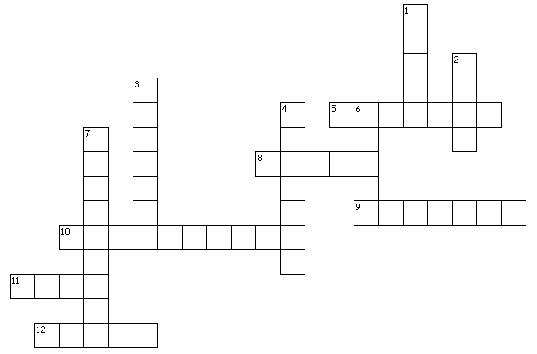

Across
5. don't _?_ the dead
8. At Horeb, the people were frightened to hear the _?_ of the Lord
9. Don't practice divination or _?_
10. because of _?_ practices, God will drive out those nations
11. The Israelites were afraid to see God's _?_ any more
12. God's prophet would be someone like _?_

Down
1. I will put my _?_ in his mouth
2. He will _?_ them everything I command
3. Do not learn to _?_ detestable ways of nations there
4. God will raise up a _?_
6. Don't interpret _?_
7. you must be _?_ before the Lord

Paranormal Crossword
Deuteronomy 18:9-18 (NIV)
More activities at
http://tinyurl.com/ya6lxahf

