1. Motivate

What would make you want to stand up for someone?
- see them with a problem
- they are helpless
- they are being unjustly wronged
- they have no one else to help them
- this is a close friend in need
- the person once helped me
- you owe this person a favor

2. Transition

God calls us to defend those who cannot defend themselves.
- Today we consider what it means to be champions for justice.

3. Bible Study

3.1 Speak Up for Justice

Listen for the do not’s.

Exodus 23:1-3 (NIV) "Do not spread false reports. Do not help a wicked man by being a malicious witness. 2 "Do not follow the crowd in doing wrong. When you give testimony in a lawsuit, do not pervert justice by siding with the crowd, 3 and do not show favoritism to a poor man in his lawsuit.

According to these verses, how was a person to act on the witness stand?
- tell the truth
- don’t mess up someone’s life by lying
- don’t be afraid to go against the crowd
- when others are doing wrong, don’t follow along
- tell the truth, even when you are in the minority
- don’t let someone’s economic status influence how you respond

Why are we sometimes tempted to blend in with the crowd?
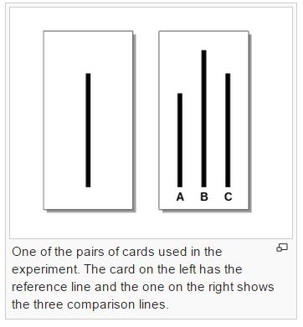
- psychologically we think we might be wrong if everyone else is going that direction
- we don’t want to appear weird
- it’s part of the “majority rule” concept in our minds
- we’re often told “go along to get along”
- if we stand out as different, we might receive unwanted attention or even abuse

Consider the Asch Conformity Experiments
- Participants were shown a card with a line on it, followed by a card with three lines on it (lines labeled A, B, and C, respectively). Participants were then asked to say aloud which line (i.e., A, B, or C) matched the line on the first card in length.
- Confederates to the experiment were told to unanimously give the correct response or unanimously give the incorrect response. The group sat in a manner so that the real participant was always the last to respond.
- In the control group, with no pressure to conform to confederates, the error rate was less than 1%.
- Trials in the experimental group revealed that one-third of all responses were incorrect. These incorrect responses often matched the incorrect response of the majority group (i.e., confederates)
- http://en.wikipedia.org/wiki/Asch_conformity_experiments

⇨ We are easily influenced by peer pressure … even in an objective issue which should be obvious.

Our passage says “do not pervert justice by siding with the crowd”

Why is abiding by these principles important for one who professes to be in right relationship with God?
- these represent how God acts
- God always communicates truth
- God always acts rightly, justly
- God is not influenced by the crowd … He is not affected by the concept of democracy

Why might the principle in verse 3 surprise us? What are some ways the affluent in our culture receive special treatment?
- they have the money for the best lawyers
- consider the concept of the special lobbies that work to influence legislative bodies
- even shows up in things such as first class seats
- rich people get good seats because they pay for them
- they also get special treatment because we want to be in their good graces
- they have influence to “hand out” as well as money to spend for good treatment

So why would God say don’t show favoritism to the poor in the context of a lawsuit?
- one’s financial standing should not have any bearing on right or wrong
- our feeling sorry for someone might incorrectly influence our judgment
- being poor is not an excuse for violating the law
- neither is it license for gouging the rich

3.2 Don’t Abuse Innocent Oppressed

Listen for God’s intolerance.

Exodus 23:6-7 (NIV) "Do not deny justice to your poor people in their lawsuits. 7 Have nothing to do with a false charge and do not put an innocent or honest person to death, for I will not acquit the guilty.

What will God not tolerate? (23:6-7)
- injustice for anyone, rich or poor
- false charges
- letting the guilty go free
- punishing the innocent

We see the word “poor” in both verses 3 and 6. They are different words in the original language.
- Verse 3 ⇨ focus on someone lacking in material substance
- Verse 6 ⇨ focus is on someone of the lower class, financially poor and also lacking in social strength and influence

Who are the poor, the innocent and defenseless in our community?
- the unborn
- little children who are abused … physically, emotionally, sexually
- immigrants – legal or otherwise

How does this passage influence your response to issues such as abortion?
- the unborn are certainly innocent
- it’s entirely wrong to put to death an innocent person
- an abortion is the punishment/execution of an innocent
- that is injustice in its most basic form

What is the penalty for lying on the witness stand in our society?
- perjury under federal law may face up to five years in prison and fines.
- under state law it is a felony, carries a possible prison sentence of at least one year, plus fines and probation
- Penalties are increased in relation to how much the perjury interfered with the proceeding.
- a perjurer may even be charged as an accessory to a crime

Secular law places high importance on telling the truth. What does that tell us about why God puts such a premium on honesty?
- it is the basis for justice
- it is the foundation for everything else that is right
- truth (that which coincides with, aligns with reality) is what all fairness and fair dealing rely on

3.3 Lift Up the Outsider

Listen for more do not’s.

Exodus 23:8-9 (NIV) "Do not accept a bribe, for a bribe blinds those who see and twists the words of the righteous. 9 "Do not oppress an alien; you yourselves know how it feels to be aliens, because you were aliens in Egypt.

What does God think of bribes? (23:8)
- don’t do it!
- it blinds those who are involved
- it twists the words of the righteous

In what different ways does bribery take place today?
- someone stopped for speeding hands over a large bill along with their drivers’ license
- a building or health inspector is offered cash to overlook an infraction
- a worker is paid in cash in order to avoid paying income tax
- a witness is offered money to shade his/her testimony
- an athlete is offered money to rig how a game turns out
- kickbacks are offered to someone in order to receive their business

In what ways could a bribe pervert the administration of justice?
- can prevent truth from coming out in court
- can cause false witness
- can result in danger to the population
- if a dangerous person is let free, they can continue to wreak havoc

How were the Israelites to treat foreigners? (23:9)
- don’t oppress the alien
- treat them fairly
- remember how it felt when you were in Egypt
- even after hundreds of years you were mistreated because you were different

On what basis did the Lord make His appeal for equality and fair treatment?
- the history of the people of Israel
- they were considered aliens during the years they were in Egypt
- even though they had been there a long time, they were still “different”
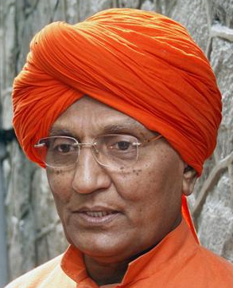
- they were considered as a lower class of people

Suppose a Hindu family moves into a house on your street … their manner of dress is different … you hear that they have real idol images in their house and burn incense. People can hear Indian sounding music from the house. Only the children can speak any English. Your neighbors are upset that such a different type of person has moved into the neighborhood. They have a petition going around to object to their presence. The man of the house comes to you repeatedly asking (with his son as an interpreter) for help with various issues common to moving into a new house and new community.

According to this passage, how are we to respond?
- with kindness, helpfulness
- with Christian love – invite them to meal in your home (careful to be aware of their dietary restrictions)
- invite them to your church’s special holiday observations (Christmas or Easter or patriotic celebrations)
- they will feel honored to be included … and they will hear the gospel!
4. Application

4.1 Pray
- For those oppressed and treated unjustly
- For unborn babies at risk for abortion
- For people caught up in human trafficking

4.2 Get involved
- Support a crisis-pregnancy center or organizations which minister to victims of injustice
- Volunteer or give financial support

4.3 Be aware
- Teens are not the only ones who succumb to peer pressure
- Watch for how you might be influenced by neighbors or people at work who have strong and vocal attitudes
- Stand up for what is right … even if it is the minority voice

