1. Motivate
Dear kindly Sergeant Krupke,
You gotta understand,
It's just our bringin' up-ke
That gets us out of hand.
Our mothers all are junkies,
Our fathers all are drunks.
Golly Moses, natcherly we're punks!
What are some ways our culture responds to failure?
- heads will roll
- fire the coach
- a forced retirement
- make fun of the failure
- cry
- make excuses … “not my fault” … “ I had a tough childhood”
- from West Side Story, “I'm depraved on account I'm deprived.”

2. Transition

The Children of Israel encountered failure.
- God told Joshua what the problem was and how to deal with it
- Today we consider how to confront failure, deal with it, and move forward

3. Bible Study

3.1 Identify Cause of Failure

Listen for how the perpetrator would be identified.

Joshua 7:13-15 (NIV) 13 "Go, consecrate the people. Tell them, 'Consecrate yourselves in preparation for tomorrow; for this is what the LORD, the God of Israel, says: That which is devoted is among you, O Israel. You cannot stand against your enemies until you remove it. 14 "'In the morning, present yourselves tribe by tribe. The tribe that the LORD takes shall come forward clan by clan; the clan that the LORD takes shall come forward family by family; and the family that the LORD takes shall come forward man by man. 15 He who is caught with the devoted things shall be destroyed by fire, along with all that belongs to him. He has violated the covenant of the LORD and has done a disgraceful thing in Israel!'"

How would the Lord reveal to the Israelites who had taken the devoted things from Jericho? (7:14-15)
- God would help them narrow it down
- He would indicate the tribe, the clan, the family, and finally the individual

What are some of your initial reactions to these verses?
- a variety of personal failures are directly related sinful choices
- God doesn’t “mess around”
- you cannot hide your sins from God
- God will deal with sin in our lives
- God has been very merciful with each of us … we don’t receive the punishment for our acts of rebellion against God

This passage focuses on Israel’s failure as a community. How does that impact your understanding of these verses?
- one person’s sin often impacts multiple people
- we are more interconnected spiritually that we realize
- means we need to take more care and thought for the choices we make

What do you think God meant when He told them, “Consecrate yourselves in preparation for tomorrow”?
- meditate on the severity of the problem
- set aside all other daily tasks, “clear your calendar” for doing business with God
- think about who God is and what He requires of His people
- get ready to do business with God
- this will be an important confrontation … settle down and focus on your relationship with God

How should we consecrate ourselves today?
- some of the same considerations … clear out mundane issues from your life and focus on who God is and what He wants to be in your life
- tell God He is the most important Person in your life
- declare your intent to follow Him and Him alone
- set aside the peripheral issues in your live and submit, surrender to His Lordship
- confess to God the “idols” in your life,
- repent of those substitutes for God that exist in your life

3.2 Admit and Confess Sin

Listen for what was confessed.

Joshua 7:19-21 (NIV) 19 Then Joshua said to Achan, "My son, give glory to the LORD, the God of Israel, and give him the praise. Tell me what you have done; do not hide it from me." 20 Achan replied, "It is true! I have sinned against the LORD, the God of Israel. This is what I have done: 21 When I saw in the plunder a beautiful robe from Babylonia, two hundred shekels of silver and a wedge of gold weighing fifty shekels, I coveted them and took them. They are hidden in the ground inside my tent, with the silver underneath."

According to Joshua, for what reason was Achan asked to confess his sin?
- give glory to the Lord
- give Him praise by confessing

How does our turning away from sin give glory to God?
- shows our desire to obey
- in a sense it is an act of faith … I choose to believe that God’s commands are right, are best for me … my own choices have been wrong

Why did Achan take the devoted things from Jericho?
- he saw the fancy stuff, the material riches
- he coveted them
- someone else had owned them, now the material things were to be destroyed and the money given to God
- he probably thought this was a waste … there was plenty for God, “how about a little for me?”

In what specific ways do you think people allow greed to creep into their lives?
- we get bored with or take for granted what we have
- we decide we need something more … look, that’s something I really need
- I could use that … it would be an important part of my life …
- starts out as a wish, can become an obsession

How can you guard yourself against the sin of greed?
- practice thankfulness to God
- look for things for which to praise and thank God
- live on a budget
- take a class on how to live within your means

What kinds of things can happen to us when we try to hide sin?
- we sin more to cover up the original sin
- begin to live a life of hypocrisy
- we become bitter
- it is harder and harder to bring ourselves to a place of repentance and confession as time passes
- we drift farther and farther out of fellowship with God
- our testimony is ruined … we can negatively affect lives of others around us

Thinking along the same line as the previous question, how does unconfessed sin affect our relationship with God and others?
- we are out of fellowship with God
- our prayers go unanswered because of the unconfessed sin
- our attitude of rebellion is seen by others, communicated to them
- it negatively affects our relationships within our family and friends
- we can react in an abrasive manner because we know we are in the wrong with God and maybe with others

Why is confession a necessary step for moving beyond failure?
- confession is agreeing with God we have sinned
- if we don’t admit that to ourselves and to God, it is still there, still causing problems
- lack of confession means the sin is still there … it “festers” like an infection and causes further problems

3.3 Refocus on God’s Plan

Listen for God’s sentence of punishment.

Joshua 7:25-26 (NIV) Joshua said, "Why have you brought this trouble on us? The LORD will bring trouble on you today." Then all Israel stoned him, and after they had stoned the rest, they burned them. 26 Over Achan they heaped up a large pile of rocks, which remains to this day. Then the LORD turned from his fierce anger. Therefore that place has been called the Valley of Achor ever since. 8:1 Then the LORD said to Joshua, "Do not be afraid; do not be discouraged. Take the whole army with you, and go up and attack Ai. For I have delivered into your hands the king of Ai, his people, his city and his land.

How would you have disciplined Achan if you were in charge?
- surrender the illegally obtained items
- pay a fine, 30 lashes, march at the end of the column, wear a sign

Why do you think the punishment was so severe?
- he had caused the deaths of more than 30 soldiers in the lost battle
- he had openly defied God’s commands … it was an “in your face” rebellion against God
- he was to be made an example for others … don’t mess with God’s commands

⇨ Sin is serious … it is necessary to confront the sin which is behind spiritual failures!

Why do you think Joshua need special encouragement when the Lord told him to attack the city of Ai? (8:1)
- even though the sin had been discovered and dealt with, this was still a group of people that had given them a sound trouncing
- didn’t want to lose any more soldiers
- Joshua may still have doubts about his leadership … “maybe I didn’t provide sufficient military strategy”

How do we keep the focus on moving forward as we deal with sin and failure?
- thank God for His mercy, his grace, His forgiveness
- tell God you are trusting in His strength to empower you to make the right choices next time
- Bill Bright of Campus Crusade (CRU) called it “spiritual breathing” http://www.cru.org/train-and-grow/classics/the-spirit-filled-life.html

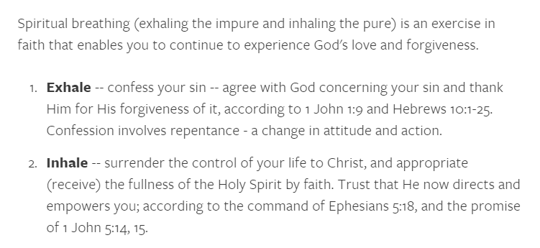

4. Application

4.1 Examine
- Spend 10 minutes in a quiet place today and ask God to reveal to you any sins you have been harboring
- Confess any sin He brings to your mind
- Exercise “Spiritual Breathing” as described in the lesson

4.2 Deal with sin regularly
- If confession and repentance are not part of your daily routine, make them so
- Ask God to help you be specific about any attitude, action, or inaction that has become a barrier in your relationship with Him
- Thank the Lord for His forgiveness

4.3 Confront in love
- You may be facing a situation in which sin is having a devastating effect among those you influence
- Ask God to help you bring His truth and love to the person(s) involved
- Pray for His wisdom to know when and how to confront the situation
- Pray for those involved to be open to godly correction

