1. Motivate

In every culture and every age men and women have general accepted roles. What women are expected to know today is much different than in our grandmother's day. What do you think are the top three skills a woman should have?
- cooking
- taxi the kids
- balance housekeeping with job
- child counselor, amateur psychologist
- internet researcher
- homework consultant
- referee for sibling rivalry

2. Transition

While your grandmother may have known how to milk a cow and make dresses, women today know how to book airline tickets online.
- The specific skills change, but the basic qualities of being a godly woman (and man) remain the same.
- Proverbs 31 tells us the qualities God values in women.

3. Bible Study

3.1 Be Enterprising

Listen for activities of the godly woman.

Proverbs 31:13-15 (HCSB) She selects wool and flax and works with willing hands. 14 She is like the merchant ships, bringing her food from far away. 15 She rises while it is still night and provides food for her household and portions for her female servants

According to these verses, in what tasks does the noble wife engage?
- selects wool and flax
- works it with willing hands
- brings food from far away
- get up early to prepare and provide for daily meals

How is the noble wife of this chapter different from or similar to the popular ideal today?
Similarities | Differences
- hard working  - busy  - productive  - provides for family | - productiveness at a different level  - not necessary to weave cloth, make clothes, cook from scratch, hand wash clothes  - modern skills such as technology  - likely to be a working wife

How are we (both husbands and wives) to be enterprising, creative, and industrious with the assets the Lord gives to us?
- make good use of our time
- faithful use of resources
- don’t squander finances
- model our Christian faith for children (see Deut. 6)

How might this passage give us guidance in talks we have with teens concerning what to look for in a spouse?
- look for responsibility
- how does a potential spouse treat their siblings (and other people around them)?
- how good are they at handling finances?
- do they take their school work and other responsibilities seriously?
- do their actions and attitudes match the testimony they claim
- is this someone you could pray with (even on a date)?

⇨ Remind your teens that in all likelihood, the person they will marry is currently alive (near or far) … and they could be praying for them … God’s guidance, protection, blessing

What characteristics of a Proverbs 31 woman are not generally appreciated in our culture today?
- mention of housekeeping as the main or only activity of the wife
- sewing and cooking – often hard to do those kinds of things if the wife is working
- what we might consider “low level” tasks such as spinning thread and weaving cloth

What is the greatest hindrance to becoming a Proverbs 31 woman?
- self-centeredness
- lack of help/cooperation/teamwork from husband
- world’s influence on materialism
- humanistic mentality from the world

What is the greatest motivation to becoming a Proverbs 31 woman?
- needs of family
- encouragement of scripture
- God’s direction in one’s life

3.2 Evaluate Purchases

Listen for further activities described.

Proverbs 31:16-17 (HCSB) She evaluates a field and buys it; she plants a vineyard with her earnings. 17 She draws on her strength and reveals that her arms are strong.

What skills are attributed to the woman in these verses?
- evaluate real estate
- dealing in real estate
- directing a farming enterprise
- use strengths to better the financial well-being of the family

What suggests she prepared herself for the work she undertook?
- did her homework
- evaluate the suitability of the property
- due-diligence of the real estate
- puts the property to work
- the investment of time and money has a reasonable return

When have you been most tempted to spend money impulsively?
- watching Home Shopping Network
- … and it can be yours for only $19.99 … but wait, we will double the order …
- half-off sale
- grocery shopping when you are hungry
- new car season

What steps can we make to be more thoughtful in our spending?
- comparison shop
- study Consumer Reports
- pray about large purchases
- live by a budget … don’t spend on a whim
- don’t abuse credit cards, pay them off monthly – or get rid of them

How can the gifts and abilities of one family member (wife or husband) bless other family members?
- not unlike God’s Spiritual Gifts for the Church
- what one member lacks, another can be gifted or skilled in that area
- brings a balance and unity to the family
- includes not only Mom and Dad, but children and extended family – in-laws and outlaws

When might withholding help or a gift be a responsible thing to do?
- when someone else needs to develop that same skill
- Mom might be super organized, but the children need to learn organizational skills for themselves and may have to suffer consequences of neglecting to plan
- Dad might be super good at finance, but Mom needs to learn how to balance a checkbook – especially since women more often outlive men

3.3 Be Industrious

Listen for the woman’s outreach.

Proverbs 31:18-21 (HCSB) She sees that her profits are good, and her lamp never goes out at night. 19 She extends her hands to the spinning staff, and her hands hold the spindle. 20 Her hands reach out to the poor, and she extends her hands to the needy. 21 She is not afraid for her household when it snows, for all in her household are doubly clothed.

What suggests this woman found her work to be high quality and personally satisfying?
- sees her profits are good
- willing to stay up late doing what needs to be done
- uses skills

In what way was the woman personally invested in her work?
- evaluated her work
- checked to make sure it is coming out right
- willing to stay up late to do what needs to be done
- it is her hands on the spindle

How can we learn that to provide for those entrusted to our care is to be considered a blessed privilege, not a laborious obligation.
- live according to biblical principles
- daily walk with God … read His Word, worship Him, talk to Him in prayer
- daily submission to God, to His Holy Spirit at work in our lives

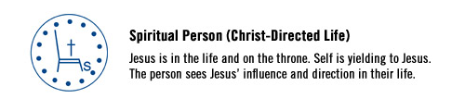
Contrast with …
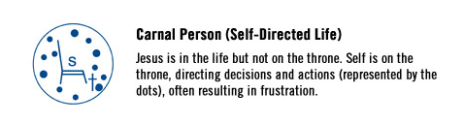
https://www.cru.org/train-and-grow/spiritual-growth/the-spirit-filled-life.html

Use the last page as a handout so your learners can take home the application points of this week’s lesson.
Application
Take inventory
- List main talents and abilities God has given you
- List also major resources God has entrusted to your care (money, possessions, property, etc.)
- Evaluate each list … which are you currently using to advance God’s kingdom?

Memorize
- Choose a favorite verse or passage from Psalm 31 … one that summarizes how you want to live as a steward of God’s resources
- Memorize that verse or passage this week

Go deeper
- Learn more about money management by reading a book or taking a course
- Topics should include investment, getting out of debt, philanthropy, etc.
- Consider asking a friend or family member to join you in learning about being a good steward of God’s resources

Proverbs 31 Word Search
Left to right, top to bottom, and diagonally
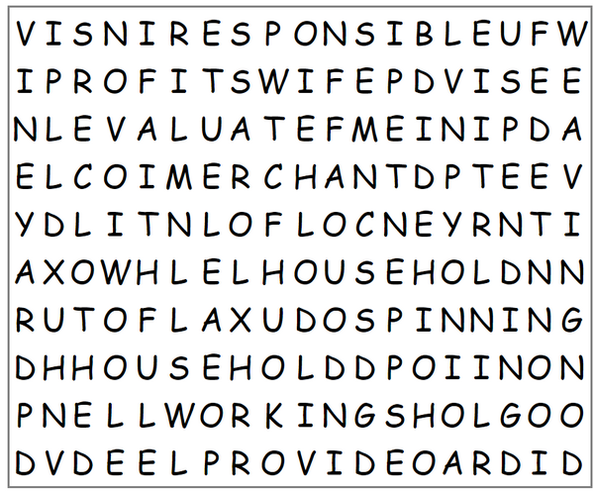
clothed
evaluate
faithful
flax
food
household (twice … oops)
lamp
merchant
needy
poor
productive
profits
provide
responsible
spending
spinning
vineyard
weaving
wife
wool
working

