1. Motivate

When has someone gone out of his or her way to help you?
- paid a bill for me
- stopped to help change a tire
- showed me how to do a math problem
- gave me a tool and showed me how to use it
- watered my garden while I was gone
- visited my aging parent when I wasn’t around
- mowed my lawn while I was sick
- allowed us to borrow a car when ours was broken
- gave us a ride to the airport at 5:00 am

2. Transition

Helping one another is a way we show the love that Jesus spoke of
- Today we look at how loving God will be demonstrated in how we love others
- Sometimes that love will be costly

3. Bible Study

3.1 Loving God, Loving Others

Listen for Jesus’ teaching style.

Luke 10:25-28 (NIV) On one occasion an expert in the law stood up to test Jesus. "Teacher," he asked, "what must I do to inherit eternal life?" 26 "What is written in the Law?" he replied. "How do you read it?" 27 He answered: "'Love the Lord your God with all your heart and with all your soul and with all your strength and with all your mind'; and, 'Love your neighbor as yourself.'" 28 "You have answered correctly," Jesus replied. "Do this and you will live."

What different motivations do people have for asking questions about God and of God?
- want to justify themselves
- may honestly want to know Truth
- just want to argue
- want to show that you as a Christian are wrong or foolish
- want to understand why God allowed such a thing to happen
- want to blame God for what happened
- they enjoy debate

Actually, this question is arguably the most important question any person can ask. Give your opinion why you think the lawyer was or was not sincere in asking it.
Sincere | Not Sincere
- the subject of the question shows it is sincere  - he was focused on the most important issue of life | - it says he asked it to test Jesus  - he already knew a proper answer (as a student of the Law)

If it was not a sincere question, but a test … what kind of test do you think this was?
- did Jesus really know what He was talking about
- would Jesus’ answer agree with the lawyer’s opinion
- could the lawyer find some detail of the law to trip up Jesus

Note that Jesus responds with a question of His own (a good teaching technique). What answer did the lawyer give about the requirements of the law?
- Love the Lord with all your heart, soul, strength, mind
- love your neighbor as yourself

What is involved in loving God with all your heart, soul, strength, mind?
- emotions
- intellect
- total focus
- God is the very center of every element of your life

What does it mean to “love your neighbor as yourself”?
- our natural tendency is to put oneself in first place
- we are quick to watch out for our own interests
- comes naturally (note tendency of a 2 yr old, “MINE”)
- God calls us to act counter to that natural tendency and act the same way towards others … looking out for their interests … as we do for ourselves

What conditions do we sometimes put on giving love to one another?
- I will love you if you will love me
- I will only be nice to you if you do what I want
- I’ll be mean to you if you don’t treat me nice, if you don’t love me
- I’ve only got so much love to go around … you may or may not be within my limit

This man was an expert on scripture and the Mosaic Law. How might spending too much time simply studying the Bible lead to an unbalanced spiritual life?
- too much theory, not enough practice
- you can end up too heavenly to be any earthly good
- James spoke of faith without works is questionable faith

Why would knowledge with little or no works be a poor testimony for Christ?
- does not reflect Christ’s attitude
- Christ gave up His very life for others
- shows the love of Christ working in our lives
- demonstrates that God changes lives, wants to minister to people’s needs

3.2 Love Takes Action

Listen for who did not show love.

Luke 10:29-32 (NIV) But he wanted to justify himself, so he asked Jesus, "And who is my neighbor?" 30 In reply Jesus said: "A man was going down from Jerusalem to Jericho, when he fell into the hands of robbers. They stripped him of his clothes, beat him and went away, leaving him half dead. 31 A priest happened to be going down the same road, and when he saw the man, he passed by on the other side. 32 So too, a Levite, when he came to the place and saw him, passed by on the other side.

In wanting to justify himself, what did the legal expert really want to do?
- limit who he was supposed to love
- limit the definition of “neighbor”
- is it someone close, someone nice
- hope it isn’t someone who I don’t like, someone who is offensive

Put yourself in the position of the priest or Levite. What would be the pros and cons of stopping to help this man?
- he’s already too far gone to help
- I might be ceremonially unclean if I touch a dead person
- this might be a trap … the robbers might be just waiting for me to stop
- I’m late … cannot be delayed
- I can’t afford to get involved

What natural inclinations make it easier for you to act like the priest and the Levite?
- same reasons … cannot afford the time or the resources involved
- they got themselves into the problem, they can get themselves out
- they need to learn to stand on their own two feet
- they deserve the plight they are in … it’s God’s judgment!
- I’m already too busy with family, school, job, church … someone else will help them
- those people are just too different from us … we cannot relate to them, they probably won’t understand or appreciate our help

How do we overcome barriers like these?
- confess your lack of love and concern for others in need
- Ask God to work in our lives to give us His love for them
- get to know the people, then you realize their true needs
- when they become your friends, you are more willing to help them
- pray for them … often God uses you to be the instrument of answering your own prayers

How did the wounded man present a limited window of opportunity for the priest and Levite?
- he was in need right then
- if they waited until it was more convenient, the man would probably die
- despite their commitments to other things, this might be a priority presented by God

3.3 Love without Limits

Listen for who showed love.

Luke 10:33-37 (NIV) But a Samaritan, as he traveled, came where the man was; and when he saw him, he took pity on him. 34 He went to him and bandaged his wounds, pouring on oil and wine. Then he put the man on his own donkey, took him to an inn and took care of him. 35 The next day he took out two silver coins and gave them to the innkeeper. 'Look after him,' he said, 'and when I return, I will reimburse you for any extra expense you may have.' 36 "Which of these three do you think was a neighbor to the man who fell into the hands of robbers?" 37 The expert in the law replied, "The one who had mercy on him." Jesus told him, "Go and do likewise."

What attitude differentiated the Samaritan’s response from that of the priest and Levite?
- priest and Levite just passed on by, let him be
- Samaritan helped him

Why would a Samaritan be considered an unlikely hero?
- Jews hated Samaritans
- Samaritans considered religiously and racially to be inferior
- during Jewish captivity, Samaritans had been left behind and their worship had drifted away from Jehovah
- they had intermarried with local pagans

How did the Samaritan prove his compassion?
- took pity
- bandaged his wounds
- gave medication
- gave him a ride
- took him to an inn, cared for him
- paid for further care

What does it cost us to show compassion to people in need around us?

- finances
- time
- physical energy
- emotional energy

What can we do as individual Christians or as a church to help remove the barriers that prevent God’s love and message of compassion from reaching all people?
- pray for people in need
- ask God to give you compassion that you do not have within yourself
- become involved in outreach ministries,
- become a volunteer (rescue missions, Habitat for Humanity efforts, etc.)
- be a “reading buddy” in local grade schools – many little children need someone to show personal interest
Use the last page as a handout so your learners can take home the application points of this week’s lesson.

Application

As a family, discuss the meaning of “loving your neighbor as yourself”
- Talk about how much we work to do good things for ourselves
- Think of people around us who need our love, people who are hurting
- Pray together that God will show you how you can love them “as yourself”

Who are some people in your community with whom you are hesitant to share Christ’s love
- Where do they live?
- How do they act? Which causes you be hesitant?
- What do they believe?
- Again … pray that God will empower you to actually show love for them

Ask God to help you overcome barriers that keep you from reaching out with God’s love …
- We mentioned finances, time, effort …
- Believe God to multiply your resources as you use them for his kingdom
- Become a “good Samaritan” … someone who gives of himself/herself to reach out to people different from yourself

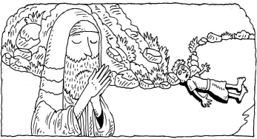
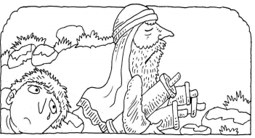
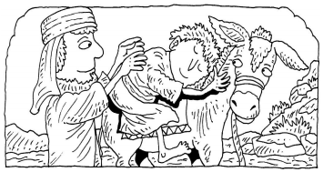
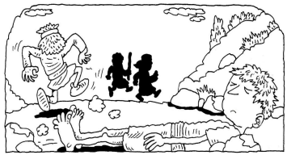
Have your children or grandchildren join you in filling in the word bubbles of what these men (the Levite, the priest, and the Samaritan) might have thought or said.
Then identify people in your community who might need your help.
People you could help:

