1. Motivate

How do the people you love (whether close friends, spouse, or family members) know that you love them?
- what you say to them
- how you say it to them
- if your actions then match your words
- you make them feel important
- you do what is best for them
- timing … say the right thing at the right time
- do nice things for them without being asked or without expectation of kindness in return
- always be careful when your spouse asks “do I look OK in this outfit” !!!
- considerate treatment, fairness, kindness, understanding

2. Transition

Jesus spoke to the issue of how to love.
- He said we should base every relationship on the unconditional love He has for us

3. Bible Study

3.1 Remain in Jesus’ Love

Listen for how to have joy.

John 15:9-11 (NIV) "As the Father has loved me, so have I loved you. Now remain in my love. 10 If you obey my commands, you will remain in my love, just as I have obeyed my Father's commands and remain in his love. 11 I have told you this so that my joy may be in you and that your joy may be complete.

What is Jesus’ desire concerning love?
- remain in His love
- obey His commands
- love others in the same way Jesus loves us
- love others as God the Father loves Jesus, the Son

What provides evidence that a person truly loves the Lord?
- obedience to Jesus’ commands
- follow the example of how Jesus obeys the commands of God the Father

Why did Jesus share His message with His disciples?
- so that they (and we) experience the same joy Jesus does
- so our joy will be complete

How were Jesus’ disciples to remain or abide in His love? How are we to remain/abide in Jesus?
- obedience
- following Jesus’ commands
- follow the example of how Jesus obeyed God the Father

Is obedience the requirement or the result of abiding/remaining in Jesus’ love?
Requirement | Result
- Jesus does not love it when we disobey  - it pleases God when we obey  - some people would say that if you want Jesus to love you, then you should be obedient | - God loves me no matter what I do  - my actions do not cause Jesus to love me more or love me less  - I respond to God’s love for me by obeying His commands  - I demonstrate my love for the Lord by obeying His commands

⇨ We should understand that obedience is the result of abiding or remaining in Jesus’ love.
⇨ Obedience demonstrates our love for Jesus.

How does obeying God’s commands demonstrate our love for Him?
- I realize how much He loves me and want to respond to that
- I begin to see that His commands are good for me
- I come to understand that God loves me and gives directions how to live that benefit me and glorify Him
- obedience also demonstrates trust, faith in Him – I can love God and obey Him because I trust His commands are the best way to live

What does this passage tell us about God’s design for our class, our church?
- God wants joy for us
- even when times are tough we can know assurance of God’s love
- the church, the Body of Christ will support one another with love
- when we are walking in God’s love, it will be contagious, it will be passed along

3.2 Love with Jesus’ Love

Listen for how to love.

John 15:12-13 (NIV) My command is this: Love each other as I have loved you. 13 Greater love has no one than this, that he lay down his life for his friends.

What command did Jesus give His disciples?
- along with loving God, we are to love each other also
- love each other in the same manner as Jesus loves us
- this is the kind of love that works to benefit and bless the other person with no requirement or even expectation of reciprocation

What is the greatest manifestation of love?
- surrender or lay down your life for someone else
- example of a soldier who dives on a grenade to save his buddies
- risk, willing to give up your life for someone else

When do you struggle with loving others the way Jesus has loved you?
- not all others are lovable … they are mean
(statistician’s joke: on average people are mean)
- some people “hate your guts”
- some people are unpleasant to be around (they stink, they dress weird, they use foul language, they are sloppy, crude)
- some people might be unpleasant because they are snooty, talk down to/at you, think they are better than you

To what future event does Jesus’ statement in verse 13 allude?
- His own substitutionary death
- Jesus would die on the cross in our place
- He would take the death punishment each of us deserves upon Himself
- Jesus would receive the judgment for sin that should have been ours

When have you experienced the power of sacrificial love?
- parents who provided
- someone went out of their way to do for you
- spouse bought that special gift (story of the “Gift of the Magi”)
- parent who gave up sleep to help you do big homework project
- spouse who worked to put you through school
- parents who saved up to take you on a special vacation or send you to camp

What opportunities do you have to “lay down your life” for others? What does it look like to love others the way Jesus loves us?
- we might not end up dying for someone else, but we can give up things to help others
- I might forego a purchase I wanted to make it possible that a child or grandchild was able to do something special
- give of your valuable time to help someone with a need they had
- dedicate a time in my schedule each day to join others in prayer for a special ministry of our church or our mission
- willing to drive across town, out of my way to enable some kids to come to a special program
- donate skills to do help a family in need
- share the Gospel
- give to send the Gospel around the world
- pray faithfully for children, grandchildren

3.3 Love with a Lasting Love

Listen for a new relationship Jesus declares.

John 15:14-17 (NIV) You are my friends if you do what I command. 15 I no longer call you servants, because a servant does not know his master's business. Instead, I have called you friends, for everything that I learned from my Father I have made known to you. 16 You did not choose me, but I chose you and appointed you to go and bear fruit--fruit that will last. Then the Father will give you whatever you ask in my name. 17 This is my command: Love each other.

What word does Jesus use to describe the elevated relationship His disciples have with Him?
- friends
- no longer servants/bond slaves

Note the contrasts Jesus makes between servants and friends (He calls us friends).
Servants | Friends
- does not know his master’s business  - Jesus no longer calls us servants | - great love demonstrated by laying down one’s life for a friend  - God’s friends do what He commands  - Jesus calls us friends  - Jesus made known all He learned from the Father to His friends

What does it mean to be “friends” with Jesus?
- trust Him
- submit to Him
- serve Him
- follow Him

Do you remember as a child when they would choose up sides for a game … were you ever the last one chosen? You weren’t even chosen, the person with last choice had to take you. How did you feel?
- rejected
- not much self esteem

It says here that God chose us … to be His friends! For what other purpose did God choose us?
- appointed, commissioned us to go everywhere with the gospel
- to bear fruit … lasting fruit
- Fruit of the Spirit (love, joy, peace, patience, kindness, goodness, faithfulness, gentleness, self-control)
- fruit of spiritual harvest – new believers

Use the last page as a handout so your learners can take home the application points of this week’s lesson.

Application
Reflect.
- Take some time to think about how God loves you, and reflect on your love for Him.
- List at least three reasons obeying Jesus brings joy.

Read.
- Read John 15:9-17 each day and note what it says about your relationship with God.
- Ask God to give you a fresh perspective each day and to help you stay focused on Him.

Share.
- Find ways this week you can bring joy to others— in your workplace, family, school, or neighborhood.
- Bringing joy to others is a way to show Christ’s love, and it can pave the wave for a verbal witness.

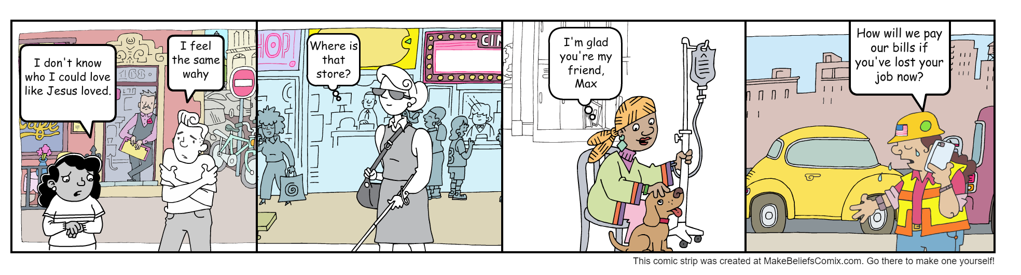
Sue and Jim wonder how they could apply today’s lesson to people in their neighborhood.
Based on the people they often come in contact with, write down some ideas in the space below.

Sue and Jim could …

