1. Motivate

What’s something you’d love to add to your celebration of Christmas?
- Holy land trip
- celebrate Christmas in Hawaii (or Switzerland or Disney World)
- a sleigh ride … over the river and through the woods …
- hear the Messiah in some big theater or cathedral
- picture made with Santa
- binge on Christmas movies
- would like to see again the movie The Man in the Santa Clause Suit
- buy my spouse a new car … red with white interior (Ha!)

2. Transition

Many of our celebrations include being together with family
- Christmas is more memorable when we celebrate our relationships
- Actually Jesus was born to bring us into a relationship … a relationship with God.

3. Bible Study

3.1 God’s Plan and Timing

Listen for hardships experienced.

Luke 2:4-7 (NIV) So Joseph also went up from the town of Nazareth in Galilee to Judea, to Bethlehem the town of David, because he belonged to the house and line of David. 5 He went there to register with Mary, who was pledged to be married to him and was expecting a child. 6 While they were there, the time came for the baby to be born, 7 and she gave birth to her firstborn, a son. She wrapped him in cloths and placed him in a manger, because there was no room for them in the inn.

What were the conditions in Bethlehem the night Jesus was born? (2:7)
- town was full of visitors
- many people there to register and pay tax
- no vacancies in what few lodging places there were
- Mary and Joseph had to stay in a stable … and that’s when the baby decided to be born
What were the difficulties involved in this trip?
- travel, in general would have been tough (90 miles, uphill, trip of 3 – 4 days)
- Mary is 9 months pregnant
- no place to stay when they get there
- Baby decides to be born away from home

Actually, only the husband was required to go for the census registration – what are some possible reasons why Mary accompanied Joseph?
- just wanted to be with him
- people back home were talking about the less than 9 month bride being pregnant
- they might have decided to move there
- Joseph wanted to protect her from the talk

What are some things that are incongruous about the birth of the King of Kings?
- born of very poor parents
- born in what appeared to be questionable circumstances
- born in a very poor location
- might make modern ob-gyn folks nervous about the lack of facilities, cleanliness
- born in a small, inconsequential town
- very few people were aware of the events of that night

If the birth of Jesus was so momentous, why was He born in such humble circumstances?
- consistent with the Servant role of Jesus
- everything about Jesus would be miraculous
- His virgin birth, his conception
- His divinity/humanity combination (incarnation)
- His ministry
- His resurrection
- It showed his identification with all men
- It underlined the humanity of Jesus – there is no question of his humanity – he was not plunked down in a palace as a special grown up envoy of deity

In what ways did God manage the events of history to get Joseph and Mary where He wanted them at the appropriate time?
- Jesus was prophesied to be born in Bethlehem
- Mary was engaged to Joseph who was a direct descendant of King David
- Cesar declared a census, people had to register in their ancestral home town
- that caused Joseph (along with Mary) to travel to Bethlehem … the city of David

What impresses you the most about the circumstances of Jesus birth?
- virgin birth
- he left heaven to become a man
- he limited himself to becoming a baby – did he limit his understanding, his ability to talk, to reason as a child
- how conscious was he of his deity when he was 1, 2, 3, …
- he submitted to the authority of parents, even when he knew he was deity
(what if he had to endure a spanking – though undeserved)

⇒ He loved us enough to come and live in the squalor of a middle eastern village, knowing that one day he would endure a tortured death

3.2 Jesus, Our Salvation

Listen for the announcement.

Luke 2:8-14 (NIV) And there were shepherds living out in the fields nearby, keeping watch over their flocks at night. 9 An angel of the Lord appeared to them, and the glory of the Lord shone around them, and they were terrified. 10 But the angel said to them, "Do not be afraid. I bring you good news of great joy that will be for all the people. 11 Today in the town of David a Savior has been born to you; he is Christ the Lord. 12 This will be a sign to you: You will find a baby wrapped in cloths and lying in a manger." 13 Suddenly a great company of the heavenly host appeared with the angel, praising God and saying, 14 "Glory to God in the highest, and on earth peace to men on whom his favor rests."

Suppose you were a shepherd outside of Bethlehem some 2000 years ago … you’ve got the sheep settled down, you’re taking turns being on watch against predatory animals and thieves … a brilliant light appears in the sky. What are some possible responses?
- run away fast, dive under something to hide
- gather the sheep – don’t want a stampede
- try to wake up from your bad dream
- try to figure out what it is

List words of encouragement and celebration that appear in the angel’s announcement
- don’t be afraid
- I bring you good news of great joy, the good news is for all the people
- a Savior has been born to you today, He is the Messiah, the Lord
- A great angel choir appeared praising God, pronouncing peace to men

Shepherds were at the bottom of the socio-economic structure in those days. They were considered ceremonially unclean in Jewish culture. Why then would God bring the news of the Messiah’s birth first to them? (There are hints in the passage)
- God was not concerned about social opinions
- God sent the Savior for all people, no matter who
- This was “good news of great joy that will be for all the people”
- He wanted to stress that Jesus came for even the lowest strata of society

⇨ Jesus came for the rich and the poor, for the Jews and the Gentiles

What specific information were the shepherds given?
- Savior born today in Bethlehem (town of David)
- He is the Messiah, the Lord
- the specific child you should look for is one wrapped in cloths and lying in a feeding trough

Why is the angelic visit to the shepherds a significant event in the story?
- this is an important event
- God wanted to announce this to the world
- God wanted witnesses to what had just happened
- God wanted people to know this was more than just another childbirth
- this was a heavenly event
- it was a sign, demonstrated the special status of the birth
3.3 Jesus’ Birth Proclaimed

Listen for different responses to the events.

Luke 2:15-20 (NIV) When the angels had left them and gone into heaven, the shepherds said to one another, "Let's go to Bethlehem and see this thing that has happened, which the Lord has told us about." 16 So they hurried off and found Mary and Joseph, and the baby, who was lying in the manger. 17 When they had seen him, they spread the word concerning what had been told them about this child, 18 and all who heard it were amazed at what the shepherds said to them. 19 But Mary treasured up all these things and pondered them in her heart. 20 The shepherds returned, glorifying and praising God for all the things they had heard and seen, which were just as they had been told.

How did the shepherds respond to what they had seen and heard?
- hurried off, found Mary, Joseph, the baby
- they told others about what they had heard and what they found
- when they eventually went out to the sheep pastures they glorified and praised God for all they had heard and seen

What specific things do you think they said as they glorified and praised God?
- You should have seen those angels
- Wow could they sing … don’t know where the orchestra came from, though
- We had to look several places, but we finally found the baby
- Can you believe it? That was the Messiah we saw!

Why do you think the shepherds told the people of Bethlehem?
- was so exciting, they couldn’t keep it to themselves
- too good of a secret to keep
- not much good happens to shepherds, when it does, it’s worth telling

How does celebrating Jesus birth bring you joy?
- the beauty of the music which declares the birth of Jesus
- the Truth about who Jesus and what He has done
- the reminder of His humanity
- the Power of God to accomplish His redemption of mankind in this way

Note that the shepherds were the first to tell the Good News of the coming of Jesus!
- they were thrilled and excited
- probably, you couldn’t have shut them up

⇒ The same should be true of our knowledge of Jesus, our Savior
- we should have similar thrill and excitement about knowing who He is
- about knowing what He has done

Luke says that Mary treasured this experience in her heart. What can we treasure about God, thinking about it over and over?
- the miracle of salvation
- why God would love us (we know down deep what we’re really like)
- God’s power, authority, majesty
Use the last page as a handout so your learners can take home the application points of this week’s lesson.
- God is in control … no matter what the economy or politics
Application
Treasure.
- Think on the things you’ve seen or heard that have confirmed God’s reality and power to you.
- Treasure these things in your heart so you can recall them and share them with others.

Write.
- Write out your testimony—what Jesus has done in your life—and pray about finding one person you can share it with this week.

Celebrate.
- Determine one or more ways you can turn the celebration of Christmas into a proclamation of what Christ has done for you.
- How can you, like the shepherds, leave those you speak with astonished at what they’ve heard about Jesus?
AMAZED
ANGEL
BABY
BETHLEHEM
CHRIST
DAVID
EXPECTING
FIRSTBORN
FLOCKS
GLORY
HEART
INN
JOSEPH
JOY
LORD
MANGER
MARY
NAZARETH
NEWS
PEACE
PONDERED
PRAISING
REGISTER
SAVIOR
SHEPHERDS
SIGN
TERRIFIED
TREASURED

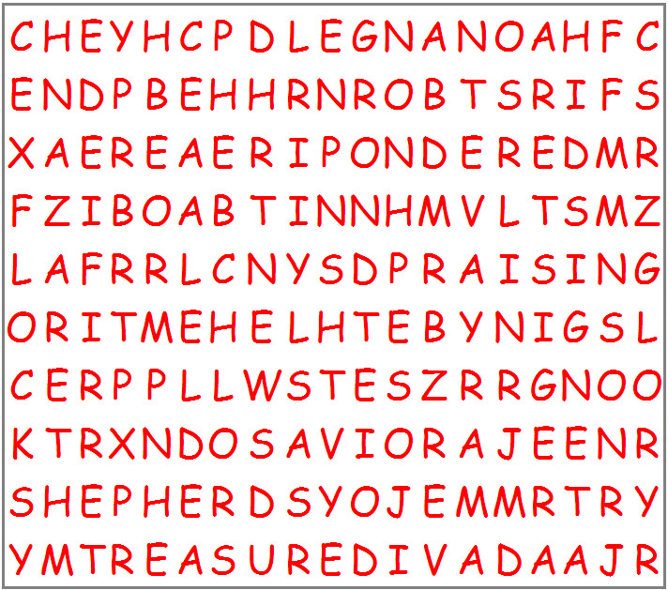

Nativity Word Search
Find the words in the grid below that are in the list to the right. The words could be forwards, backwards, up, down, or diagonal. Find the solution at https://tinyurl.com/y8ktrdoe along with other family activities.

