1. Motivate

What are some social customs you were taught to follow?
- yes sir/mam, no sir/mam
- please, thank-you
- no elbows on the table
- no belching (when others are present)
- how to hold and use fork, spoon, knife
- hold door open for a lady, for an elderly person
- children should be seen, not heard
- be quiet in church, pay attention
- speak when spoken to
- eat your veggies without complaining (much)
- wait for everyone to be served before eating
- giving thanks before a meal
- wear good clothes to special events

2. Transition

Your family probably had special standards of dress and behavior.
- These are usually good things. Even so …
- Jesus calls us to a higher standard – on a different level.

3. Bible Study

3.1 God’s Commands

Listen for who is hypocritical.

Mark 7:5-8 (NIV) So the Pharisees and teachers of the law asked Jesus, "Why don't your disciples live according to the tradition of the elders instead of eating their food with 'unclean' hands?" 6 He replied, "Isaiah was right when he prophesied about you hypocrites; as it is written: "'These people honor me with their lips, but their hearts are far from me. 7 They worship me in vain; their teachings are but rules taught by men.' 8 You have let go of the commands of God and are holding on to the traditions of men."

What were the Pharisees and teachers of the law concerned about? Why?
- Jesus’ disciples didn’t wash their hands in the correct way before eating
- this was a tradition of the elders
- Note, this was not a hygiene issue, it was a way of showing correct spiritual living … how to be righteous, holy

How did Jesus avoid answering the Pharisees’ question directly? What were these critics guilty of doing?
- Jesus told them they were hypocrites
- said they were just play acting at true religion, true faith
- quoted Isaiah … you honor God with what you say
- in reality your hearts are far from me
- you are worshiping in vain, uselessly, for nothing
What’s wrong with "holding on to the traditions of men"?
- you end up letting go of the commands of God
- you end up worshiping in vain
- your hearts become far from God

What did Jesus want His audience to do?
- obedience directly to God’s commands
- don’t make up new laws that supersede God’s commands
- don’t substitute your own standards for God’s standards

What church traditions either can or do stand in the way of non-believers becoming interested in Christianity?
- forbid some Sunday activities
- who can belong, who can hold office
- too many sermons on giving money
- how to dress for church – failure is frowned upon, dirty looks given
- some churches allow certain activities, others do not
- specify how long your hair should be
- reject (and preach against) any scripture version other than King James

When do believers concern themselves more with external issues than internal issues?
- always pray before meals, but yell and argue during the meal
- absolutely no sports allowed on Sundays, but are first out of the back of the church to beat the other denominations to the favorite buffet restaurant
- dress up “to the nines” for Sunday church … and gossip about those who don’t
- make sure to be at church on time, but complain when the preaching goes too long and causes missing the kick-off of this week’s NFL game

3.2 Twisting God’s Commands

Listen for a loophole.

Mark 7:9-13 (NIV) And he said to them: "You have a fine way of setting aside the commands of God in order to observe your own traditions! 10 For Moses said, 'Honor your father and your mother,' and, 'Anyone who curses his father or mother must be put to death.' 11 But you say that if a man says to his father or mother: 'Whatever help you might otherwise have received from me is Corban' (that is, a gift devoted to God), 12 then you no longer let him do anything for his father or mother. 13 Thus you nullify the word of God by your tradition that you have handed down. And you do many things like that."

How were the Pharisees being hypocritical in this instance?
- set aside commands of God
- enable them to observe their own traditions

What example did Jesus give to prove His accusations against the Pharisees?
- the procedure called Corban
- where God said, “Honor your father and mother” and “do not curse your father or mother’’
- they came up with a loophole to enable people to avoid supporting elderly parents

Explanation of “Corban”
- A gift dedicated to God
- You may devote property or money to God.
- It cannot be given to anyone else – including needy parents
- According to the religious leaders of Jesus’ day, the corban vow was irrevocable.
- The scribes and Pharisees held that vows to God overruled any other obligation or commitment, including to one’s parents.

What effect did practice of this tradition have on what God had said?
- nullify word of God
- create a tradition that bypasses what God commands
- this collection of traditions grows and gets handed down
- end up with many such loophole traditions

What drives people to twist God’s commands to their own advantage?
- laziness – desire to avoid God’s precepts, commands
- greed – avoid giving of resources to God
- rebellion against God
- sneakiness … want to get by with their own desires, but look spiritual
- rationalize behavior that you know is displeasing to God

What can we do to place traditions—especially religious traditions—in proper perspective?
- be well studied in scripture … read, meditate daily
- daily communication with God … prayer
- the principles you live by should be Bible-based
- apply teachings of God’s word to your life

3.3 Internal Righteousness

Listen for what defiles.

Mark 7:14-15 (NIV) 14 Again Jesus called the crowd to him and said, "Listen to me, everyone, and understand this. 15 Nothing outside a man can make him 'unclean' by going into him. Rather, it is what comes out of a man that makes him 'unclean.'
How did the Pharisees’ use of "unclean" (hand washing) differ from that of Jesus’?
Pharisees’ “unclean” | Jesus’ “unclean”
- wash a certain way  - wash at certain times  - do not touch certain things  - do not do certain things  - do some activities in a specific way  - outward actions | - inward impurity which comes out  - think unkind thoughts  - say unkind things  - lust in your heart  - anger, jealousy, coveting

To whom are these words directed?
- He was speaking to “the crowd” but His comments refuted the position of the scribes and Pharisees who had confronted Him
- religious people
- today, it would be church people … believers

What is the source of spiritual defilement?
- inward sinful nature
- yielding to temptations
- poor choices
- rebellious attitude
- ignoring God’s Spirit’s convicting/convincing

How can we make sure our hearts are pure as opposed to our lives merely appearing to be pure?
- confess your failures (sins) to the Lord quickly
- repent, turn away from sinful attitudes and actions
- turn to God, trust Him for forgiveness
- allow God to cleanse you
- be sensitive to God’s Holy Spirit speaking to you in your heart

What steps can we take to demonstrate grace rather than legalism?
- think about, meditate on God’s grace and mercy shown to you
- remember God’s forgiveness to you
- pray God’s blessing on others
- pray for God to work in people’s lives
- act with kindness towards others … even those who are unkind to us

Use the last page as a handout so your learners can take home the application points of this week’s lesson.

Application
Dig.
- Identify some of the “church traditions” you grew up with or currently practice.
- Divide them into three groups: rituals, preferences, and Bible-centered practices.

Bury.
- Stand strong for Christ-centered practices, but let go of those things that are just your preferences.
- Determine not to expect others to live according to your preferences.

Plant.
- Take someone out for coffee this week who is struggling with their faith because of the practices or customs they experienced in a particular church.
- Share your story.
- Help them see that a relationship with God is not tied to these practices but to faith in Christ
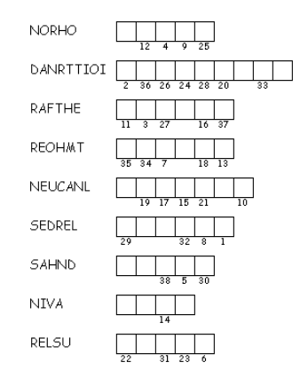

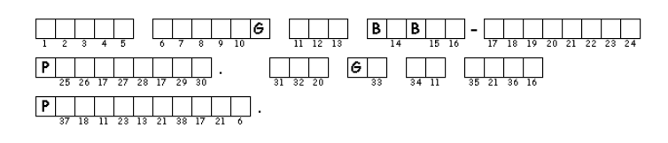
Double Puzzle
Unscramble each of the clue words which come from our Scripture passage today. Copy the letters in the numbered cells to other cells with the same number. Find the solution and other family activities at https://tinyurl.com/y727n5de

