1. Motivate

What is good or bad about a face-to-face meeting between feuding parties?
Good | Bad
- opportunity to settle things  - this may take care of the problem  - no more fuming or yelling  - now it can be finished | - could escalate  - now bad things could happen  - someone’s going to get hurt  - call the cops
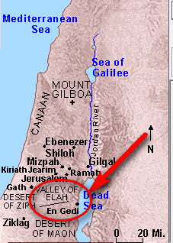

2. Transition

At the heart of so much conflict is the desire to get what I want or to have things my way.
- That sets the tone for conflicts among siblings, spouses, whole nations, and every relationship in between.
- In today’s lesson a conflict between Saul and David can give us some insight into how thinking of God and others is the best choice in conflict situations.

3. Bible Study

3.1 Jealous Pursuit

Listen for who was chasing whom.

1 Samuel 24:1-2 (NIV) After Saul returned from pursuing the Philistines, he was told, "David is in the Desert of En Gedi." [2] So Saul took three thousand chosen men from all Israel and set out to look for David and his men near the Crags of the Wild Goats.

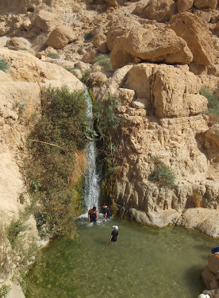
What activity did Saul resume as soon as the Philistine threat abated?
- gathered 3000 chosen men
- set out to look for David and his men
- went off in the wilderness, looking to kill David

Note on the map the location of En Gedi … near the western shore of the Dead Sea.

What might have made this a potentially good refuge?
- it’s out in the middle of nowhere
- good places to hide
- game to supply them
- water sources from streams leading to Dead Sea

Pictures from the blog: Random Musings from a Doctor's Chair, by Alex Tang
What facts in these verses support the view that Saul was unreasonably obsessed by his desire to capture David?
- after a national threat by Philistines, this is the first thing he thinks of
- he’s only wanting to find one person, David
- and he takes a whole army, 3000 men
- he leaves the comforts of his residence and heads off into a nasty wilderness

What happens in a relationship when one of the people thinks only of himself or herself?
- the other person is put off
- the relationship begins to crumble
- conflict originates from the selfishness
- you might find out that you pay a high price for constantly demanding your own way

What do you think were some of David’s thoughts as he probably heard Saul was coming to hunt him?
- oh no, not again
- what is with that guy?
- why can’t he just leave us alone?
- I’ve never done him dirty, why does he hate me so?
- since he has 3000 men, we’ll easily avoid such a noisy and obvious crowd
- by the way, where is God in all of this?

Consider … if God’s immediate plan is not clear …
- it can be easy for our own selfishness to show
- we can misinterpret circumstances
- we can even act against God's will

⇨ David and his men were not immune to this problem

3.2 Firm Refusal
Pictures from the blog: Random Musings from a Doctor's Chair, by Alex Tang

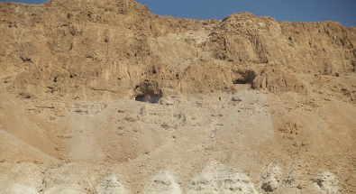
Listen for David’s stealthy act.

1 Samuel 24:3-7 (NIV) He came to the sheep pens along the way; a cave was there, and Saul went in to relieve himself. David and his men were far back in the cave. [4] The men said, "This is the day the Lord spoke of when he said to you, 'I will give your enemy into your hands for you to deal with as you wish.' " Then David crept up unnoticed and cut off a corner of Saul's robe. [5] Afterward, David was conscience-stricken for having cut off a corner of his robe. [6] He said to his men, "The Lord forbid that I should do such a thing to my master, the Lord's anointed, or lift my hand against him; for he is the anointed of the Lord." [7] With these words David rebuked his men and did not allow them to attack Saul. And Saul left the cave and went his way.

How did Saul come to be alone for a short time?
- Saul’s army was in an area where there were caves
- Saul went off into a cave to relieve himself
- wanted privacy
- unbeknownst to Saul, this was the very cave where David and his men were hiding, farther back in the cave

What did David’s men tell him when they discovered Saul alone in the cave?
- here’s your chance
- God is delivering Saul into your hands
- this is God’s providence
- this is when you can get rid of the one who is chasing you

What tempts people to take matters into their own hands?
- Selfishness and/or self-centeredness.
- sometimes you just have to look out for yourself
- “I don’t need God, I can take care of this”
- we think of the quote, “God helps those who help themselves.” (not from scripture)
- lack of Christian maturity

What action did David take while Saul was unaware?
- crept up behind him
- Saul didn’t know he was there
- cut off a corner of Saul’s robe

What was the single most important reason David had for not harming Saul?
- David did not have the right to harm/kill Saul
- God had placed Saul on the throne
- God would be the one to reverse that … in God’s time
- David did not want to assume the role of God

How do you think Saul would have behaved toward David if their situations had been reversed?
- Saul would have killed David
- that’s why he was out with his army
- it was his whole purpose … to chase down and do away with David

When does restraint speak more loudly than action?
- when you could have done something and chose not to
- shows you have the integrity, the wisdom, the fortitude to do what is right
- shows your will makes the right choice, even when your emotions (and maybe your friends) are screaming otherwise

3.3 Godly Trust

Listen for David’s confession.

1 Samuel 24:8-15 (NIV) Then David went out of the cave and called out to Saul, "My lord the king!" When Saul looked behind him, David bowed down and prostrated himself with his face to the ground. [9] He said to Saul, "Why do you listen when men say, 'David is bent on harming you'? [10] This day you have seen with your own eyes how the Lord delivered you into my hands in the cave. Some urged me to kill you, but I spared you; I said, 'I will not lift my hand against my master, because he is the Lord's anointed.' [11] See, my father, look at this piece of your robe in my hand! I cut off the corner of your robe but did not kill you. Now understand and recognize that I am not guilty of wrongdoing or rebellion. I have not wronged you, but you are hunting me down to take my life. [12] May the Lord judge between you and me. And may the Lord avenge the wrongs you have done to me, but my hand will not touch you. [13] As the old saying goes, 'From evildoers come evil deeds,' so my hand will not touch you. [14] "Against whom has the king of Israel come out? Whom are you pursuing? A dead dog? A flea? [15] May the Lord be our judge and decide between us. May he consider my cause and uphold it; may he vindicate me by delivering me from your hand."

How did Saul learn that David had just had him at his mercy?
- David calls out to him
- points out the severed hem of the robe
- David confesses what he has done

What arguments did David give to prove that he was not conspiring against the king?
- look at how God just now gave me the perfect opportunity to kill you
- in fact, my friends urged me to do so
- in spite of all of that, I spared you
- I had vowed not to harm my master
- I will not harm the Lord’s anointed/chosen
- here’s the proof … the corner of the robe … that’s all I did
- I could have killed you, but did not
- you chase me all over and cannot catch me, I end up with the perfect opportunity to kill you, but do not

In what context did David invoke the name of the Lord?
- God can look at me and see both the reasons and opportunities I have to take revenge against you
- Let God judge who is in the right
- Let God punish the person who really deserves it

Why is it better to allow God to vindicate you rather than you trying to do it yourself?
- Note the definition and synonyms of vindicate
- show or prove to be right, reasonable, or justified.
- synonyms: justify, warrant, substantiate, ratify, authenticate, verify, confirm, corroborate, prove, defend, support, back up, bear out
- your efforts could fail and you end up looking even more guilty and the other faction looks even more right
- if you use force to “prove” yourself right, maybe you really didn’t prove it
- if you allow God to show you were right, it’s more convincing

4. Application

4.1 Jealousy can cause a person to lose perspective and develop misguided priorities
- Ask God to help you recognize selfish obsessions
- Ask Him to keep you from unreasonable actions which might result

4.2 When we are faced with choices, it is often vital to determine God’s direction
- Some might argue that it is God’s providence to do what is obvious
- But we must stand firm for what we believe to be right in God’s sight.
- Refuse the urging of people around you to do otherwise

4.3 God’s people are to demonstrate compassion, not a spirit of vengeance
- Judgment and vengeance on the wicked belong to the Lord
- Trust the Lord to bring vindication and deliverance into those situations where you are attacked unjustly.

