1. Motivate

Of what opportunities have you failed to take advantage? Why?
- invest when things were on the way up
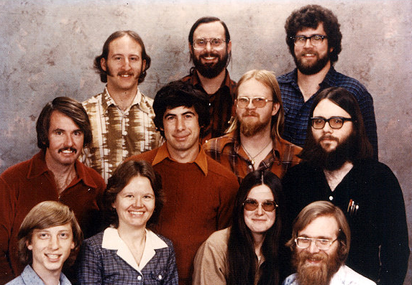
- held on to that car for another 5 hears, it would have been worth a lot now
- buy those fancy dishes when I saw them
- bought a house in the neighborhood when it was such a great price … now its worth has doubled
- gone on that trip
- gone to school when I had the chance

Would you invest with this startup group?
(Microsoft 1978, Bill Gates – lower left)

2. Transition
https://en.wikipedia.org/wiki/History_of_Microsoft

When it comes to your money, God wants us to plan and invest wisely.
- Today we look at what the author of Ecclesiastes teaches

3. Bible Study

3.1 Diversify

Listen for investment advice.

Ecclesiastes 11:1-2 (HCSB) Send your bread on the surface of the waters, for after many days you may find it. 2 Give a portion to seven or even to eight, for you don’t know what disaster may happen on earth.

What did Solomon tell his readers to do … what did his phrases mean?
- cast/send your bread on the waters
- after many days it will come back, you will find it
- make an investment when you can
- it will eventually pay off
- diversify your investments

What are good and bad ways people respond to the uncertainty of the future?
Wise ways | Foolish ways
- stock up supplies  - keep a “nest egg”  - don’t invest in only a single thing, diversify | - use it up now, won’t have it later  - anything can happen, might as well enjoy things now  - it’s never as bad as people predict

Why are we often tempted to “put all our eggs in one basket”?
- it looks like a fool proof plan
- when my “ship comes in” I’ll be rich
- I don’t have time to investigate all the other possibilities
- the guy said this investment opportunity was really going places
- I can make a bundle easily … double my money in no time

What is the advantage of diversification of investment?
- you are getting an average return, some low, some high
- you don’t take a hit when an investment tanks
- since you cannot predict the future, you “place your bets” in more than one place
- high risk when you are younger
- low risk when you are older, closer to retirement

What kinds of things prevent a person from taking calculated risks in life?
- worry
- can’t sleep at night
- only a few resources to start with … none to “gamble” with
- uncertainty of the future of politics in today’s world

On the other hand, hoarding our resources is non-productive and prevents us from maximizing their potential. What steps could I take to set aside $50 each month to be placed in savings?
- go out to eat two less times each month
- carry a lunch to work instead of eating in a restaurant
- don’t go shopping just for entertainment
- don’t go to the movies so often
- back off on the number of cable channels you subscribe to … you don’t watch even half the channels available

How do wise investments make you a better disciple of Jesus?
- God has given us many different kinds of resources
- when you use them wisely, you are acting responsibly
- it is part of God’s way of providing for you
- you can multiply God’s provision and use it for His Kingdom

3.2 Keep Working

Listen for when to invest.

Ecclesiastes 11:3-4 (HCSB) If the clouds are full, they will pour out rain on the earth; whether a tree falls to the south or the north, the place where the tree falls, there it will lie. 4 One who watches the wind will not sow, and the one who looks at the clouds will not reap.

What sort of person did Solomon criticize?
- someone who worries about the future
- someone who is keeps waiting for the perfect opportunity will never be able to take advantage of it
- don’t be paralyzed by indecision

How did the Preacher illustrate his point that some things in life are predictable and some are inevitable?
- weather happens … no way to stop it
- we would say “it is what it is”
- life happens … both good and bad
- unbelievers might call it fate, but both good and bad events enter our lives

What is the danger of focusing too much attention on misfortune?
- negative thoughts
- worry about things that will probably never happen
- focus on the glass half empty, not the half full
- miss opportunities because of worry
- also shows a lack of faith in God’s protection and provision

How are we to respond to excessive concern over what might or might not happen?
- make wise choices
- trust God for guidance and wisdom
- research the possibilities, then pray for God’s wisdom

How have you reacted to misfortune in the past?
- when you worry, when you doubt … run in circles scream and shout
- “cinch up your belt” and go on
- use it as an opportunity to grow, a learning opportunity
- try a different approach than the one which didn’t work

What steps can we take when worry seems to have us paralyzed?
- daily study of God’s Word … thinking about Who God is, His power, His authority, His love for you
- learn to take small steps in trusting God
- talk to God about it
- maybe seek out godly counsel
- there may be health or physical causes for which there are solutions

3.3 Trust God

Listen for spiritual advice.

Ecclesiastes 11:5-6 (HCSB) Just as you don’t know the path of the wind, or how bones ⌊develop⌋ in the womb of a pregnant woman, so you don’t know the work of God who makes everything. 6 In the morning sow your seed, and at evening do not let your hand rest, because you don’t know which will succeed, whether one or the other, or if both of them will be equally good.

What is the lesson behind the imagery of sowing seed morning and evening?
- do what needs to be done
- God will multiply your efforts
- don’t be lazy
- fulfill your responsibilities and trust God to take care of things

What undergirds all that happens in the course of human affairs?
- God is the one in control
- He is the one who controls nature
- He is the one who establishes how bodies grow, how seeds grow … everything
- He can be trusted

In what ways do you marvel at or are at a loss to comprehend the activity of God?
- God’s creation at both the macro (large) level and the micro level
- how ecology of the planet works
- how much God has allowed us to discover in science … and we still don’t understand so much of what is there
- how kids with the same parents can be so different (both good and bad)

In what areas of life do you feel uncertain about the future?
- retirement
- my kids/grandkids future
- crazy political situation
- our society’s attitude towards Christianity and people of faith

In a conversation about one of these topics, someone tells you, “I have no understanding, no knowledge of what is happening in my situation. How can I trust God?” How could you respond?
- God knows, God understands
- He wants to meet your needs, provide for you and your family
- He has the solution to all that you face
- He has the power and authority to make things right
- He loves you … He is trustworthy … worthy of your trust in Him

Use the last page as a handout so your learners can take home the application points of this week’s lesson.

Application
Submit to God
- Trusting God is the first step in any kind of wise investment
- As you pray this week, intentionally submit yourself to God’s will and plan for your future … both short term and long term.

Invest in God’s Kingdom
- Look for opportunities to invest your resources in ministries and businesses that seek to honor God and work for His kingdom
- Make investments that carry eternal significance

Secure a plan for the future
- If you have not done so, make an appointment with a legal professional to finalize your last will and testament
- Make sure you have a wise plan in place for allocating resources God have given you


Ecclesiastes 11 Crossword
Across
2. Send your _?_ on the water
3. don't let your hand _?_
6. sow your seed in the _?_
9. if you keep watching the wind and clouds, you will not _?_

Down
1. you don't know the path of the _?_
2. don't keep all your eggs in one _?_
4. keep a nest _?_
5. Give a portion to seven or eight, you don't know what might happen
7. if the clouds are full, they pour out _?_
8. where the tree _?_, there it will lie

