1. Motivate

What is something you’ve made with your own hands and then, even after your creation was completed, you continued to examine, enjoy, and appreciate it?

- cook a meal
- knitted a scarf, mittens, sweater
- baked a cake, pie, sweet rolls
- built a bookcase, table, house
- rebuilt an old car
- carved a bear with a chainsaw
- built a brick mailbox
- built a wooden canoe
- painted a picture
- created a needlepoint picture
- printed something with 3D printer
- planted a garden

2. Transition

This concept of continuing to enjoy your handiwork or accomplishments, even after they are completed, applies to us and God, our Creator.
- Remember that God has made each one of us
- Every life that He has created is important … every life counts – including yours

3. Bible Study

3.1 God Knows and Values You

Listen for God’s knowledge of David.

Psalm 139:1-6 (NIV) O LORD, you have searched me and you know me. 2 You know when I sit and when I rise; you perceive my thoughts from afar. 3 You discern my going out and my lying down; you are familiar with all my ways. 4 Before a word is on my tongue you know it completely, O LORD. 5 You hem me in--behind and before; you have laid your hand upon me. 6 Such knowledge is too wonderful for me, too lofty for me to attain.

To what areas did the psalmist refer to describe the detailed nature of the Lord’s knowledge about him?
- thoughts
- speech
- actions
- location

How did the psalmist respond to his awareness of the Lord’s vast knowledge about him?
- too wonderful for him to imagine
- to lofty for him to attain
- couldn’t imagine how God did it … even why

Which of the statements in 139:1-5 do you find most comforting? Why?
- God is watching over me, protecting me
- can see the dangers and pitfalls (literal and figurative, physical, emotional, spiritual, relational) ahead in my life
- laid His hand on me … guiding me, holding me back from danger, nudging me in the right direction
Which one makes you most uncomfortable? Why?
- sees the things I do that I might hide from other people
- wish might be able to hide from Him also
- knows my words before I say them … implies He knows my thoughts, motives, plans
- (sometimes I don’t know what I’m going to say)

Why does it matter that God knows you so intimately? What difference does it make?
- shows His interest in me personally
- knows my fears, desires, needs
- He is a personal God … not some powerful ruler who dictates His will from far off
- totally unlike politicians … they like to say they represent us when they have no idea what we are like

What are some advantages of God knowing everything about you?
- knows my personal needs
- knows my strengths and weaknesses
- we know He loves us (He died to accomplish our rescue from sin) so He will do good things for us, with each of us as individuals … not just as a group

What kind of people do certain parts our culture feel are expendable, even wish they would just go away?
- the poor, the homeless
- unwanted pregnancies
- elderly who are unable to care for themselves
- people who disagree with us (especially concerning politics)
- the liberal media!

⇨ God sees and knows all these people just like He knew the Psalmist.
- God considers them valuable! He loves them each.
- God’s grace restores all who repent and seek His forgiveness.

How does seeing yourself as valuable, help you regard others as valuable – and treat them so?
- God values them, so should I
- God works to redeem them, so should I
- show love, compassion – not rejection

3.2 God Has A Plan for You

Listen for what amazed David.

Psalm 139:13-16 (NIV) For you created my inmost being; you knit me together in my mother's womb. 14 I praise you because I am fearfully and wonderfully made; your works are wonderful, I know that full well. 15 My frame was not hidden from you when I was made in the secret place. When I was woven together in the depths of the earth, 16 your eyes saw my unformed body. All the days ordained for me were written in your book before one of them came to be.

According to verse 13, why does God know you so well?
- He created each individual
- He created our innermost being …
  - our complicated physical being
  - our personalities, likes and dislikes
  - our skills
- He created the process … “knit me together,” “woven together”
- His eyes saw our unformed bodies

What two similar images or word pictures does David use in 139:13 and 15 when he speaks of God creating him? What insight do these images give you about your creation?
- God has a part in developing who we are, what we are like
- we inherit various characteristics from our parents and other ancestors via DNA
- He knew about how the DNA helix worked … He created it
- He knows before you were born which genes you would inherit from which parent/grandparent … hair and eye color, tall vs. short, good at certain subjects in school, etc.

Why does David thankfully praise God in 138:14? What does this verse tell you about how you should view our own existence?
- says we are fearfully (awesomely) and wonderfully made
- David knew less than we did about our physical bodies
- yet he sensed that the human body is a remarkable “machine”
- the more we know about our bodies, our nervous systems, etc. the more amazed we should be

What do you think David meant about being "unique in remarkable ways?"
- our unique differences, we are not cloned, not carbon copies
- God is infinitely creative
- God created us the way we are
- God likes us the way we are (Recall Mr. Roger's "I like you just the way you are")

What different kinds of traits has God given you?

- musical ability
- empathy and concern for others
- witnessing
- a good cook
- mechanical skills
- organizational skills

⇨ God saw those before you even got a chance to discover and use them!
⇨ His purpose was that you use them for His Kingdom … He values who you are!

So what should characterize our treatment of others … the sick, poor, disabled, elderly, in light of the fact that we are all fearfully and wonderfully made?
- God values them
- so should we
- they are worth our attention, our help
- God does not marginalize them, we cannot either
- God does not treat them as if they are a burden … neither can we
3.3 God Is With Us

Listen for David’s use of hyperbole.

Psalm 139:17-18 (NIV) How precious to me are your thoughts, O God! How vast is the sum of them! Were I to count them, they would outnumber the grains of sand. When I awake, I am still with you.

How does David describe God’s attention?
- God’s thoughts are precious
- the total sum of them is vast
- they are uncountable

What kinds of things slip our minds? What do we so easily forget?
- what to buy at the grocery store
- supposed to call someone
- forget to invite someone
- forget an appointment
- forget a family member’s or friend’s birthday
- forget where we put keys, glasses, wallet, tv-remote, cell phone etc.

⇨ David points out that we don’t slip God’s mind … He thinks about us constantly!

Not only are God’s thoughts with us, His presence is also constantly with us. How does that reality make you feel?
- relieved
- encouraged
- empowered
- assurance that I’m not alone
- me and God make a majority

How can we demonstrate or model God’s loving presence to people our culture treats as expendable?
- unsolicited acts of kindness
- a smile
- giving of resources (time, finances, effort) towards those in need around us (benevolence ministries)
- volunteer work for hospice
- work in a food bank or delivering meals-on-wheels
- support of homes/facilities for unwed mothers

Some people might be scared off by God’s greatness and omnipresence. How can we minister to those frightened of God’s presence?
- a personal testimony of how you depend on God’s presence
- sharing your assurance of God’s love
Use the last page as a handout so your learners can take home the application points of this week’s lesson.
- assurance of God’s forgiveness
- relate God’s gift of salvation

Application
Pray.
- Pray that the eyes of our lawmakers, judges, and political leaders will be opened to the fact that every life was created by God and counts.
Psalm 139:13-14 (NIV) For you created my inmost being; you knit me together in my mother's womb. 14 I praise you because I am fearfully and wonderfully made; your works are wonderful, I know that full well
Memorize.
- Commit Psalm 139:13-14 to memory (cut out the card at the right).
- Let these verses take hold in your mind and heart, so that it not only impacts how you see yourself but how you see those around you.

Volunteer.
- Commit an hour a week to serve at a local Christian pregnancy center, retirement home, or ministry to those with special needs.
- Help others see the truth in Psalm 139 that every life—including theirs— matters.
Word Search
Look at the words in the list below. Find them in the grid at the left. They can be forward, backwards, up, down, or diagonal. The solution and other activities can be found at https://tinyurl.com/ybgabngg
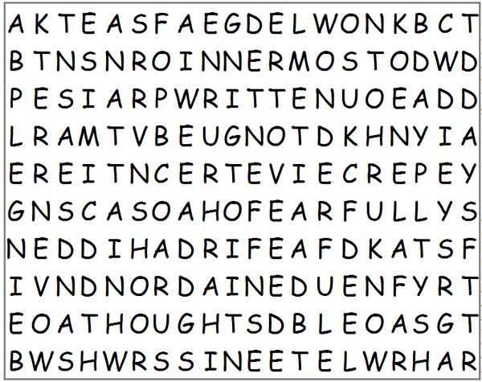



afar
attain
before
behind
being
book
days
discern
eyes
fearfully
frame
grains
hand
hidden
innermost
knit
know
knowledge
lofty
ordained
perceive
praise
precious
rise
sand
searched
sit
thoughts
tongue
vast
ways
wonderful
word
woven
written

