1. Motivate

What are some tools you rely on most days?
- computer
- cell phone
- Google
- washing machine
- dryer
- dishwasher
- vacuum cleaner
- calculator
- kitchen utensils
- stove, microwave
- woodworking tools
- mechanic’s tools

2. Transition

Most homes are well equipped with labor saving devices which enable us to perform our daily tasks
- We also need those things which enable us to live a victorious Christian life
- Today we study how God equips us for the spiritual battles we face.

3. Bible Study

3.1 We Are in a Spiritual Battle.

Listen for how we are at war.

Ephesians 6:10-13 (NIV) 10 Finally, be strong in the Lord and in his mighty power. 11 Put on the full armor of God so that you can take your stand against the devil's schemes. 12 For our struggle is not against flesh and blood, but against the rulers, against the authorities, against the powers of this dark world and against the spiritual forces of evil in the heavenly realms. 13 Therefore put on the full armor of God, so that when the day of evil comes, you may be able to stand your ground, and after you have done everything, to stand.

What would have to be their source of strength if the Ephesians were to be victorious in spiritual battle?
- be strong in the Lord
- depend on His mighty power
- put on the full armor of God
- then you can stand against the devil

What did Paul urge them to do?
- put on God’s full armor
- then you can stand against the devil’s schemes

What are words or phrases in this passage that describe our enemy?
- devil’s schemes
- not flesh and blood
- rulers, authorities, powers of this dark world
- spiritual forces of evil in heavenly realms

What are some kinds of things that would be included in the devil’s schemes to draw us into sin?
- lies to us
- makes bad things look good
- hide the end results of what he has for us
- disguise evil things
- repeatedly say things are good and OK when they are really evil
- bait and switch
- cause confusion
- get people mad at one another
- discourage people from serving God, from witnessing

What kinds of spiritual battles do believers face today?
- enslavement to substance abuse
- immorality (made to look OK in entertainment)
- discouragement, depression
- overcoming anger or any bad habit
- being drawn into gambling, materialism
- faithfulness in spending time with God (personal devotions, group worship)

What is the key to being “strong in the Lord and in his mighty power?”
- learn to depend on God
- don’t depend on self
- don’t depend on other people
- realize that His power is available
- realize that His power is sufficient, even superior

What are some actions, words, attitudes that help you do this before or during spiritual warfare?
- tell God every day that you are depending on Him
- memorize and/or study scriptures which remind you of God’s power, strength
- get into the habit at the beginning of each activity of asking for God’s strength as you begin
- listen to Christian music which keeps those themes running through your mind (instead of the drivel and/or evil lyrics of secular music)
- find a prayer partner with whom you can share needs and support for one another
- be quick to give God glory for answers to prayer, supply of needs

3.2 God Equips and Protects

Listen for description of armor and weapons.

Ephesians 6:14-17 (NIV) 14 Stand firm then, with the belt of truth buckled around your waist, with the breastplate of righteousness in place, 15 and with your feet fitted with the readiness that comes from the gospel of peace. 16 In addition to all this, take up the shield of faith, with which you can extinguish all the flaming arrows of the evil one. 17 Take the helmet of salvation and the sword of the Spirit, which is the word of God.

What defensive, offensive equipment do you see in the passage?
Defensive | Offensive
- belt of truth  - breastplate of righteousness  - shield of faith  - helmet of salvation | - shoes of the gospel (you can advance!)  - sword of the Spirit (the word of God)

For each of the pieces of equipment, what part of the body does it protect, what spiritual ability does it provide?
Armor | Physical area protected or capability provided | Spiritual protection or capability
helmet of salvation | the head, the brain | the mind
breastplate of righteousness | the chest, the heart | the emotions
shoes of the gospel | feet protected, firm footing, ability to advance, kick! | stand firm, enable attacks, advancement against Satan’s territory
sword of the Spirit (Scripture) | stab, slash, close infighting | use God’s word in teaching, preaching, witnessing
belt of truth | strap on armor, hold everything in place | truth anchors and holds everything in place
shield of faith | overall, all around protection | protection from whatever angle Satan attacks, keep an attitude of faith

You would not want to leave out any one piece of physical armor. What would happen if we left out one or more of the elements of spiritual armor?
Spiritual armor element | Problem when missing
Truth/scripture/gospel | absolute necessity; enables preaching, teaching, encouragement, promises
Faith | absolute necessity; only way of salvation
Righteousness | God’s righteousness protects our heart/emotions  Unprotected emotions can get us down, allow Satan to discourage
Salvation | God’s salvation protects our minds, our intellect  Unprotected mind can cause confusion, misdirection, allow Satan to easily fool us
How do we consciously “put on” this spiritual armor?
- choose to read, study, apply God’s word
- daily declare your faith in what God is telling you each day
- thank God for His righteousness, confess your inability to live a righteous life in your own strength
- daily tell God that you are receiving, applying His armor for your spiritual victories over Satan’s attacks

3.3 Military/Spiritual Communication

Listen for one more battle requirement.

Ephesians 6:18-20 (NIV) 18 And pray in the Spirit on all occasions with all kinds of prayers and requests. With this in mind, be alert and always keep on praying for all the saints. 19 Pray also for me, that whenever I open my mouth, words may be given me so that I will fearlessly make known the mystery of the gospel, 20 for which I am an ambassador in chains. Pray that I may declare it fearlessly, as I should.

What connections exists between these verses and verses 10-17?
- consider that soldiers need communications capabilities
- along with armor and weapons you would need communications
- prayer is that communication

What characteristics of prayer does Paul give us? How should we pray?
- in the Spirit
- on all occasions
- with all kinds of prayers
- with all kinds of requests
- pray with alertness
- always keep on praying

What did Paul want his speaking to accomplish?
- to make known the mystery of the Gospel
- to tell others the Truth about Jesus
- represent Jesus to unbelievers – an ambassador

What do you think it means to “pray in the Spirit?”
- let your prayers be guided by the Spirit
- allow God’s spirit to direct you what to pray about
- to pray over true Spiritual issues, not just selfish wants
- to pray concerning the spiritual battles (in the context of the passage)

What kinds of things could we pray about for other people, praying in the Spirit?
- for their salvation
- for spiritual struggles they have
Use the last page as a handout so your learners can take home the application points of this week’s lesson.
- for their ministries
- for wisdom, boldness, peace
- that they would be victorious in their Christian lives
Application

Take everything to God in prayer. Everything.
- Your victories begin with prayer.
- Make prayer a regular part of your day, knowing you need to continually look to God for strength.

Stand.
- If you find you’re susceptible to “the flaming arrows of the evil one”—his lies, doubts, and
- temptations—use God’s armor.
- Pick up the shield of faith in God’s promises and stand firm in Him.
- Identify several promises from God’s Word on which you can stand against spiritual attacks.

Stand together.
- Discuss ways to support and encourage each other in the spiritual battles you face.
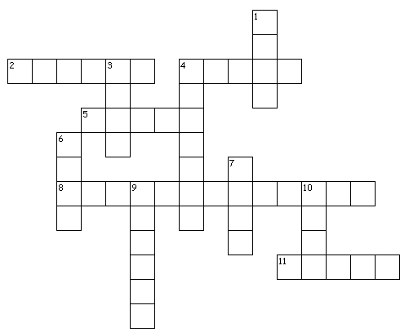
Spiritual Armor Crossword
Eph 6:10 – 20 (NIV)

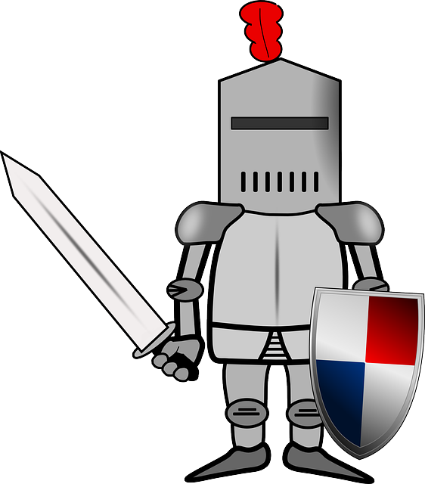
Down
1. we struggle against the powers of this _?_ world
3. be strong in the _?_
4. you need to stand against the devil's _?_
6. stand _?_ then ...
7. put on the _?_ armor of God
9. _?_ of salvation
10. we struggle with forces of _?_

Across
2. _?_ of faith
4. _?_ of the Spirit
5. belt of _?_
8. breastplate of _?_
11. our struggle is not against flesh and _?_
More Family Activites at http://tinyurl.com/ybstjhep

http://biblestudiesbysteve.com/SundaySchool/FamilyActivities/SpiritualArmor/index.htmhttp://biblestudiesbysteve.com/SundaySchool/FamilyActivities/SpiritualArmor/index.htm

