1. Motivate

What was the funniest time you were caught “red-handed”?
- hand in the cookie jar
- crumbs/jelly/lipstick on my face
- soaping someone’s window at Halloween
- trying to sneak in at night past curfew
- left muddy tracks on the floor
- icing on my fingers
- the gas tank was empty the next morning
- with my head in the fridge at 2:45 am

2. Transition

With God we will always be found out
- We deserve punishment
- But God forgives!

3. Bible Study

3.1 God is Judge, Not Us

Listen for a trap.

John 8:2-6 (NIV) At dawn he appeared again in the temple courts, where all the people gathered around him, and he sat down to teach them. 3 The teachers of the law and the Pharisees brought in a woman caught in adultery. They made her stand before the group 4 and said to Jesus, "Teacher, this woman was caught in the act of adultery. 5 In the Law Moses commanded us to stone such women. Now what do you say?" 6 They were using this question as a trap, in order to have a basis for accusing him. But Jesus bent down and started to write on the ground with his finger.

What did Jesus sit down to do in the temple courts?
- all the people gathered around him
- sat down
- began teaching

Whom did the Pharisees bring before Jesus?
- brought a woman caught in adultery
- made her stand before the group
- announced her sin
- noted the penalty stated in the Law of Moses
- asked Jesus to comment

How was this a trap?
- if Jesus said “stone her” it would be a violation of Roman law (only Roman courts could sentence to capital punishment)
- if He said “let her go” he would be condoning adultery
- they wanted to put Jesus in a “lose-lose” situation

How did Jesus respond to the Pharisees’ question? Why do you think He did this?
- initially he kept quiet
- kneeled down and began writing in the dust on the ground
- He seemed to let them stew, let them think about their accusation
- must have been a setup, so He let them think about why they were really confronting Him

Which sins do we tend to categorize as “big” sins (those that are worse than all others)?

- murder
- adultery
- crimes involving a gun or drugs or violence
- crimes involving a large amount of money
- actions that harm innocent people, children
- sexual abuse

Which sins do you think God classifies as “big” sins?
- any sin is a “big” sin
- any sin is rebellion against God
- sinfulness is a condition … all sinful actions are the result of our condition

Why do we tend to hope some people will be caught in their sin?
- their actions are egregious (shocking, appalling, terrible, awful, horrendous, frightful, atrocious, abominable, abhorrent, outrageous)
- they seem like they always get away with it
- we want justice for them (but mercy for ourselves … we may be bad, but not that bad)

Why is it necessary for sin to be punished?
- God is totally righteous, holy, separate
- Sin cannot exist in His presence
- it demands immediate punishment, judgment by death
- sin is rebellion against God and His law
Note that in some situations forgiveness will not include a renewed trust.

How should we treat people who have sinned?
- treat them as someone for whom Christ died
- point them to the only One who can truly forgive them
- Jesus said we should forgive them seventy times seven … many, many times

3.2 None Is Without Sin

Listen for Jesus’ response.

John 8:7-9 (NIV) When they kept on questioning him, he straightened up and said to them, "If any one of you is without sin, let him be the first to throw a stone at her." 8 Again he stooped down and wrote on the ground. 9 At this, those who heard began to go away one at a time, the older ones first, until only Jesus was left, with the woman still standing there.

Jesus said, “If any one of you is without sin, let him be the first to throw a stone” Why do you think Jesus responded this way?
- as experts in the Law, they were all aware of their own foibles (if they were honest with themselves)
- they knew (should have known) that any one sin is enough to classify a person as a “sinner”
- to God, there’s no difference between what we classify as big or little sins
- any sin deserves God’s judgment

How did the Pharisees respond to Jesus’ challenge?
- they seemed to be ashamed at what they had done and demanded
- they began to walk away
- the oldest went first, then the younger ones
- maybe the older ones realized they had more sins and were even less justified in making the charges

They are said to have left oldest to youngest. What do you think was the significance of this ordering?
- the older ones realized their own foibles or were willing to admit them
- the older men had had more opportunity to realize their own failures (sin) over the years
- older is often wiser … they caught Jesus point quicker
- younger is often brash and idealistic … takes longer to see our own mistakes

Why is it sometimes easier to see others’ sins more than our own?
- we wear moral “blinders”
- when you see/accuse someone else of something, it’s easier to forget your own issues
- we do a moral contrast, “I’m not so bad, look at that person”
- we don’t want to admit our own sin, but compensate by seeing/accusing others

About what do we tend to be self-righteous?
- church attendance
- participation in church activities (choir, usher, tithing, helping with SS, etc.)
- my “I ♥ my church” bumper sticker
- always carry my big Bible
- read it every day!

How should Jesus statement in verse 7 influence our everyday actions and attitudes?
- be more forgiving to others
- be more honest before God of our own failures (sins)
- be willing to confess, repent, and seek God’s forgiveness
- trust in, pay attention to God’s Holy Spirit who convinces (convicts) us of our actions even before we transgress

3.3 God Forgives by His Grace

Listen for Jesus response to the woman.

John 8:10-11 (NIV) Jesus straightened up and asked her, "Woman, where are they? Has no one condemned you?" 11 "No one, sir," she said. "Then neither do I condemn you," Jesus declared. "Go now and leave your life of sin."

What are Jesus’ comments to the lady after they are gone?
- where are your accusers
- I don’t accuse/condemn you either
- go and do not sin any more

Why might she have felt a sense of relief on the one hand but of concern on the other?
Relief | Concern
- I’ll not be stoned  - I’ve been set free from punishment  - those guys who trapped and accused me are gone | - what I did was still wrong  - not easy to leave sinful ways  - still have to deal with the results of sinful choices

Think about a time when you got a second chance, a chance to start over. How did it make you feel?
- relieved
- encouraged God offers that to us today, no matter what we’ve done
- thankful

What was the heart of Jesus’ message for the woman?
- even though sin is wrong and harmful, forgiveness is available
- everyone has sin in their lives, but Jesus offers forgiveness and a restored relationship
- some of the results of the sin may remain, but God can redeem, free us from the slavery to the sin

What opportunities do we have to extend God’s grace instead of condemnation?
- with our children
- with other family members
- with someone who is on the fringe of our church family
- with fellow workers who have wronged us

What is the relationship between forgiveness and right living?
- we are not forgiven so we can keep on sinning
- we are forgiven to be set free from both sin’s penalty and sin’s power over us
- we are offered the strength to live a life free from sin through the power of the Holy Spirit within us

Page 5 is a handout that learners can take with them as a reminder of the lesson application. A word puzzle is also included to engage them further in the lesson concepts.

Application
Confess your sin
- Is a certain sin of yours weighing on you mind and spirit?
- Confess … agree with God, “this is sin”
- Receive by faith His forgiveness and strength to turn away from this action or attitude

Forsake condemnation
- Do you find yourself hoping someone will “really pay for what they did”?
- Ask God to search your heart for a spirit of condemnation
- Respond to what God shows you, seek His forgiveness

Be an agent of forgiveness
- Condemnation can destroy relationships
- Offer yourself to God this week as His instrument to bring forgiveness and reconciliation to a relationship that is broken

Forgiveness Puzzle
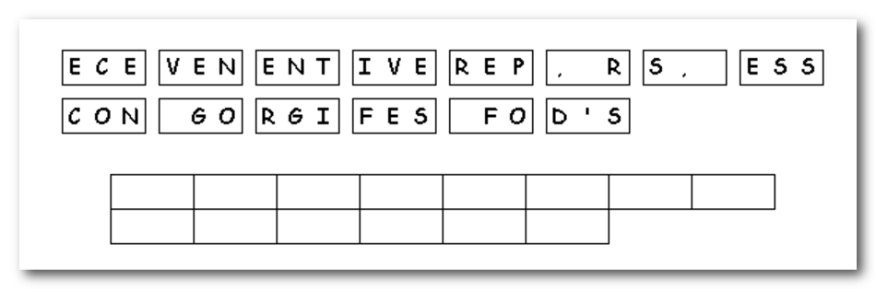
Unscramble the 3-letter tiles to reveal a message.

