1. Motivate

What are some of the most unusual phobias you’ve heard about?
- spiders
- snakes
- Friday the 13th
- fear of cheese
- Somniphobia- fear of falling asleep. ...
- Coulrophobia – fear of clowns. ...
- Hylophobia- fear of trees. ...
- Omphalophobia- fear of the navel. ...
- Nomophobia- fear of being without mobile phone coverage. ...
- Ombrophobia- fear of rain.
- see www.phobialist.com 350+ phobias listed

2. Transition

Some phobias seem silly … yet our fears can be very real and can hinder our lives
- Today we look at what John had to say about hindering spirits and forces in our lives
- We don’t need to fear evil forces when we’re in Christ.

3. Bible Study

3.1 God’s Spirit in Believers

Listen for commands.

1 John 3:23-24 (NIV) And this is his command: to believe in the name of his Son, Jesus Christ, and to love one another as he commanded us. 24 Those who obey his commands live in him, and he in them. And this is how we know that he lives in us: We know it by the Spirit he gave us.

What is God’s command?
- believe in the name of God’s Son
- believe in the name Jesus Christ
- love one another

What does it mean to “believe in the name of Jesus Christ”?
- believe in the authority of the name
- receive by faith who Jesus is
- that He is God and he is man … both at the same time
- receive by faith what He has done
- to put your belief on Jesus in the sense of trusting in Him,
- relying on Him, and clinging to Jesus.
- It isn't about intellectual knowledge or understanding, it is about trust.

What is the result when we obey God’s command, believe in the name of Christ?
- we live in Him
- He lives in us
- we receive the Holy Spirit who dwells within the life of the believer

3.2 Test the Spirits

Listen for criteria to judge.

1 John 4:1-3 (NIV) Dear friends, do not believe every spirit, but test the spirits to see whether they are from God, because many false prophets have gone out into the world. 2 This is how you can recognize the Spirit of God: Every spirit that acknowledges that Jesus Christ has come in the flesh is from God, 3 but every spirit that does not acknowledge Jesus is not from God. This is the spirit of the antichrist, which you have heard is coming and even now is already in the world.

What did John instruct his readers to do?
- do not believe in every spirit
- test the spirits
- see if they are from God

John goes on to warn about false prophets in the world. Considering this warning along with our previous recent studies on spirits, what do you think He means by the phrase “test the spirits”?
- could mean the general attitudes and spirit of thinking
- could mean evil spirits we studied about
- actually the Greek word for spirit is the same one used to describe evil spirits
- note that John proceeds directly spirits to the false prophets
- he believed that false prophets were influenced, even controlled by evil spirits

How can we distinguish truth from error in spiritual matters? How do we “test the spirits”?
- compare/contrast what they say with what scripture teaches
- if they make predictions, do they come true always … 100% accuracy
- Old Testament criteria was that if a prophet makes a prediction that does not come true, he is a false prophet (Deut. 18:22).
- test means, “to prove or to examine.”
- examine messages to see if they are from God.
- examine sources behind messages, don’t accept without questioning

According to this passage, what is the so called “litmus test” to recognize the Spirit of God?
- does the spirit acknowledge that “Jesus Christ has come in the flesh”
- if yes, the message is from God’s Holy Spirit
- if no, the message is from the spirit of the antichrist

How does this tie in with the verses we just looked at from end of chapter 3?
- believe in the authority of the name of Jesus
- receive by faith who Jesus is
- that He is God and he is man … both at the same time

Why is this fact important … what if Jesus was only God or only man?

If Jesus was only human
- would have had to die for his own sins
- could not die a substitutionary death
- all humans are born sinful

If Jesus was only God, not a man
- could not live a sinless life as a human
- could not die a substitutionary death this way either

Note some modern examples of groups who spread false teachings regarding the full humanity and full divinity of Jesus:
- Mormonism
- Jehovah’s Witnesses
- Islam
- Hinduism

Common characteristics of cults – false spirits … signified by math symbols
- + They add to Scripture
- - The subtract from the deity of Christ
- × They multiply the importance of works
- ÷ They are divisive, causing divisions in families, among friends, separating their adherents from other belief systems

What spirits should we be testing today? What false prophets are in the world today?
- biased news media
- statements by politicians
- people claiming to be prophets
- anyone who preaches, adheres to beliefs other than Scripture
- those who advocate policies and practices that are contrary to Scripture
- entertainment that advocates immoral, ungodly attitudes and activities

What is there about these influences that could classify them as “false prophets”?
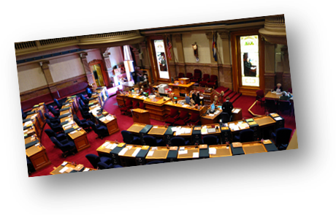

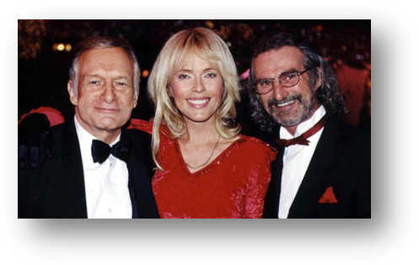
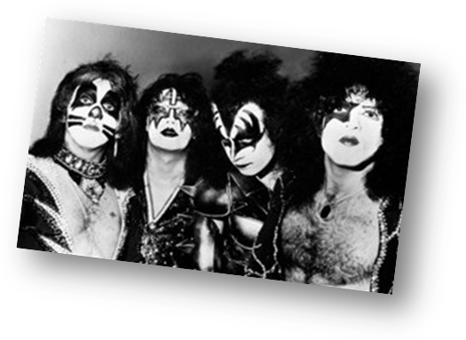

3.3 God Is Greater

Listen for words of hope.

1 John 4:4-6 (NIV) 4 You, dear children, are from God and have overcome them, because the one who is in you is greater than the one who is in the world. 5 They are from the world and therefore speak from the viewpoint of the world, and the world listens to them. 6 We are from God, and whoever knows God listens to us; but whoever is not from God does not listen to us. This is how we recognize the Spirit of truth and the spirit of falsehood.

What evident truths did John identify to encourage his readers to continue to resist false teachers?
- you are from God
- you have (God living through you has) overcome the world’s philosophies
- greater is the One who is in you than the one who is in the world

Between what two spirits must we choose in considering the direction of our lives?
- spirit of the world
- Holy Spirit of God

Contrast the two philosophies … that of the world and those who belong to God.

World View
- from the world
- speak from a worldly viewpoint
- unbelievers listen to an heed these spirits
- does not listen to Biblical view
- spirit of falsehood

Believers’ View
- from God
- knows God
- listens to God’s Holy Spirit
- heeds the teaching of Scripture
- pay attention to the Spirit of Truth

Jesus is greater than those who oppose us. How will this truth influence your life?
- base my life on that reality
- trust God when facing opposition
- pray for believers who are in actual life and death danger because of their faith in Christ
- read, study, meditate on Scripture’s teaching of God’s power, authority, love for me

Use the last page as a handout so your learners can take home the application points of this week’s lesson.
Answer to Fallen Phrase: The Spirit who lives in you is greater than the spirit who lives in the world.

Application
Memorize.
- If you are prone to fear, memorize 1 John 4:4.
- Place cards with this verse in various places where you will see them throughout the day. Make the verse the lock screen on your phone.
- Do this until you have memorized the verse, and recite the verse whenever you feel afraid.

Be filled.
- God has placed His Holy Spirit in your life.
- Continually rely on His indwelling Spirit to fill you, lead you, and give you discernment.

Be discerning.
- Regularly evaluate the different “voices” you encounter in books, sermons, studies, and online devotions and articles.
- Determine what they believe about Christ and to what degree they lift up and honor the name of Christ.
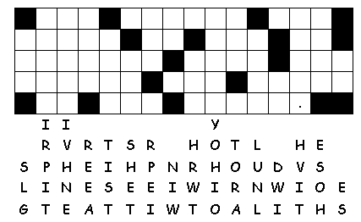
I N
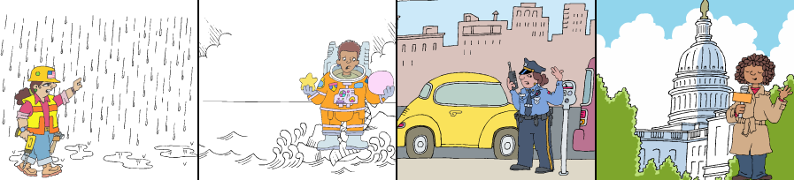
Fallen Phrase Puzzle
The first step is to fill in any blank spaces with just one letter underneath. This one doesn’t seem to have any. ☹
Next look for common one- , two- , or three-letter words. There are several here
A fallen phrase puzzle is a puzzle where all the letters have fallen to the bottom. However, they got mixed up on their way down, but remain in the same row.
It’s a good idea to cross out letters as you use them.
More activities at http://tinyurl.com/y88wurx6
/
/

