1. Motivate

What is the silliest argument you were ever a part of?
- color of the paint
- how to get to a certain place
- which was the nicest tie to wear with that suit
- what was the best movie to go see
- who had the best team
- who caught the biggest fish last year
- was the call of the referee right or wrong

2. Transition

We typically assume conflict involves a “good guy” and a “bad guy,”
- But conflict does not always mean someone is in the wrong.
- Today we look at how conflict can arise because of different priorities

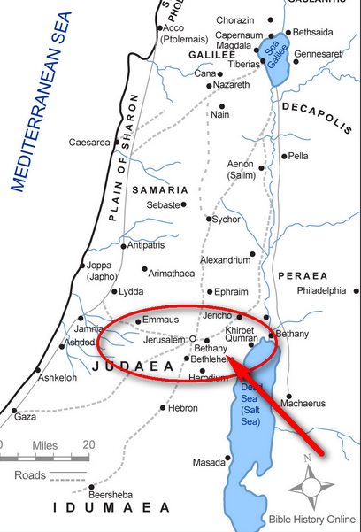
3. Bible Study

3.1 Jesus Visits a Home

Listen for who entertains Jesus.

Luke 9:51 (NIV) As the time approached for him to be taken up to heaven, Jesus resolutely set out for Jerusalem. … 10:38As Jesus and his disciples were on their way, he came to a village where a woman named Martha opened her home to him.

Note the geography of this story
- Jesus on the way to Jerusalem, ultimately to the cross
- They stop at a friend’s house a little bit outside of Jerusalem

What is your home like shortly before guests arrive? What kinds of things would Martha have been doing before or when Jesus arrived?
- cleaning
- straightening up
- make sure yard looks good
- put away stuff
- cooking
- sweeping
- tidying up
- setting the table

Think about why hospitality was important, especially in Bible times?
- a trip to a distant place took many days
- hotels and inns were few and/or expensive
- a traveler needed room, board, and protection
What do you enjoy about formal or informal dinners?
- good food
- good fellowship
- renew old friendships
- learn what is happening in their lives
- meet new and interesting people

When you have guests, what stresses you the most?
- Worrying about making sure you have made all the necessary preparations
- Wanting everything to be perfect and nothing will go wrong
- Making sure you have enough food
- Maybe special dietary needs (allergies) of your guests
- seating the right people together

- Serving is a good thing … but sometimes doing a good thing can get in the way of doing something better

3.2 Difference of Opinion

Listen for Martha’s complaint.

Luke 10:39-40 (NIV) She had a sister called Mary, who sat at the Lord's feet listening to what he said. [40] But Martha was distracted by all the preparations that had to be made. She came to him and asked, "Lord, don't you care that my sister has left me to do the work by myself? Tell her to help me!"

Mary was Martha’s sister. Where was Mary while Jesus was talking?
- sat at Jesus’ feet
- listening to what Jesus said
- enjoyed Jesus teaching

What did Martha do while Mary listened to Jesus’ teachings?
- distracted, not sitting and listening
- involved in preparations
- cooking
- probably getting on a good mad

What are some words and phrases that would describe the “Marthas” (male and female) that you know?
- focused on the details of entertaining
- a neat freak
- not so much a people person
- concerned more about appearances
- a detail person
- very organized
- wants everyone else to be similarly organized and busy

How about describing the “Marys” you know?
- not so concerned about stuff
- easily distracted
- interested in ideas, not in physical details
- oblivious as to how things get taken care of
- sometimes you feel the person is clueless about real life

If you had been Martha in this situation, how would you have reacted to your sister’s choice to sit and just listen to Jesus?
- upset
- angered at being left to handle preparations on your own
- she’s lazy
- she’s just trying to get out of work
- who does she think she is?

Of what did Martha accuse Jesus?
- said Jesus didn’t care
- He wasn’t concerned about the inequity of the workload
- maybe didn’t even notice that Mary wasn’t helping
- said He should tell her to get up and help

The conflict boils down to a difference of priorities. Contrast the different priorities and attitudes we find in these verses.
Mary | Martha
- sat at the Lord’s feet,” listening to what He said  - prioritized the time with Jesus  - focuses on knowing Truth  - entertainment, hospitality involves good communication  - details cold wait until they finished listening to Jesus | - busy preparing for Jesus’ coming and all the things He would need while there.  - her job as a hostess, and worried tasks would be left undone without Mary’s assistance  - preparations for His stay in their home  - decided that her priority needed to be everyone’s priority.

What task(s) or activities can take you away from your relationship with Christ?
- cleaning
- even your job
- taking care of your vehicle
- recreation
- TV
- taxiing your kids around
- involvement with all the kids activities

⇒ Note, these are often good things … well worth doing … they just require making the right thing or the right person the priority

3.3 Priorities

Listen for Jesus response to Martha’s complaint.

Luke 10:41-42 (NIV) "Martha, Martha," the Lord answered, "you are worried and upset about many things, [42] but only one thing is needed. Mary has chosen what is better, and it will not be taken away from her."

How did Jesus try to calm down Martha?
- noted her concern
- pointed out He was aware of her feelings … “worried and upset”
- suggested her concerns were unfounded
- said the one thing was needed was what Mary had chosen

What do you think Jesus meant when He said that “only one thing is needed”?
- Martha was worried about many details, “many things”
- Jesus implies that these are not as important as she thinks
- the one thing was to be interested and focused on Kingdom ministries
- her priority should have been learning spiritual truths

How can our responsibilities sometimes lead to conflict?
- our different personalities and priorities are sometimes in conflict
- each task for which we feel responsibility can be a good thing
- the priority God gives to one person might well not be the same priority for others
- we can easily feel that our “truth” is ultimate … it is not!
- differences in opinion or differences in priorities become a spiritual issue, rather than finding a practical balance

Why is spending time in personal study not always the best thing to do when there’s work to be done?
- you can work at acting so spiritual, that you are no earthly good
- the work might be very critical, very important it’s important to be able to make the value judgment between which must take priority
- need to be more flexible … learn to adjust your schedule to fit the context of what is going on

What must you consider when deciding between good, better, and best?
- who is affected
- what will be the effect on different people
- we often us the phrase, “What would Jesus do?”
- is it a matter of timing?
- as the Lord to help you see what your priority should be

What happens when we embrace God’s priorities in our lives?
- peace, less conflict
- God’s tasks for us get done more effectively
- we are closer to God and closer to fellow believers
- unity of the Body of Christ … the Church
4. Application

4.1 Serving the Lord is a good thing.
- Ask God to give you wisdom on when and how to go about that service
- Be aware of other people or situations that need our attention
- Be sensitive this week to the difference of what is good and what is better to be doing

4.2 Your priorities might well be different from someone else’s
- Ask God to help you have the right priorities.
- Also ask Him for insight on how you deal with differing priorities.

4.3 Discipleship includes learning of, learning from Jesus
- These lessons cannot be taken from you
- When you find yourself in conflict with another believer, know that it can be settled by coming together in Jesus’ presence

