1. Motivate

What do you typically do when you feel afraid?
- whistle a happy tune
- turn on all the lights
- get my gun
- pray
- decide to wake up from my bad dream
- “when you worry, when you doubt, run in circles, scream and shout”
- break into a sweat
- cry
- nervous laughter
- get goosebumps
- faint

Note to teachers about this subject: C.S. Lewis stated that there are two errors we commonly fall into concerning the subject of evil spirits.
1. The first is to disbelieve in their existence
2. The second is to feel an excessive and unhealthy interest in them

My theology professor would spend extra time in prayer when he approached lectures on this topic. We need to face this lesson with a sense of seriousness and special dependence on God’s power to reveal and apply His Truth.

2. Transition

Some of our fears are imagined, some are real.
- Today we consider how demonic forces are real
- We will also learn that Christ is greater.

3. Bible Study

3.1 Demons Seek to Destroy Us

Listen for actions of the evil spirit.

Mark 9:17-22 (NIV) 17 A man in the crowd answered, "Teacher, I brought you my son, who is possessed by a spirit that has robbed him of speech. 18 Whenever it seizes him, it throws him to the ground. He foams at the mouth, gnashes his teeth and becomes rigid. I asked your disciples to drive out the spirit, but they could not." 19 "O unbelieving generation," Jesus replied, "how long shall I stay with you? How long shall I put up with you? Bring the boy to me." 20 So they brought him. When the spirit saw Jesus, it immediately threw the boy into a convulsion. He fell to the ground and rolled around, foaming at the mouth. 21 Jesus asked the boy's father, "How long has he been like this?" "From childhood," he answered. 22 "It has often thrown him into fire or water to kill him.

A man describes a problem with his son. What had the evil spirit done to this boy?
- robbed the boy of ability to speak, seized him, threw him to the ground
- the boy foams at the mouth, gnashes his teeth, becomes rigid (sounds like what we might term a seizure)
- would often throw him into water or fire … try to kill the boy

Previous verses mention an argument. What does the man say about the disagreement?
- the man had asked the disciples to drive out the spirit, they could not
- he teachers of the law had been arguing with the man and with the disciples about the problem

What are some words and phrases you read that describe Jesus felt at this point?
- they were an unbelieving generation
- Jesus laments “how long shall I stay with you?”
- “how long shall I put up with you”
Explain what Jesus means by his questions in v. 19 "how long shall I stay with you? How long shall I put up with you?”
- expressing frustration
- knowing that his time on earth was limited
- thinking about how much training, teaching they still needed
- concerned that they learn all the lessons before He went back to heaven

Consider who Jesus was referring to when He said: “You unbelieving generation.” Describe how each of these groups could be classified as unbelieving.
Crowds | Religious Leaders | Disciples
- maybe didn’t know enough to believe  - just plain ignorant  - they were there for the exhibition | - saw Jesus as a threat to their authority  - thought He was merely someone trying to grab attention  - determined not to believe | - still learning  - still needing to become more informed  - needed to become totally convinced  - wanting to do the right thing, but doing it in their own strength

In what ways do you think we are an "unbelieving generation" like the people of Jesus’ day?
- not totally convinced about God at work in our lives
- don’t realized the power, the authority, the love for us that God has
- we are a generation of “humanists”
- we look to solve our own problems – Google the internet for the answer
- go to God only as a last resort

What evidence do you see of demonic activity in today’s world?
- the hatred and deceit that are demonstrated in the political arena
- the control that substance abuse has over people
- the decline of morals in our culture
- the rise of anti-Christian attitudes and actions … around the world and in our own society
- the worship of materialism – our “stuff” becomes our idols

3.2 Christ’s Authority over Demons

Listen for a confession.

Mark 9:22b-27 (NIV) But if you can do anything, take pity on us and help us." 23 "'If you can'?" said Jesus. "Everything is possible for him who believes." 24 Immediately the boy's father exclaimed, "I do believe; help me overcome my unbelief!" 25 When Jesus saw that a crowd was running to the scene, he rebuked the evil spirit. "You deaf and mute spirit," he said, "I command you, come out of him and never enter him again." 26 The spirit shrieked, convulsed him violently and came out. The boy looked so much like a corpse that many said, "He's dead." 27 But Jesus took him by the hand and lifted him to his feet, and he stood up.
The father prefaces his request “if you can do anything…” Why would he have had doubts about Jesus’ ability?
- he had already made the same requests to the disciples
- they had failed … not sure if Jesus was any more capable
- the religious leaders were there, they hadn’t been much help either

What was Jesus’ admonition to the man?
- “what do you mean ‘if’ ?
- everything is possible
- possible if you believe

What was the father’s response?
- I do believe
- help me overcome my unbelief

How can the father (and we) have both faith and unbelief at the same time?
- we read the verses and agree with them …
- we say, “yes, that’s what it says”
- still we have doubts, we have qualifications
- we don’t know how or when God might act and we want it done now and want it to be resolved in a certain way
- we are not convince of God’s power, authority, love for us
- Jesus did miracles then, will He still do them today? for me?

When have you felt like the father— wanting to believe but struggling with it?
In what area of your life do you struggle with doubt?
- health issues
- our children’s struggles in school
- when our teenagers seem to rebel
- job security, finances
- security of our relationships
- the screwy political situation
- apparent dominance of evil in the world, in our own society

How can we be strengthened as a result of this admission of unbelief?
- it is a confession of the sin of unbelief
- Consider 1 John 1:8-9 (NIV) If we claim to be without sin, we deceive ourselves and the truth is not in us. 9 If we confess our sins, he is faithful and just and will forgive us our sins and purify us from all unrighteousness.
- note that the man also asked Jesus to restore his faith, his ability to trust God
- he was both confessing and repenting … turning away from unbelief, turning to an attitude of trust in God

3.3 Faith and Dependence on Christ

Listen for the need to pray.

Mark 9:28-29 (NIV) 28 After Jesus had gone indoors, his disciples asked him privately, "Why couldn't we drive it out?" 29 He replied, "This kind can come out only by prayer."

What do you suppose they had been doing, instead of prayer?
- just demanding of or yelling at the spirit
- maybe telling the boy to “just believe”
- telling the father “you have to believe”
- they might have been trying different combinations of what they had heard Jesus do
- trying to do it on their own, without calling on God to do it

Why is faith in Jesus essential when dealing with evil?
- it is faith in God’s power, authority
- it is faith in God’s holiness, righteousness/justice
- faith in what God says, His promises
- belief in God’s ultimate victory over evil
- belief in the fact that Jesus’ death and resurrection has doomed Satan and his demons

Contrast the practical differences between trying to fight evil on our own versus allowing Jesus to fight for us?
Fighting on your own | Allow Jesus to fight for you
- work harder  - research on the internet  - find a different doctor  - read a different book  - spend more time studying the problem  - hire a counselor | - tell Jesus you are trusting Him  - daily reading from, meditating on God’s Word  - spending more time in prayer  - join with others in prayer, having an accountability partner

In what areas of life do you think we fail to see success because we do not pray?
- relationships
- spiritual struggles
- struggles with unhealthy or sinful habits
Use the last page as a handout so your learners can take home the application points of this week’s lesson.
- worry
- anger

How can you become more dedicated to prayer?
- set aside a time every day to read God’s Word and pray
- use a notebook to keep track of prayer requests and answers to prayer
- use the A.C.T.S. pattern of prayer … Adoration, Confession, Thanksgiving, Supplications (specific requests)
- don’t pray in broad generalities (“Lord bless all those missionaries overseas”)
- pray specifically (“Lord, Sue and Dave Smith in Africa are traveling today, watch over them and use them to draw people to the Savior”)

Application
Pray.
- Ask God to increase and strengthen your faith.
- Make it a habit to ask God to strengthen your faith and guide you into a deeper truth in Him.

Pray.
- Stop relying on yourself as you face difficulties and spiritual attacks.
- Express your total dependence on God through prayer.

Pray.
- Invite the presence of Jesus into every situation.
- In the passage from Mark 9, we see that the demon’s work in the boy’s life dominated the crowd, the disciples, the father, and his son—until Jesus showed up.
- He has all authority and all power no matter the spiritual attack you are under.
Mark 9 Word Search
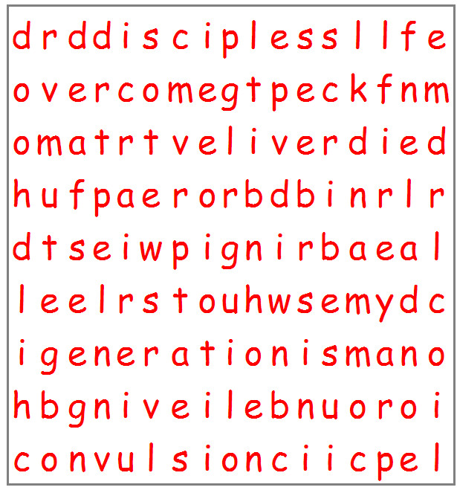
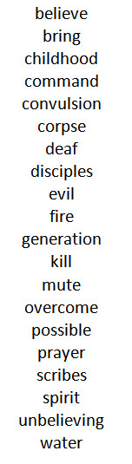

More activities at http://tinyurl.com/y8ltzlyd

