1. Motivate

What’s something you enjoy doing so much that you lose track of time?
- video games
- social media
- TV
- cooking
- hobby – painting, knitting, woodcarving, fishing, golf, …
- conversation – on the phone, over the back fence, texting
- gardening
A video for the lesson introduction is available.
View at https://watch.liberty.edu/media/t/1_hr1oftqn
Download from https://tinyurl.com/yxhynvju
- surfing the internet
- reading a good book

2. Transition

How you use your time is a commentary on what is important to you.
- Today we consider the importance of worship in our lives
- God calls us to live our lives as an act of worship.

3. Bible Study

3.1 Worship – Sacrifice and Obedience

Listen for extravagance of worship.

2 Chronicles 15:10-15 (NIV) They assembled at Jerusalem in the third month of the fifteenth year of Asa's reign. 11 At that time they sacrificed to the LORD seven hundred head of cattle and seven thousand sheep and goats from the plunder they had brought back. 12 They entered into a covenant to seek the LORD, the God of their fathers, with all their heart and soul. 13 All who would not seek the LORD, the God of Israel, were to be put to death, whether small or great, man or woman. 14 They took an oath to the LORD with loud acclamation, with shouting and with trumpets and horns. 15 All Judah rejoiced about the oath because they had sworn it wholeheartedly. They sought God eagerly, and he was found by them. So the LORD gave them rest on every side.

What was extravagant about the numbers of the animals sacrificed? What was the source of the offerings they sacrificed unto the Lord?
- 700 head of cattle
- 7000 sheep and goats
- was from the plunder they brought back from their recent military victory
- they offered to God that which He had enabled them to capture

Note when the people gathered in Jerusalem and the significance of it being the third month?
- third month of fifteenth year of Asa’s reign
- coincided with one of God’s specified times of worship
- about same time as Feast of Weeks or Firstfruits
- at time of harvest

What were elements of the covenant they entered into? Through what practices did they affirm their commitment to the covenant agreement and declare their loyalty to the Lord?
- promised to seek the Lord
- seek with all their heart and soul
- took an oath to Jehovah
- included loud acclamation , shouting, trumpets and horns
- all who resisted or refused were to be put to death

How did the Lord respond to them?
- they sought God eagerly and He was found by them
- God gave them rest on every side

What do you think it means for us today to “seek God eagerly”?
- communicate daily with God
- read God’s Word
- meditate on what it says and apply it to your life

What does it look like to worship God with both your mind and heart?
- talk to God – praise Him, thank Him, tell Him your joys and sorrows and problems
- tell God you are trusting Him
- be consciously looking for ways you see God at work all around you … from the beauty of creation to the answers to our prayers

Worship of God includes giving unto Him from all the resources with which He has blessed us. What are resources from which we can give to God?
- finances
- time
- energy
- skills
- use of our possessions – home, tools, vehicles, etc. – to serve God

How can believers demonstrate the seriousness of their commitment to Christ?
- base your daily choices of how you live on God’s Truth, God’s commands
- live by the principles established in Scripture
- Go to God with joys and sorrows
- trust Him for guidance
- your choices and actions may go counter to culture and society
- God’s way of living is primary in your life

3.2 Focus on God Alone

Listen for how Asa was totally committed.

2 Chronicles 15:16-19 (NIV) King Asa also deposed his grandmother Maacah from her position as queen mother, because she had made a repulsive Asherah pole. Asa cut the pole down, broke it up and burned it in the Kidron Valley. 17 Although he did not remove the high places from Israel, Asa's heart was fully committed [to the LORD] all his life. 18 He brought into the temple of God the silver and gold and the articles that he and his father had dedicated. 19 There was no more war until the thirty-fifth year of Asa's reign.
What or who could have been one major, personal challenge Asa faced in carrying out his reform?
- his grandmother – the “queen mother”
- apparently had significant influence in that role
- she continued to worship the goddess Asherah
- had a repulsive idol pole

So, what did Asa do to his grandmother?
- deposed her from her position
- cut down her idol pole
- broke it up, burned it in the Kidron Valley

Why would such action be necessary?
- in her position as queen mother she had influence
- the influence was pagan
- would mislead some of the people
- if King Asa let it be, it would appear he was condoning her actions, endorsing them

What additional actions of worship did Asa carried out?
- brought into the temple silver and gold articles
- items he and his father had dedicated
- vs. 17 says his heart was fully committed to the Lord all his life

What evidence is there that the Lord accepted Asa’s worship?
- a protracted time of peace, lack of war
- no more war until 35th year of his reign – 20 years of peace

What is our responsibility to help our family members be wholehearted followers of the Lord? How should we respond to family members who don’t follow the Lord?
- prayer for them
- witness to them
- model the Christian life before them
- follow the admonition of Deut. 6: 6-9 (MSG) Write these commandments that I’ve given you today on your hearts. Get them inside of you and then get them inside your children. Talk about them wherever you are, sitting at home or walking in the street; talk about them from the time you get up in the morning to when you fall into bed at night. Tie them on your hands and foreheads as a reminder; inscribe them on the doorposts of your homes and on your city gates.

How can we identify and remove idols from our lives?
- ask God to show you elements of your life that have become more important to you than He is
- Confess this as sin, agree with God that it is sin
- repent from these actions and attitudes … turn away from them, turn to God
- ask God for the strength to give these things up
- replace these actions and attitudes with seeking God, worshiping Him, doing His will, serving Him

How can authentic worship happen beyond Sunday?
- daily reading, heeding God’s Truth
- make sure that your prayer time is more than just listing all your needs and burdens
- follow the ACTS acronym for prayer
  - Adoration of God
  - Confession of sins, failures
  - Thanks to God for His blessings, His answers to prayer
  - Supplications – requests for your needs, the needs of others

How does your giving express your worship to God? How does it bring you joy?
- demonstrates faith
- says you are willing to trust God to meet your needs despite living on 90% of income or less
- says you are interested in furthering the Kingdom of God
- gives “feet” to your prayers for various ministries – missions, outreach, evangelism

What are some of the greatest challenges to your worship of the Lord?
- busyness of daily life
- finding time to be alone with God
- distractions
  - TV,
  - social media,
  - family responsibilities
  - work responsibilities

How can we overcome these challenges and distractions?
- make the decision to make time for God
- set aside some of these distractions
- consider it a “fasting” of TV watching or social media
- give up one or more of your normal activities in order to make time and space for God in your life

Use the last page as a handout so your learners can take home the application points of this week’s lesson.

Application
Memorize.
- Memorize Psalm 105:4: “Look to the Lord and his strength; seek his face always.”
- Let the challenge of that verse become second nature to you.

Take inventory.
- During the coming week, take note of the things that distract you on a daily basis.
- Beside each item on your list, note practical steps you can take to avoid these distractions.

Share.
- Talk with a trusted friend about the things that tend to pull you away from wholehearted worship.
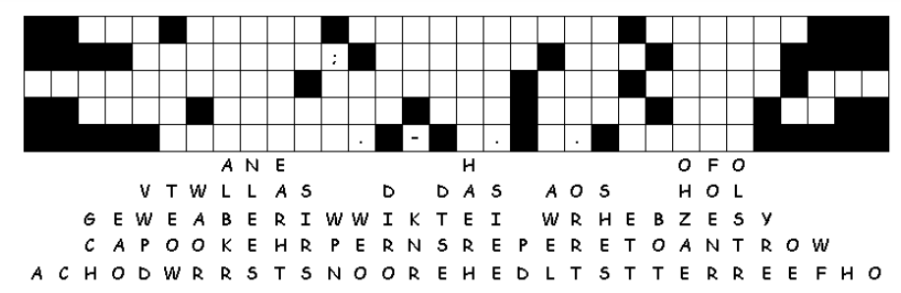
- Ask them to hold you accountable to stay away from away distractions and to covenant with you to pray.
Just look at the mess. The letters have fallen out of their columns straight down. And let me tell you, there’s something important there about worship. Replacing some letters are easy to figure out, like where there’s only one blank in that column. Look for two or three letter words and figure what two or three letters in those columns make a sensible word. If you get stuck, you can find help at https://tinyurl.com/yxhynvju There’s other fun Family Activities there also.
