1. Motivate

What makes forbidden things so tempting?
- the very fact that you are not supposed to do something is an in-your-face challenge to do it

- we think about how much we want what is forbidden
- we think it is unfair that it is forbidden
- we believe it really doesn’t apply to us … we will be able to handle the “forbiddenness” of it
- maybe it really isn’t bad, someone else just made a mistaken rule

2. Transition

Temptations come at us from many directions
- Our inborn sinful nature is why we so easily fall into temptation
- Today we study how the opportunity for a perfect relationship with God has been ruined because of sin.

3. Bible Study

3.1 Sin – Failure to Keep God’s Commands

Listen for sneaky questions.

Genesis 3:1-7 (NIV) Now the serpent was more crafty than any of the wild animals the LORD God had made. He said to the woman, "Did God really say, 'You must not eat from any tree in the garden'?" 2 The woman said to the serpent, "We may eat fruit from the trees in the garden, 3 but God did say, 'You must not eat fruit from the tree that is in the middle of the garden, and you must not touch it, or you will die.'" 4 "You will not surely die," the serpent said to the woman. 5 "For God knows that when you eat of it your eyes will be opened, and you will be like God, knowing good and evil." 6 When the woman saw that the fruit of the tree was good for food and pleasing to the eye, and also desirable for gaining wisdom, she took some and ate it. She also gave some to her husband, who was with her, and he ate it. 7 Then the eyes of both of them were opened, and they realized they were naked; so they sewed fig leaves together and made coverings for themselves.

What did the serpent ask the woman
- he questioned what God “really” said
- distorted what God’s command was
- suggested God had forbidden all the trees

How did Satan’s version of what God said differ from what God actually said?
Satan’s version | God’s version
"Did God really say, 'You must not eat from any tree in the garden'?" | "We may eat fruit from the trees in the garden, … God did say, 'You must not eat fruit from the tree that is in the middle of the garden, and you must not touch it, or you will die.' "

Why did the serpent say that God did not want the woman to eat the forbidden fruit?
- surely you won’t die
- God knows that when you eat from that tree your eyes will be opened
- you will be like God
- you will know good and evil

How did she change her opinion of the forbidden fruit?
- she saw it was good for food
- it looked good
- she desired to gain wisdom
- so she ate it
- she gave some to Adam and he ate it

How does Satan distort the truth today?
- what’s wrong with getting a little “gusto” … go ahead and have that drink
- have another doughnut … it’s got a hole in it .. it’s mostly air
- if you really love each other it must be OK
- every one’s doing it … how can they all be wrong
- your parents are really old and don’t understand modern ways
- no one’s looking … go ahead … if no one sees you do it, then you aren’t caught (and it’s not so bad)

What people, situations, fears, pressures prompt a person to rebel against God today?
- anger
- friends tempt us to go along
- we are afraid we will be unpopular
- we fear we will miss some pleasure we’ve been wanting
- we want our own way – we don’t want to be controlled by someone else … even if it’s God

Why do we pick and choose which of God’s commands to obey?
- then we can say we did the right thing in all these other situations
- we want to balance all the good things against the few little bad things

Paul said, “But when you are tempted, he will also provide a way out so that you can stand up under it.” 1 Cor. 10:13 (NIV) How can we recognize these places of escape from Satan’s temptations?
- scripture memorization can bring the right thoughts to our minds
- the earliest point of escape is not to go near the temptation to start with
- focus on Jesus, not on how tempting something is
- what you fill your mind with on a daily basis is important … doesn’t give Satan the same odds
- be on very familiar speaking terms with the Lord … just like you recognize someone’s voice on the phone, you recognize (and listen to) his voice speaking to you

3.2 Serpent Ultimately Defeated

Listen for God’s judgment.

Genesis 3:14-15 (NIV) So the LORD God said to the serpent, "Because you have done this, "Cursed are you above all the livestock and all the wild animals! You will crawl on your belly and you will eat dust all the days of your life. 15 And I will put enmity between you and the woman, and between your offspring and hers; he will crush your head, and you will strike his heel."

How did God punish the serpent?
- you will be cursed more than all the animals
- you will crawl on your belly
- you will “eat dust” all your life

Note the use of the word “enmity” describing God’s declaration of the relationship between Eve and the serpent. What are some synonyms for this word?

- hostility
- hate
- antagonism
- hatred
- animosity
- antipathy
- rancor
- ill will

Lecture: This is a prophecy that speaks to much more than just fear, hate or squeamishness about snakes.
- God was speaking of the eventual coming of the Messiah – Eve’s eventual offspring
- Jesus’ death and resurrection would defeat the penalty of sin
- the judgment of death upon sin for each of us would be taken by Jesus
- the power of sin and evil would be broken
- Satan would be definitely defeated and eternally banned to hell
- Satan would “strike the heel” of the Messiah when Jesus was put to death
- but Jesus’ death and resurrection would crush Satan

How do these verses apply to the Gospel, the Good News?
- people can receive the gospel message
- salvation is repentance, confession, and faith in Christ
- they are set free from the penalty of sin … eternal death (separation from God)
- they are given eternal life, new life, spiritual life … both present and eternal union with God
- we are also given freedom from the power of sin over us in this life
- we will eventually be free from the presence of sin … Satan banned to eternal damnation

3.3 Consequences of Sin

What are some synonyms for “consequence”

- penalties
- costs
- outcome
- outgrowth
- aftermath
- sequel
- price
- punishment

Listen for the consequences of Adam and Eve’s disobedience.

Genesis 3:16-19 (NIV) To the woman he said, "I will greatly increase your pains in childbearing; with pain you will give birth to children. Your desire will be for your husband, and he will rule over you." 17 To Adam he said, "Because you listened to your wife and ate from the tree about which I commanded you, 'You must not eat of it,' "Cursed is the ground because of you; through painful toil you will eat of it all the days of your life. 18 It will produce thorns and thistles for you, and you will eat the plants of the field. 19 By the sweat of your brow you will eat your food until you return to the ground, since from it you were taken; for dust you are and to dust you will return."

What were some different kinds of consequences for Adam and Eve?
Spiritual | Emotional | Physical
- separation from fellowship with God  - spiritual death | - embarrassment, guilt at nakedness  - fear of God’s presence  - desire for husband, he will rule over wife | - increased pain at childbirth  - painful toil of the ground  - eventual physical death

Adam and Eve in the garden (then thrown out) experienced consequences as they chose to sin. What consequences of sin do people experience when they choose to sin?
- loss of health
- loss of peace
- in trouble with the law
- people around you are hurt
- can include loss of God’s blessing, protection
- lack of victorious life
- no demonstration of the Fruit of the Spirit (love, joy, peace, patience, kindness, goodness, faithfulness, gentleness, longsuffering)
Yes, and be angry at people who are getting away with their sin!

Agree or disagree …
Be happy when people suffer consequences
Agree | Disagree
- they have it coming  - ‘bout time they get their just desserts  - God’s dealing with them  - Ha! Justice! | - God has forgiven them  - they could experience His forgiveness  - God could heal those problems

What can long time Christians do to help people understand that sin has consequences?
- share testimony of lessons God has taught you
- gently warn them about what they are facing when you see them about to be blindsided
- pray for them a lot – that their eyes will be opened to what is happening
Use the last page as a handout so your learners can take home the application points of this week’s lesson.
Application
Memorize
- Our sins can be forgiven if we confess them to God.
- Memorize 1 John 1:9”If we confess our sins, he is faithful and just and will forgive us our sins and purify us from all unrighteousness.”
- Receive this as a promise and source of encouragement as you confess your sins to God.

Seek forgiveness.
- If your sin involves someone else, ask their forgiveness.
- Seek to make amends for your part in hurting another person or harming your relationship.

Avoid sin.
- If certain sins are a constant struggle for you, determine what makes it easy for you to give in to the temptation.
- Make a plan for removing those things from your life.
- If specific individuals encourage or enable your sin, stop associating with them.
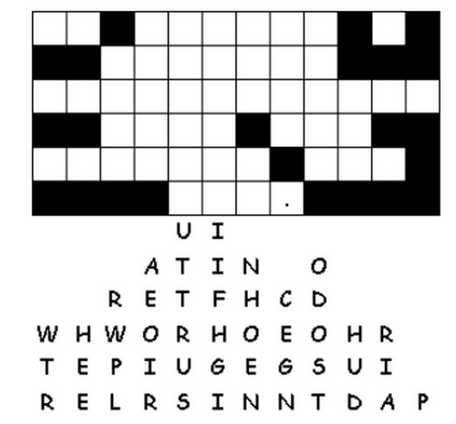

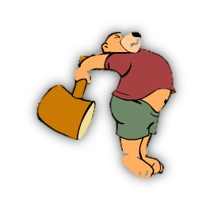
Oh no, I accidentally knocked all the letters out of the statement. They fell straight down. Some are easy to find, like where there’s only one blank in that column. Look for two or three letter words and figure what two or three letters in those columns make a sensible word. This is an important message, get to work! If you get stuck check out the solution at
https://tinyurl.com/ycvqe7tc
And there’s other Family Activities, too.
Fallen Phrases

