1. Motivate

What are some things you trust to work even though you don’t know how they work?
- starting the car
- stopping the car, the breaks
- Wi-Fi, the Internet, cell phone
- Cable, satellite TV
A video introduction to the lesson is available. View it at https://tinyurl.com/479p2n3h If you don’t have wi-fi where you teach, you must download the video file to your computer from https://tinyurl.com/47suf286
- my 3D printer
- Amazon Prime
- ball point pens
- the kids’ calculators
- online ordering

2. Transition

Even more amazing is how God works in our lives.
- No doubt Mary continued to be amazed at God at work through her life.
- We can know that God will accomplish great things in our lives.

3. Bible Study

3.1 Unexpected Possibilities

Listen for a startling revelation.

Luke 1:26-30 (NIV) In the sixth month, God sent the angel Gabriel to Nazareth, a town in Galilee, 27 to a virgin pledged to be married to a man named Joseph, a descendant of David. The virgin's name was Mary. 28 The angel went to her and said, "Greetings, you who are highly favored! The Lord is with you." 29 Mary was greatly troubled at his words and wondered what kind of greeting this might be. 30 But the angel said to her, "Do not be afraid, Mary, you have found favor with God.

How could we describe Mary, based on this passage?
- a virgin
- pledged/espoused to be married to Joseph
- angel announces she is highly favored and God is with her
- she was afraid (greatly troubled), wondered who this really was

She was described as being pledged or “espoused” to Joseph.
- A structured year of engagement.
- A legal arrangement.
- When this angel encounter occurred, she was within this year of engagement.

Why was Mary troubled?
- you’d be troubled too if an angel appeared with you
- this was not the typical “Shalom” greeting, no “Howdy, miss” or “Good morning, ma’am ”
- how could this be good news … looked like life might change or be interrupted in a big way

On what grounds did Gabriel urge Mary not to be afraid?
- the Lord is with you
- God, Himself favored her, approved of her
- “you have found favor with God”

Since Luke did not cite any Old Testament reference to a virgin birth, what might have been the significance of Luke’s identifying Mary as a virgin?
- she was going to bear a child without having sexual relations
- it supports the fact that Jesus was not human alone, he was also God
- it emphasizes the fact that Jesus was both wholly man and wholly God

Since Jesus existed before time, why is it significant that He come as a baby?
- speaks to His humanity
- if He just appeared in human form (as He occasionally did in the Old Testament) He would not be considered human

How do you think God specifically chose Mary?
- she lived at the right time and in the right place
- God desired to bring blessing to Mary … God’s grace at work
- she was receiving a blessing, favor she did not merit/deserve
- she had not done anything to deserve the honor of bearing the Messiah
- she was an ordinary young woman, God had sovereignly chosen to bless

How about today … how does God choose people today? How does He favor us and choose us for special tasks?
- in a sense we are all chosen to do special tasks for the Lord
- each believer is gifted (favored) by the Holy Spirit, enabled for service
- God doesn’t need us but he chooses to work through His children for specific tasks
- some of the tasks are high profile …
  - evangelists, musicians, teachers, philanthropists
- some of the tasks to which He calls us are low profile …
  - prayer warriors, church bus mechanics, church maintenance, nursery workers

What do you think he meant by declaring her to be “highly favored”?
- God had exercised his grace on her
- she was receiving a blessing, favor she did not merit/deserve
- she had not done anything to deserve the honor of bearing the Messiah
- she was an ordinary young woman, God had chosen to bless
3.2 God’s Plans Are Not Hampered

Listen for titles and descriptions given.

Luke 1:31-34 (NIV) You will be with child and give birth to a son, and you are to give him the name Jesus. 32 He will be great and will be called the Son of the Most High. The Lord God will give him the throne of his father David, 33 and he will reign over the house of Jacob forever; his kingdom will never end." 34 "How will this be," Mary asked the angel, "since I am a virgin?"

What description to we see here about the child Mary would bear?
- would be a son, she should name him Jesus
- He would be great, He would be called “Son of the Most High”
- God would give him the throne of his father David
- He would rule over the house of Jacob forever, His kingdom would never end.

What is the significance of the names and titles given to this child?
Name | Significance
Jesus | A version of the name Joshua – Joseph told in Matthew 1:21 “…give him the name Jesus, because he will save his people from their sins."
Son of the Most High | contrast to “prophet of …” title given to John  Most High ⇒ God  Jesus would be God, divine … at the same time, human
Given throne of David | born of the line of David, recall the Davidic covenant  would be a king with a throne – not a literal or political kingdom, but a spiritual kingdom
Kingdom included House of Jacob | A Hebrew patriarch  name changed to Israel – for whom the nation was named  never ending kingdom


The “Kingdom of God” is the realm where God rules. Therefore, in what way is Jesus to be King today?
- King of our lives
- ruler over the church – the body of believers
- to sit on the throne of our hearts and minds

Note how is this kingdom different from other kingdoms?
- Spiritual kingdom … not political, does not possess land or geographical territory
- The King has infinite power and authority
- The source of the power, is the King, himself (not in the size or skill of his army)
- The subjects of the kingdom can choose whether or not to obey – the King does not force His authority on believers

3.3 God’s Power Can Do Great Things

Listen for evidence of God’s power.

Luke 1:35-38 (NIV) The angel answered, "The Holy Spirit will come upon you, and the power of the Most High will overshadow you. So the holy one to be born will be called the Son of God. 36 Even Elizabeth your relative is going to have a child in her old age, and she who was said to be barren is in her sixth month. 37 For nothing is impossible with God." 38 "I am the Lord's servant," Mary answered. "May it be to me as you have said." Then the angel left her.

What are some reactions by the world to the concept of Jesus being born to a virgin?
- impossible
- pretty sick, a deity having sex with a human
- obviously a myth
- shows the Bible is merely a bunch of fairy tales
- how can you believe that stuff?

How did Gabriel explain Mary’s conception?
- Spirit of God would “overshadow” her
- was not a case of God having sex with a human
- would be a miracle spiritually and physically

So, with all those emotions, how did Mary respond to the angels message?
- I am the Lord’s servant
- May it be to me as you have said
- she accepted God’s plan for her, she embraced God’s call
- the passage implies simple and more or less immediate acceptance – took great faith!

Why is Mary’s acceptance of God's plan significant?
- this was a life changing event
- this would potentially make her famous and/or infamous
- she would face both scandal and a huge challenge to be the mother to raise this most important child
- the passage implies simple and more or less immediate acceptance – took great faith!

How can we similarly respond to God’s call on our lives?
- live like nothing is impossible with God
- trust in His power, authority and love with obedience
- believe that same way for our children and grandchildren

Use the last page as a handout so your learners can take home the application points of this week’s lesson.

Application
Pray.
- Ask God to strengthen the faith of a discouraged friend.

Journal.
- Write your testimony of how God has surprised you through unique circumstances that strengthened your faith.
- Share your gratefulness to God and His mercy with a friend or post your story on social media.

Retreat.
- Both Mary’s and Zechariah’s encounters with God happened in solitude.
- Plan a silent retreat where you get away from all the noise of your life and enter into fellowship with God.
- Read Luke 1–2 to discover how the stories of Zechariah, Elizabeth, and Mary align as related to the births of John and Jesus. Listen closely for His guidance.
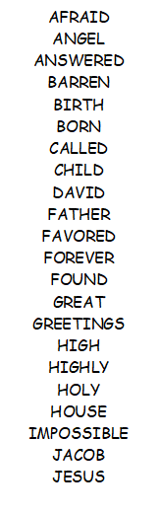

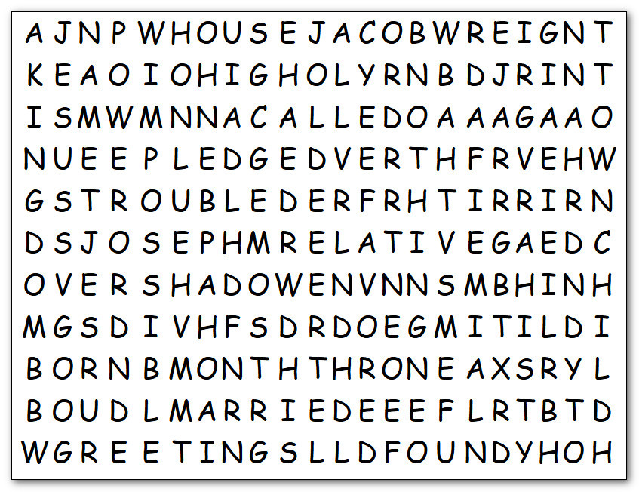

Word Search
Humph! It’s evident your understanding is falling well short. This exercise should help. FIND THE WORDS ! It ought to be easy, they only go left to right, top to bottom and North-east and South-east. If you wimp out, you can ask that other class. They’re usually on top of things. Humph! Or you can go to https://tinyurl.com/47suf286 for help or give up and do the color page!

