1. Motivate

What is the toughest competition you’ve ever participated in?
- football/baseball/basketball championship
- marching band competition
A video introduction to the Bible study is available. Go to https://tinyurl.com/ybndnjf5 to view. If you have no wi-fi where you teach, you must download the vide file to your computer from https://tinyurl.com/5n79hxtz
- tennis match
- spelling bee
- weightlifting
- running an iron man
- trying out for the high school wrestling team
- being interviewed for an important job

2. Transition

Our confidence can also waver when facing temptations.
- Today we look at what John has to say about confidence.
- We can stand victoriously because of Christ.

3. Bible Study

3.1 Remain and Obey

Listen for Jesus’ command.

1 John 3:21-24 (NIV) Dear friends, if our hearts do not condemn us, we have confidence before God 22 and receive from him anything we ask, because we obey his commands and do what pleases him. 23 And this is his command: to believe in the name of his Son, Jesus Christ, and to love one another as he commanded us. 24 Those who obey his commands live in him, and he in them. And this is how we know that he lives in us: We know it by the Spirit he gave us.

Verse 21 says our confidence is affected by our heart. Can you think of a time when feelings lagged behind truth?
- struggling with a sinful habit
- when unbelievers accuse or make fun of you as a believer
- when enduring a season of health/financial/relationship struggles
- when a problem at work seems to have no end
- taking a difficult course in school and fighting to keep from failure

John distinguishes between condemnation from our own hearts and confidence before God. What is the danger of letting our feelings define our standing with God?
- feelings may easily not align with the Truth of God’s Word
- our standing with God is determined by faith in God’s Truth
- not with how we feel
- emotions can have wide swings up and down – happy to sad – which are not entirely based on the reality of God’s Truth

What does it mean to “believe in the name of Jesus Christ”?
- believe in the authority of the name
- receive by faith who Jesus is
- that He is God and he is man … both at the same time
- receive by faith what He has done
- to put your belief on Jesus in the sense of trusting in Him,
- relying on Him, and clinging to Jesus.
- It isn't about intellectual knowledge or understanding, it is about trust

How is it possible to keep these and any other commandment of God?
- God’s Holy Spirit lives within us
- we surrender to His authority in our lives
- we depend on Him for guidance and power to live a life that pleases God

This diagram illustrates how God dwells in the life of the believer in the person of the Holy Spirit. How do we dwell/live in Him as it also says in verse 24?
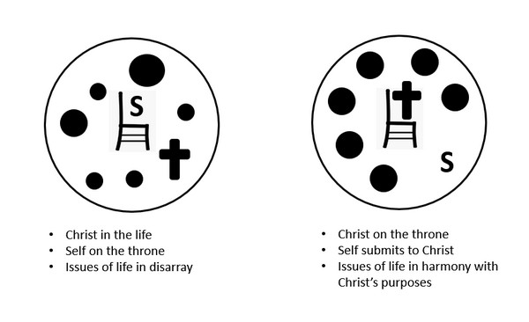
- when we place our trust in Jesus Christ for our salvation, God’s Holy Spirit comes and lives within our lives
- we trust God not only for our salvation from eternal death, we also place our lives in His hands for daily strength to live for Him, to serve Him
- Jesus talked about He was the Vine, and we are the branches … grafted in to His family, dwelling in Him

3.2 Walk in the Truth

Listen for criteria to judge.

1 John 4:1-3 (NIV) Dear friends, do not believe every spirit, but test the spirits to see whether they are from God, because many false prophets have gone out into the world. 2 This is how you can recognize the Spirit of God: Every spirit that acknowledges that Jesus Christ has come in the flesh is from God, 3 but every spirit that does not acknowledge Jesus is not from God. This is the spirit of the antichrist, which you have heard is coming and even now is already in the world.

What did John instruct his readers to do?
- do not believe in every spirit
- test the spirits
- see if they are from God

According to this passage, what is the so called “litmus test” to recognize the Spirit of God?
- does the spirit acknowledge that “Jesus Christ has come in the flesh”
- if yes, the message is from God’s Holy Spirit
- if no, the message is from the spirit of the antichrist

How does this tie in with the verses we just looked at from end of chapter 3?
- believe in the authority of the name of Jesus
- receive by faith who Jesus is
- that He is God and he is man … both at the same time

Why is this fact important … what if Jesus was only God or only man?
Only God | Only Man
- could not live a sinless life as a human  - could not die a substitutionary death this way either | - would have had to die for his own sins  - could not die a substitutionary death  - all humans are born sinful

Note some modern examples of groups who spread false teachings regarding the full humanity and full divinity of Jesus:
- Mormonism, Jehovah’s Witnesses, Islam, Hinduism, Humanism

Common characteristics of cults – false spirits … signified by math symbols
- + They add to Scripture
- - The subtract from the deity of Christ
- × They multiply the importance of works
- ÷ They are divisive, causing divisions in families, among friends, separating their adherents from other belief systems

What spirits should we be testing today? What false prophets are in the world today?
- biased news media
Note, the news headlines shown in PPT are fictional … but realistic
- statements by politicians
- people claiming to be prophets
- anyone who preaches, adheres to beliefs other than Scripture
- those who advocate policies and practices that are contrary to Scripture
- entertainment that advocates immoral, ungodly attitudes and activities

3.3 Stand Victorious in Jesus

Listen for words of hope.

1 John 4:4-6 (NIV) You, dear children, are from God and have overcome them, because the one who is in you is greater than the one who is in the world. 5 They are from the world and therefore speak from the viewpoint of the world, and the world listens to them. 6 We are from God, and whoever knows God listens to us; but whoever is not from God does not listen to us. This is how we recognize the Spirit of truth and the spirit of falsehood.

Between what two spirits must we choose in considering the direction of our lives?
- spirit of the world
- Holy Spirit of God

How does our confidence in Christ (3:21–24) prepare us to test the spirits (4:1–6)? What happens to discernment when assurance is weak?
- we are assured of Jesus’ teaching, Truth and precepts
- we believe (with good reason) Jesus’ birth, death, resurrection
- If God has given us good Truth, we base our judgments on God’s Truth
- but … if our assurance is weak, if we have doubts and questions about who Jesus is and what He has done, then our discernment will be shaky

Contrast the two philosophies … that of the world and those who belong to God. How does the world decide what sounds true? How does God’s truth often run counter to popular opinion?
World’s View | Believers’ View
- from others of the world  - speak from a worldly viewpoint  - unbelievers listen to and heed worldly spirits  - does not listen to, rejects Biblical view  - spirit of falsehood | - from God  - knows God  - listens to God’s Holy Spirit  - heeds the teaching of Scripture  - pay attention to the Spirit of Truth

Verse 4 is one of the most encouraging statements in Scripture. What does “He who is in you is greater than he who is in the world” mean in daily life?
- we need not fear the influences of the world, we need not live in fear of current events
- God’s Holy Spirit lives in the life of every believer
- as we allow Him to direct our lives, He will direct our thinking and enable us to respond appropriately in our emotions
- the Holy Spirit guides our responses to fear, doubt, or pressure from our culture
- pray for believers who are in actual life and death danger because of their faith in Christ
- read, study, meditate on Scripture’s teaching of God’s power, authority, love for me

Jesus is greater than those who oppose us. How will this truth influence your life this coming week?
- base my life on that reality, trust God when facing opposition
Use the last page as a handout so your learners can take home the application points of this week’s lesson.
Application
Read.
- God’s Word is filled with encouraging words for us when our confidence fails.
- Take a few minutes to look up and meditate on Exodus 15:2; Psalm 28:7-8; and 2 Corinthians 12:9-10.

Correspond.
- Write a note to someone in your life who is experiencing stress, exhaustion, or bewilderment.
- Let that person know that you are in his or her corner.

Fast.
- When you fast, God strengthens your spirit and gives you clarity.
- If you are able, plan to fast from food, entertainment, social media, or some other thing you enjoy
- This can clear away distractions and connect you more strongly with God.
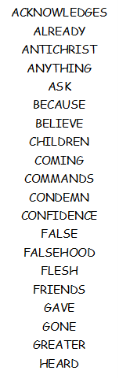
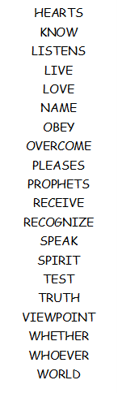

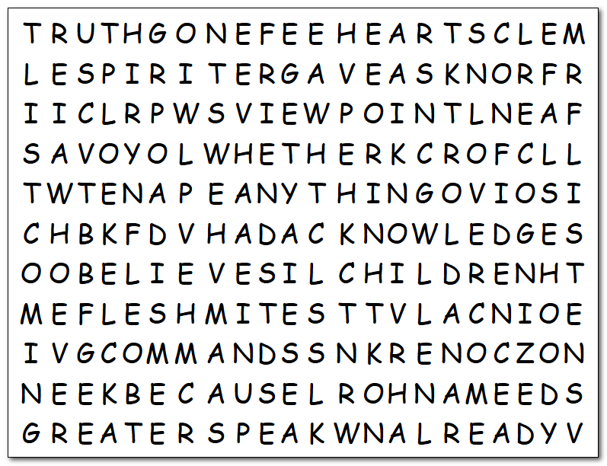
Word Search
Whining about no confidence? HUMPH! This exercise will build up confidence in your vocabulary. All good words. Quiz on Tuesday on their meanings. Reading the passage (1 John 3:21 – 4:6 NIV) will help. Meanwhile, find them in the grid. You know the drill, the spellings are left to right, top down, Northeast and Southeast. Nothing backwards. Humph … getting soft in my old age. If you chicken out, you can go to https://tinyurl.com/5n79hxtz for help or the color page.

