1. Motivate

What is a mistake you made that you still laugh about today?
- wore the same outfit to an event as someone else
- ran the wrong direction in a football or basketball game
- drove to the wrong airport
- knocked over the wedding cake
- wore two different socks/shoes to an important event
- introduced someone and forgot their name
- served a cake for which you had left out an important ingredient
- forgot your wedding anniversary (or birthday)
- on a stop during a long trip, you drove off without one of the family members

2. Transition

Some of our mistakes we are not able to laugh about.
- But … God can redeem our mistakes

3. Bible Study
A video introduction is available. View it at https://tinyurl.com/yc7hcjfj . If you have no wi-fi where you teach, you must download the video file to your computer from https://tinyurl.com/2s3svswc .

3.1 Unintended Consequences

Listen for intrigue.

Exodus 2:11-15 (NIV) One day, after Moses had grown up, he went out to where his own people were and watched them at their hard labor. He saw an Egyptian beating a Hebrew, one of his own people. 12 Glancing this way and that and seeing no one, he killed the Egyptian and hid him in the sand. 13 The next day he went out and saw two Hebrews fighting. He asked the one in the wrong, "Why are you hitting your fellow Hebrew?" 14 The man said, "Who made you ruler and judge over us? Are you thinking of killing me as you killed the Egyptian?" Then Moses was afraid and thought, "What I did must have become known." 15 When Pharaoh heard of this, he tried to kill Moses, but Moses fled from Pharaoh and went to live in Midian, where he sat down by a well.

What did Moses see that troubled him?
- as an Egyptian VIP he was out “slumming”
- watched his people at hard labor
- saw Egyptian slave master beating up a Hebrew worker

What actions in verse 12 suggest that what Moses did was intentional but wrong?
- looked all around
- made sure no one was looking
- after killing the Egyptian slave master
- buried him in the sand to hide the event

What might this reveal about Moses’ sense of justice and identity at that point in his life?
- realized his people were being abused in general
- here was an outrageous situation which needed to be made right
- he could rescue a fellow Hebrew and get some revenge also
- actually their people as a whole needed to be set free
- this could be a step in that direction

How did his murderous action catch up with him?
- next day tried to break up a fight between two Hebrews
- one of them objects to his intervention
- “who made you ruler over us?”
- “I suppose you’re going to kill me like you did the Egyptian”

What were the consequences he faced that appeared to interrupt his good life and threaten his future?
- the story got around
- Pharaoh eventually hears it
- sends the authorities out to kill Moses
- Moses flees to Midian

Why do you think Moses took matters into his own hands instead of seeking God’s direction?
- immature thinking
- didn’t have a sense of God’s power and overrule in their situation
- thought his palace connections gave him the sense of power
- didn’t realize God had a bigger and better plan

When has taking matters into your own hands made a situation worse?
- as a kid you might have tattled on someone else who did something bad
- you broke an object and tried to glue it back together
- took a chunk out of a newly baked and decorated cake … tried to cover the missing piece with more icing
- “borrowed” dad’s car to take a friend home and ended up with a fender bender
- as a football player you did something different than the called play and the other team scored

3.2 God Uses Unintended Consequences

Listen for another intervention by Moses.

Exodus 2:16 – 22 (NIV) Now a priest of Midian had seven daughters, and they came to draw water and fill the troughs to water their father's flock. 17 Some shepherds came along and drove them away, but Moses got up and came to their rescue and watered their flock. 18 When the girls returned to Reuel their father, he asked them, "Why have you returned so early today?" 19 They answered, "An Egyptian rescued us from the shepherds. He even drew water for us and watered the flock." 20 "And where is he?" he asked his daughters. "Why did you leave him? Invite him to have something to eat." 21 Moses agreed to stay with the man, who gave his daughter Zipporah to Moses in marriage. 22 Zipporah gave birth to a son, and Moses named him Gershom, saying, "I have become an alien in a foreign land."

What ordinary, daily event became the means of a new opportunity for Moses?
- arrived in Midian and came to the local well
- along came seven sisters to water their sheep
- some local shepherds gave them a hard time, chased them away

How did Moses once again stand in defense of the abused or helpless ones?
- decided here was another situation of “Prince Moses to the rescue”
- chased away the ruffian shepherds
- enabled the sisters to water their sheep

What conversation did Reuel and his daughters have that opened a door for Moses to a new way of life?
- the sisters relate the events to their father, Reuel
- Reuel ask, where is this hero, invite him for dinner
- then invites him to stay with them
- ends up marrying one of the sisters (probably the oldest, by culture)

In what ways do you think God used Moses’ years in Midian to prepare him for the greater mission ahead?
- provided a wife and family
- gave responsibilities – no longer a palace dependent
- grew up and matured
- no longer had the “Egyptian Prince” mentality and mindset
- got him to the place where God could speak to him

How does seeing God’s provision for Moses give us hope in spite of our mistakes?
- God provided a safe place for Moses
- and a wife, the daughter of a God fearing priest
- even though Moses initially acted unwisely and had to flee
- God intervenes to give Moses safety, a family, and time to mature
- God is always at work in our lives, guiding and preparing us for His purposes for our lives
- we likely will suffer some consequences for our failures, but over all, in the big picture, God is working out His purposes as we trust and obey

How can we learn to wait on God’s timing instead of rushing ahead with our own plans?
- study God’s power and authority and love for us
- study people and events in Scripture that show us how God is in control
- talk to God about your plans
- ask Him to guide your thinking
- ask Him to open the right doors and close the wrong ones
3.3 God Benefits Others

Listen for God’s purposes.

Exodus 3:5-10 (NIV) "Do not come any closer," God said. "Take off your sandals, for the place where you are standing is holy ground." 6 Then he said, "I am the God of your father, the God of Abraham, the God of Isaac and the God of Jacob." At this, Moses hid his face, because he was afraid to look at God. 7 The LORD said, "I have indeed seen the misery of my people in Egypt. I have heard them crying out because of their slave drivers, and I am concerned about their suffering. 8 So I have come down to rescue them from the hand of the Egyptians and to bring them up out of that land into a good and spacious land, a land flowing with milk and honey--the home of the Canaanites, Hittites, Amorites, Perizzites, Hivites and Jebusites. 9 And now the cry of the Israelites has reached me, and I have seen the way the Egyptians are oppressing them. 10 So now, go. I am sending you to Pharaoh to bring my people the Israelites out of Egypt."

How did God identify Himself, and why would that be important?
- I am the God of your father, I am the God of Abraham, Isaac, Jacob
- Moses would get the connection, he would have known the history of the Children of Israel

How did Moses respond? What does that indicate?
- hid his face, afraid to look at God, awe, holy fear
- convinced this was more than just a hallucination

How would Moses know that God does care for His people, even though Moses had wondered.
- I have seen the misery of my people, I have heard them crying out
- I am concerned about their suffering
- I have come down to rescue them, to bring them out of that land, into a good land
- I have seen Egyptians oppressing them, I am sending YOU to bring them out of Egypt

Moses had two basic options … accept or reject God’s call. What would have been the consequences of each option?
Consequences: Accept God’s Call | Consequences: Reject God’s Call
- must confront Pharaoh  - endure Pharaoh’s anger  - people would end up free  - receive possession of Promised Land  - escape from enslavement  - have the honor of leading God’s people | - avoid a confrontation  - avoid angering Pharaoh  - people continue in slavery  - no escape to “land of milk and honey”  - miss out on leading God’s people  - God would raise up someone else

How does this story show that God’s calling is not canceled by our failures—but often refined through them?
- we can mistakenly proceed to handle situations on our own, only to fail
- but God can use that event to teach us, train us, open up new opportunities
- one failure does not negate God’s ultimate purposes for our lives
Use the last page as a handout so your learners can take home the application points of this week’s lesson.

Application
Ask God’s forgiveness.
- If sin put you in the wilderness, confess your sin and receive God’s forgiveness.
- Read Psalm 103:10-14; Ephesians 1:7; Colossians 1:14; and 1 John 1:9.

Recall wilderness times from your past.
- Reflect on the wilderness seasons of your life.
- Look back to times of unexplained waiting and try to determine if God used those times to refine you, from the inside and out.
- In God’s hands, consequences aren’t just for correcting but for cultivating.

Follow God’s call.
- Moses felt disqualified, just like we do.
- Ask the Holy Spirit to guide you as you seek to be obedient to His call.
- Following Him is always what is best at every stage of life.
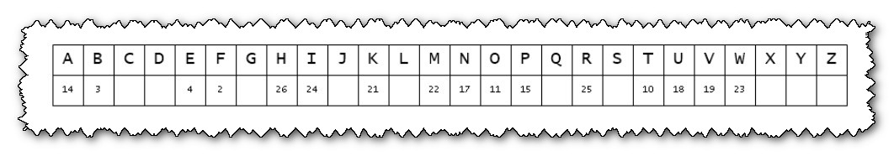
Cryptogram Puzzle

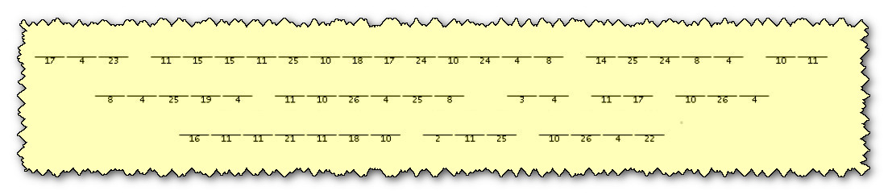
"Mon ami, the Baptist consulate in Kirat Guaybar has received, by two most curious and separate deliveries, the fragments of a secret message. It appears that our friends in the underground church wish for you to remember a truth of great importance. Alas! The decryption team, they are taking the holiday—what you call the middle school fall break. And so, it is to you that we turn for the little grey cells! Use the key, place each letter in its proper position—order and method, always! When you have uncovered the full message, be so good as to forward it to your youth pastor, n’est-ce pas?" You can find help and the ever popular crossword at https://tinyurl.com/2s3svswc

