1. Motivate

Consider the fill in the blank statement, “Marriage is________.” What are some ways our current society might complete this statement?
- now often considered temporary
- same sex marriages
- armed conflict
- not necessary – just live together
- old fashioned
- means the wife must submit to the husband

2. Transition

Our culture’s views do not change God’s design for marriage.
- Marriage is between one man and one woman for life.
- Humanity needs marriage – the sacred relationship between one man and one woman

3. Bible Study

3.1 Marriage Was Designed by God

Listen for what God says about man being alone.

Genesis 2:18-20 (NIV) The LORD God said, "It is not good for the man to be alone. I will make a helper suitable for him." 19 Now the LORD God had formed out of the ground all the beasts of the field and all the birds of the air. He brought them to the man to see what he would name them; and whatever the man called each living creature, that was its name. 20 So the man gave names to all the livestock, the birds of the air and all the beasts of the field. But for Adam no suitable helper was found.

What did the Lord God identify as not good as far as the man was concerned?
- it was not good that the man was alone
- God intended to make a helper suitable for him

What was one act the man took as part of his assignment to have dominion over other living creatures?
- name the animals
- whatever Adam called them, that’s what they were
- names for beasts of the field

The King James Version says God wanted an “help meet” for him? What does that mean?
- a helper
- a companion
- someone to share life with
- did not include the animals he had viewed and named
- the helper would be more than a friendly doggy

What does the fact that it was not good for man to be alone tell us about the importance of relationships?
- God made us as social beings
- God knew that being alone was less than optimum
- we need the interaction with others
- we need to need one another
- we are built to be interdependent
- in a sense, that is why He created humankind – God desired fellowship, relationship with someone who would choose to be with Him

What is the value in a spouse who complements but is different than you?
- where one is weak, the other is strong
- each has different skills and abilities needed by the two people together
- together, they are stronger emotionally, physically, spiritually than either one is alone

Why is it still true that it is not good for us to be alone?
- for all the same reasons God designed Eve for Adam
- we still need each other
- every person has aspects of their being that need input and interaction with others
- even if it is not an intimate marriage relationship, we need that give and take with other people
- we need that same interaction and guidance and input from God

How can the God-given need for fellowship be met regardless of our marital status?
- within the Body of Christ (the Church) we have fellowship
- the members of the Body minister to one another
- when one member is in need, the other members exercise their spiritual gifts and work together to meet that need
- this is true no matter what one’s marital status
- the Church is also a good place to meet potential marital partners

3.2 Man and Woman Created as Unique Genders

Listen for how Eve’s creation was different.

Genesis 2:21-22 (NIV) So the LORD God caused the man to fall into a deep sleep; and while he was sleeping, he took one of the man's ribs and closed up the place with flesh. 22 Then the LORD God made a woman from the rib he had taken out of the man, and he brought her to the man.

What steps did the Lord take in making the woman?
- caused Adam to fall into a deep sleep
- while he was sleeping, God performed an operation
- took out one of Adam’s ribs
- closed up the incision
- made woman from the rib

How did this differ from the way He created the man and the other creatures of the land?
- Adam and the animals were made of the ground
- Eve made from Adam’s rib

What does God’s creating the woman from a part of the man (his rib) say about the relationship God wants for the husband and wife?
- they are to be united
- their union is to draw them together so that they become, in essence one unit
- they complement each other
- the skills and abilities of each is need by the other partner
- consider that couples who’s marriages have grown close over the years are often thinking the same thoughts, responding in the same way to a question or comment

In what ways does our culture challenge God’s distinct design of men and women?
- people born of one gender “changing” to the other
- people rejecting the way God made them
- culture rejects God’s design

How did God bring you together with your spouse? If you are unmarried, tell about how God brought your parents together.
- met in college
- grew up together in high school
- lived in the same neighborhood for believers … nothing is by chance
- met at church camp
- a blind date set up by mutual friends

Note that God brought Eve to Adam. What does this suggest about choosing a spouse?
- God’s plan for us is good
- If we seek His will, He will guide our paths to the right person
- if we take matters into our own hands we might make poor choices
- pray that our children, our grandchildren will be open to God’s direction in their choices
- pray that within their marriage, they will be submissive to God and to each other

On what attributes of God were Adam and Eve forced to trust? What attributes of God should we likewise be trusting?
- God’s wisdom, God’s power, God’s sovereignty
- God’s love
- God’s insight into their needs

3.3 Marriage Is One Man, One Woman, United for Life

Listen for Adam’s response to God’s gift.

Genesis 2:23-25 (NIV) The man said, "This is now bone of my bones and flesh of my flesh; she shall be called 'woman,' for she was taken out of man." 24 For this reason a man will leave his father and mother and be united to his wife, and they will become one flesh. 25 The man and his wife were both naked, and they felt no shame.
What was Adam’s response when the Lord presented the woman to him?
- this is now bone of my bones
- and flesh of my flesh
- called “woman” for she was taken out of man
- In Hebrew there is a play on words between the word for “woman” (Hebrew, ishshah) and the word for “man” (Hebrew, ish).
- The man explained the play on words when he stated, “she was taken out of man.”

According to these verses, in what ways are man and women similar / dissimilar?
Similar | Dissimilar
- she is “bone of my bones”  - she is “flesh of my flesh”  - when united they both leave parents  - perceived no shame at their nakedness  - they both need each other | - man made of dust of the ground  - woman made from rib of Adam

Note the phrase “become one flesh.” We usually think of a sexual union, but what else is implied by “one flesh” or marriage unity?
- united in pooling finances
- working together to raise the children
- common goals for family activities
- minister to one another – the particular skills of both partners complement one another
- act in love – giving of self to do for the other
- united in facing the struggles of life – financial, health, family issues, aging

How does this understanding of “oneness” change and grow during the years of a marriage?
- changing circumstances shifts the ways in which we must help each other (accidents, health, financial reversals, the job market)
- from babies to children to teens to young adults, the children require different “strategies” of parenting and responsibilities
- midlife crises require different kinds of attitudes towards each other

What are the gifts that result from God’s design of a marital relationship?
- companionship
- pleasure of intimacy
- children, grandchildren
- mutual support
- stability, dependability of relationship (as God designed it)

Use the last page as a handout so your learners can take home the application points of this week’s lesson.

Application
Pray.
- If you are married, pray for your spouse daily.
- If you’re not married, pray for those who are.
- Pray marriages would be lived in ways that honor Christ.

List.
- Make a list of the strengths and qualities your spouse brings to your marriage—those traits that make for a strong marriage.
- If you’re not married, list the qualities you would look for in a mate.

Respect.
- Respect all individuals as created in the image of God.
- Show grace and compassion to those who disagree with the biblical definition of marriage.

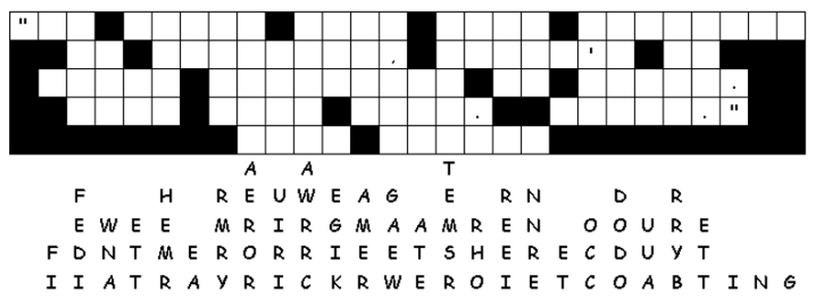

Fallen Phrases Puzzle
It’s bad enough picking up all this laundry. Now were inundated with letters. They’ve fallen out of their columns straight down. And let me tell you, there’s something important there about marriage. You can fix it – both your marriage and the sign. Replacing some letters are easy to figure out, like where there’s only one blank in that column. Look for two or three letter words and figure what two or three letters in those columns make a sensible word. If you get stuck go to https://tinyurl.com/y9en7bs5 And there are other fun Family Activities there also.

