1. Motivate

What would you say is your most important role in life? What lifestyle, priorities, spending, and conversations support (or challenge) that theme?

Role:
- parent, grandparent
- teacher
- wage earner
- boss
- believer

Supporting or challenging activities
- time spent on the job, with your kids, with your spouse, with your buddies
- vocabulary - presence or lack of
  - foul language vs kindness, purity
  - encouragement vs complaining or nagging
  - teaching vs berating
- entertainment you watch

2. Transition

Believers are called to lives of ongoing, continuing spiritual growth
- Today we consider ways to determine if faith is increasing, decreasing, or stagnating

3. Bible Study

3.1 True Discipleship Means Gospel Growth for a Lifetime

Listen for what the “therefore” is there for.

Romans 12:1-2 (NIV) Therefore, I urge you, brothers, in view of God's mercy, to offer your bodies as living sacrifices, holy and pleasing to God--this is your spiritual act of worship. 2 Do not conform any longer to the pattern of this world, but be transformed by the renewing of your mind. Then you will be able to test and approve what God's will is--his good, pleasing and perfect will.

The “therefor” points to the preceding verses in Chapter 11:

Romans 11:33-36 (NIV) Oh, the depth of the riches of the wisdom and knowledge of God! How unsearchable his judgments, and his paths beyond tracing out! 34 "Who has known the mind of the Lord? Or who has been his counselor?" 35 "Who has ever given to God, that God should repay him?" 36 For from him and through him and to him are all things. To him be the glory forever! Amen.

How do these preceding verses encourage you to become “living sacrifices”, not conform to worldly patterns, and allow your mind to be renewed and transformed?
- God is all wise, all knowing
- He works in and through our lives in amazing ways that we can’t understand
- He does it without price for us – but great price to Himself
- He deserves our praise and worship

How do these preceding verses suggest that God has the right to ask us for a full commitment to Him?
- He is all wise, He knows what is best for us
- from Him and through Him and to Him are all things
- He is in control – at the same time we have a free will to make choices
- we know He is the loving and powerful God and it only makes sense to give ourselves over to Him

What do you think “living sacrifice” means as used here?
- comparison to an animal sacrifice as seen in the Old Testament, and also in Christ’s substitutionary death on the cross
- the sacrificed animals (and Christ died) – we can allow our self-claims, our self-control to die and be given to Him
- it means we give up our own claim to run one’s own life
- you abdicate the throne of your life and surrender to Christ’s control

Which parts of one’s life can be harder to give up to Christ’s control?
- finances
- a relationship
- how you spend your time
- the all you can eat pizza buffet
- or any other substance abuse
- your boat/car/TV/sound system/ …
- your drive for power and authority

How do we go about “renewing our minds” so we can discern God’s will? What spiritual practice has helped you in this area?
- fill your mind with God’s Truth – daily reading and applying God’s Word to your life
- communicating with God
  - listen to what He is saying in the Bible
  - heed the challenges in sermon or group Bible study
  - talk to God … Adoration, Confession, Thanksgiving, Supplication A.C.T.S.
- gathering with fellow believers for worship and teaching/preaching is a habit … not an option

3.2 True Discipleship Means Walking with God for a Lifetime.

Listen for an expert.

Matthew 22:34-38 (NIV) Hearing that Jesus had silenced the Sadducees, the Pharisees got together. 35 One of them, an expert in the law, tested him with this question: 36 "Teacher, which is the greatest commandment in the Law?" 37 Jesus replied: "'Love the Lord your God with all your heart and with all your soul and with all your mind.' 38 This is the first and greatest commandment.

Why do you think the scribe questioned Jesus?
- heard Jesus debating
- they were like members of the press, wanting to catch an official in an embarrassing mistake
- his fellow Pharisees put him up to it

What was Jesus’ answer to what is the most important commandment?
- to Love God with all your heart, soul, mind, strength

Why do you think Jesus quoted Scripture to answer the question instead of replying with His own words?
- the authority of the Scripture would have more weight
- it was something the scribe would be very familiar with
- was not Jesus opinion, so much as God’s opinion

What role does the mind play in loving God? How can we grow in that area?
- fill your mind with God’s Truth
- daily reading and thinking about God’s Word
- memorizing Scripture
- avoid filling your mind with a lot of other drivel
- specifically avoid overindulgence in worldly entertainment,
- don’t binge on secular news (of either side of the political spectrum)

What does it mean to love God with all your strength? How can our physical energy, resources, or talents be part of that love?
- use those resources for spiritual ministries
- be a good steward of your physical energies
  - Don’t over do it and end up too tired to go to church
  - Don’t end up as a “couch potato” with no energy to do anything useful
- Don’t just hold down a pew in church – become involved in one of the ministries of the church

What role does the heart play in loving God? How can we grow in that area?
- our emotions
- motivation, dedication
3.3 True Discipleship Means Loving Others for a Lifetime.

Listen for part two.

Matthew 22:39-40 (NIV) And the second is like it: 'Love your neighbor as yourself.' 40 All the Law and the Prophets hang on these two commandments."

Jesus said the second most important commandment was to love your neighbor as yourself. What do you think it means to “love your neighbor as yourself”?
- what you want for yourself, you want for your neighbor
- when you see the neighbor in need, you put yourself in his place and help to meet the need

Why is the order of the commandments appropriate?
- need to be in right relationship with God first
- only then can we be in right relationship with people around us
- it’s more than an issue of priorities
- it’s a necessary logical sequence

What are some ways you can determine which is more apparent in your life – love for self or love for others?
- how you spend your resources … time, finances, energy?
- who you think of to satisfy first … self or others?
- how much are you involved in church ministries?

Recall that when asked “Who is my neighbor?” Jesus told the story of the Good Samaritan. How does that tell us we are to “love as yourself”?
- note it was someone the Jews would have disliked … a Samaritan
- he was a surprise hero in the story
- we are called to love other than just people we like
- more than relatives
- includes both “in-laws and ‘outlaws’ “
- includes people we might dislike or even possibly hate

What are some ways we can show love for our “neighbors”?
- it’s so easy to ignore them – they have their schedule, you have yours – maybe all you do is wave as you pass in your cars
- at very least, kind greetings
- helpfulness, acts of unsolicited kindness
- come to their aid when they have needs, problems
- pray for them, even with them


Application
Put God first.
- What are the areas of your life that rival the place only God should occupy?
- Check your calendar and your bank statement.
- Where do you spend your time and money?

Seek God always.
- To love God with your mind means you seek truth.
- What are you reading that will help you love God with your mind?
- Consider reading a book, like You Are a Theologian by J. T. English and Jen Wilkin, that will sharpen your understanding of biblical truth.

Love God with your strength.
- Find a person in need in your church or community and gather a group to help meet that need.

- It could be yard work, maintenance, or even errands this person is incapable of completing.
Fallen Phrases

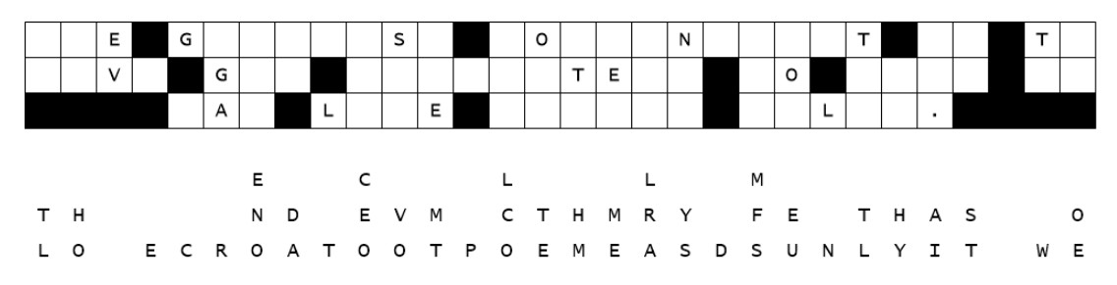
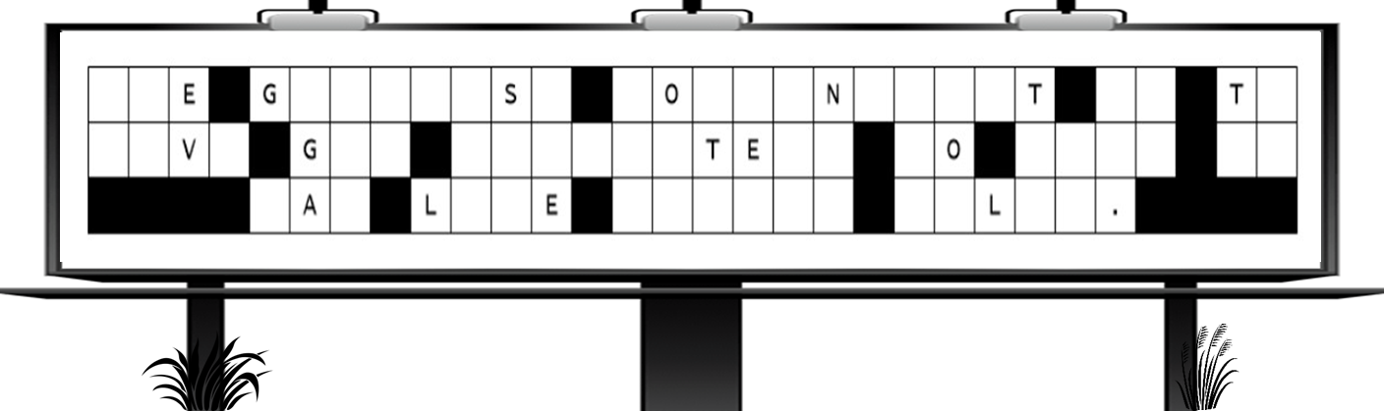
"One of our decryption specialists decided to have a bit of sport with your church sign. He’s rearranged the letters—dropped them neatly beneath their proper places. Rather cheeky, really. Claims his team can crack the code faster than your class. Here’s a tip, straight from MI6: start with the single missing letters, then move to the two- and three-letter words—insert what fits naturally. Log your completion time and report your results to your Bible Study leader. Should you require technical assistance—or crave further diversion—consult the link: https://tinyurl.com/bdhmf7vt . Good luck, agent."

