1. Motivate
A video introduction to the lesson is available. View at https://watch.liberty.edu/media/1_wiu9wbl1
If no Wi-Fi where you teach, better to download to your computer from https://tinyurl.com/yyh86pmy

When have you been surprised by the unexpected?
- wake up to a big snow storm
- come around the corner and face a big truck
- get to school and find out there is a test today
- get in the car to go to work and find a flat tire or a dead battery
- the pandemic interrupts the whole world economy
- a call in the middle of the night that someone close has had a bad accident
- the boss ran off with his secretary
- the stock market tanked overnight … we’re broke
- one of the kids came home with a 100% on a test
- the stock market went through the roof … we’re rich!

2. Transition

We can easily be surprised by an unexpected problem.
- However, we need not be destroyed.
- We stand strong with God’s armor and the support of others.

3. Bible Study

3.1 We Are in a Spiritual Battle

Listen for who is the enemy.

Ephesians 6:10-13 (NIV) Finally, be strong in the Lord and in his mighty power. 11 Put on the full armor of God so that you can take your stand against the devil's schemes. 12 For our struggle is not against flesh and blood, but against the rulers, against the authorities, against the powers of this dark world and against the spiritual forces of evil in the heavenly realms. 13 Therefore put on the full armor of God, so that when the day of evil comes, you may be able to stand your ground, and after you have done everything, to stand.

Who is our enemy?
- not necessarily flesh and blood, not always human opposition
- the enemy is spiritual
- rulers, authorities, powers of this dark world
- spiritual forces of evil

What are some kinds of things that would be included in the devil’s schemes to draw us into sin?
- lies to us
- makes bad things look good
- hide the end results of what he has for us, disguise evil things
- repeatedly say things are good and OK when they are really evil
- bait and switch
- cause confusion
- get people mad at one another
- discourage people from serving God, from witnessing
What would have to be their source of strength if the Ephesians were to be victorious in spiritual battle?
- strong in the Lord
- God’s mighty power

What did Paul urge them to do?
- put on the full armor of God
- this enables you to stand your ground
- you can stand against the devil’s schemes

What kinds of spiritual battles do believers face today?
- enslavement to substance abuse
- immorality (made to look OK in entertainment)
- discouragement, depression
- overcoming anger or any bad habit
- being drawn into gambling, materialism
- faithfulness in spending time with God (personal devotions, group worship)

What is the key to being “strong in the Lord and in his mighty power?”
- learn to depend on God
- don’t depend on self
- don’t depend on other people
- realize that His power is available
- realize that His power is sufficient, even superior

What are some actions, words, attitudes that help you do this before or during spiritual warfare?
- tell God every day that you are depending on Him
- memorize and/or study scriptures which remind you of God’s power, strength
- get into the habit at the beginning of each activity of asking for God’s strength as you begin
- listen to Christian music which keeps those themes running through your mind (instead of the drivel and/or evil lyrics of secular music)
- find a prayer partner with whom you can share needs and support for one another
- be quick to give God glory for answers to prayer, supply of needs

3.2 God Equips and Protects

Listen for a description of spiritual armor.

Ephesians 6:14-17 (NIV) Stand firm then, with the belt of truth buckled around your waist, with the breastplate of righteousness in place, 15 and with your feet fitted with the readiness that comes from the gospel of peace. 16 In addition to all this, take up the shield of faith, with which you can extinguish all the flaming arrows of the evil one. 17 Take the helmet of salvation and the sword of the Spirit, which is the word of God.

What defensive, offensive equipment do you see in the passage?
Defensive | Offensive
- belt of truth  - breastplate of righteousness  - shield of faith  - helmet of salvation | - shoes of the gospel (you can advance!)  - sword of the Spirit (the word of God)

For each of the pieces of equipment, what part of the body does it protect, what ability does it provide?
Armor | Physical area protected or capability provided | Spiritual protection or capability
helmet of salvation | the head, the brain | the mind
breastplate of righteousness | the chest, the heart | the emotions
shoes of the gospel | feet protected, ability to advance, good footing, kick! | enable attacks, advancement against Satan’s territory
sword of the Spirit (Scripture) | stab, slash, close infighting | use God’s word in teaching, preaching, witnessing
belt of truth | strap on armor, hold everything in place | truth holds everything in place
shield of faith | overall, all around protection | protection from whatever angle Satan attacks

What would happen if we left out one or more of the elements of spiritual armor?
Spiritual armor element | Problem when missing
Truth/scripture/gospel | absolute necessity; enables preaching, teaching, encouragement, promises
Faith | absolute necessity; only way of salvation
Righteousness | God’s righteousness protects our heart/emotions  Unprotected emotions can get us down, allow Satan to discourage
Salvation | God’s salvation protects our minds, our intellect  Unprotected mind can cause confusion, misdirection, allow Satan to easily fool us

How do we consciously “put on” this spiritual armor?
- choose to read, study, apply God’s word
- daily declare your faith in what God is telling you each day
- thank God for His righteousness, confess your inability to live a righteous life in your own strength
- daily tell God that you are receiving, applying His armor for your spiritual victories over Satan’s attacks

3.3 Pray for One Another

Listen for the importance of prayer.

Ephesians 6:18-20 (NIV) And pray in the Spirit on all occasions with all kinds of prayers and requests. With this in mind, be alert and always keep on praying for all the saints. 19 Pray also for me, that whenever I open my mouth, words may be given me so that I will fearlessly make known the mystery of the gospel, 20 for which I am an ambassador in chains. Pray that I may declare it fearlessly, as I should.

What connections exist between these verses and the previous passage, verses 10-17?
- this is also an element of how to face spiritual battles
- this speaks to communication – like the soldier’s radio
- talk to Headquarters – the Lord
- tell God what we need, what fellow “soldiers” need

For what needs did Paul ask the Ephesians to pray?
- that he would know what to say
- for God’s help in his preaching, teaching
- for lack of fear in speaking
- for wisdom to explain the “mystery of the gospel”
- to be a good ambassador, be a representative for the Lord to other people

Why is prayer an important tool in spiritual battle?
- it is our communication with God
- we have the privilege of going “straight to the top” with our requests
- we express our awe of God’s power and authority and love for us
- we communicate our trust in God’s intervention, God’s supply
- we share with God our burdens, our concerns
- we thank Him for His power at work in our spiritual battles

What do you think it means to “pray in the Spirit?”
- let your prayers be guided by the Spirit
- allow God’s spirit to direct you what to pray about
- to pray over true Spiritual issues, not just selfish wants
- to pray concerning the spiritual battles (in the context of the passage)

What are specific ways we can pray for one another as we engage in spiritual warfare?
- physical needs
- spiritual struggles
- wisdom, boldness, peace
- strength to stand up for what is right
- guidance to make the right choices, live victorious Christian lives
- for their ministries
Use the last page as a handout so your learners can take home the application points of this week’s lesson.

Application
Take your stand.
- Through prayer, commit yourself anew to standing firm in the strength of the Lord in spiritual battle.

Stand with your church.
- Take spiritual ownership of your church by praying regularly for your pastor(s), teacher(s), and fellow church members.
- Begin a prayer journal as a guide to help you pray.

Stand with the nations.
- Research the global church including missionary needs, unreached people groups, and persecution.
- The following websites are valuable resources to help shape your mind and your prayers: imb.org, joshuaproject.net, and operationworld.org.

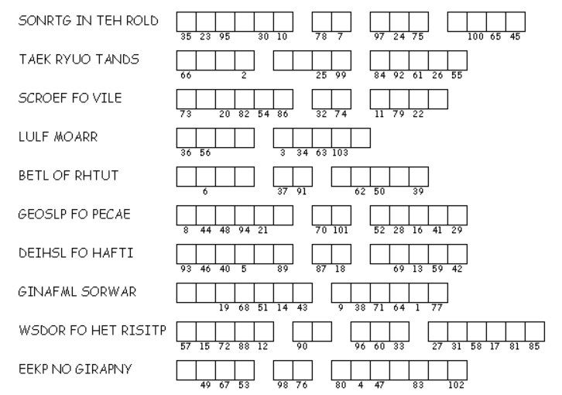Double Puzzle
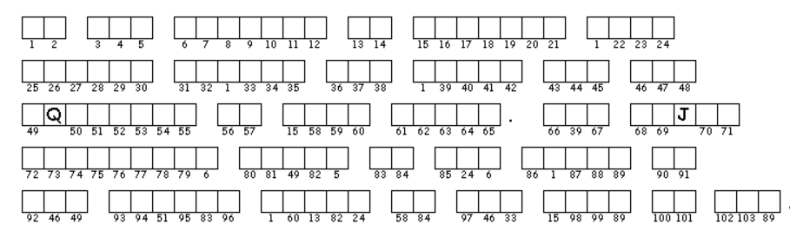
As the Word Ninja, it’s my duty to make sure this message gets through. If you need help decrypting the clue phrases, go to Ephesians 6:10-20. Then copy the letters in the numbered cells to other cells with the same number. Dr. A. W. Tozer wanted us to be aware of this important Truth. If you get stuck, go to https://tinyurl.com/yyh86pmy where there are also other fun and instructive Family Activities related to the lesson.

