Motivate

What sound or voice can you recognize easily from a distance?
- spouse’s cough
A video introduction to the lesson is available. Watch at https://watch.liberty.edu/media/t/1_dmuz81t1 If you have no wi-fi where you teach, best to download from https://tinyurl.com/y2stwere
- our dog barking from a block away
- our child’s crying
- a former teacher
- a work colleague
- an often-watched movie or TV personality
- one of my parents
- an annoying student
- the neighbor’s loud car
- my kid’s boom box

Transition

Some sounds or voices may puzzle you when you hear them.
- But when Christ returns, everyone will know it is Him

Bible Study

3.1 Guard Against Deception

Listen for Jesus’ warning.

Matthew 24:23-25 (NIV) At that time if anyone says to you, 'Look, here is the Christ!' or, 'There he is!' do not believe it. 24 For false Christs and false prophets will appear and perform great signs and miracles to deceive even the elect--if that were possible. 25 See, I have told you ahead of time.

Against what or whom does Jesus issue a warning?
- false messiahs or christs
- false prophets
- people who claim to be great saviors

What are false Christs and false prophets?
- people who make claims to have redemptive powers
- they claim they are going to rescue others from some injustice
- people who claim to be able to tell what will happen in the future
- those who claim to have great wisdom or revelations

What devices might they use to deceive people in today’s world?
- social media
- radio, tv
- they are peddling their book
- they could use political power
- they might have ability to control the news media
- they might make great promises to increase their support

Present-day false prophets will …
- market political correctness, woke cancel culture,
- demonstrate open hostility to a biblical worldview of law, order, and justice,
- tout grand rebellious ideologies and economic or racial determinism, - celebrate rebellion in the name of absolute freedom, - sow chaos, madness.
- Division and discord are their parallel tracks to power.

Jesus said, “You will know the truth, and the truth will set you free.” Have class members look up these references to know how to respond to untruth.
1. Ephesians 6:11 (NIV) Put on the full armor of God so that you can take your stand against the devil's schemes.
      - Helmet of salvation – guards our minds
      - Breastplate of righteousness – guards our emotions
      - Belt of Truth – God’s Truth holds our armor in place
      - Shoes of the Gospel – We stand firm, we march forward with the Gospel message, with good “footing”
      - Sword of the Spirit (Word of God) – a weapon against the enemy
      - Shield of Faith – protection against Satan’s temptations and deceptions
    - Philippians 1:9 (NIV) And this is my prayer: that your love may abound more and more in knowledge and depth of insight.
    - Ephesians 4:15 (NIV) Instead, speaking the truth in love, we will in all things grow up into him who is the Head, that is, Christ.
    - 1 Peter 3:15 (NIV) But in your hearts set apart Christ as Lord. Always be prepared to give an answer to everyone who asks you to give the reason for the hope that you have. But do this with gentleness and respect,
    - Ephesians 4:3 (NIV) Make every effort to keep the unity of the Spirit through the bond of peace.

3.2 Creation’s Proclamations

Listen for natural phenomena events.

Matthew 24:26-29 (NIV) "So if anyone tells you, 'There he is, out in the desert,' do not go out; or, 'Here he is, in the inner rooms,' do not believe it. 27 For as lightning that comes from the east is visible even in the west, so will be the coming of the Son of Man. 28 Wherever there is a carcass, there the vultures will gather. 29 "Immediately after the distress of those days "'the sun will be darkened, and the moon will not give its light; the stars will fall from the sky, and the heavenly bodies will be shaken.'

What counsel does Jesus offer to those who claim to have special insight concerning the Christ?
- don’t follow them
- don’t chase after their popularity
- don’t believe what they are saying
- you have to know Truth so you can see the deceptions

Why will no one miss Christ’s return? What examples does Jesus use to illustrate the visibility of the return of Christ?
- just like lightning flashes can be seen for miles, Jesus’ return will be recognized anywhere - people will be drawn to His return just like vultures zero in on roadkill

How does Jesus picture the spectacular nature of His coming? What natural phenomena does He describe?
- sun darkened
- stars fall from the sky
- heavenly bodies shaken

Consider Isaiah 13:9-10 (NIV)
See, the day of the LORD is coming --a cruel day, with wrath and fierce anger-- to make the land desolate and destroy the sinners within it. The stars of heaven and their constellations will not show their light. The rising sun will be darkened and the moon will not give its light.

What are some ways creation announces truths about God today?
- the land will become desolate
- people will die from natural disasters
- stars of heaven will not show their light (not recent news of black holes swallowing up stars in certain galaxies)
- our sun and moon will not give light (clouds or smoke?)

In what ways will creation help us understand the return of its Creator?
- creation will be involved in punishing the world for its evil
- wickedness and sin will feel the effect of God’s creation
- God will use natural forces to end the arrogance of the haughty – consider the force of hurricanes, blizzards, earthquakes, tsunamis, tornadoes, famines
- the proud will be humbled
- we like to think we can control things, but God is in control
3.3 Christ’s Return Will Be Unmistakable

Listen for more clarity concerning Christ’s return.

Matthew 24:30-31 (NIV) "At that time the sign of the Son of Man will appear in the sky, and all the nations of the earth will mourn. They will see the Son of Man coming on the clouds of the sky, with power and great glory. 31 And he will send his angels with a loud trumpet call, and they will gather his elect from the four winds, from one end of the heavens to the other.

What is meant by the sign of the “Son of Man”?
- the Messiah, the Christ
- Jesus Himself
- Jesus used this name to speak of Himself
- reference to both His humanity and Deity
- lacked political implications of the title “Messiah” or “Son of David”
- in the Old Testament book of Daniel, “Son of Man” was also used
- In Daniel, the title is used to identify the glorious person who comes in the clouds to receive dominion and glory

Why will some mourn at His coming?
- they will see the reality of God’s Truth
- they now know they in jeopardy of God’s judgment
- they no longer have the option or opportunity to repent and receive God’s salvation

In what way does Jesus emphasize that His coming will be a public event, not something secret or “spiritual” in nature?
- He will appear in the sky
- all the nations of the earth will see, know, and realize who He is
- they will see Him coming
- His power and glory will be obvious

How would you contrast Jesus’ first coming with His second coming?
 | First Coming |  | Second Coming
-  -  -  -  -  -  - | as a little baby in an obscure town witnessed by a few shepherds visited later on by a few Wise Men lived only 33 years  taught and preached for 3 years had a handful of followers | -  -  -  - | as a conquering King literally everyone will see and know comes to gather millions, billions of believers – the “elect”  brings the church age to culmination

Use the last page as a handout so your learners can take home the application points of this week’s lesson.
How does Jesus’ imminent return give you hope?
- the world we see now is in a mess
- it has been a mess but it is getting exponentially worse

Application
Reflect
    - Take a moment and reflect on your life.
    - Ask yourself, “are you ready for Christ’s return?”
    - Spend some time in prayer asking God how you can be more prepared for His return.

Remember
    - One way we can guard ourselves from false teachers is by knowing what the Bible says.
    - Spend some time this week reading and memorizing scripture.

Realize
    - The return of Christ is joyfully anticipated by believers, but it will be a day of judgment for non-believers.
    - Who do you know that doesn’t know Christ? Pray for their salvation.
LIGHT
LIGHTNING
LOOK
MIRACLES
MOON
MOURN
NATIONS
PERFORM
POSSIBLE
POWER
PROPHETS
ROOMS
SHAKEN
SIGNS
SKY
STARS
TIME
TOLD
TRUMPET
VISIBLE
VULTURES
WEST
WHEREVER
AHEAD
ANGELS
ANYONE
APPEAR
BELIEVE
BODIES
CARCASS
CHRIST
CLOUDS
COMES
COMING
DARKENED
DECEIVE
DESERT
DISTRESS
EARTH
EAST
ELECT
FALSE
GLORY
HEAVENLY
HEAVENS
IMMEDIATELY
INNER
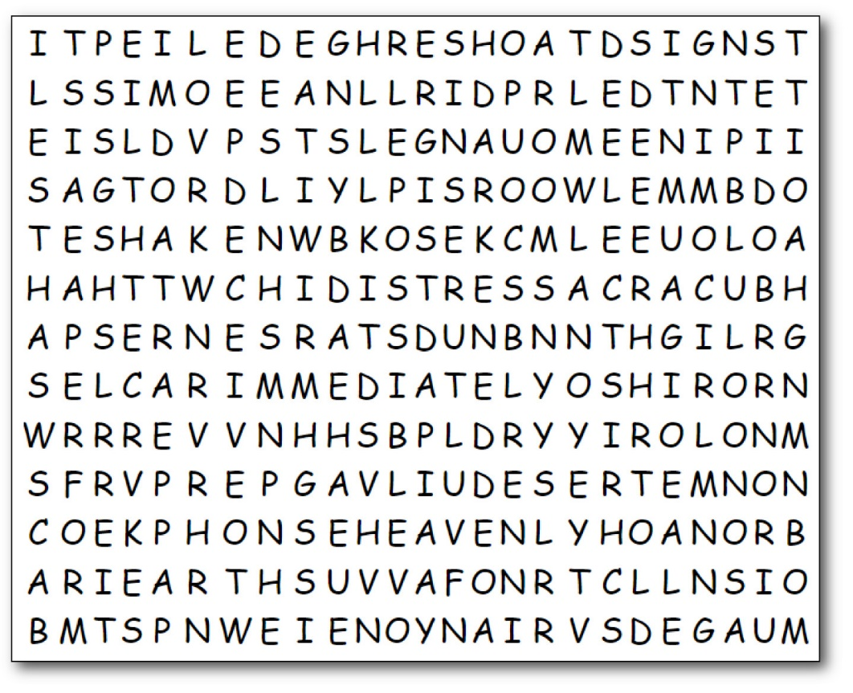
Word Search Puzzle
Humph! So, you think you can Watch? We’ll see! You’re going to need to look close to find these words. Watch out you don’t miss the words going up, down, left, right and diagonally. Better get it done so you have time for that book report. Humph! Bet you’ll need some help or wimp out and do the Crossword, Go to https://tinyurl.com/y2stwere

