1. Motivate
An introduction video is available.
View at https://watch.liberty.edu/media/t/1_67nji2t9
Download from https://tinyurl.com/ycxa6mgv

What was our favorite gift to give this Christmas?
- something I made for the other person
- something the kids were really wanting but never figured they’d get
- a model train I could play with too
- something that really surprised the other person
- an educational toy that will last more than a couple of days
- a gift that showed love
- the gift from me, to me … I knew no one would get that for me
- a family trip that we would remember forever

2. Transition

Today we will discover some things about the original Christmas gift givers and the gifts they delivered to Jesus.
- We study the Magi, the Wise Men
- Their gifts were significant and showed their worship

3. Bible Study

3.1 The Supreme Ruler

Matthew 2:1-6 (NIV) After Jesus was born in Bethlehem in Judea, during the time of King Herod, Magi from the east came to Jerusalem 2 and asked, "Where is the one who has been born king of the Jews? We saw his star in the east and have come to worship him." 3 When King Herod heard this he was disturbed, and all Jerusalem with him. 4 When he had called together all the people's chief priests and teachers of the law, he asked them where the Christ was to be born. 5 "In Bethlehem in Judea," they replied, "for this is what the prophet has written: 6 "'But you, Bethlehem, in the land of Judah, are by no means least among the rulers of Judah; for out of you will come a ruler who will be the shepherd of my people Israel.'"

What was extraordinary about the visit of these men from the east?
- they came a long way
- they were gentiles, why/how would they be interested in a royal birth
- they were led there by a star
- they came without knowing the whole story, the specifics of where to go
- (some people quip that if they were “wise women” instead of wise men, they’d not have had to ask for directions and they would have brought something useful, like a casserole!)

The Magi knew of the king of the Jews because of the special star they saw, what did the not know?
- where He was born, when He was born
- who He actually was
- that He was the Messiah – the “Sent One”
- that He was not a political king

How did King Herod react to the visit of the Magi?
- he was disturbed
- this caused all Jerusalem to also be disturbed
- when the king was unhappy, they knew there would be trouble

Why was a powerful king disturbed by the presence of a helpless baby?
- if he was the king, he didn’t want any competition
- when someone came along informing him of the birth of “the” king of the Jews, it threatened his power and authority
- the Magi seemed to be learned and informed men, what did they know that Herod did not

Herod felt that the Baby Jesus (the potential king) was in competition with him. Actually, Herod was in competition with God, Himself. How can we tell if someone or something is in competition, vying for God’s position of ruler in our lives?
- by how much time we spend involved in something, with someone
- by considering how much money we spend on that thing or that person
- by observing what tends to fill our thoughts, our dreams, our wishes
- by what we constantly talk about to others
- the types of books, magazines we read … how much, how often
- what kinds of plans we make

If the scholars knew what the scriptures said about the promised Messiah, why do you think they did not go worship Him themselves?
- they didn’t believe the gentile astronomers/astrologers
- they figured the Messiah would make a more grand and glorious entry onto the scene
- the appearance of the Messiah would be more obvious
- they thought His role would become evident when He assumed political or military power

They missed the Truth God had placed in scripture. What are some things we can do so we do not miss Truth God wants us to know as we study His Word?
- ask God to reveal it to you
- read it with an open mind
- learn some good study techniques
- look for what it says, what it means, what God wants you to do about it

3.2 Some Oppose Jesus’ Rule

Listen for Herod’s scheme.

Matthew 2:7-8 (NIV) Then Herod called the Magi secretly and found out from them the exact time the star had appeared. 8 He sent them to Bethlehem and said, "Go and make a careful search for the child. As soon as you find him, report to me, so that I too may go and worship him."

What were King Herod’s instructions to the Magi?
- tell me exactly when you saw this star that initiated your journey, your quest
- go and carefully search for the child
- when you find him, report to me
- “then I can go and worship him also “

How does it feel to have a rival—to feel as though you are being overlooked or replaced?
- humiliating
- discouraging
- alarmed, worried
- angry

How can a competitive, prideful, or insecure spirit alter a person’s behavior?
- anger
- plotting
- defensive
- scheming
- results in treachery
- or could go in the opposite direction and just give up, thinking the situation hopeless

Herod deceitfully used religion for personal ends. In what ways do people do this in our society today?
- join a church to look good, to gain a good image in the eyes of others
- go to church to make business or social contacts
- participate in various church activities to establish a position of power
- so they can play on the church baseball team
- to meet other singles
- for the inexpensive church dinners
- they like the music

Herod wanted to keep other people from showing allegiance to this “new king” – what kinds of things might keep you from truly worshiping when you come to worship services?
- distractions (people talking, personal problems, health problems)
- the environment (too hot, cold, uncomfortable, bright, dim)
- style of worship, music
- poor preaching
- wandering mind – lack of concentration, falling asleep

Some of these things you cannot change – but what can you deal with?
- ask for God's help to set personal problems aside
- sit in a different location to avoid talking around you
- take notes in order to help pay attention
- get more sleep outside of the worship service
- look for ways of focusing on God, not on the particular style of music that doesn’t fit your personal favorite
3.3 Worship Jesus, the King

Listen for how the Magi worshiped.

Matthew 2:9-11 (NIV) After they had heard the king, they went on their way, and the star they had seen in the east went ahead of them until it stopped over the place where the child was. 10 When they saw the star, they were overjoyed. 11 On coming to the house, they saw the child with his mother Mary, and they bowed down and worshiped him. Then they opened their treasures and presented him with gifts of gold and of incense and of myrrh.

Why did seeing the star again create feelings of joy?
- the star continued to guide them
- the star stopped over the place where Jesus and his family lived
- they had actually found the new born king

What did the wise men do when they finally saw the young King?
- bowed down
- worshiped Him
- opened their treasures, their gifts
A video is available which brings out these points.
View at https://watch.liberty.edu/media/t/1_botzmpcd
Download at https://tinyurl.com/ycxa6mgv
What might be the significance of their gifts?
- Gold: for Jesus royalty
- Frankincense: for Jesus deity
- Myrrh: for Jesus humanity

What are some various "presents" we might give to Christ?
- faithful giving of tithes and offerings
- our time and energy in the ongoing outreach of the church
- our skills and abilities

What do these verses teach us about authentic worship?
- the bowing down demonstrate showing honor, submission
- the gifts show honor and devotion
- the gifts honor Jesus royalty, eternality, even a prophetic element – myrrh being an embalming substance

What are some ways we can best express worship of Jesus?
- daily reading and meditation of God’s Word – heeding what God says
- daily communication with God through prayer
- sharing what Jesus means to you with others
- obedience
- regular joining together with others to sing His praises and receive teaching from pastors and teachers
- participation in the growth of the Kingdom of God, the advancing of the Gospel message around the world
Use the last page as a handout so your learners can take home the application points of this week’s lesson.

Application
Look.
- Slow down and reflect on some aspects of God’s beauty in creation.
- As you see something in God’s handiwork, like a star, let God lead you to worship Christ.
- Look for ways to pursue worshiping God.

Invite.
- Invite others to join you in worshiping the King.
- One way to start is by bringing them to your Bible study group.
- Encourage their participation and let them find Christ as they meet and worship with others.

Give.
- Just as the wise men gave gifts to the King, we also express our worship though giving.
- Make a commitment to give toward the ministry and mission of His kingdom’s work.
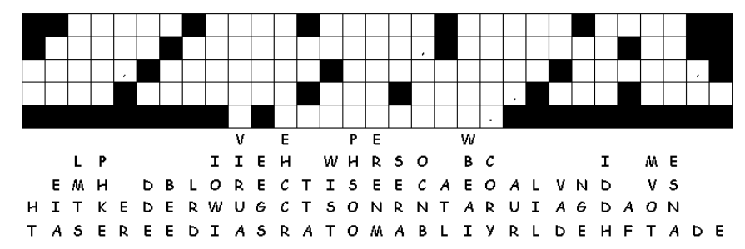

Fallen Phrases
The “Wise” Men dropped all the letters. You can figure out the message. The letters of the words fell straight down. Some letters are easy to figure out, like where there’s only one blank in that column. Look for two or three letter words and figure what two or three letters in those columns make a sensible word. This is an important message, get to work! If you get stuck, the solution is at https://tinyurl.com/ycxa6mgv Lots of other great family activities also.

