1. Motivate

What is something about work that you find satisfying?
- lawn mowing (and painting), you can see your progress, and when done, looks good
- when teaching and seeing the eyes light up in understanding
- finish a manual task and everything works
- put together something and no parts left over
- change oil on car and you mind tells you the car is now running smoother
- when you get a “thank you” or “good job” from client or customer
- just finishing the day and being able to relax
- anticipation of a vacation … counting the days

2. Transition

Some days, our jobs seem frustrating, other days they feel rewarding.
- Today we study Solomon’s take on working
- We will conclude that our work gains meaning when it’s done to honor Christ

3. Bible Study

3.1 Feeling of Futility

When we make out our wills, consider the decisions of who are recipients of our inheritance?
- In most cases our children, our progeny
- We may leave certain things to the one we feel is most responsible (house, family business)
- We might leave other things to those who we know will treasure them (jewelry, family heirlooms)

Listen for how Solomon felt about leaving behind his accomplishments.

Ecclesiastes 2:18-23 (NIV) I hated all the things I had toiled for under the sun, because I must leave them to the one who comes after me. 19 And who knows whether he will be a wise man or a fool? Yet he will have control over all the work into which I have poured my effort and skill under the sun. This too is meaningless. 20 So my heart began to despair over all my toilsome labor under the sun. 21 For a man may do his work with wisdom, knowledge and skill, and then he must leave all he owns to someone who has not worked for it. This too is meaningless and a great misfortune. 22 What does a man get for all the toil and anxious striving with which he labors under the sun? 23 All his days his work is pain and grief; even at night his mind does not rest. This too is meaningless.

Find words in the text that describe Solomon’s feelings or emotions.
- hated
- despair
- misfortune
- anxious, unrest
- pain
- grief
What concern did he have about the character of the person who would succeed him and inherit or in some way acquire all he had worked hard to gain for himself?
- that person could be either wise or a fool
- he/she might squander it or do nothing with it or build it even more … who knows?
- it is an uncertainty that causes all my effort to be a great misfortune

When have you seen someone working all of their life and leaving it to someone else to reap the benefits?
- current inheritance laws force a hardworking farmer or business owner’s family to lose the business when he passes
- when the next generation runs the business into the ground
- when a son or daughter has no inclination to work and the parent has no one willing or able to continue the business
- the following generation squanders the family’s fortune

When have you felt like your work was futile or limited?
- students who refuse to learn
- when you finished your task and someone or some event happens to ruin the work
- you work hard on a project and someone else gets the credit or reward
- you get done and the object you’ve created is no longer needed, wanted
- the whole time you’re working on a task, you know it is just busy work

What products can you think of where almost overnight are made obsolete by a different industry?
- slide rules replaced by calculators
- chalk boards replaced by white boards with markers
- VCR’s replaced by streaming video on demand, digital files
- camera film development, also replaced by video files
- daisy wheel and dot matrix printers – replace by ink-jet and laser printers
- Overhead projectors, slide projectors (and photographic slides) – now use video projectors
All these represent people who designed and manufactured products and have lost those jobs. Even if you found other or similar work, you still could feel frustration at all the previous work now meaningless.
- Polaroid cameras, film cameras – by digital cameras
- Library card catalogs --
- Beepers, pagers
- Cassette tapes, vinyl records
- Typewriters
- Rotary phones, Public phone booths, phone books
- Walkman, portable cd players, mp3 players

How would you summarize the current older generation’s approach to work?
- work hard
- keep at it
- you might not like what you do, but it pays the bills
- it’s your job … do it

How has our culture’s attitude toward work changed over the years?
- I want the high paying job right now
- I want the nice house and the cool car right now
- I want all that great looking furniture in my new house … right now
- my job will have at least two weeks’ vacation from the git-go
- no dirty jobs for me

In what ways does a misplaced focus on work, money, and leaving an inheritance lead to many sleepless nights?
- worried about having enough
- worried about paying for what you do have
- worried about children who do nothing but play, have no sense of work
- worried about what majors kids might take in college – (art history, political science, performing arts, etc. … all nice, but not always marketable skills)

What actions on our part increase the likelihood that those who follow us will treasure the real treasures and work for genuine values?
- when we value relationships
- when we place priority on knowing and serving God … not idols of some of the dead ends we’ve talked about today
- model a correct attitude towards intellectual pursuits, pleasures, material goods, work … what you do speaks louder than what you say

3.2 Work Is God’s Gift

Listen for comments on eternity.

Ecclesiastes 3:9-13 (NIV) What does the worker gain from his toil? 10 I have seen the burden God has laid on men. 11 He has made everything beautiful in its time. He has also set eternity in the hearts of men; yet they cannot fathom what God has done from beginning to end. 12 I know that there is nothing better for men than to be happy and do good while they live. 13 That everyone may eat and drink, and find satisfaction in all his toil--this is the gift of God.

How is the fact that God has placed eternity in our heart manifested in our society?
- most people believe in some sort of existence after physical death (though some do not)
- people talk about a “former existence” or a “former life”
- people will say, “when I die, I want to come back as a …”
- people try to contact the spirits of the deceased
- we want to believe that physical death is not the end of it all

According to these verses, how might the anticipation of eternity be frustrating?
- we cannot fathom what God is doing – what is God’s overall plan
- it can be an abstract concept
- it is outside the realm of our experience and we’re not sure exactly what to expect
- we have an inborn drive to stay alive, yet we can see (like Paul) that to be with the Lord is better than what we have now

What troubling question does the Preacher surface in these verses?
- what does the worker gain from his toil?
- is there anything besides our pay that we gain?
- is that all there is to work?
- can’t we accomplish something that gives us a sense of contributing to society (beyond building/manufacturing more widgets for people to buy)?

How does the Preacher seem to assess work in the scheme of God’s order of things?
- God wants us to have happy and fulfilling lives
- we need to be “doing good”, both in our work and our personal lives
- when people work, they are able to provide food for themselves and their families
- God wants us to find satisfaction from our labor

Solomon says that our labor, our work is a gift from God. How would that attitude help us? What difference does one’s attitude toward work make in doing that work?
- realize we cannot take our jobs for granted
- it is worth more to us than just the check at the end of the pay period
- it gives meaning to life
- it helps us realize that God intends for us to accomplish something good in what we do … even if it is one of Mike Rowe’s “Dirty Jobs”

What are some things you can do in your current phase of life to enjoy the fruit of your labor?
- enjoy leisure time, hobbies
- have pursuits such as sports
- anticipate our vacations
- enjoy seeing our children mature and become productive citizens
- thank the Lord when we see our kids following the Lord faithfully, our teachings pay off and our prayers answered

How could approaching work as a gift from God benefit you and be a witness to others?
- you are grateful to God for an opportunity to make a living
- you look at the job as more than just a paycheck
- you work faithfully – on time, giving best effort, maintain a positive attitude
- fellow workers see that mindset in you
- you can share with them your philosophy of God at work in your life

Use the last page as a handout so your learners can take home the application points of this week’s lesson.

A video is available for the Application Points
View at https://watch.liberty.edu/media/t/1_zfnevapd
Download at https://tinyurl.com/y4x7n5se

Application
Be thankful.
- Acknowledge that the job you have and the work you do is from God.
- Give Him thanks.

Rest.
- Balance your work with rest.
- Your work is important, but it should never consume you.
- Block out time daily for rest, and set aside a day for rest.

Work for Christ.
- Consider the ways you can honor Christ and bring an eternal perspective to your work.
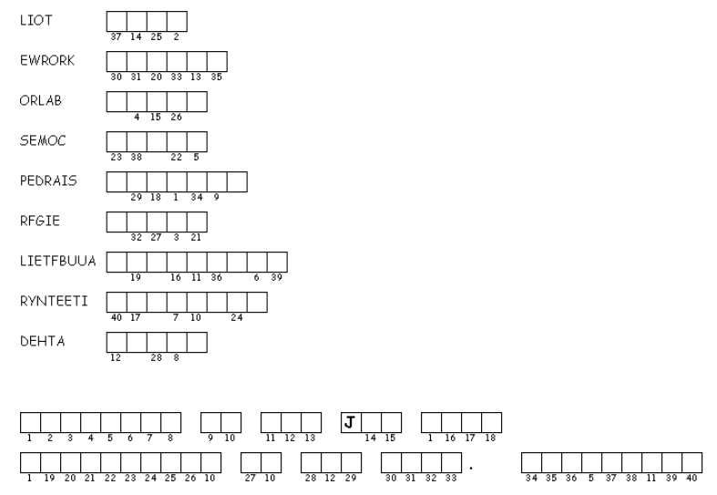
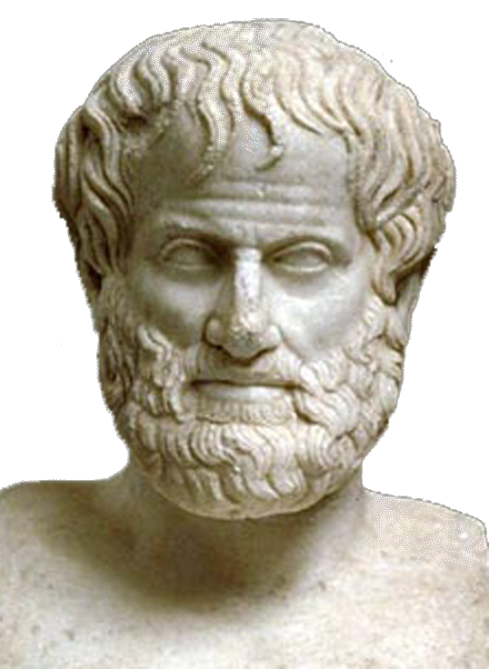
- Don’t consider just the things you do; consider the people you interact with. Look for ways to point to Christ in your work-related relationships
Hard to believe one of my quotes are still around … and how did it get onto the internet (whatever that is). Unscramble each of the clue words (which you can find in Ecclesiastes 2:18-23; 3:9-13 , NIV) and then copy the letters in the numbered cells to other cells with the same number, you might be able to figure out what I said … and who I am.
Find the solution and other great family activities at
https://tinyurl.com/y4x7n5se

Double Puzzle

