1. Motivate

What valuable life lesson have you learned that had nothing to do with formal education?
- how to swim
- how to play baseball, football, basketball
- mechanical stuff … changing a tire, changing the breaks on a car, changing the oil on a vehicle
- skills on hobbies … carving, sewing, crafting, golf, weaving, fishing, …
- best way to mow a lawn, mop a floor
A video is available for the introduction
View at https://watch.liberty.edu/media/t/1_ovjc0tkv
Download at https://tinyurl.com/y283nekr
- how to make dishwashing easy
- getting along with others

2. Transition

Education and even experience can only do so much
- True Wisdom is grounded in trust in God.

3. Bible Study

3.1 Limited Advantages of Wisdom

Listen for a contrast.

Ecclesiastes 2:12-17 (NIV) Then I turned my thoughts to consider wisdom, and also madness and folly. What more can the king's successor do than what has already been done? 13 I saw that wisdom is better than folly, just as light is better than darkness. 14 The wise man has eyes in his head, while the fool walks in the darkness; but I came to realize that the same fate overtakes them both.15 Then I thought in my heart, "The fate of the fool will overtake me also. What then do I gain by being wise?" I said in my heart, "This too is meaningless." 16 For the wise man, like the fool, will not be long remembered; in days to come both will be forgotten. Like the fool, the wise man too must die! 17 So I hated life, because the work that is done under the sun was grievous to me. All of it is meaningless, a chasing after the wind.

What subject did the Preacher return to in these verses? What two things did he contrast?
- wisdom
- madness and folly

What advantage did wisdom have over folly?
- it is better than folly
- like light is better than darkness
- wisdom gives ability to “see”
- the fool goes around like he’s in the dark

Why is human wisdom inadequate for life’s biggest problems?
- many things are beyond our knowledge or skill
- as we grow older that knowledge is harder to recall, the skills fade
- we might know what to do, but don’t have the influence or resources to make it happen
- other forces work against us to make our wisdom ineffective or inapplicable

Who are some people you’ve heard of whose memory of them has lasted longer than others?
- “Wrong Way Corrigan” took off from NY headed for LA and ended up in Dublin
- Einstein is remembered for his theories on relativity, other well-known scientists
- Other famous sports figures – like the guy on the Wide World of Sports who demonstrated the “agony of defeat” – though few know his name – Vinko Bogataj
- many famous or infamous political figures
- royalty who made a big splash in the news or in history

Nevertheless, what fate did both the wise and the foolish, the famous and the infamous share in common?
- they share the same fate
- they both end up dying
- wisdom or fame, either one, doesn’t keep you from dying

Why did his realizing that common fate prove to be troublesome to the Preacher?
- if you are wise or famous, memory of you will not last forever
- if you are a fool or infamous, memory of you will also fail eventually

What words or phrases did the Preacher use again concerning wisdom and his search for significance?
- says he hated life
- all his work was grievous
- meaningless
- like chasing after the wind

How does knowing Christ as your personal Savior and Lord change each of Solomon’s perceptions of life?
- Jesus gives us life abundant
- being set free from the penalty and power of sin gives new meaning to life
- serving the Lord gives focus and provides opportunity for eternal accomplishments

3.2 Limited Abilities of Wisdom

Listen for what is unreachable.

Ecclesiastes 7:23-25 (NIV) All this I tested by wisdom and I said, "I am determined to be wise"-- but this was beyond me. 24 Whatever wisdom may be, it is far off and most profound-- who can discover it? 25 So I turned my mind to understand, to investigate and to search out wisdom and the scheme of things and to understand the stupidity of wickedness and the madness of folly.

What had the Preacher determined to do? How successful was he?
- tested all his experiences by applying wisdom
- he determined to be wise and act wisely
- found out some things were beyond his ability, skills, wisdom

Why did he fail? If he came to know anything, what was it?
- wisdom is “far off”
- it is too profound to be fully acquired or applied
- who can discover it
- our sinful natures are limited

What are some things in our day that human wisdom still cannot explain?
- the extent of the universe
- gravity – we measure it, but don’t know why or how it works
- is light made up of waves or particles
- what is time?
- the origin of the universe (Big Bang theory … God said “Bang” and there it was ☺ ),
- sub-atomic particles
- certain functions of our bodies

Since wisdom is beyond us, why do we continue pursuing it?
- we want to know more, to gain more knowledge
- God has made us inquisitive … “inquiring minds want to know”
- we want the wisdom to be able to solve our problems and the problems of society

How does a person gain true wisdom? What advice would you give to Solomon?
- study
- life experiences
- God’s Word – read it carefully, ponder it, apply it to your life
- allow God to illuminate His Truth in scripture
- heed the guidance of God’s Holy Spirit

3.3 Pursue Knowledge and Apply God’s Wisdom

Listen for what people search.

Ecclesiastes 7:26-29 (NIV) I find more bitter than death the woman who is a snare, whose heart is a trap and whose hands are chains. The man who pleases God will escape her, but the sinner she will ensnare. 27 "Look," says the Teacher, "this is what I have discovered: "Adding one thing to another to discover the scheme of things-- 28 while I was still searching but not finding-- I found one [upright] man among a thousand, but not one [upright] woman among them all. 29 This only have I found: God made mankind upright, but men have gone in search of many schemes."

What did Solomon find while he was still searching? (7:27-29)
- upright people are hard to find
- one in a thousand of men … 0 in a thousand of women
- God made men upright
- but men have “gone in search of many schemes”

Why do people tend toward extremes rather than balance?
- desire for fame
- desire for power
- just to pursue their own desire, pleasures

Why do people choose to go in search of their own schemes rather than follow God’s plan?
- sinful nature
- to satisfy their own appetites
- lack of faith in God’s wisdom, power, authority, love

What sort of schemes are people in our society pursuing?
- get rich quick
- sexual pursuits
- fame and power in politics
- fame in sports
- pleasure in substance abuse

What example did the Preacher cite of something to be avoided by one who would live according to godly wisdom?
- giving in to sexual temptations, enticements
- being trapped, ensnared, enslaved by sexual desires
- ruins all the good that God has given us in a marriage

How does trust in God’s wisdom add value to your life?
- confession, repentance, and placing faith in Christ’s redemptive work sets us free from sin’s penalty
- continued trust in God sets us free from sin’s power over us
- Jesus is the “author and finisher” of our faith
- we are made both positionally and experientially free from sin
- we are enabled to live a life that pleases God, an abundant life
- when we follow the “Owner’s Manual” for living (the Bible) our lives are richer, fuller

How does the fear of God (Prov. 1:7) help us gain wisdom?
- fear of God is awe of Who God is and what He can do
- instead of being in awe of what the world offers, we are in awe of God’s ways
- we will gain wisdom by learning more about God
- by learning more of His power, and authority, and love
Use the last page as a handout so your learners can take home the application points of this week’s lesson.

Application
Consider God’s good creation.
- On a clear night this week, go outside and look up at the stars.
- Read Genesis 1 and Psalm 8, and thank God for His wise, creative, and powerful work.

Memorize Proverbs 3:5-6.
- “Trust in the Lord with all your heart, and do not rely on your own understanding; in all your ways know him, and he will make your paths straight.”
- As you go through the week, think of ways you can pursue God and trust in His wisdom, rather than relying on yourself.

Have a conversation.
- Spend time with an unbelieving friend, and ask them how they might explain the problems in the world and the nature of sin and evil.
- As you listen without judging, pray and seek the opportunity to share the gospel and the wisdom of God.
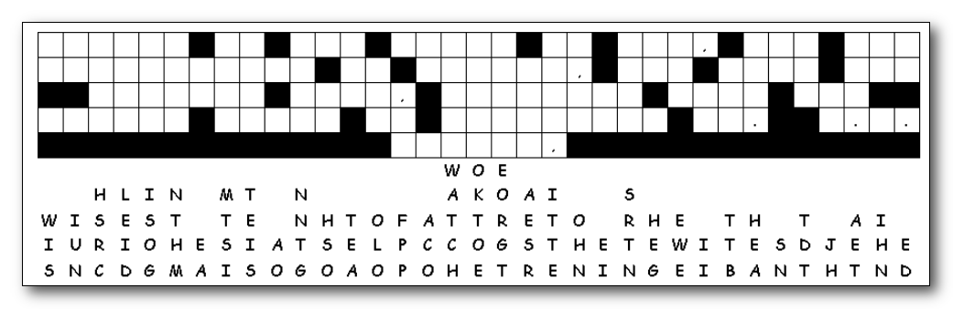
Fallen Phrases
The letters up above fell straight down! Replacing some letters should be easy to figure out, like where there’s only one blank in that column. Look for two or three letter words and figure what two or three letters in those columns make a sensible word. You can learn an important fact about wisdom by solving the puzzle. If you’re stuck, find the solution at
https://tinyurl.com/y2vd93pe along with other really cool Family Activities


