1. Motivate

Why do you think the entertainment industry (movies, television, etc.) is such a booming
business?
A video introduction is available. View at https://watch.liberty.edu/media/t/1_qxd273hi
Download at https://tinyurl.com/y5cmtrdl
- people have excess time
- people looking for pleasure
- it is an escape
- much of TV is informational (although slanted in a certain direction) and inquiring minds want to know
- they are dissatisfied with their own lives and want to experience something else
- new technologies make TV and movies very engaging experiences (visual, audio, surround sound … no smell-o-vision yet)

2. Transition

Today we look at someone who had the money and time and power to experience everything that life in his day could offer
- He came to the conclusion that it was futile … they were all dead ends.
- Pleasures and possessions don’t offer lasting joy

3. Bible Study

3.1 Pleasure Accomplishes Nothing

Listen for attempts for satisfaction.

Ecclesiastes 2:1-3 (NIV) I thought in my heart, "Come now, I will test you with pleasure to find out what is good." But that also proved to be meaningless. 2 "Laughter," I said, "is foolish. And what does pleasure accomplish?" 3 I tried cheering myself with wine, and embracing folly--my mind still guiding me with wisdom. I wanted to see what was worthwhile for men to do under heaven during the few days of their lives.

What things did Solomon try to find pleasure?
- laughter, humor
- alcohol

What was his conclusion?
- laughter is foolish
- the pleasures he sought were meaningless

How does society encourage the pursuit of pleasure?
- television, movies
- use of alcohol and other mind altering substances
- acquiring bigger and better stuff – cars, houses, sports equipment, large screen TV’s, phones
- spectator sports

When does pleasure become meaningless or even harmful?
- over spending
- health affected
- time wasted
- when it becomes something that controls us

What kinds of pleasures are bad, lead us away from God?
- pleasures that pervert the good things God gives us (sex, humor, even food)
- pleasures that are temporal only – feel good now, hurt us in the long run (substance abuse)
- things that become idols in our lives … become more important to us than God is

Note Solomon’s risky behavior in regard to alcohol: (This portion is lecture)
- Solomon experienced the pull of alcohol without letting it take control of his life. This is not always possible. Drunkenness and alcoholism can lead to misery.
- The Hebrew word for folly refers to practicing self-indulgence.
- Solomon practiced moderation. He maintained his senses and still found no purpose or meaning in wine.

What kinds of pleasures can lead to God’s purposes in our lives?
- Christian music
- appreciation of nature (sunsets, beautiful flowers, majestic mountains, etc.)
- sports which help us keep fit and healthy
- a sense of humor, ability to laugh at our own foibles – Proverbs 17:22 (KJV) A merry heart doeth good like a medicine: but a broken spirit drieth the bones.

3.2 Possessions Distract

Listen for all that Solomon acquired.

Ecclesiastes 2:4-8 (NIV) I undertook great projects: I built houses for myself and planted vineyards. 5 I made gardens and parks and planted all kinds of fruit trees in them. 6 I made reservoirs to water groves of flourishing trees. 7 I bought male and female slaves and had other slaves who were born in my house. I also owned more herds and flocks than anyone in Jerusalem before me. 8 I amassed silver and gold for myself, and the treasure of kings and provinces. I acquired men and women singers, and a harem as well--the delights of the heart of man.

List the possessions identified in the passage.
- male and female slaves
- herds, flocks
- silver and gold
- treasure of kings and provinces
- men and women singers
- a harem

Identify the various actions he undertook to enhance his pursuit of pleasures that might add meaning to his life.
- Building projects – houses, vineyards, gardens, parks with fruit trees
- Accumulating wealth
- Patronizing the arts
- Indulging himself sexually

What might the fact that he tried so many things say about the effectiveness of any one of them?
- satisfied only for a time
- the interest in the waned
- not ultimately fulfilling

Why do you think we find pleasure in accumulating stuff?
- we have to have that one more or new and improved item
- we tell ourselves that will make life better
- the old one is worn out or looks bad compared to the neighbor’s
- it will save us time … or … make us look better

Consider Tim. 6:17-19 Command those who are rich in this present world not to be arrogant nor to put their hope in wealth, which is so uncertain, but to put their hope in God, who richly provides us with everything for our enjoyment. [18] Command them to do good, to be rich in good deeds, and to be generous and willing to share. [19] In this way they will lay up treasure for themselves as a firm foundation for the coming age, so that they may take hold of the life that is truly life.

According to Timothy, what is God’s purpose for possessions?
- don’t arrogantly put hope in wealth
- put hope in God
- trust Him to provide everything for our enjoyment
- do good, be rich in good deeds
- be generous and willing to share
- lay up for yourselves treasures in heaven

3.3 Pleasure and Possessions Don’t Last

Listen for Solomon’s final conclusion.

Ecclesiastes 2:9-11 (NIV) I became greater by far than anyone in Jerusalem before me. In all this my wisdom stayed with me. 10 I denied myself nothing my eyes desired; I refused my heart no pleasure. My heart took delight in all my work, and this was the reward for all my labor. 11 Yet when I surveyed all that my hands had done and what I had toiled to achieve, everything was meaningless, a chasing after the wind; nothing was gained under the sun.

What did Solomon seem to be bragging about?
- became greater by far than anyone who had proceeded him
- was able to deny himself nothing he wanted
- took delight in his work – this was his reward
- maintained his wisdom

But upon a deeper introspection in light of his desire to find meaning in life, what disturbing conclusion did he reach?
- surveyed all he had accomplished
- looked at all the things he had worked on
- decided ultimately it was meaningless
- it was a chasing after the wind
- nothing was actually gained

Why do you think he felt this way?
- despite all the stuff he wasn’t truly satisfied
- stuff doesn’t ultimately satisfy
- joy and satisfaction is found more in relationships than in ownership
- God did not create us to find meaning in our acquiring more material things
- God intended that we find meaning and satisfaction and joy in knowing and serving Him
- Solomon discovered this fact after spending lots of time and resources

Why can’t we rely on our possessions to bring us fulfillment?
- they break, wear out, become obsolete
- they interest us for a while but fail to keep us satisfied
- always someone else who has newer, better, bigger
- the people who try to sell us all that stuff are not working to help us, they’re after our money

How can we determine how much we are basing our self-worth on personal achievements or accumulations?
- look at your checkbook or your credit card bill … where is your money going
- look at your schedule … how are you spending your time
- look at how much stuff you have that never or rarely gets used
- contrast these with how much of your resources are being spent on the Kingdom of God

Our Bible study lesson resources states: We may accomplish our heart’s desire, but those desires are void of meaning if they exclude God.

So how do we include God in how we spend our time and energy?
- Involvement in Christian, spiritual ministries
- Daily time with God – Scripture reading, careful consideration and application of its Truth, talking to God in prayer
- mentoring our children, grandchildren
- spending quality time with family – prioritized ahead of work and hobbies
- sharing your faith – through words and deeds
Use the last page as a handout so your learners can take home the application points of this week’s lesson.

Application

Give God the glory.
- How can you fight against the empty pursuit of pleasure?
- Identify something you enjoy—and do it.
- But do it to honor Christ and give God the glory.

Memorize Philippians 4:4-7.
- Memorize this passage and recall it when you become anxious, discouraged or the toils of your own struggle tempt you to seek “reward” in the wrong way.

Acknowledge the achievements of others.
- Too often, we get caught up in our own achievements. That leads to a false “reward” mentality.
- Contact others and thank them for their achievements.
- Encourage them.
- Consider ways to do this that also affirms them in the presence of others.
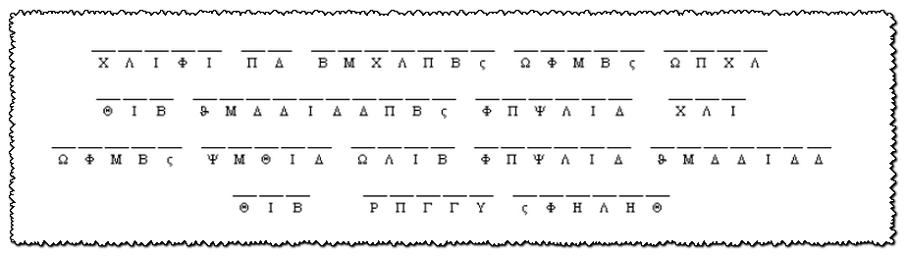


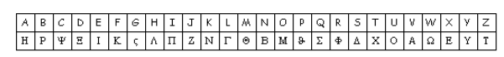
Cryptogram
I found this secret message floating in the river. Because of the water damage, I cannot read it. We did receive a dry version of the message, but it’s encrypted. Help me out here and use the key below to find out what it says and who it’s from. It’s supposed to have to do with your Bible Study from Ecclesiastes 2, so that’s a clue. The solution and other engaging activities can be found at https://tinyurl.com/y5cmtrdl

