1. Motivate
What are some warning labels you actually pay attention to?
- close cover before striking
- do not remove this tag upon penalty of law
- don’t take this medicine and operate heavy machinery
- don’t drive and text
A video introduction is available. View it at https://watch.liberty.edu/media/t/1_4l858dp2 If you have no wi-fi where you teach, best to download to your computer from https://tinyurl.com/zptmj7ze
- don’t hold the wrong end of the chainsaw
- do not use microwave for drying your pet
- Do not stand, sit, climb, or lean on zoo fences
- Touching wires causes instant death, $2000 fine

2. Transition

Warning labels are there for our protection
- Wouldn’t it be nice if temptation came with a warning label?
- Today we look at resisting temptation
- It’s easier to resist when we know what is at stake

3. Bible Study

3.1 Be Careful !

Listen for good news and bad news.

Genesis 39:1-7 (NIV) Now Joseph had been taken down to Egypt. Potiphar, an Egyptian who was one of Pharaoh's officials, the captain of the guard, bought him from the Ishmaelites who had taken him there. The LORD was with Joseph and he prospered, and he lived in the house of his Egyptian master. 3 When his master saw that the LORD was with him and that the LORD gave him success in everything he did, 4 Joseph found favor in his eyes and became his attendant. Potiphar put him in charge of his household, and he entrusted to his care everything he owned. 5 From the time he put him in charge of his household and of all that he owned, the LORD blessed the household of the Egyptian because of Joseph. The blessing of the LORD was on everything Potiphar had, both in the house and in the field. 6 So he left in Joseph's care everything he had; with Joseph in charge, he did not concern himself with anything except the food he ate. Now Joseph was well-built and handsome, 7 and after a while his master's wife took notice of Joseph and said, "Come to bed with me!"
Even though Joseph was sold as a slave, how did God bless Him?
- gave him a good master
- blessed Joseph’s work
- prospered Potiphar as Joseph served him
- Potiphar trusted him
- God was with him

As far as his assets were concerned, to what degree did Potiphar trust Joseph?
- put Joseph in charge of his household
- entrusted to Joseph’s care everything he owned
- did not have to concern himself with any of his responsibilities

We are told that God was with Joseph. In general, what characteristics about someone suggest that God is with him or her?
- stable personality
- capable with job responsibilities
- “self-starter”
- can be trusted, has integrity
- honest, trustworthy
- problem solver
- not easily rattled
- attitude of trust towards God

What are some dangers we face when things are going well for us?
- complacency
- forget it was God who blessed and gave success
- begin to attribute the success to our own stellar abilities
- quit trusting God

Why is it important to stay on guard against temptation when things are going well?
- we forget it was God who blessed and gave success
- figure we can handle anything that comes along
- tend not to depend on God’s help
- when we try to handle things on our own, we are in danger of failure

What was the temptation with which Joseph was confronted?
- Potiphar’s wife saw how handsome he was
- she tried to seduce him
- she pursued him repeatedly

3.2 Be Ready !

Listen for trouble.

Genesis 39:8-10 (NIV) But he refused. "With me in charge," he told her, "my master does not concern himself with anything in the house; everything he owns he has entrusted to my care. 9 No one is greater in this house than I am. My master has withheld nothing from me except you, because you are his wife. How then could I do such a wicked thing and sin against God?" 10 And though she spoke to Joseph day after day, he refused to go to bed with her or even be with her.

How did the temptation intensify?
- she repeated her invitation
- got to be a daily proposition

On what basis did he refuse to give in to the temptation?
- didn’t want to betray the trust Potiphar had placed in him
- didn’t want to sin against his boss
- didn’t want to sin against God
- this would be a wicked thing to do

Why did Joseph have to exercise constant vigilance?
- she was persistent in pursuing Joseph
- spoke to him day after day
- his duties required his presence in and around the house where she was

What are the consequences of sexual sin?
- the obvious is an unwanted pregnancy
- can quickly ruin multiple marriages
- causes irreparable harm to relationships
- remember all the trouble David got into trying to cover up his sin against Bathsheba … lying, murder, involvement of others with the cover up

What kinds of negative effects result when we give in to any temptation?
- an offense to God
- makes sin easier the next time
- sin takes you out of fellowship with the Lord
- your testimony is at stake
- your relationship with the lord is harmed

What should motivate us to strive for holiness?
- God’s commands
- our close relationship with the Lord
- our testimony with those close to us
- desire to do the right thing
- God’s indwelling Holy Spirit places within us a desire to do the right thing
- the negative results of sin

3.3 Run !

Listen for an escape plan.

Genesis 39:11-12 (NIV) One day he went into the house to attend to his duties, and none of the household servants was inside. 12 She caught him by his cloak and said, "Come to bed with me!" But he left his cloak in her hand and ran out of the house.
In what unavoidable situation did Joseph find himself?
- Mrs. Potiphar set him up
- no one else in the house except her
- Joseph must enter to carry out his responsibilities
- she waylays him physically by grabbing his clothing and hanging on
- insists on involving him in sexual sin

How did Joseph respond?
- run away
- she’s got hold of his cloak, he sheds it and takes off
- she’s left holding an empty cloak

In a culture saturated with temptation, how do we avoid giving in to temptation?
- claim God’s promise, 1 Corinthians 10:13 (NIV) … God is faithful; he will not let you be tempted beyond what you can bear.
- avoid situations where you know you will be tempted
- fill your mind with God’s Truth
- don’t expose you mind to the world’s temptations
- like Joseph, run away

We talked about negative effects of giving in … what would be positive effects of resisting and rejecting temptation?
- makes you stronger for the next time
- keeps your mind and emotions free from the shame and guilt of giving in
- pleasing, glorifying to God when you choose right over wrong
- we will see that Potiphar’s wife got him in trouble by lying, but even then, Jospeph had the assurance that he had done the right thing

What role does our group play in helping us overcome temptation?
- prayer support
- accountability support
- actual physical help
- promise one another, “call me if you are stuck, if you are about to fail”
Use the last page as a handout so your learners can take home the application points of this week’s lesson.
Application
Take stock.
- Do you find it difficult to walk away from certain temptations?
- Ask God to help you form a plan to fight repeating temptations in your life.

Partner up.
- Sometimes the best gift God can give us in the face of temptation is a godly friend.
- Reach out to a friend this week and ask if they will hold you accountable to a specific temptation you are trying to avoid.
Begin a fast.
- One of the ways to overcome temptation is to train our minds using a spiritual discipline like fasting.
- This week, choose to devote TV time to devotional reading, developing friendships, or taking prayer walks.

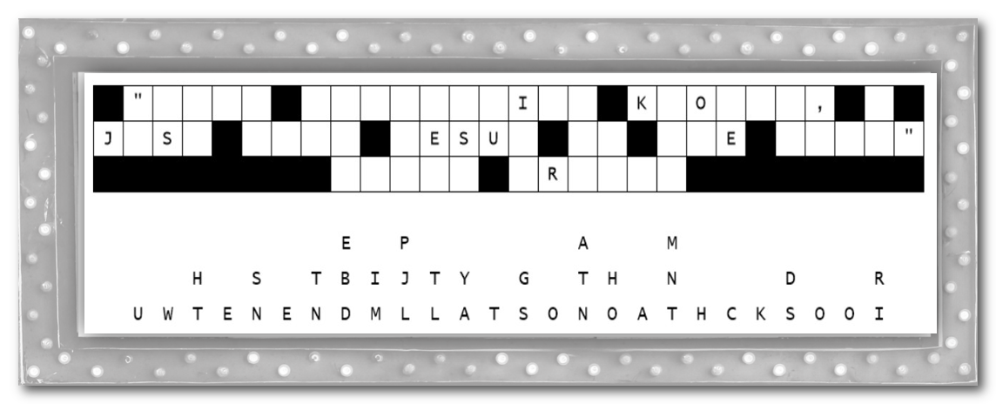
Fallen Phrases Puzzle
Oh no … the fasteners on the marquee let loose and all of the letters fell straight down. Help us out, please. Look for single letter columns, then check shorter words and see what letters make sense in those columns. A free movie for you if you can fix it for us! If you get stuck, go to https://tinyurl.com/zptmj7ze You’ll find additional Family Activities there as well

