1. Motivate

As a child or a young person, what events did you eagerly anticipate?
- Christmas
- birthday
- vacation
- visit by/to grandparents
- siblings home from college
- end of school year
A video introduction to the lesson is available. View it at https://tinyurl.com/ywt78p53 .
If you have no wi-fi where you teach, you should download the video file to your computer from https://tinyurl.com/bdhpzarb
- first date
- graduation

2. Transition

In the spiritual realm the one great event to which we look forward is Jesus' return.
- The Christians in Thessalonica were worried that loved ones who had passed with regard to the Second Coming of Christ.
- Today we consider the truth that Jesus will return one day.
- We are admonished to be ready

3. Bible Study

3.1 Jesus Will Return

Listen for all that announces Christ’s return.

1 Thessalonians 4:16-18 (NIV) For the Lord himself will come down from heaven, with a loud command, with the voice of the archangel and with the trumpet call of God, and the dead in Christ will rise first. 17 After that, we who are still alive and are left will be caught up together with them in the clouds to meet the Lord in the air. And so we will be with the Lord forever. 18 Therefore encourage each other with these words.

What are the three methods of announcing Christ's return? Why will it not be missed or overlooked by the whole world?
- a shout
- the archangel's voice Everyone in the world will hear/see/know.
- the trumpet of God

Some believers within the local church had died since Paul had visited with them.
- Those still alive were confused.
- Would these dead believers miss the resurrection at Jesus return?

How does Paul reassure them?
- God will bring those with Him who have "fallen asleep" through Jesus
- the dead in Christ will rise first

What does this suggest how Christians should mourn the death of a fellow believer? How can these words help a person who is grieving over loved ones who have died?
- we certainly grieve and miss that person
- we miss our interaction with them, the relationship we had
- BUT … we know that Heaven is a better place to be
- if they died of sickness, they are totally healed now … they suffer no more
- they are with their own loved ones who have passed on previously
- best of all, they are with Jesus!

What will the living experience when Christ returns?
- we still alive will have no advantage over those who had died
- we still alive will be caught up together with them to meet the Lord in the air
- thus we will always be with the Lord

What makes you think that the Lord’s return could happen in our lifetime?
- world events
- the growing anti-Christian attitude in our country
- the growing persecution of believers in other countries
- Scripture talks of “wars and rumors of wars” … which we have
- also mentions increase in earthquakes … which we see

How can these words help a person who is grieving over Christian loved ones who have died?
- as believers we will be with them again
- they are in God’s presence now
- they (and we) will be in God’s presence forever
- certainly we can miss them now, but we will one day be reunited

Note the end of the passage about being with the Lord forever … someone said that people who don't enjoy Jesus' presence now might not be comforted by the thought of eternity with Him!

How can we seek to increase our joy in Jesus company here on earth?
- Christian friendships
- worship
- prayer
- singing praises to Him
- Bible study
- enjoying His creation (not always quite so concerned about your golf score or the fish you hope to catch or how your team will do this weekend)

3.2 Specific Time Unknown

Listen for a timetable.

1 Thessalonians 5:1-3 (NIV) Now, brothers, about times and dates we do not need to write to you, 2 for you know very well that the day of the Lord will come like a thief in the night. 3 While people are saying, "Peace and safety," destruction will come on them suddenly, as labor pains on a pregnant woman, and they will not escape.

Actually, Paul says there’s no need to write about the exact time of Christ’s return. Why do you think he stressed this point? Why doesn’t God intend for us to know?
- He didn’t know the time or sequence of events
- Recall that Jesus declared that as a human, He didn’t know, only the Father did
- God doesn’t tell us because He wants us to live by faith
- Otherwise we would goof off until the week, day, hour of His return until we got our act together

Verse 2 compares the coming of the Lord to “a thief in the night.” What parts of this metaphor suggest about how we should prepare for Christ’s return?
Thief in the Night | Christ’s Return
- Know he’s coming, don’t know when  - Prepare for the possible event  - Set a watch for his coming  - You know he’s coming, be ready | - exactly the same  - live like it’s today, work like it’s far off  - be looking for signs given in Scripture  - live like it’s today, work like it’s far off

In verse 3, Paul mentions people saying, “Peace and safety,” just before sudden destruction comes. How do we see that in our world today?
- easy to be complacent
- things are going OK right now
- politicians and even some Christians are focusing on the relative peace in the world
- politicians are working towards de-escalation of hostilities and anticipating good results

What might this warning mean for us today? For unbelievers? For believers?
- we focus on the hoped for “peace and safety”
- we tend to ignore the “sudden destruction”
- for unbelievers there will be destruction
- believers must be focusing on God’s plan and purposes

How can we balance living with hope for Christ’s return and being responsible with our present lives? What practical steps can we take to be ready, even though we don’t know when He will come?
- daily communication with God – read, think seriously on Scripture … talk to God in prayer
- be involved in Kingdom ministries – church outreach, ministering to the Body of Christ
- live as a credible Christian before unbelieving friends, family, on the job, neighbors
- support God’s work – local, around the world
3.3 Diligently Wait

Listen for contrasts.

1 Thessalonians 5:4-8 (NIV) But you, brothers, are not in darkness so that this day should surprise you like a thief. 5 You are all sons of the light and sons of the day. We do not belong to the night or to the darkness. 6 So then, let us not be like others, who are asleep, but let us be alert and self-controlled. 7 For those who sleep, sleep at night, and those who get drunk, get drunk at night. 8 But since we belong to the day, let us be self-controlled, putting on faith and love as a breastplate, and the hope of salvation as a helmet.


Note these three contrasting metaphors Paul used to refer to spiritual virtues essential to living in anticipation of the Lord’s return. Describe the application of each.
Metaphor | Meaning
- Darkness vs light  - Asleep vs alert  - Self-controlled vs drunk | - awareness of God’s Truth  - application, heeding of God’s Truth  - allowing God to control your life

How can we help one another navigate through a world growing increasingly dark?
- faithful in exposing ourselves to God’s Truth
- personal study of God’s Word
- regular attendance and participation in group Bible Studies
- involvement in ministry together

What are some threats to the church standing united in a world wrapped in darkness?
- our culture and society push that spiritual darkness at us
- in popular entertainment
- in woke ideologies
- emphasis on materialism
- divisiveness of politics

How are faith and love like a breastplate?
- body armor protects vital organs
- we think of the heart as the seat of emotions
- faith and love protect our emotional being

How is salvation like a helmet?
- a helmet protects our brain
- the reality of our salvation protects our intellect
- the Truth of Christ’s redemptive act is a fact
- we can base our spiritual life on that reality
- our thoughts and reasoning are protected by God’s Truth

Use the last page as a handout so your learners can take home the application points of this week’s lesson.
Application
Be alert.
- Look at your calendar.
- Regardless of what you’ve got planned for the week ahead, consider each day as if Jesus could return.
- What would you change?

Be self-controlled.
- Take time in the middle of each day next week to see how you’re doing.
- Redirect or reorder your calendar if you’ve gotten off track.

Warn others.
- Consider how you can winsomely remind others this week that Jesus is coming back.
- You might consider beginning the conversation with a question:
- “What would you say to Jesus if He came back for you this week?”

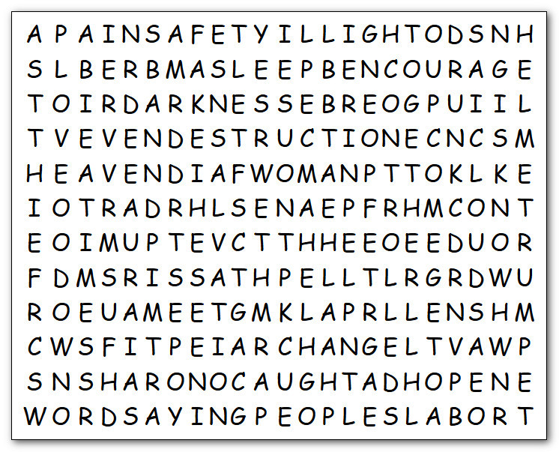
Well, I’ve returned … but not from the dead. Humph! It’s from my classroom to bring you these words to be found. You can will do it … OR ELSE! The words in this grid go from left to right, top down, and diagonally … but nothing backwards. (That other class complained about backwards words, Humph! A bunch of wimps.) They will probably go to https://tinyurl.com/bdhpzarb for the solution or to find some other Fun Family Activity
HOPE
KNOW
LABOR
LEFT
LIGHT
LOVE
MEET
NIGHT
PAINS
PEACE
PEOPLE
PREGNANT
RISE
SAFETY
SALVATION
SAYING
SUDDENLY
SURPRISE
THIEF
TIMES
TOGETHER
TRUMPET
WOMAN
WORDS

ALERT
ALIVE
ARCHANGEL
ASLEEP
BREASTPLATE
BROTHERS
CAUGHT
CLOUDS
COME
COMMAND
CONTROLLED
DARKNESS
DATES
DESTRUCTION
DOWN
DRUNK
ENCOURAGE
ESCAPE
FAITH
FOREVER
HEAVEN
HELMET
HIMSELF
Word Search

