1. Motivate

In your opinion, who is the greatest of all time in one of these fields:
Sports | Books/Authors | Movies
- Shohei Ahtoni  - Walter Payton  - Jim Brown  - Walter Payton  - Babe Ruth  - Willie Mays  - Mickey Mantle | - Bible  - The Great Gatsby  - Moby Dick  - books by Clancy  - books by Grishom  - books by Dick Francis  - Winds of War | - Star Wars movies  - Gone with the Wind  - Where Eagles Dare  - Dirty Harry movies  - The Music Man  - Sound of Music  - My Fair Lady

2. Transition

The Point:
- Probably will not find agreement for any category.
- But the One great name over all is Jehovah God
- Today we consider the reality that there is only one God
- Only His name deserves glory and exaltation.

3. Bible Study
A video introduction to the lesson is available. View it at https://tinyurl.com/3ferapsb . If you have no wi-fi where you teach, you should download the video file from https://tinyurl.com/2jj4zaep .

3.1 Behold, God’s Servant

Listen for description of the Servant.

Isaiah 42:1-4 (NIV) "Here is my servant, whom I uphold, my chosen one in whom I delight; I will put my Spirit on him and he will bring justice to the nations. 2 He will not shout or cry out, raise his voice in the streets. 3 A bruised reed he will not break, and a smoldering wick he will not snuff out. In faithfulness he will bring forth justice; 4 he will not falter or be discouraged till he establishes justice on earth. In his law the islands will put their hope."

God, through His prophet calls attention to “my Servant”. List words and phrases in verse 1 that describe this “Servant”.
- chosen one
- in whom I delight
- I will put my Spirit on Him
- He will bring justice to the nations

What hope do these verses give you about the Servant’s mission?
- the Spirit of God is upon Him, within Him, is one with Him
- He will bring justice to the nations
- He does so in a angry, noisy manner
- He will not give up
- we can put our hope in Him … wherever, whoever we are
How does verse 3 encourage you in your walk with God?
- He is not a monster or angry deity
- He is gentle
- He is faithful
- He is just, righteous … He does what is right

Looking at God's justice and faithfulness described in verses 1-4, what specific qualities make Him worthy of our honor and worship?
- God has chosen Him, delights in Him – He has good “references”
- He is faithful
- He is promised to accomplish justice – to do righit
- His work is for all peoples … not just the nation of Israel
- His working is around the world

What does this passage show about the way God’s chosen servant (the Messiah) brings justice to the nations?
- not with anger,
- nor with violence
- but gently
- in a way that attracts people to his rule

How does Jesus’ mission reveal God’s worthiness to receive glory and honor from all nations?
- He works to bring justice to all nations
- He has the power and authority to do this
- no one else has these kinds of abilities
- His promises are fulfilled – what He says, He will do
- Thus He is worthy of our worship and praise

3.2 The Work of God’s Servant

Listen for assurances.

Isaiah 42:5-8 (NIV) This is what God the LORD says-- he who created the heavens and stretched them out, who spread out the earth and all that comes out of it, who gives breath to its people, and life to those who walk on it: 6 "I, the LORD, have called you in righteousness; I will take hold of your hand. I will keep you and will make you to be a covenant for the people and a light for the Gentiles, 7 to open eyes that are blind, to free captives from prison and to release from the dungeon those who sit in darkness. 8 "I am the LORD; that is my name! I will not give my glory to another or my praise to idols.

What do these verses reveal about God’s role as the Creator compared to every other so-called “god” or idol?
- created the heavens
- stretched them out
- spread out the earth
- created all that is in the earth
- gives breath to its people
- gives life to all that walk the earth

Which of the metaphors about God’s work in the world have you seen play out in others’ lives?
- holds our hands
- keeps you safe
- the Light of the Gospel has come to us (Gentiles)
- opens spiritual eyes
- releases believers from the prison of sin’s penalty and power

Why do you think God says, “I will not give my glory to another or my praise to idols”?
- idols are useless substitutes for God
- they offer satisfaction but don’t deliver
- they don’t deserve praise and glory
- idols distract us from knowing and experiencing a personal relationship with the One True God

In what ways do you see people giving glory to idols instead of to God?
- pursuit of money, material goods
- chasing after pleasure, entertainment
- desire for power
- misplaced relationships

What evidence does this passage give us that Jehovah alone has the power to accomplish His purposes in the world?
- His creation
- the balance and design of His creation
- the very essence of life itself is given to us
- He is the source of all

How does knowing that God alone created the heavens and the earth affect the way we respond to Him in worship?
- the more you study biology, physics, science, the more you realize the design of the great creator
- He is omnipotent, omniscient, omnipresent, loving, sovereign
- no other being, no other object/thing comes even close to who Jehovah God is … He is The God Who IS … no one else is
3.3 Glory from All People

Listen for music instructions.

Isaiah 42:9-12 (NIV) See, the former things have taken place, and new things I declare; before they spring into being I announce them to you." 10 Sing to the LORD a new song, his praise from the ends of the earth, you who go down to the sea, and all that is in it, you islands, and all who live in them. 11 Let the desert and its towns raise their voices; let the settlements where Kedar lives rejoice. Let the people of Sela sing for joy; let them shout from the mountaintops. 12 Let them give glory to the LORD and proclaim his praise in the islands.

Where does the activity of the Lord fit into human history?
- He existed and created before any of creation
- He is the source of all that exists in our universe
- He created them out of nothing, just by speaking
- as humans, we don’t “create” in the same way … we make new things out of stuff that already existed
- we merely innovate

What assurance concerning His promises for the future comes from acknowledging what He has done in the past?
- consider all that He has done
- consider how God keeps it all together, keeps the worlds in place, keeps the stars shining
- He is the one who ultimately maintains all of nature’s workings
- as we trust Him, He can likewise keep us
- we can trust Him for safety, healing, sufficiency, salvation
- we live with broken bodies in a broken universe, but God offers spiritual healing, an eternal relationship with Him … the very creator and sustainer of the universe

What does the prophet instruct the peoples of every tribe, nation, and region to do?
- sing to the Lord a new song
- praise Him all peoples – around the world
- attribute to Him the beauty and power of the oceans, the mountains, the deserts
- in big towns and in the middle of nowhere you can see reasons to praise the Lord

Verses 10-12 call for universal praise - from the earth, the sea, the islands, and all who live in them. Why does God deserve praise from all creation?
- both in a macro sense (the size and complexity of the totality of the universe)
- and in a micro sense (the make up of atomic particles, the design of the DNA code of every cell)
- the beauty of creation – sunsets, flowers, the landscape, mountains, the oceans
- the power of these same things
Use the last page as a handout so your learners can take home the application points of this week’s lesson.

Application
Memorize.
- Commit Philippians 2:9-11 to memory.
- Reflect on those words.
- Ask God to show how you can live under His lordship each day.

Write.
- The Bible speaks of a new song.
- Write a hymn, poem, or spoken word poem to thank the Lord.
- Thank the Lord for His faithfulness in the past and His promises for the future.
- Share this work with others or use it in your personal worship to glorify God.

Encourage.
- There are many bruised people in our communities.
- Someone you know is going through a hard time.
- Send this person a note of encouragement with a promise from God of His faithfulness.

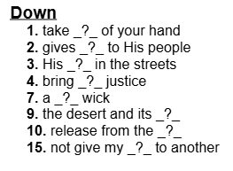

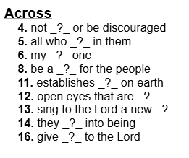
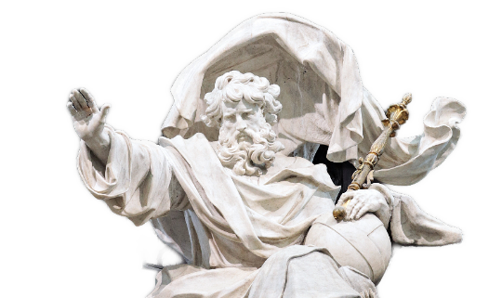
Crossword
Clues and Words taken from Isaiah 42:1-12 (NIV)

