1. Motivate

What is a debt you have taken on that seemed worth it at the time?
- car loan
A video introduction to the Bible study is available. View it at https://tinyurl.com/3crmeh57 If you do not have wi-fi where you teach, it is best to download the video file to your computer from https://tinyurl.com/22u8ykzs
- house mortgage
- student loan
- had to buy a new tire, “90 days, same as cash”
- new furniture
- needed a new suit
- wanted to get that boat/RV
- had to pawn my typewriter a couple of times while in college
- needed to buy some expensive textbooks one semester

2. Transition

One debt we all have but cannot pay … the judgment for our sinful condition.
- Jesus died to pay the debt of our sin.

3. Bible Study

3.1 Forgiving Words from the Cross

Listen for a cast of characters.

Luke 23:32-34 (NIV) Two other men, both criminals, were also led out with him to be executed. 33 When they came to the place called the Skull, there they crucified him, along with the criminals--one on his right, the other on his left. 34 Jesus said, "Father, forgive them, for they do not know what they are doing." And they divided up his clothes by casting lots.

Note the names used for the place of crucifixion.
- “The Skull”
- Calvary – which means “skull” --- and many of our Easter songs speak lovingly about “Calvary”
- Golgotha – also means “skull”

What other people show up in this scene? What were they doing, saying?
- two criminals – also being crucified, hurling insults
- soldiers – dividing up his clothes, mocking, offering wine vinegar
- rulers – sneering, mocking
- people – watching

How did Jesus respond to His abusers? What do Jesus’ words reveal about His character?
- Father, forgive them
- they don’t know what they are doing
- shows His mercy – does not intend they should get what they deserve
- shows His grace – wants good for them that they do NOT deserve

To whom do you think Jesus was offering forgiveness?
- those who were crucifying Him
- soldiers
- the crowd who clamored for His death
- the two criminals
- even the disciples who had run away

What kinds of things do you find easy to forgive?
- someone bumps into you in a hallway
- someone calls you by the wrong name
- someone misses you as they are passing out handouts in Sunday School
- someone accidentally calls your phone and it’s the wrong number (not in the middle of the night)

What kinds of things are more difficult to forgive?
- someone dents your car in the parking lot
- a neighbor’s kid breaks an expensive window with a baseball
- a neighborhood dog digs up your prize winning flowerbed
- you are falsely accused of a crime

How can Jesus’ love motivate us to be able to forgive people?
- if He forgave us (in effect we put Him to death), then we should be able/willing to do the same for much lesser offenses
- God’s Holy Spirit lives within us, generating the Fruit (of the Spirit) of Love
- On our own, we cannot generate that attitude, those kinds of actions … only God can do so

What kinds of words and phrases would you use to explain to a child or grandchild the meaning of God’s forgiveness?
- God loves us very much
- God shows His love for us in many ways – gives us homes, loving families, beautiful surroundings of nature
- when we do bad things, it makes God very sad – actually, we deserve to be punished
- we can talk to God in prayer and confess (admit to Him) what we have done wrong
- we can ask Him to be forgiven … to remove our guilt and punishment
- the Bible says that God actually forgets (and does not remember) our sinfulness
- He does not give us the punishment we deserve (mercy) …
- instead He gives us blessings that we do not deserve (grace)
3.2 A Saving Word from the Cross

Listen for who are saved.

Luke 23:35-43 (NIV) The people stood watching, and the rulers even sneered at him. They said, "He saved others; let him save himself if he is the Christ of God, the Chosen One." 36 The soldiers also came up and mocked him. They offered him wine vinegar 37 and said, "If you are the king of the Jews, save yourself." 38 There was a written notice above him, which read: THIS IS THE KING OF THE JEWS. 39 One of the criminals who hung there hurled insults at him: "Aren't you the Christ? Save yourself and us!" 40 But the other criminal rebuked him. "Don't you fear God," he said, "since you are under the same sentence? 41 We are punished justly, for we are getting what our deeds deserve. But this man has done nothing wrong." 42 Then he said, "Jesus, remember me when you come into your kingdom." 43 Jesus answered him, "I tell you the truth, today you will be with me in paradise."

Who were the three groups who taunted Jesus on the cross and what did their taunts have in common?
- the rulers – sneering at Him
- people who mock the claims that He is the Messiah, The Christ, The Chosen One
- Soldiers – offered him sour wine vinegar
- also made fun of the “King of the Jews” title
- that sign had been ordered placed there – apparently by Pilate
- criminal also insulted Him using the title “the Christ”
- all mocked that as the Messiah He should have the power to at the very least, rescue Himself

Why did Jesus not save Himself from such a horrible and tragic death?
- this was Jesus’ purpose for coming to earth
- rejection and death sentence from the religious leaders was not Plan B on God’s part
- He took upon Himself the sinfulness of each of us
- He received the punishment in our place
- He had to die so that we could have eternal life … eternal union with God

One of the two criminals defended Jesus. What was his defense? More importantly, what request did he make of Jesus?
- we deserve what we are getting, we did the crime – we’re paying the penalty
- somehow he knew that Jesus was being unjustly executed
- he declared that Jesus had done no wrong
- he believed that Jesus would come through this and be victorious
- asked that Jesus “remember” him at that time

Note the specifics of Jesus’ promise:
- The certainty of the promise I assure you
- The time of the promise Today
- The limit of the promise (singular) you (who have believed)
- The Person of the promise will be with me
- The place of the promise in paradise – heaven, a definite place
3.3 A Final Word

Listen for a final word.

Luke 23:44-49 (NIV) It was now about the sixth hour, and darkness came over the whole land until the ninth hour, 45 for the sun stopped shining. And the curtain of the temple was torn in two. 46 Jesus called out with a loud voice, "Father, into your hands I commit my spirit." When he had said this, he breathed his last. 47 The centurion, seeing what had happened, praised God and said, "Surely this was a righteous man." 48 When all the people who had gathered to witness this sight saw what took place, they beat their breasts and went away. 49 But all those who knew him, including the women who had followed him from Galilee, stood at a distance, watching these things.

What two phenomena did Luke identify as occurring as Jesus died.
- total darkness for three hours
- says the sun stopped shining (likely clouds heavy enough to bring on the darkness, blot out the sun)
- curtain of the temple torn in two (from other accounts, “top to bottom”)

What do you think was the significance of the darkness?
- symbolic of the presence of all that sin placed upon Jesus
- symbolic of God the Father’s “turning His back” on Jesus
- certainly a sign that something supernatural was taking place

What about the veil in the temple being ripped in two … of what significance is this?
- this was the curtain that closed off the “most holy place”
- it was the place of God’s very presence
- this area was only entered once a year for special ceremony of atonement
- God’s presence could only be entered by the priest to bring the offering of the shed lamb’s blood
- God caused the curtain to be opened … now anyone can enter God’s presence anytime

When has God done something dramatic that really got your attention?
- changed one’s life
- dramatic answer to prayer
- when God seemed to miraculously intervene in a time of danger
- maybe when we get to heaven, we’ll see video replays of times when God did intervene and we never realized it

Consider the reality of what God has accomplished
Use the last page as a handout so your learners can take home the application points of this week’s lesson.
- overcome the problem of sin in the world
- forgiveness of sins for all who receive Christ

The lives of all who were involved were changed … our lives are changed
This Truth is powerful … it continues to change lives as we faithfully communicate it

Application
Commit to Memory.
- Memorize 1 Corinthians 1:18b : “It is the power of God to us who are being saved.”
- It reminds you of the great reversal that came as a result of the cross

Commit to Prayer.
link to family discussion
- Commit to pray daily this week for one person close to you who has not yet believed in the death and resurrection of Jesus.
- Pray specifically that God would open their eyes to the work of Jesus on his or her behalf.

Commit to Study.
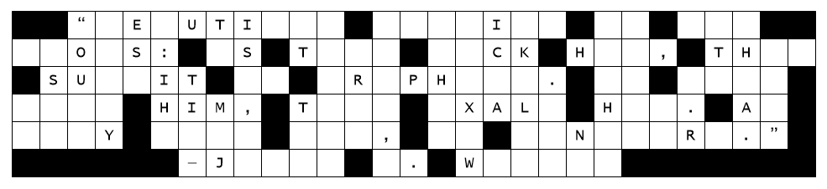
Fallen Phrases Puzzle
- What is one specific area of your life in which you are currently feeling anxious?
- Spend fifteen minutes journaling about how the cross of Christ ought to influence your confidence and actions in that situation.
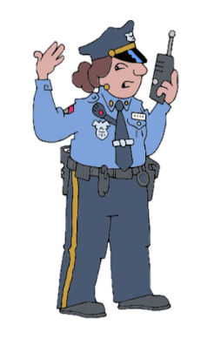
We have letters down … that windstorm last night did a number on this billboard. We need workers from your class to get these letters back in place. Oddly enough they all fell straight down, but not in order from the column. You’ll need to focus first on columns with a single letter missing. Then look at two and three-letter words and find which letters make reasonable words. Cars will be coming past this billboard soon, so we need to get the message back in place. Technical help and more Fun Family Activities related to the lesson are available at https://tinyurl.com/22u8ykzs

