1. Motivate

When have you had a warranty that really paid off?
- computer that died
A video introduction is available. View it at https://watch.liberty.edu/media/t/1_xc4f4tp0 . If you have no wi-fi where you teach, best to download to your computer from https://tinyurl.com/5b33pzc4
- tv that had a wonky picture
- bicycle that pedal crank broke
- tire that blew
- lifetime balance on tires purchased at Sams
- car engine broke down before warranty was up
- paint faded after only a few months, warranty paid for labor also
- printer broke down, company sent out a repair guy
- computer company sent a repair guy to install update
- insurance paid for outdrive replacement on a boat

2. Transition

You always wonder if the warranty will actually pay off or the company will weasel out.
- Contrast that with God’s promises
- We can be sure God saves us when we trust in Christ.

3. Bible Study

3.1 Jesus is the Christ

Listen for how to be born of God.

1 John 5:1-5 (NIV) Everyone who believes that Jesus is the Christ is born of God, and everyone who loves the father loves his child as well. 2 This is how we know that we love the children of God: by loving God and carrying out his commands. 3 This is love for God: to obey his commands. And his commands are not burdensome, 4 for everyone born of God overcomes the world. This is the victory that has overcome the world, even our faith. 5 Who is it that overcomes the world? Only he who believes that Jesus is the Son of God.

What is key to being born of God?
- believe that Jesus is the Christ, the Messiah
- demonstrated by love for God the Father and God the Son

What is the relationship of being born of God, believing in Jesus as the Christ, loving others, and loving God?
- born of God by belief in the saving work of Jesus, the Messiah
- like James said, this will be demonstrated by obedience, by works
- you are not saved for obeying God’s commands
- you will obey God’s commands as the result of your new relationship of faith in God

How do believers demonstrate their love for God?
- love the children of God … fellow believers
- obey His commands
- overcoming the world’s influence

Verse 3 says loving God will be displayed by obedience of God’s commands. What are some commands of God with which you struggle with obeying?
- some people are hard to love … they are just not nice people
- some destructive habits are hard to break
- some worldly activities are pleasurable (at least at first) and we don’t like to give them up
- materialism … we love our “stuff”
- some people are stuck on popularity or on the power they hold over others
- tithing
- coveting
- worry

How then can John say that God’s commands are not burdensome?
- we don’t have to struggle with these issues on our own
- God’s presence within our lives in the person of the Holy Spirit will empower us to do the right things
- He empowers us to give up the wrong things
- we overcome the world’s influence in our lives by trusting in the saving power of Jesus
- we are saved not only from the penalty of sin, we are being saved from the power of sin over us

What makes a person willing to give to or to love sacrificially the people they know?
- you have a sense of how they will respond
- it’s less of a risk
- you anticipate they will receive your kindness, your actions of love
- you like them, it’s easy to demonstrate that

What makes a person willing to love sacrificially someone you don’t know personally?
- God’s love is at work within you
- you are empowered by God’s indwelling Holy Spirit
- God gives you the love for that person who needs it
- you cannot conjure up this love or grit your teeth and make it happen

3.2 God’s Word Says So

Listen for the importance of God’s Word.

1 John 5:11-13 (NIV) And this is the testimony: God has given us eternal life, and this life is in his Son. 12 He who has the Son has life; he who does not have the Son of God does not have life. 13 I write these things to you who believe in the name of the Son of God so that you may know that you have eternal life.

Why did John write this letter?
- wrote to those who believe in the name of the Son of God
- wrote to declare the possibility of eternal life
- wrote to explain, assure believers of their eternal union with God
What does it mean to believe on the name of the Son of God?
- Name represents everything that makes a person who he is,
- including thoughts, feelings, character, and authority.
- It is everything that comes to mind when a name is spoken.
- we then believe in who that name represents
- we can trust the love, power, and authority of who Jesus is

What assurance did John want his readers to have that moved him to write to them?
- he was writing to believers, people who had believed in who Jesus is and what He had done
- he was assuring them that their act of believing, their attitude of faith enables them to know for sure that they have eternal life

What does it mean to have “life through the Son?”
- spiritual death is separation from the love and presence of God (both now and ultimately forever)
- spiritual life is spiritual union with God as the result of our faith in Who God is and What He says
- we enjoy God’s presence within our lives here in this lifetime
- we will enjoy God’s presence through eternity beyond this lifetime

Why is it sometimes hard for people to believe faith in Jesus is enough for salvation?
- they have the mindset of working for something
- we live our lives earning a living
- even when receive gifts at birthday or Christmas it is from those who “owe us” because of some sort of relationship
- God doesn’t owe us anything … He wants to bless us with eternal life

What aspect of eternal life is most exciting for you?
- we are rescued not only from the penalty and power of sin
- we will be rescued, freed from the presence of sin
- we will rule and reign with God
- we will know and understand infinitely more of Who God is and what He is like
- we might discover and investigate the creation of God in both the micro and macro magnitudes … the small and the large … the close and the far

3.3 My Life Has Been Changed

Listen for one more reason of assurance.

1 John 5:18-21 (NIV) We know that anyone born of God does not continue to sin; the one who was born of God keeps him safe, and the evil one cannot harm him. 19 We know that we are children of God, and that the whole world is under the control of the evil one. 20 We know also that the Son of God has come and has given us understanding, so that we may know him who is true. And we are in him who is true--even in his Son Jesus Christ. He is the true God and eternal life. 21 Dear children, keep yourselves from idols.

What are the various claims about Jesus made in these verses?
- the believer does not continue to sin, is no longer under sin’s enslaving power
- God keeps us safe from Satan’s influence
- 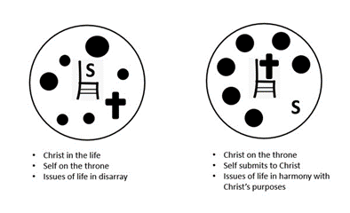we are children of God … our loving Heavenly Father protects us, empowers us, teaches us
- God gives us understanding to know Him better, to know His Truth better
- Christ is in us and we are in Him (like the branches are in the Vine)

By whom is the believer’s salvation secured?
- God keeps us safe
- the world is under Satan’s control
- we are under God’s protection and control

Why can a believer refrain from a lifestyle of sin?
- Consider 1 John 5:18 (NLT2) We know that God’s children do not make a practice of sinning, for God’s Son holds them securely, and the evil one cannot touch them.
- it’s not true that the devil “made me do it”, Jesus protects us
- the sin does not have the power over us it once did, enslaving us
- it may occasionally trip us up, but as we come to God for forgiveness (1 John 1:9)
- we can trust God for the power and wisdom to grow stronger to resist similar temptations

How has your life changed since you first encountered Christ?
- change in vocabulary
- don’t worry like before
- don’t get angry any more
- don’t have to give in to that same old temptation
- set free from certain habits

How does verse 21 fit into John’s overall message?
- idols are things which become more important to a person than God is
- if something is more important to you than God is, then you will ignore God’s guidance in your life and fall into sin
- the rest of the passage is saying we don’t have to be enslaved by sinful attitudes and actions
- we can be set free … when we submit to God’s direction, guidance

How can we guard ourselves from idols?
- daily communication with God
- read His words to you each day
- talk to Him in prayer (Adoration, Confession, Thanksgiving, Supplications)
- experience God’s love, power, authority
- let Jesus be the “Boss” in your life
Use the last page as a handout so your learners can take home the application points of this week’s lesson.
- the idols will be seen to be weak and no longer inviting
Application
Evaluate your life.
- Does your life reflect the triad of assurance: faith, love, obedience?
- If you say yes, but not as well as it should, what changes need to be made in your life to better reflect these salvation qualities?

Align your life.
- Have you started taking steps in your life to be a faithful witness?
- Practice sharing your testimony.
- Download the Life on Mission app (namb.net) on your phone, learn the presentation, and be prepared to share.

Make a difference in someone’s life.
- Make an intentional effort to lead someone to faith in Christ this week.
- Set up a coffee or lunch meeting.
- Make it a priority to share the gospel. Remember, it’s not your job to save them, but God does want you to share.
- 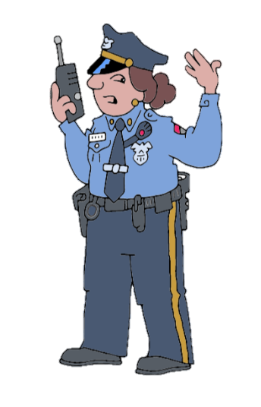Trust Him for the results
We have a report of letters down. Witnesses say they fell straight down out of their columns. Some remain in place. We’re going to need repair crews to study the fallen letters and look first for single empty cells, then to two and three letter patterns whose combinations make sense. Don’t be fooled by punctuation marks. Operators are standing by for your expertise. If you get stuck, go to https://tinyurl.com/5b33pzc4

Fallen Phrases Puzzle

