1. Motivate

What are some sure things you can count on in life?
- sunrise, sunset
A video introduction is available. View it at https://watch.liberty.edu/media/t/1_z5p4q5vx If you have no WiFi where you teach, best to download to your computer from https://tinyurl.com/hy2c7vu7
- death and taxes (Ben Franklin)
- politicians pontificate
- the weather will change
- football in the fall, baseball in the spring
- fashion fads change (so they can sell new styles)
- legislatures argue debate

2. Transition

Some people remain unsure of their relationship with God
- God assures us that we are forgiven when we confess our sin and walk with Christ.

3. Bible Study

3.1 Turn from Darkness to Light

Listen for a contrast.

1 John 1:5-7 (NIV) This is the message we have heard from him and declare to you: God is light; in him there is no darkness at all. 6 If we claim to have fellowship with him yet walk in the darkness, we lie and do not live by the truth. 7 But if we walk in the light, as he is in the light, we have fellowship with one another, and the blood of Jesus, his Son, purifies us from all sin.

What contrasting imagery did John use to describe what God is like?
- God is light
- in Him is no darkness … none, absolutely none at all

Why is it not possible to be in fellowship with God and live a life of sin?
- we would be walking in sin/darkness
- God is characterized by light – righteousness, truth, holiness
- these are mutually exclusive lifestyles
- if we do this we are lying to, fooling ourselves

What does verse 7 say about the results of “walking in the light”?
- we have fellowship with God
- and fellowship with one another
- the blood of Jesus purifies us from all sin
- Jesus’ sacrifice is made effective for us

What evidence do you see of darkness and light in your town or community?
Darkness | Light
- availability of addictive substances  - read the section of the paper about police arrests  - violence in homes, in schools  - crowded jails  - so called “adult” entertainment | - people responding to the gospel message  - baptisms  - preaching of the gospel  - lives changed when they find Jesus  - Christian radio stations

In what way do we sometimes “walk in darkness”?
- we act out of our sinful nature
- we commit sins
- we ignore God’s Truth
- we make bad choices
- we hurt one another or ourselves
- we close our eyes to what we know is right
- From A. W. Tozer, Sin, I repeat, in addition to anything else it may be, is always an act of wrong judgment. To commit a sin a man must for the moment believe that things are different from what they really are; he must confound values; he must see the moral universe out of focus; he must accept a lie as truth and see truth as a lie; he must ignore the signs on the highway and drive with his eyes shut; he must act as if he had no soul and was not accountable for his moral choices.

In what way is God similar to light?
- light reveals things not seen in the darkness … God’s Holy Spirit reveals our sin to us
- light enables us to see what we are doing … God’s Truth reveals to us our true actions and attitudes
- darkness represents sin … God is light … no sin present in Him

What does it mean to walk in the light?
- live a life in accord with God’s Truth
- a life of obedience, submission to God
- doing His will
- in a practical sense, it would mean filling your mind with God’s Truth
- reading God’s Word daily, meditating on its implications for living
- applying God’s Truth to your life

3.2 Willing to Confess Our Sin

Listen for the importance of confession.

1 John 1:8-10 (NIV) If we claim to be without sin, we deceive ourselves and the truth is not in us. 9 If we confess our sins, he is faithful and just and will forgive us our sins and purify us from all unrighteousness. 10 If we claim we have not sinned, we make him out to be a liar and his word has no place in our lives.

In what ways do we sometimes deceive ourselves about our own sin?
- it wasn’t really wrong to do that
- it was so small in contrast to the big and nasty sins
- it was not sin, it was a mistake
- it’s like a “Mulligan” in golf … you get another shot at no penalty
- I deserved to do that … the other guy had it coming … God will thank me for dispensing His justice
- unwilling to admit the reality of our sinful condition
- we are all born as sinners … to deny this is to deny the Truth, deny Reality

What is the relationship of confession to forgiveness and spiritual cleansing?
- to confess our sins is to agree with God that our actions and attitudes are sinful
- we tell God, “yes, you are right … I can see that I am a sinner”
- confession (along with repentance) is an absolute requirement for forgiveness and cleansing
- refusing to confess is the same as calling God a liar

What have you found challenging about accepting God’s forgiveness?
- for many people, I feel unwilling to forgive them for what they have done
- yet I find I do similar things, I offend God and other people in similar ways
- things I have done seem absolutely unforgivable to me
- why would God or anyone be willing to forgive me?

How can people get out from under the burden of guilt after God has forgiven them?
- daily claim God’s promises of forgiveness
- thank God daily
- praise and worship God daily for His love, compassion, and holiness
- search out verses on forgiveness and memorize them, meditate on them
- just like Deut. 6 says for children, carefully consider and think on God’s forgiveness when you get up, when you go to bed, when walking around, when eating meals, … all the time

3.3 Forgiveness through Christ

Listen for who is our advocate.

1 John 2:1-2 (NIV) My dear children, I write this to you so that you will not sin. But if anybody does sin, we have one who speaks to the Father in our defense--Jesus Christ, the Righteous One. 2 He is the atoning sacrifice for our sins, and not only for ours but also for the sins of the whole world.

So, why did John write this letter?
- so the readers not sin, that is live practicing sin
- so people are not slaves to sin
- so people who do occasionally fail and sin can get things made right with God
- so people realize that one can have his/her relationship with God restored even though failure and sin has broken that relationship

Why did John write that they “will not sin” but discuss options if they did?
- John knew what we are like and what God’s desire for us is
- we have been set free from the penalty of sin
- God wants us to also be free from the power of sin
- God is at work in our lives, chipping off the attitudes and actions which are sinful
- God’s Holy Spirit works in us continually shaping us to be more and more like Jesus
- similar to the shaping of a sculpture … cutting away everything that doesn’t look like what God intends for us to be
- that happens as a process … as we learn to trust in God’s power to live in victory over sin
- when we do stumble, fail, and sin Jesus is our advocate

In what way is Jesus an advocate?
- God the Father initially views us with all our flaws and sins,
- Jesus can step forward and say, “Yes, but the punishment (judgment) for those sins has already been executed … I took that punishment”
- Jesus will declare us to be justified, innocent in God’s view because of the substitutionary punishment of death He took in our place

How do God’s character qualities (such as holiness, love, and justice) contribute to His forgiveness?
- one of the reasons God forgives is that He loves us
- in order to forgive, God’s justice had to be satisfied, sin’s penalty is death
- that is why God allowed Jesus to die as a substitutionary sacrifice for the judgment against our sin
- only a holy, unique God could demonstrate love for us in that way

What does it mean that He is the propitiation for our sins?
- God’s wrath against sin has been satisfied
- He demanded judgment of death for sin
- Jesus, the Son of God, took that punishment in our place

How do God’s character qualities (such as holiness, love, and righteousness/justice) contribute to His forgiveness?
- one of the reasons God forgives is that He loves us
- in order to forgive, God’s justice had to be satisfied, sin’s penalty is death
- that is why God allowed Jesus to die as a substitutionary sacrifice for the judgment against our sin
- only a holy, unique God could demonstrate love for us in that way

Use the last page as a handout so your learners can take home the application points of this week’s lesson.

Application
Examine.
- Consider the principles taught today.
- They will either encourage you as a believer or accuse you as a nonbeliever.

Meditate.
- Every day this week pray according to Psalm 139:23-24, “Search me, God, and know my heart; test me and know my anxious thoughts. See if there is any offensive way in me, and lead me in the way everlasting.”

Share.
- Share your personal story of forgiveness with someone this week.
- “‘Do not fear their threats; do not be frightened.’ But in your hearts revere Christ as Lord. Always be prepared to give an answer to everyone who asks you to give the reason for the hope that you have. But do this with gentleness and respect” (1 Peter 3:14b-15).
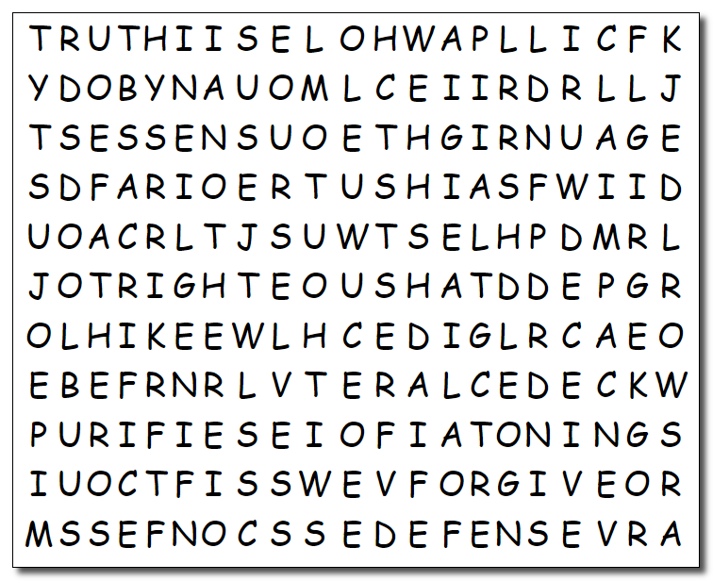
I’ve been waiting to see you again. Humph! These words deal with important theology, you can be SURE of that! You’ll have to find them going left, right, up, down, and diagonal. You’ll probably get stuck so you can go to https://tinyurl.com/hy2c7vu7 There’s other exceptional stuff there also.
Extra credit on your book report if you finish this puzzle by Tuesday!
Word Search Puzzle
LIE
LIGHT
LIVE
MESSAGE
ONE
OURSELVES
PURIFIES
RIGHTEOUS
SACRIFICE
SIN
SPEAKS
TRUTH
UNRIGHTEOUSNESS
WALK
WHOLE
WITHOUT
WORD
WORLD
WRITE
ANOTHER
ANYBODY
ATONING
BLOOD
CHILDREN
CLAIM
CONFESS
DARKNESS
DEAR
DECEIVE
DECLARE
DEFENSE
FAITHFUL
FATHER
FELLOWSHIP
FORGIVE
HEARD
JESUS
JUST
LIAR

