1. Motivate

When has someone gone out of his or her way to help you?
- paid a bill for me
- stopped to help change a tire
- showed me how to do a math problem
- gave me a tool and showed me how to use it
- watered my garden while I was gone
- visited my aging parent when I wasn’t around
- mowed my lawn while I was sick
- allowed us to borrow a car when ours was broken
- gave us a ride to the airport at 5:00 am

2. Transition

Helping one another is a way we show the love that Jesus spoke of
- Today we look at how loving God will be demonstrated in how we love others
- Sometimes that love will be costly
A video introduction to the Bible study is available. View it at https://watch.liberty.edu/media/t/1_xl6myeks If you don’t have wi-fi where you teach, you need to download the video file to your computer from https://tinyurl.com/2utpkr8j
3. Bible Study

3.1 Loving God, Loving Others

Listen for Jesus’ teaching style.

Luke 10:25-28 (NIV) On one occasion an expert in the law stood up to test Jesus. "Teacher," he asked, "what must I do to inherit eternal life?" 26 "What is written in the Law?" he replied. "How do you read it?" 27 He answered: "'Love the Lord your God with all your heart and with all your soul and with all your strength and with all your mind'; and, 'Love your neighbor as yourself.'" 28 "You have answered correctly," Jesus replied. "Do this and you will live."

What different motivations do people have for asking questions about God and of God?
- want to justify themselves
- may honestly want to know Truth
- just want to argue
- want to show that you as a Christian are wrong or foolish
- want to understand why God allowed such a thing to happen
- want to blame God for what happened
- they enjoy debate

Actually, this question is arguably the most important question any person can ask. Give your opinion why you think the lawyer was or was not sincere in asking it.

Sincere | Not Sincere
- the subject of the question shows it is sincere  - he was focused on the most important issue of life | - it says he asked it to test Jesus  - he already knew a proper answer (as a student of the Law)

If it was not a sincere question, but a test … what kind of test do you think this was?
- did Jesus really know what He was talking about
- would Jesus’ answer agree with the lawyer’s opinion
- could the lawyer find some detail of the law to trip up Jesus

Note that Jesus responds with a question of His own (a good teaching technique). What answer did the lawyer give about the requirements of the law?
- Love the Lord with all your heart, soul, strength, mind
- love your neighbor as yourself

Loving God with all your heart, soul, strength, mind involves …
- Emotions
- Intellect
- Total focus
- God is the very center of every element of your life

What does it mean to “love your neighbor as yourself”?
- our natural tendency is to put oneself in first place
- we are quick to watch out for our own interests
- comes naturally (note tendency of a 2 yr old, “MINE”)
- God calls us to act counter to that natural tendency and act the same way towards others … looking out for their interests … as we do for ourselves

The man was said to be an “expert in the law.” How can spending too much time simply studying the Bible lead to an unbalanced spiritual life?
- too much theory, not enough practice
- you can end up too heavenly to be any earthly good
- James spoke of faith without works is questionable faith

Why would knowledge with little or no works be a poor testimony for Christ?
- does not reflect Christ’s attitude
- Christ gave up His very life for others
- shows the love of Christ working in our lives
- demonstrates that God changes lives, wants to minister to people’s needs
3.2 Looking Beyond Biases

Listen for how Jesus begins to define “neighbor.”

Luke 10:29-32 (NIV) But he wanted to justify himself, so he asked Jesus, "And who is my neighbor?" 30 In reply Jesus said: "A man was going down from Jerusalem to Jericho, when he fell into the hands of robbers. They stripped him of his clothes, beat him and went away, leaving him half dead. 31 A priest happened to be going down the same road, and when he saw the man, he passed by on the other side. 32 So too, a Levite, when he came to the place and saw him, passed by on the other side.

When the lawyer asked, “who is my neighbor?” What do you think was behind his question ?
- not always easy to love your neighbor
- neighbors are not always loveable
- just how far down the street, around the corner, across the city, etc. does the term “neighbor” extend
- there must be some folks that the term “neighbor” does not apply – thus no need to love them
- he wanted to debate, to split theological hairs

What natural inclinations make it easier for you to act like the priest and the Levite?
- cannot afford the time or the resources involved
- they got themselves into the problem, they can get themselves out
- they need to learn to stand on their own two feet
- they deserve the plight they are in … it’s God’s judgment!
- I’m already too busy with family, school, job, church … someone else will help them
- those people are just too different from us … we cannot relate to them, they probably won’t understand or appreciate our help

How do we overcome barriers like these?
- confess your lack of love and concern for others in need
- Ask God to work in our lives to give us His love for them
- get to know the people, then you realize their true needs
- when they become your friends, you are more willing to help them
- pray for them … often God uses you to be the instrument of answering your own prayers

Agree or disagree … “You can never be too impulsive in acting on the motivation of love.”
Agree | Disagree
- acting in love is for the benefit of the recipient  - sort of like “if you snooze, you lose” … you can miss the opportunity if you don’t act right away  - you must act when God’s Spirit moves you | - sometimes you must carefully evaluate the situation  - you might be getting scammed  - you need to determine whether or not you have the resources  - impulsive is not always God’s Spirit … it might be just emotions

3.3 Difficult and Inconvenient

Listen for a surprise hero.

Luke 10:33-37 (NIV) But a Samaritan, as he traveled, came where the man was; and when he saw him, he took pity on him. 34 He went to him and bandaged his wounds, pouring on oil and wine. Then he put the man on his own donkey, took him to an inn and took care of him. 35 The next day he took out two silver coins and gave them to the innkeeper. 'Look after him,' he said, 'and when I return, I will reimburse you for any extra expense you may have.' 36 "Which of these three do you think was a neighbor to the man who fell into the hands of robbers?" 37 The expert in the law replied, "The one who had mercy on him." Jesus told him, "Go and do likewise."

Note what the traveling Samaritan did for the injured man.
- Bandaged his wounds, put medicine on them (oil and wine)
- Transported the man to an inn, took care of the man there personally
- Paid for additional days of stay in the inn

Why did the Samaritan do this? Why go to all this trouble?
- had pity on the injured man
- concerned for a person in need
- acted as a neighbor … saw the injured man as a neighbor in need

What barriers did the Samaritan overcome to demonstrate compassion to the injured man?
- racial (Samaritans and Jews pretty much hated each other)
- safety issue – still existed possibility of robbers lurking about
Share some background as to why the animosity
- financial – cost him something to help the man
- health – the man might be diseased
- reputation – friends and family might not understand

What does it cost us to show compassion to people in need around us?
- finances
- time
- physical energy
- emotional energy

What can we do as individual Christians or as a church to help remove the barriers that prevent God’s love and message of compassion from reaching all people?
- pray for people in need
- ask God to give you compassion that you do not have within yourself
- become involved in outreach ministries,
- become a volunteer (rescue missions, Habitat for Humanity efforts, etc.)
- be a “reading buddy” in local grade schools – many little children need someone to show personal interest

Use the last page as a handout so your learners can take home the application points of this week’s lesson.

Application
Confess.
- Has your life ever followed the pattern of the priest or Levite in the parable,
- Confess it to the Lord in prayer.
- Ask God to make you aware of the needs of others and to act with compassion toward them.

Assess.
- Identify those you tend to avoid because of their spiritual lostness.
- Prayerfully examine your schedule and your attitudes.
- Determine what are the main obstacles for you to love others.
- Make the appropriate changes and look for someone who needs a neighbor.

Express.
- Use creative ways to express your love for others.
- Send a card or a text.
- Invite an acquaintance to lunch.
- Just be a good neighbor!
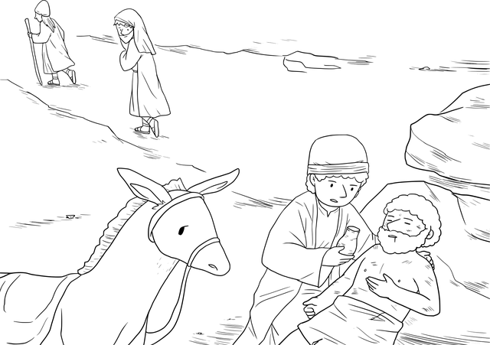

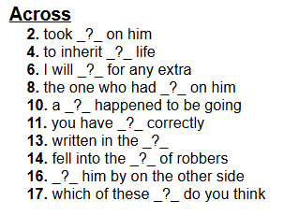
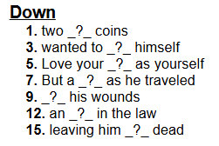
Crossword Puzzle
Words and Clues taken from Luke 10:25-37 (NIV) Help at https://tinyurl.com/2utpkr8j

