1. Motivate

What kinds of things could cause you to change your mind about something?
- you learned new information about the issue
- you experienced something that shifted your perspective
- you realized a flaw or weakness in your previous opinion
- friends (or enemies) persuaded you to a different point of view
- a change in your emotions caused you to reconsider your thoughts
- your values changed as you grew older and more mature
- the circumstances of your life changed … location, job, financial loss or gain
- realization that you were mistaken
- external factors – current events, catastrophic weather, pandemic, economic changes

2. Transition

Maybe a change in your values has to do with a spiritual experience.
- Living for Christ changes the way we think.
A video introduction to the lesson is available. View it at https://watch.liberty.edu/media/t/1_v5gbwfzg . If you have no wi-fi where you teach, best to download the video to your computer from https://tinyurl.com/mtdz8asu
3. Bible Study

3.1 A Renewed Mind

Listen for an appeal.

Romans 11:33 (NIV) Oh, the depth of the riches of the wisdom and knowledge of God! How unsearchable his judgments, and his paths beyond tracing out! … [36]For from him and through him and to him are all things. To him be the glory forever! Amen. [12:1] Therefore, I urge you, brothers, in view of God's mercy, to offer your bodies as living sacrifices, holy and pleasing to God--this is your spiritual act of worship. [2] Do not conform any longer to the pattern of this world, but be transformed by the renewing of your mind. Then you will be able to test and approve what God's will is--his good, pleasing and perfect will.

The word therefore is a transition word … what follows is based on what has just been said. What do we learn about God prior to the “therefore”?
- the depth of His riches
- He is wise, all knowing. His judgments are unsearchable
- we cannot always follow what He is doing, His paths
- for Him, through Him, to Him are all things

Based on the reality of who God is and what He is like, what are we urged to do?
- offer your bodies as living sacrifices
- do this as a spiritual act of worship
- don’t conform to the pattern of the world (don’t let the world squeeze you into its mold)
- be transformed
- allow your mind to be renewed
Sacrifices in Jewish worship were slain animals. Consider how this sheds meaning on giving your body as a living sacrifice.
- The owner was surrendering the value of the animal
- Killing it guaranteed a 100% surrender of the animal to God
- God wants 100% of what we are, who we are to belong to Him
- We surrender ownership and control of our lives to Him … as if we were dead

What makes offering our bodies as living sacrifices an act of worship?
- surrender yourself to God
- allow God to be in charge of your life
- you declare God worthy of being in control
- you trust Him to guide and shape your life in a way that pleases Him

What would be the effect of a transformed way of thinking?
- Paul says your mind would be renewed
- you mind is now focused on Christ
- you daily, moment by moment seek to know what He wants of you
- you focus on His commands, His strengthening power
- God’s indwelling Holy Spirit brings these thoughts and directions to your mind and your decision making process

What are the patterns of the world that tempt us to conform?
- what types of entertainment we are urged to enjoy
- the material goods advertisements tell us we must have
- the attitudes towards how to dress
- the priorities of church in our schedule
- our language
- focus on advancing oneself over all others

Surround by non-Christian worldview, how then can a Christian renew his or her mind?
- make a choice whose voice, which influence you will heed
- listen to, heed God’s words as found in Scripture
- be sensitive to God’s Spirit speaking to you, giving direction as you …
  - choose entertainment
  - act as a steward of the resources God has given you
- practice making good choices
- talk to God, ask Him to shape and mold your thoughts

How would these things help us discern the will of God?
- we are not focusing on secondary issues
- we would be focusing on what God wants
- not on what we want or the world says we should want

3.2 Thinking about Ourselves

Listen for how to think about yourself.

Romans 12:3-5 (NIV) For by the grace given me I say to every one of you: Do not think of yourself more highly than you ought, but rather think of yourself with sober judgment, in accordance with the measure of faith God has given you. 4 Just as each of us has one body with many members, and these members do not all have the same function, 5 so in Christ we who are many form one body, and each member belongs to all the others.

What two-pronged challenge did he offer about the way believers are to think?
- don’t think of yourself mor highly than you ought
- think of yourself with sober judgment
- be honest with yourself
- you are not to think less of yourself, but think of yourself less

Why was a believer not to think of himself more highly than he ought to think?
- we are all sinners
- only by God’s mercy (He didn’t give us judgement we deserve) and grace (He gives us blessings we don’t deserve) are we of any worth at all
- anything good about us is because God has accomplished it

How does the analogy of the human body help us better understand how the church should work?
- we realize that different parts of our body depend on each other
- feet depend on eyes to see where to walk
- hands depend on feet to get them to the right object
- blood depends on heart, all the body depends on the blood
- And all the people within a congregation
(and even believers from elsewhere) have much to contribute to each other

Agree or disagree – “It’s more important to have an eye than an ear.”
Agree | Disagree
- you need the eye to see things, hearing is secondary  - you could learn to read lips  - you could still drive | - you miss a lot around you  - lots of jobs you couldn’t do  - you don’t get to enjoy music, either listening or making it

The point is, that both are equally important … Paul is saying no one believer is more important than the other … all are equally important.

In God’s economy, the little old ladies who pray are just as important as the Billy Graham who preaches to millions

3.3 Our Attitude toward Others

Listen for how to work with others.

Romans 12:9-13 (NIV) Love must be sincere. Hate what is evil; cling to what is good. 10 Be devoted to one another in brotherly love. Honor one another above yourselves. 11 Never be lacking in zeal, but keep your spiritual fervor, serving the Lord. 12 Be joyful in hope, patient in affliction, faithful in prayer. 13 Share with God's people who are in need. Practice hospitality.

What are some ways Paul identified for how love will manifest itself in relationship to others?
- sincerity
- honor others above yourselves
- serve the Lord with zeal, with fervor
- joyful in hope
- patient in affliction
- faith in prayer
- share with those in need
- practice hospitality

What can we do to learn to hate evil?
- focus on God
- be aware of the contrast to worldly attitudes and actions
- similar to studying real currency so as to immediately see the contrast to counterfeit

How can one hate evil yet not hate the evildoer?
- know, remember that God loves the person
- realize that it is what they do and say that is evil
- respond to what they do with kindness … return evil with good

How can a Christian learn to love others as God loves them?
- allow God to love them through you
- if God is in control of your life, He will change your attitudes
- don’t rehearse in your mind all the bad things that person does
- remembering how much God loves your and how little you deserve it – God’s grace
- fill your mind with God’s Truth

Paul advises the Romans to be patient in affliction and to be faithful in prayer. How do you understand the relationship between patience in affliction and prayerfulness? How can prayer help us navigate challenging times?
- as you talk to God, you should tell Him how you feel, confess your fears, frustrations
- ask God for patience
- tell God you are trusting Him to take care of the problem
- thank Him that you know He is in control and will deal with issues in His time, in His way
Use the last page as a handout so your learners can take home the application points of this week’s lesson.
Application
Recognize.
- Assess your self-image.
- Evaluate whether your view of yourself is consistent with how God sees you.
- If you identify spiritual pride, be quick to confess it and root it out wherever it can be found.

Read.
- Spend some time working on the transforming of your mind.
- We know that this is God’s work, but God uses means.
- Consider reading a book such as The Mind of Christ by T. W. Hunt.

Replicate.
- Connect with a Christian friend to share what you have learned.
- Set an appointment this week and encourage that friend to share principles from this session with another person the following week.
Word Search Puzzle
Help and MORE at https://tinyurl.com/mtdz8asu
MEASURE
MEMBERS
MERCY
MIND
OFFER
OUGHT
PATIENT
PATTERN
PERFECT
PLEASING
PRAYER
RENEWING
SACRIFICES
SERVING
SHARE
SINCERE
SOBER
SPIRITUAL
TEST
THINK
TRANSFORMED
VIEW
WORLD
WORSHIP
YOURSELF
ZEAL
APPROVE
BODIES
BODY
BROTHERLY
BROTHERS
CLING
CONFORM
DEVOTED
EVIL
FAITH
FAITHFUL
FUNCTION
GOOD
GRACE
HATE
HIGHLY
HOLY
HONOR
HOPE
HOSPITALITY
JOYFUL
JUDGMENT
LACKING
LIVING
LONGER
LOVE
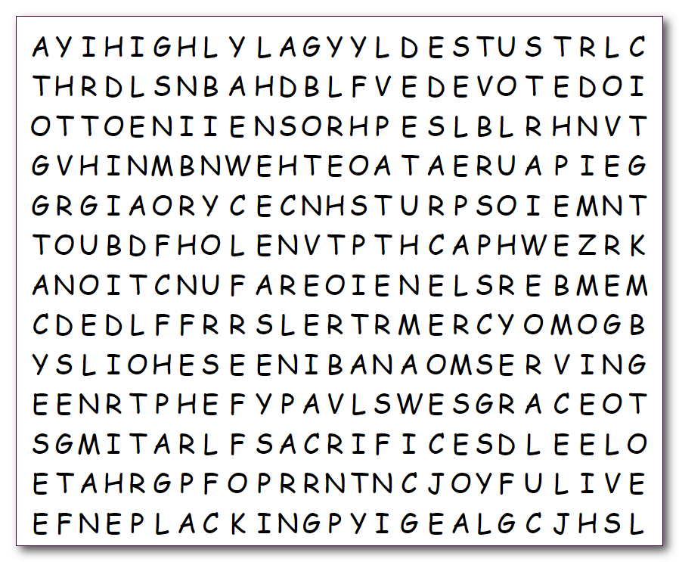
Humph. What were you thinking? It’s about time you look for some good words that are found in your Bible Study. Remember, they go up, down, left, right, and diagonally. See how many you can find. Maybe your teacher has a prize for those with the most. Humph!

