1. Motivate

What kinds of things do people have as priorities in their lives?

- jobs
- making money
- gaining power
- being entertained
- enjoyment
- playing with their “toys”
- getting out of work
- exercise
- chocolate
- church ministries

2. Transition

Today we look at a conversation Jesus had with a man who had misplaced priorities.
- Jesus teaches you must choose either Him or worldly wealth.
- You cannot live for both.
A video for the introduction is available
View at https://watch.liberty.edu/media/t/0_5uvhgij5
Download at https://tinyurl.com/yxfka55q

3. Bible Study

3.1 Outward Obedience Not Enough

Listen for a claim and a question.

Matthew 19:16-20 (NIV) Now a man came up to Jesus and asked, "Teacher, what good thing must I do to get eternal life?" 17 "Why do you ask me about what is good?" Jesus replied. "There is only One who is good. If you want to enter life, obey the commandments." 18 "Which ones?" the man inquired. Jesus replied, "'Do not murder, do not commit adultery, do not steal, do not give false testimony, 19 honor your father and mother,' and 'love your neighbor as yourself.'" 20 "All these I have kept," the young man said. "What do I still lack?"

What was the man seeking who came to Jesus?
- wanted to know how to get eternal life
- what good things must he do

Where is the flaw in his question?
- eternal life is a gift
- you don’t – you can’t – earn it

On what basis did Jesus begin to establish an answer to the man’s question that was appropriate to him?
- Jesus pointed to the commandments
- you must obey them
- but then, remember the flaw in the question

What astonishing claim did the young man make?
- he claimed to have obeyed all the commandments Jesus listed
- note Jesus listed the commandments having to do with our relationship to other people
- the commandments about putting God first were not yet mentioned

Why do you think Jesus quizzed the man about his commitment to the commandments?
- again, the basic flaw in the original question
- wanted to get the man thinking about how eternal life is not based on works
- you might be a very good person, but there’s more to life than a bunch of things you do

How would our culture respond to the young man’s question?
- an atheist or agnostic might claim there is no such thing as eternal life
- such a person would say we’re just like animals or plants, when we cease to have physical life, we cease to exist
- other folks might say, a loving God would not relegate people to an eternal hell
- or they might say hell is just a myth
- they say heaven is like a divine universal social security, “good times” for everyone with “no cost” to anyone

Why is keeping certain commands not enough to receive eternal life?
- we like to think we are good people
- we want to claim we obey these commandments all the time
- if honest, we would have to admit sometimes we fail one of the commandments
- fail once, and you’ve failed the whole thing
- the outward actions flow from our inward condition – we are sinners – we have a sin “sickness” we are born with

3.2 Internal Obedience to Christ

Listen for why the man is sad.

Matthew 19:21-22 (NIV) Jesus answered, "If you want to be perfect, go, sell your possessions and give to the poor, and you will have treasure in heaven. Then come, follow me." 22 When the young man heard this, he went away sad, because he had great wealth.

What further assignment did Jesus give the man who came to Him? What would the young man need to decide if he were to have eternal life?
- if you want to be really perfect, sell all your possessions
- give the proceeds to the poor
- then come follow Jesus
- this gives you treasures in heaven
- this guarantees you eternal life

What is at the heart of Jesus’ response to the young man? What point do you think Jesus was making with this rich man?
- it hit the man where his priorities were
- he was a very wealthy man
- his wealth was the most important thing to him
- it was more important to him than following Jesus
- more important than trusting and obeying God

How would you answer someone who said, “Jesus is stating here that you can earn your way to eternal life by giving all your money to God.”?
- we note that this is the only person Jesus said this to
- Jesus is not making a universal statement or a generalization
- He is speaking specifically to this man and his personal mindset
- Jesus knew this man’s priority was his wealth
- the man needed to put love for and obedience to God ahead of his love for and dedication to his finances
- in a similar manner, we must put our faith in and obedience to God ahead of anything else in our lives.

How did the man react to Jesus’ demands?
- he rejected Jesus’ suggestion/command
- he could not give up the priority of his wealth
- he wanted eternal life, but was not willing to pay the “price”
- he could not put God first in his life

Why do many poor people have a great love for God and many rich people have no interest in God?
- folks with minimal possessions trust God for even the necessities
- they need God in their lives
- people with plenty come to feel, they have no need for God
- they are “self-made”
- they can handle life on their own – just spend what is needed to acquire what you want

Why is a willingness to surrender everything necessary to follow Jesus?
- Jesus must become the most important influence in your life
- to “follow” Jesus, you must make Him the #1 priority
- trust Him, obey Him, serve Him, do His will
- surrender your will to Him

3.3 What Matters Is A Relationship with God

Listen for what seems impossible.

Matthew 19:23-26 (NIV) Then Jesus said to his disciples, "I tell you the truth, it is hard for a rich man to enter the kingdom of heaven. 24 Again I tell you, it is easier for a camel to go through the eye of a needle than for a rich man to enter the kingdom of God." 25 When the disciples heard this, they were greatly astonished and asked, "Who then can be saved?" 26 Jesus looked at them and said, "With man this is impossible, but with God all things are possible."

What astonishing statement did Jesus make about the rich and the kingdom of God?
- hard for a rich man to enter the kingdom of heaven
- difficult for a wealthy person to allow God to rule in his/her heart
- they achieved wealth and riches by controlling their own lives
- don’t want someone else (God) forcing them to do otherwise

What was the illustration He used to support His point?
- used an hyperbole of comparison
- like the difficulty of putting a camel through a miniscule hole, the eye of a needle

Why might the disciples have been surprised to hear Him say that?
- the hyperbole implied impossibility
- Jewish culture believed that wealth demonstrated God’s blessing, God’s favor, God’s positive evaluation of one’s life
- if you were poor, it showed God was withholding His blessing because of your poor spiritual condition
- Jesus comment was in direct opposition to that cultural belief

What conclusion did they seem to draw?
- so, if one’s wealth is not an indicator of God’s favor on the life …
- how can anyone be saved?
- it didn’t make sense to them
- so rich people were not necessarily spiritual or righteous
- obviously poor people were not spiritual or righteous
- … so WHO WAS? No one?

How can a rich person—or any person—enter the kingdom?
- confession of sin – agree with God you are a sinner and have committed sins
- repentance – turn away from a sinful life, turn towards God
- receive by faith Jesus’ work of redemption – trust in His promise to forgive your sins

In what ways can wealth and possessions get in the way of following Jesus?
- over occupied with gaining and keeping your wealth
- decide you don’t need God’s help in your life
- rebel against God and His commandments to gain and hold on to the wealth
- trust in your wealth more than trusting in God
- priorities change – God is less important, your “good life” is more important

What are some things other than wealth that can keep people from following Jesus?
- how you use your time
- the people you choose to associate with
- your job, don’t become a “workaholic”
- a hobby
- over indulgence in entertainment
- be a slave to social media
- substance abuse – from chocolate to pain killers to hard drugs
Use the last page as a handout so your learners can take home the application points of this week’s lesson.
How can we own possessions without possessions owning us?
- “hold on to them” lightly
- use your finances for the Kingdom of God
- use what God has prospered you with to bless others – be generous
- use your finances wisely – not squandering, not used wastefully
Application
Trust.
- If you’ve been trying to be good and moral in order to gain a good standing with God, acknowledge the futility of it.
- Trust Christ and be obedient to His Word as a response to His grace in your life.

Audit.
- Walk through your residence and look at the- things you own.
- Review each line of your financial statement.
- What do these possessions and purchases say about what’s important to you?
- Consider ways you can use what God has given you to honor Him and build up His kingdom.

Sell.
- Sell what you don’t need or give it away.
- If you have possessions that consume your time in an unhealthy way or tempt you to focus on anything but Christ, sell it.
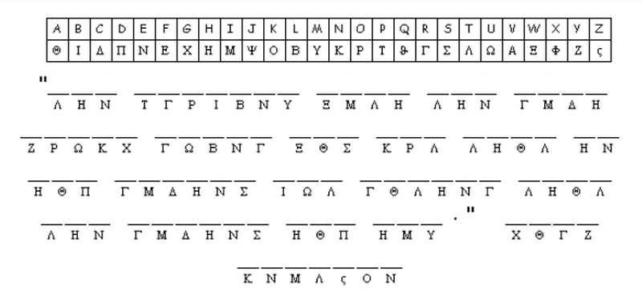

- Don’t let anything come between you and following Christ
That “rich young ruler” made an impression on someone. We need to find out who it was and what he said. Use the symbol key at the top to decode the message. Headquarters is standing by for this important information. If you’re stuck, check out https://tinyurl.com/yxfka55q There’s other fun Family Activities there also.

