1. Motivate

What is something about you that is unique?
- my glasses prescription
A video introduction is available. View at https://watch.liberty.edu/media/t/1_7qdplckd . If you have no Wi-Fi where you teach, best to download to your computer from https://tinyurl.com/uvkl9wf
- fingerprints
- retina scan
- education
- driving style
- sequence of jobs held
- places I have lived
- music skills (or lack thereof)
- my drive route to work
- wardrobe
- books read
- website

2. Transition

We are all unique in many ways.
- Our God is unique, distinct, set apart … holy
- He calls us to be set apart in Christ, sanctified, to live holy lives.

3. Bible Study

3.1 Set Apart from Our Old Life

Listen for lives changed.

1 Corinthians 6:9-11 (NIV) Do you not know that the wicked will not inherit the kingdom of God? Do not be deceived: Neither the sexually immoral nor idolaters nor adulterers nor male prostitutes nor homosexual offenders 10 nor thieves nor the greedy nor drunkards nor slanderers nor swindlers will inherit the kingdom of God. 11 And that is what some of you were. But you were washed, you were sanctified, you were justified in the name of the Lord Jesus Christ and by the Spirit of our God.

What does it mean to inherit the kingdom of God?
- the “kingdom of God” is the realm where God rules
- He wants to rule in our lives
- those who choose a wicked lifestyle do not allow God to rule in their lives
- they do not experience the kingdom/rule of God

What were the behaviors listed in verse 9, then in verse 10.
Behaviors in Verse 9 | Behaviors in Verse 10
- sexual immorality  - idolaters  - adulterers  - male prostitutes  - homosexual offenders | - thieves  - greedy  - drunkards  - slanderers  - swindlers

Now what are the differences and similarities in the two lists.
Differences | Similarities
- vs 9 have to do with sexual immorality – which our culture tends to more or less condone  - vs 10 has things most folks in our culture hold as wrong | - all are offensive to God  - God declares them all to be sin  - God does not go by what our culture says

So what had changed the Corinthians’ standing before God? What three terms did Paul use to describe the change that had taken place in them through Christ and the Spirit?
- they were washed
- sanctified … set apart from former sinful actions and attitudes
- justified … declared in right standing before God
- all based on the redeeming work of Jesus Christ in His substitutionary death and resurrection

How does it make a person feel to know that they have been washed, set apart to be holy, and declared to be sinless before God the Father?
- thrilled
- excited
- thankful
- desire to do right things, make right choices

How does this passage reflect the experience of a person with Christ in today’s culture? What difference should it make in a person’s life if they have been sanctified and justified by God’s Holy Spirit?
- people with addictions (drugs, sex, foul language, chocolate, worry, anger, etc.) are freed, delivered
- people who declare themselves to be atheists come to faith in Christ
- someone who is shy about their faith becomes an outspoken witness
- young people who have no idea about their future discover that God will direct their paths
- a person with limited skills finds God has a place where He can use them mightily
- set free from sin’s influence in our lives
- able to make right decisions with the right information in our minds, with right motivations in our hearts

3.2 Set Apart to Be One with Christ

Listen for ethical implications.

1 Corinthians 6:12-17 (NIV) "Everything is permissible for me"--but not everything is beneficial. "Everything is permissible for me"--but I will not be mastered by anything. 13 "Food for the stomach and the stomach for food"--but God will destroy them both. The body is not meant for sexual immorality, but for the Lord, and the Lord for the body. 14 By his power God raised the Lord from the dead, and he will raise us also. 15 Do you not know that your bodies are members of Christ himself? Shall I then take the members of Christ and unite them with a prostitute? Never! 16 Do you not know that he who unites himself with a prostitute is one with her in body? For it is said, "The two will become one flesh." 17 But he who unites himself with the Lord is one with him in spirit.
What false and destructive belief about freedom in Christ had some of the Corinthian believers adopted?
- they believed they had “freedom” and could do whatever they wanted
- just because they had a certain built in desire (such as appetite for food) meant they could pursue that appetite, whatever it was for
- today they might say, HBO or Netflix has all kinds of stuff, it’s there, I like it, it’s OK to watch it

How did Paul challenge the statement of some that all things are lawful?
- even though we might have a desire for something, does not mean it is beneficial or good for us
- even food which is good for us can be abused – (as witnessed by the reality shows about people who are grossly overweight and who cannot live a normal life)
- these desires of our current physical existence will pass away, they are not eternal

By what act and promise of God are we made one with Christ?
- God’s power raised Jesus from the dead
- that same power raises us from spiritual death (separation from God)
- all those sins that separate us from God will be forgiven
- their power over us in this life is destroyed

In what way did Paul argue that sexually immoral behavior dishonors the body of Christ?
- our physical bodies are meant to be “members of Christ”
- we must not unite our bodies to experiences that dishonor Christ
- it’s like viewing porn and saying, “Hey Jesus … look at this one … woo hoo!”

What did Paul mean by saying, "I will not be mastered by anything"?
- he would not allow himself to be addicted to substances
- he would not become controlled by ungodly urges
- he would reject temptations to do things he knew were wrong

Since all things are permissible, how do we evaluate what is beneficial?
- scriptural teaching
- specific commands and principles from the Bible
- guidance by God’s Holy Spirit
- God’s Spirit convicts (convinces) us when we wander out of the area of “beneficial”
- godly counsel from mature believers

3.3 Set Apart to Glorify God

Listen for what is God’s temple.

1 Corinthians 6:18-20 (NIV) Flee from sexual immorality. All other sins a man commits are outside his body, but he who sins sexually sins against his own body. 19 Do you not know that your body is a temple of the Holy Spirit, who is in you, whom you have received from God? You are not your own; 20 you were bought at a price. Therefore honor God with your body.

How did Paul advise his readers to deal with the potential of sexual sin?
- flee from it
- when the temptation comes along, go the other direction
- don’t dabble in it
- remember that Jesus died to free you from all sin
- Jesus paid a great price … don’t mock that by participating in sin

According to verse19, what makes our bodies special? What does it mean to call our bodies the temple of the Holy Spirit?
- God’s Holy Spirit lives within each believer
- to mess with sin against our bodies is like spitting on the floor in your church
- it’s like making a mess or acting destructive against your own church building
- honor your physical body, don’t desecrate it with illicit sex or physically abusive activities
- you have been bought with the price of the blood of Jesus Christ
- our bodies must be used to honor God

According to this passage, how will sexual misbehavior affect people?
- your body becomes united to something/someone outside of Christ
- a believer would be acting against the union with Christ
- the unbeliever would be creating even more of a barrier between against Christ
- you weaken godly unions (marriage) that do exist

What are other specific ways Christians can live set apart for God in today’s culture?
- allow God’s Holy Spirit to produce in and through our lives the Fruit of the Spirit – love, joy, peace, patience, kindness, goodness, gentleness, faithfulness, and self-control
- appropriate the whole armor and weapons of God for both spiritual defense, and spiritual ministry
  - Helmet of Salvation (guards your mind)
  - Breastplate of Righteousness (guards your heart/emotions),
  - Belt of Truth – holds all our beliefs in place
  - Sword of the Spirit – Word of God (used to kill sinful urges, to convict sinners – including ourselves)
  - Shoes of the Gospel – firm spiritual footing (like wearing sports cleats)
  - Shield of Faith – protects us from temptations and doubts fired at us by Satan

How can we motivate children and grandchildren to remain sexually pure?
- pray early and often
- have frank conversations – keep the TV and the internet access out in the open
- always be willing to answer questions – age appropriately
- model sexual purity in behavior and in what you say and view – whether others are watching you or not
Use the last page as a handout so your learners can take home the application points of this week’s lesson.

Application
Offer thanks.
- Reflect on how your life has changed because of Christ.
- Thank Him for setting you free from the former way of life.
- Pray for the Lord to continue His good work.

Memorize.
- Memorize 1 Corinthians 6:19-20 and repeat it to yourself when you need to flee from temptation.
- “Don’t you know that your body is a temple of the Holy Spirit who is in you, whom you have from God? You are not your own, for you were bought at a price. So glorify God with your body.”

Walk alongside others.
- Making the daily choice to live a holy life is much easier when you walk alongside other believers.
- Surround yourself with others who also choose to live their lives for Christ. Your Bible study group is a good place to start.

Cryptogram
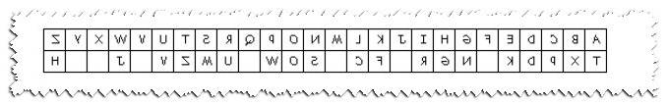

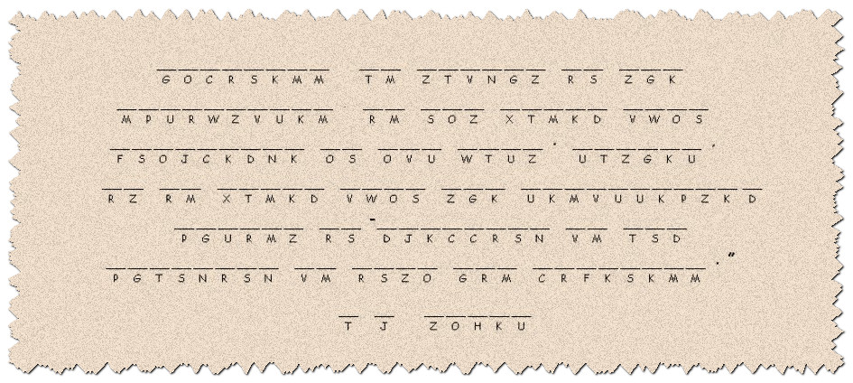
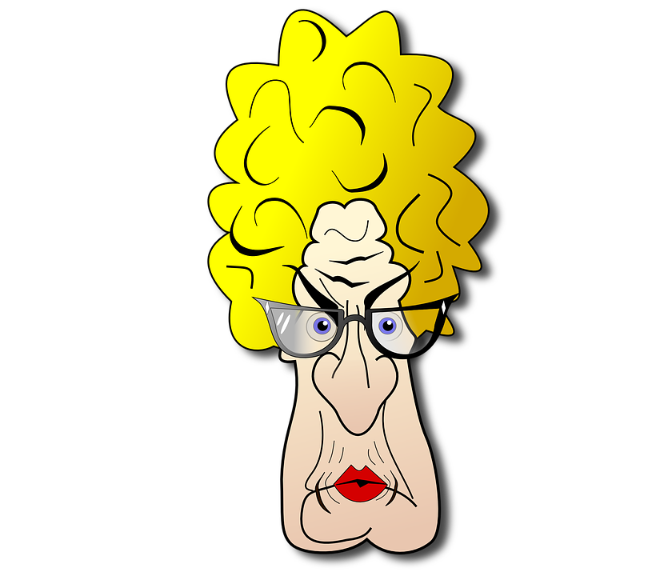
Spiros the Spy is busy. He’s working on the book report he owes me. Humph! He says the key for the secret message that came through from Kongnor Nyaviet security police and got in some water and only the back side of the paper can be read. Anyway, your youth pastor needs to know this message. Humph! Help him out before the Jr. Hi boys fill the girls’ bathroom with balloons. You’ll probably need help … or want your precious crossword. Go to https://tinyurl.com/uvkl9wf

