1. Motivate

When have you been happy for someone to step in and fix something you couldn’t?
- someone stopped and helped change a flat tire
- mow the lawn when I was sick
A video for the introduction is available. It can be viewed at https://watch.liberty.edu/media/t/1_dv4fhqns

If you don’t have WiFi where you teach, best to download to your computer from
https://tinyurl.com/qrax9v7
- wash the dishes when I had a bad burn on my hand
- a friend helped me with a school assignment I didn’t understand
- EMT’s came when someone in the family had a bad fall
- someone picked up the kids from school when our car wouldn’t start
- all the kids pitched in to do the housework when Mom was sick
- a friend helped change a leaky faucet
- the fire department came and put out a grass fire out behind our house

2. Transition

The biggest problem we have is our sin problem – which we can’t fix.
- We were separated from God because of our sin.
- Jesus made it possible for us to be righteous before God.

3. Bible Study

3.1 Declared Righteous by Christ

Listen for what the law does not do.

Romans 3:20-22 (NIV) Therefore no one will be declared righteous in his sight by observing the law; rather, through the law we become conscious of sin. 21 But now a righteousness from God, apart from law, has been made known, to which the Law and the Prophets testify. 22 This righteousness from God comes through faith in Jesus Christ to all who believe. There is no difference,

By what means did Paul say we cannot be justified?
- observing the law does not justify us
- we cannot be declared innocent by obeying the law

What is one purpose of the law?
- the law makes us conscious of sin
- we become aware of our sinfulness when we see we do not, cannot obey its demands

Aren’t we already conscious of sin? Why do we need the law to make us conscious of sin?
- We each think “I’m not so bad”
- We think we are aware of sin but we don't know how bad it is.
- Truth is, we are all a little smug, “I’m not as bad as those other folks, so I’m OK”
- We the specific message, “You have an inborn sinful nature”

To what does the righteousness of God refer?
- God is righteous, just
- God always does the right thing
- righteousness from God has been made known
- God has made known a way that we can be declared righteous, we can become justified

Note the starting words, “But now.” Why would these be important? What do they indicate?
- shows a contrast
- means things have changed
- in this case, changed from the thought of righteousness through obeying the law
- it indicates a whole new paradigm of how we come to be declared righteousness

So, what do you think Paul was referring to when he talks about “a righteousness that is apart from the law”?
- you cannot be righteous by obeying the law
- obedience is not the means to salvation (although it should be one of the results)
- Paul is preparing the reader for the Truth about how one can be declared righteous

How do people define or determine right and wrong in our culture?
- in one sense the local, state, and federal laws
- in another sense, by our own conscience
- also by what the Bible says is right and wrong – generally, the Ten Commandments
- there are also cultural influences – peer pressure, group mores, values, traditions, standards

Why do people think they’ve got to be “a good person” to get into heaven?
- similar to belonging to a group (formal or informal) – you have to meet certain standards
- God has standards
- you have to meet those standards (like the Ten Commandments) to satisfy God
- a “good person” is defined by those standards

How does God’s righteousness become active or take effect in our lives? What new righteousness has been made known?
- comes through faith in Jesus Christ
- when we realize, become convinced in our minds and hearts that Jesus died for us personally
- we communicate that belief, that conviction, that trust to God, we can be declared righteous

3.2 Redeemed by Christ

Listen for God’s solution.

Romans 3:23-24 (NIV) for all have sinned and fall short of the glory of God, 24 and are justified freely by his grace through the redemption that came by Christ Jesus.
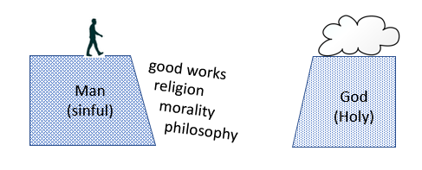
What does all humanity hold in common? What heritage do you share with every person who has ever lived?
- we have all sinned
- we all fall short of God’s standards
- we try to satisfy God with efforts such as morality, good works, philosophy, religion … but all these fall short

Exactly what is justification?
- we are declared (by God) as not guilty
- it is an act (by God)
- it is not a process (by us or God either one)
- God views us “just as if” we had never sinned

What justifies us in God’s sight?
- God’s grace
- God offers us the blessing of being declared without guilt … even though we don’t deserve it
- Jesus redeemed us
- He paid the ransom to free us from the penalty of sin … and the power of sin
- When Jesus died on the cross, He took upon Himself our sin and died in our place

Why would God offer His righteousness free to every person from the penalty of sin?
- God loves us
- God wants to have a personal relationship with each one of us
- He wants us to trust Him, depend on Him, allow Him to accomplish good things in our lives, through our lives
- God IS love

How would you describe our sinful condition and God’s grace to someone new to Christianity?
You can find these on the internet to download and print. Choose one and every evening read through it thoroughly. After a while you will be able to repeat it without looking. Practice!
- use one of several different witnessing tools
- FAITH
- Four Spiritual Laws
- Roman Road
- Steps to Peace with God
- share your own spiritual journey – a short and simple story of how you found Christ as Savior

3.3 Atonement through Christ

Listen for what is accomplished by Christ.

Romans 3:25-28 (NIV) God presented him as a sacrifice of atonement, through faith in his blood. He did this to demonstrate his justice, because in his forbearance he had left the sins committed beforehand unpunished-- 26 he did it to demonstrate his justice at the present time, so as to be just and the one who justifies those who have faith in Jesus. 27 Where, then, is boasting? It is excluded. On what principle? On that of observing the law? No, but on that of faith. 28 For we maintain that a man is justified by faith apart from observing the law.

Verse 25 in the NIV uses the term “sacrifice of atonement” – what does the KJV use? What do these terms mean?
- KJV says “propitiation”: turn away divine wrath with the appropriate sacrifice
- In Greek writings hilasmos refers to soothing the anger of the gods
- God's anger was soothed, turned away by the sacrifice of the life of Jesus, the Messiah, the Son of God
Best presented in lecture format
Consider how this demonstrated God's justice …
- God is holy, righteous – cannot abide the presence of sin (of which the world is full)
- a critic might say that God was not being true to His own standards by tolerating sin – “ in his forbearance he had left the sins committed beforehand unpunished”
- sin’s presence demanded the punishment of death – separation from God
- God took the initiative to solve the problem
- Jesus came to earth, as a human, lived a perfect life, NOT deserving death
- He suffered the death we deserved … died in our place
- He gave us the life (eternal union with God) that He deserved
- God's justice is satisfied – the sentence of death was executed for the sin in the world
- At the same time, forgiveness, justification, redemption were made available to all men

How do these Truths impact our lives today?
- What Jesus then did provides forgiveness for us today
- I can be set free from both the penalty and power of sin
- Satan cannot accuse me, discourage me about my failures – the punishment has already been meted out
- people who think they are too far gone for God to reach have already been potentially forgiven
- it is theirs for the confession, repentance, and receipt by faith of Jesus’ finished work

How do we relate this concept to witnessing to those who are lost?
- many people still think (down deep) that one must satisfy God by good works
- this speaks against humanism also (the concept that “man is his own deity”)
- It also speaks to a person who feels the failure – feels that they cannot boast – actually that means they are more ready to accept what Christ has done for them
- Jesus death and resurrection bridges the gap between sinful man and Holy God
- We can know God’s love and forgiveness by placing our faith in His completed work of redemption
Use the last page as a handout so your learners can take home the application points of this week’s lesson.
Application
Believe.
- Turn to God in faith and place your trust in Christ.
- Turn from yourself and turn to Christ who offers salvation through His death and resurrection.
- If you need help with this, read the inside front cover of your student book.

Repent.
- Examine your life for any boasting about who you are and what you’ve done.
- Confess that to God, and thank Him for His forgiveness.
- Recognize that anything you have or do is all from His grace.

Share.
- This good news is not intended to be kept to yourself.
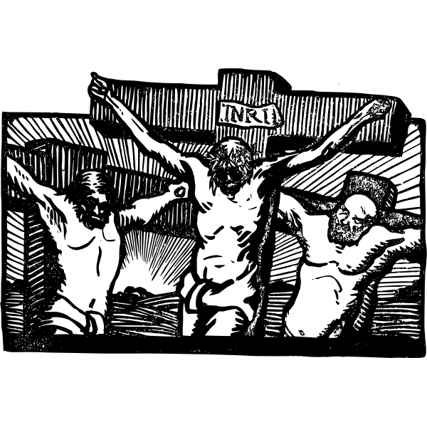
- Identify someone you know with whom you can share the gospel of God’s salvation.

Across
3. where, then, is _?_
4. fall _?_ of God's glory
5. justified by faith _?_ from the law
7. justified _?_ by His grace
10. redemption _?_ by Christ Jesus
11. to demonstrate His _?_
12. the Law and the Prophets _?_

Down
1. by the law we are made _?_ of sin
2. righteousness from God through
_?_in Jesus
3. through _?_ in His blood
4. a _?_ of atonement
6. _?_ have sinned
8. boasting is _?_
9. not declared righteous by observing
the _?_

Clues and words taken from Romans 3:20 – 28 (NIV)
Find other fun Family Activities at https://tinyurl.com/qrax9v7

